PROJECT 5
DynamoDB + Amazon ElastiCache for Valkey
Lazy Loading and Cache Invalidation
Detailed hands-on implementation report
Environment | Amazon EC2 — Amazon Linux 2023
Persistent store | DynamoDB table: project5-users
Cache | ElastiCache Serverless for Valkey, engine version 9
Region | ap-south-1
Pattern | Cache-aside / lazy loading with explicit invalidation
Cost warning
Valkey Serverless is not assumed to be free. Keep the resources only for the lab and delete them after collecting evidence.

1. Executive Summary
This project implements a cache-aside architecture in which DynamoDB is the source of truth and Amazon ElastiCache Serverless for Valkey provides low-latency access to frequently requested user records. The Python application runs on EC2 and uses an attached IAM role to access DynamoDB without storing AWS access keys in the code.
The application checks Valkey first. On a cache miss, it reads DynamoDB, converts the record into normal Python data, serializes it as JSON, and stores it in Valkey for 300 seconds. After an update or deletion, the matching cache key is explicitly removed to prevent stale data.

Objectives
- Configure EC2, IAM, DynamoDB, security groups, and Valkey.
- Validate EC2-to-DynamoDB and EC2-to-Valkey connectivity.
- Implement Redis/Valkey GET, SETEX, TTL, and DELETE behavior.
- Demonstrate cache hits, cache misses, lazy loading, update invalidation, and delete invalidation.
- Capture evidence and produce GitHub-ready documentation.

2. Architecture
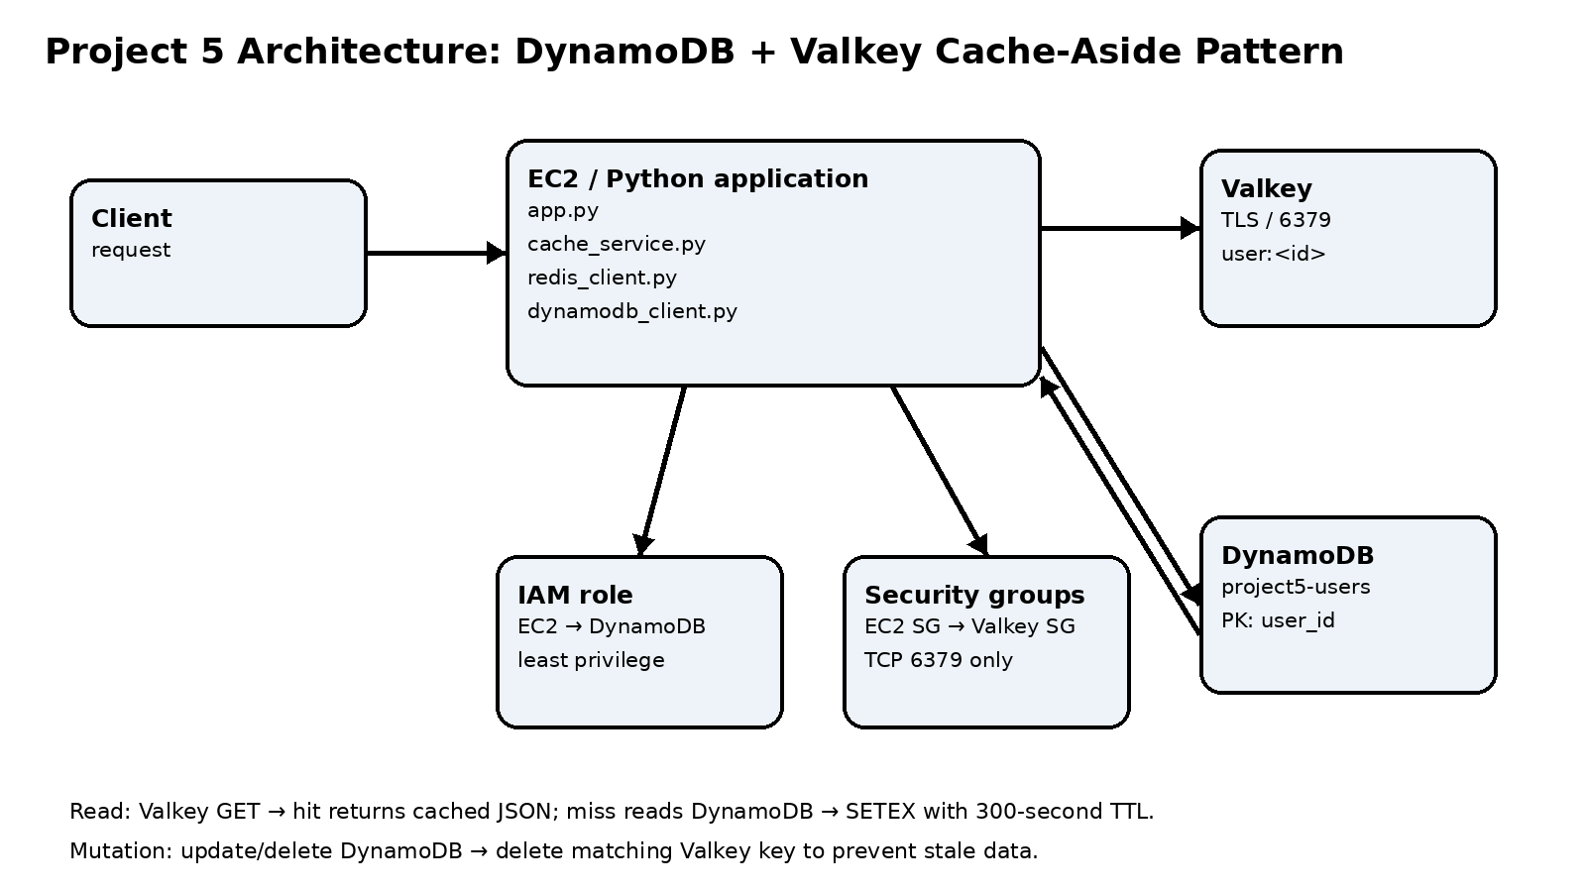
The lab used the default VPC to reduce unnecessary networking complexity. Valkey Serverless required two subnet IDs, so ap-south-1a and ap-south-1b were selected. The cache security group allowed TCP 6379 from the EC2 security group rather than from the public internet.

3. Resource Configuration
Resource | Configuration | Purpose
EC2 | Amazon Linux 2023, t3.micro, default VPC | Runs Python code and test scripts
VPC | vpc-0a2b29fe8bdc90280 | Network boundary for EC2 and Valkey
EC2 SG | project5-ec2-sg | EC2 access and trusted source for cache traffic
Valkey SG | project5-redis-sg | Allows inbound TCP 6379 from EC2 SG
DynamoDB | project5-users; PK user_id, String; PAY_PER_REQUEST | Persistent user records
IAM role | project5-ec2-dynamodb-role | Limited DynamoDB permissions for EC2
Valkey | project5-valkey-cache; Serverless; Valkey 9; TLS | Temporary in-memory cache

4. IAM and Least Privilege
The EC2 role used an inline policy scoped to the project5-users table. It allowed:
- dynamodb:DescribeTable
- dynamodb:GetItem
- dynamodb:PutItem
- dynamodb:UpdateItem
- dynamodb:DeleteItem
- dynamodb:Query
dynamodb:Scan was intentionally not granted. An AWS CLI scan attempt failed with AccessDenied, demonstrating that the role was not over-permissioned merely to make browsing convenient. The application instead used targeted GetItem operations.

5. Implementation Journey and Troubleshooting
Project location: The project was moved from OneDrive to C:\AWS-Projects\05-dynamodb-elasticache-redis after virtual-environment permission problems.
Virtual environment: A Python virtual environment was created on EC2 and boto3 plus the redis package were installed inside it.
EC2 identity: aws sts get-caller-identity confirmed that EC2 was using the assumed project5-ec2-dynamodb-role.
DynamoDB validation: The project5-users table was created and describe-table succeeded from EC2.
Valkey subnet requirement: The first configuration showed that Serverless required 2–3 subnet IDs. ap-south-1a and ap-south-1b were selected.
Network test issue: nc was initially unavailable. sudo dnf install nmap-ncat -y installed the tool, after which port 6379 connectivity succeeded.
TLS connection: Python redis.Redis used ssl=True because encryption in transit was enabled. ping() returned True.
Unexpected initial cache hit: A previous test had already populated user:user-1, so app.py first returned Cache hit. Deleting the key allowed a genuine miss to be demonstrated.
Import side effect: The DynamoDB module initially inserted a user during import. The code was corrected so writes were explicit and the module guard was used.
Python warning: Boto3 displayed a Python 3.9 deprecation warning. It did not block the tests, but a production implementation should use Python 3.10 or newer.

6. Commands Used

Activate the virtual environment
source ~/project5-dynamodb-redis/venv/bin/activate
Used before running Python project code.

Validate the EC2 identity
aws sts get-caller-identity
Confirms use of the attached IAM role.

Validate DynamoDB access
aws dynamodb describe-table --table-name project5-users --region ap-south-1
Confirms access to the target table.

Install netcat
sudo dnf install nmap-ncat -y
Installs the TCP connectivity test tool.

Test Valkey reachability
nc -vz <valkey-endpoint> 6379
Checks that EC2 can reach Valkey over TCP.

Install Redis client
pip install redis
Installs the Python client in the venv.

7. Application Logic

7.1 Cache key convention
The project used one predictable key format for every operation:
key = f"user:{user_id}"
For user-1, the key is user:user-1. Consistency is essential because a different key format would make invalidation ineffective.

7.2 Lazy-loading flow
- Build user:<id>.
- Call Valkey GET.
- If a value exists, deserialize JSON and return it: cache hit.
- If no value exists, call DynamoDB GetItem: cache miss.
- If DynamoDB returns a record, serialize it and call SETEX with a 300-second TTL.
- Return the record.

7.3 Invalidation flow
Update DynamoDB → DELETE user:<id> from Valkey
Delete from DynamoDB → DELETE user:<id> from Valkey
This means the next read cannot use the previous cached value. It must consult DynamoDB and, if a record exists, repopulate the cache.

7.4 Serialization
The low-level DynamoDB client returns typed values such as {'S': 'user-1'}. TypeDeserializer converts these values into normal Python values. Valkey stores the resulting dictionary as JSON; json.loads converts the JSON string back into a Python dictionary during a cache read.

8. Test Results
Scenario | Action | Observed result | Status
Python-Valkey connection | redis_client.ping() | True | Passed
SET/GET | Store and retrieve a test value | Value retrieved successfully | Passed
Cache miss | Delete user:user-1 and run app.py | DynamoDB record returned and cached | Passed
Cache hit | Run app.py again | Record returned from Valkey | Passed
Manual invalidation | Cache then invalidate_user() | Subsequent read returned None | Passed
Update invalidation | Update DynamoDB, delete cache key, read again | Updated record was fetched | Passed
Delete invalidation | Delete DynamoDB item and cache key | Subsequent application read returned None | Passed
Least privilege | Attempt Scan | AccessDenied as expected | Expected

9. Evidence Files
- ec2-role-authentication.png
- dynamodb-table-created.png
- ec2-dynamodb-access.png
- ec2-valkey-connectivity.png
- python-valkey-connection.png
- lazy-loading-cache-hit-miss.png
- cache-invalidation.png
- updated-data-after-cache-invalidation.png
- delete-and-cache-invalidation.png
- deleted-user-end-to-end.png

10. Production Considerations
- Keep Valkey private; never open port 6379 to the internet.
- Prefer security-group references and controlled administrative access such as Session Manager.
- Keep TLS enabled for cache traffic.
- Use IAM roles rather than static AWS credentials on EC2.
- TTL limits cache lifetime but does not replace explicit invalidation after mutations.
- Consider failures between the database write and cache deletion, retries, concurrent requests, and race conditions.
- Upgrade the runtime from Python 3.9 to Python 3.10+ before treating the implementation as production-ready.
- Monitor cache hit rate, latency, errors, memory usage, and cost.

11. Cleanup Checklist
- Copy the final code and evidence to the local project folder.
- Delete the Valkey Serverless cache.
- Delete the DynamoDB table if no longer needed.
- Terminate the EC2 instance if no longer needed.
- Remove unused IAM roles and security groups after checking dependencies.
- Review the AWS Billing dashboard.

12. Interview-Ready Summary
I built a cache-aside system on EC2 using DynamoDB as the source of truth and ElastiCache Serverless for Valkey as the cache. The application checks Valkey first, reads DynamoDB on a miss, serializes the result to JSON, and stores it with a five-minute TTL. I implemented explicit invalidation after updates and deletes, used an EC2 IAM role for DynamoDB access, restricted cache traffic with security groups, and validated cache hit, cache miss, update, delete, and missing-record scenarios.

Appendix A — Planned Repository Structure
project5-dynamodb-redis/
├── src/
│ ├── config.py
│ ├── dynamodb_client.py
│ ├── redis_client.py
│ ├── cache_service.py
│ └── app.py
├── tests/
│ ├── test_cache.py
│ ├── test_invalidation.py
│ ├── test_update_cache.py
│ └── test_delete_cache.py
├── docs/
│ ├── architecture/
│ └── screenshots/
├── requirements.txt
├── README.md
└── .gitignore

