AWS Highly Available Web Application

ALB + Auto Scaling + Self-Healing EC2 Infrastructure

1. Project Overview
This project demonstrates the design and implementation of a highly available, scalable, and self-healing web application infrastructure on AWS.
The application is hosted on Amazon EC2 instances distributed across multiple Availability Zones. An Application Load Balancer (ALB) receives incoming HTTP traffic and distributes it to healthy EC2 instances through a Target Group.
An Auto Scaling Group (ASG) manages the EC2 instances and maintains the desired capacity of the application. A Launch Template provides a consistent blueprint for every EC2 instance, including the AMI, instance type, security group, key pair, storage configuration, and User Data automation.
The infrastructure also uses Target Tracking scaling based on average CPU utilization. This allows the Auto Scaling Group to automatically adjust the number of EC2 instances according to workload.
A failure scenario was deliberately tested by terminating an active EC2 instance. The Auto Scaling Group detected the capacity reduction, launched a replacement instance, and the new instance was automatically registered with the Target Group and passed its health checks.
The project therefore demonstrates not only deployment, but also load balancing, health monitoring, automatic scaling, multi-AZ availability, and self-healing behavior.

Final Architecture
Internet
│
▼
┌──────────────────┐
│ Application │
│ Load Balancer │
│ (ALB) │
└────────┬─────────┘
│
▼
┌──────────────────┐
│ Target Group │
│ Health Checks │
└────────┬─────────┘
│
┌─────────┴─────────┐
▼ ▼
┌─────────────┐ ┌─────────────┐
│ EC2 │ │ EC2 │
│ Availability│ │ Availability│
│ Zone A │ │ Zone B │
└─────────────┘ └─────────────┘
▲ ▲
└─────────┬─────────┘
│
┌──────────────────┐
│ Auto Scaling │
│ Group │
└────────┬─────────┘
│
┌──────────────────┐
│ Launch Template │
└──────────────────┘
│
CloudWatch Metrics
│
CPU Target Tracking

2. Project Objective
The objective of this project was to build a production-style, highly available web application infrastructure on AWS and understand how the individual AWS services work together rather than configuring them independently.
The project focused on achieving the following:
- Deploy EC2 instances across multiple Availability Zones.
- Use an Application Load Balancer to distribute incoming HTTP traffic.
- Use a Target Group to maintain backend instances and perform health checks.
- Use a Launch Template as a reusable EC2 configuration blueprint.
- Use User Data to automatically install and configure the Apache web server.
- Use an Auto Scaling Group to maintain the required number of EC2 instances.
- Configure Target Tracking Scaling based on average CPU utilization.
- Restrict direct access to EC2 instances using Security Group references.
- Verify application availability through the ALB DNS endpoint.
- Simulate an instance failure by terminating an active EC2 instance.
- Verify that the Auto Scaling Group automatically launches a replacement instance.
- Verify that the replacement instance becomes healthy and is automatically registered with the Target Group.
- Understand the relationship between load balancing, health checks, scaling, and self-healing.
The final goal was not simply to deploy the infrastructure, but to observe and verify its behavior under normal operation and failure conditions.

3. AWS Services Used
The project combines multiple AWS services, with each service handling a specific responsibility in the architecture.
AWS Service | Role in the Project
Amazon EC2 | Provides the compute instances running the Apache web server and application webpage.
Amazon EC2 Launch Template | Defines the reusable configuration used to launch identical EC2 instances.
Amazon VPC | Provides the networking environment in which the ALB and EC2 instances operate.
Security Groups | Control inbound traffic to the ALB and EC2 instances.
Application Load Balancer (ALB) | Receives HTTP traffic from users and distributes it to healthy EC2 instances.
Target Group | Maintains the backend EC2 targets and performs HTTP health checks.
Auto Scaling Group (ASG) | Maintains the desired EC2 capacity and automatically replaces terminated instances.
Amazon CloudWatch | Provides CPU utilization metrics used by the Target Tracking scaling policy.
Availability Zones | Provide multi-AZ deployment for improved availability and resilience.

Service Relationship
The services work together as a chain:
User
↓
Application Load Balancer
↓
Target Group
↓
Healthy EC2 Instances
↓
Auto Scaling Group
↓
Launch Template
CloudWatch monitors the EC2 workload and provides the metric used by the Auto Scaling policy:
EC2 CPU Utilization
↓
CloudWatch
↓
Target Tracking Policy
↓
Auto Scaling Group
↓
Scale Out / Scale In
The combination of these services allows the application to remain available even when an individual EC2 instance fails.

4. Architecture Design
The architecture was designed around four main principles:
- High Availability — EC2 instances are distributed across multiple Availability Zones.
- Load Balancing — incoming traffic is handled by an Application Load Balancer instead of directly accessing EC2 instances.
- Scalability — the Auto Scaling Group can increase or decrease the number of EC2 instances based on CPU utilization.
- Self-Healing — if an EC2 instance is terminated or becomes unavailable, the Auto Scaling Group launches a replacement.

4.1 Traffic Flow
The application follows this request path:
Internet User
│
│ HTTP :80
▼
Application Load Balancer
│
▼
Target Group
│
├───────────────┐
▼ ▼
EC2 - AZ A EC2 - AZ B
│ │
└───────┬───────┘
│
Apache Web Server
Users never need to connect directly to an individual EC2 instance. The ALB acts as the single entry point for the application.

4.2 Security Flow
Two Security Groups were created:
SG-ALB
Inbound:
HTTP :80 → 0.0.0.0/0

Outbound:
All traffic
This allows users from the internet to reach the ALB.
SG-EC2
Inbound:
HTTP :80 → SG-ALB

Outbound:
All traffic
Instead of allowing HTTP traffic from the entire internet, the EC2 Security Group references SG-ALB as the source.
Therefore:
Internet
│
▼
SG-ALB
│
│ HTTP :80
▼
SG-EC2
│
▼
EC2
This prevents users from directly accessing the application instances through port 80.

4.3 Multi-AZ Design
The ALB and EC2 instances were configured across two Availability Zones:
AWS Region: ap-south-1

Application Load Balancer
/ \
/ \
ap-south-1a ap-south-1b
│ │
EC2 EC2
This provides redundancy at the Availability Zone level. If an individual instance becomes unavailable, the remaining healthy instance can continue serving traffic while the Auto Scaling Group launches a replacement.

4.4 Scaling and Self-Healing Flow
The Auto Scaling Group was configured with:
Minimum capacity: 1
Desired capacity: 2
Maximum capacity: 4
A Target Tracking policy was later configured using:
Metric: Average CPU Utilization
Target: 50%
The overall behavior is:
CloudWatch
│
CPU Utilization
│
▼
Target Tracking Policy
│
▼
Auto Scaling Group
/ \
Scale Out Scale In
│ │
▼ ▼
Add EC2 Remove EC2
For failure recovery:
EC2 instance fails/terminates
│
▼
Auto Scaling Group
│
▼
Detects capacity loss
│
▼
Launches replacement
│
▼
Target Group registers it
│
▼
Health check passes
│
▼
ALB sends traffic
This architecture was later verified experimentally by terminating an active EC2 instance and observing the Auto Scaling Group launch a replacement that became healthy in the Target Group.

5. Security Groups Configuration
Security Groups were created before launching the application infrastructure to control traffic between the internet, the Application Load Balancer, and the EC2 instances.

5.1 SG-ALB
The Security Group attached to the Application Load Balancer allows HTTP traffic from the internet.
Inbound Rules
--------------------------------
HTTP
Port: 80
Source: 0.0.0.0/0

Outbound Rules
--------------------------------
All traffic
This allows users to access the application through the ALB using HTTP.
Screenshot — SG-ALB configuration
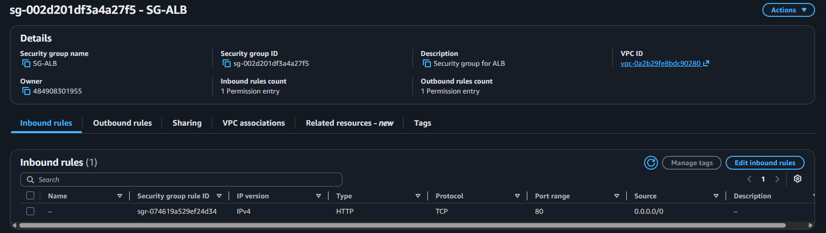

5.2 SG-EC2
The EC2 Security Group was intentionally configured differently.
Inbound Rules
--------------------------------
HTTP
Port: 80
Source: SG-ALB

Outbound Rules
--------------------------------
All traffic
The source of the HTTP rule is SG-ALB itself, rather than 0.0.0.0/0.
This means an EC2 instance accepts HTTP traffic only when it originates from a resource associated with SG-ALB.
Internet
│
│ HTTP :80
▼
SG-ALB
│
│ HTTP :80
▼
SG-EC2
│
▼
EC2
This prevents direct HTTP access to the EC2 instances from the public internet and ensures that application traffic enters through the ALB.
Screenshot — SG-EC2 configuration
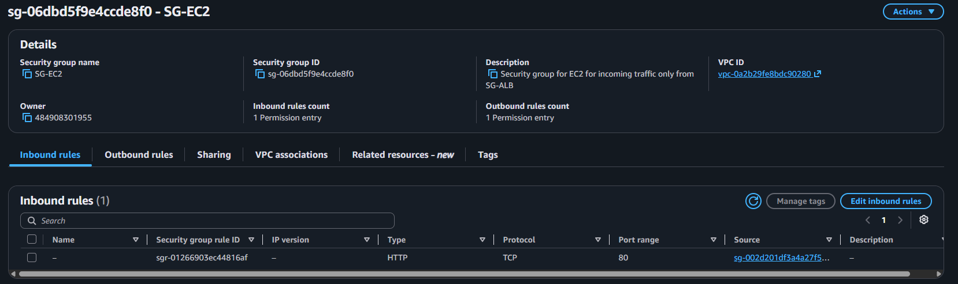

5.3 Temporary SSH Access for Testing
During the testing phase, a temporary SSH rule was added to SG-EC2 so that the EC2 instance could be accessed for verification and controlled testing.
SSH
Port: 22
Source: <Public IP>/32
The source was restricted to the specific public IP rather than allowing SSH from the entire internet.
After completing the testing, the project resources were cleaned up.
Note: SSH was used only as a temporary testing mechanism and was not part of the intended application traffic path.

6. Launch Template Configuration
The Launch Template was created to provide a consistent and reusable configuration for every EC2 instance launched by the Auto Scaling Group.
Instead of manually configuring each EC2 instance, the ASG uses this template whenever it needs to launch an instance.

6.1 Launch Template Configuration
The Launch Template was configured with:
Launch Template Name: web-server-lt
AMI: Amazon Linux 2023
Architecture: 64-bit x86
Instance Type: t3.micro
Key Pair: lab-ec2
Security Group: SG-EC2
The Launch Template was initially created as Version 1. During verification, the AMI configuration was corrected and Version 2 was created with the Amazon Linux 2023 AMI.
Version 2 was then made the default version used by the Auto Scaling Group.
Screenshot — Launch Template User Data
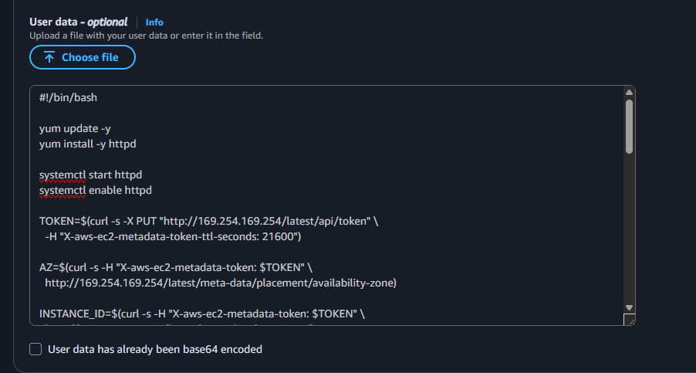
Screenshot — Final Launch Template configuration
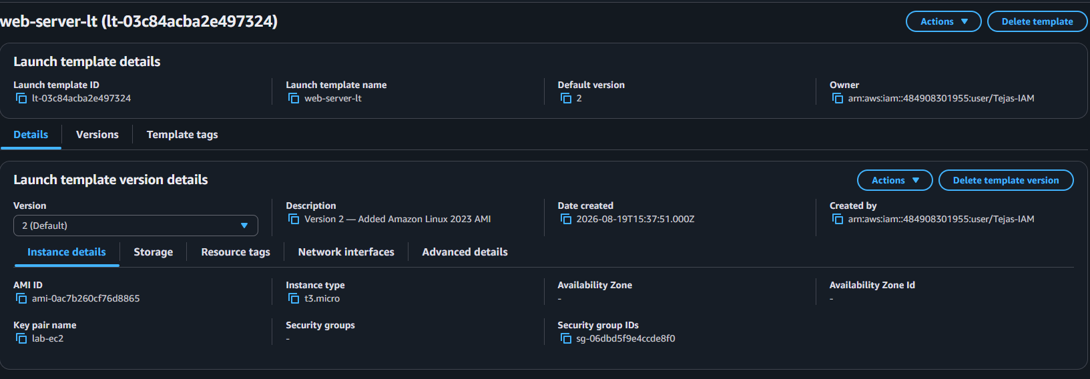

6.2 User Data Automation
User Data was used to automatically configure the EC2 instance when it launches.
The script performs the following tasks:
- Updates the system packages.
- Installs Apache (httpd).
- Starts the Apache service.
- Enables Apache to start automatically.
- Retrieves instance metadata using the EC2 Instance Metadata Service.
- Retrieves:
  - Instance ID
  - Availability Zone
  - AWS Region
- Generates a custom HTML webpage containing the instance information.
The generated webpage was intentionally made specific to the project:
AWS Highly Available Web Application

Built by Tejas Shinkar

ELB + Auto Scaling + EC2 + CloudWatch

Instance ID: ...
Availability Zone: ...
Region: ...
This allowed the ALB's traffic distribution to be visually verified later. When requests reached different EC2 instances, the Instance ID and Availability Zone displayed on the webpage changed.

6.3 Why Launch Templates Were Used
The Launch Template ensures that every EC2 instance launched by the ASG receives the same basic configuration.
This was particularly important during the self-healing test.
When an instance was terminated:
EC2 Instance Terminated
↓
Auto Scaling Group detects capacity loss
↓
Launch Template used
↓
Replacement EC2 launched
↓
User Data executes automatically
↓
Apache + application configured
This allowed the replacement instance to become a functional backend without manually configuring it.

7. Target Group Configuration
A Target Group acts as the backend pool for the Application Load Balancer. It contains the EC2 instances that can receive traffic and performs health checks to determine whether those instances are healthy.

7.1 Target Group Configuration
The Target Group was configured as:
Target Type: Instances
Target Group Name: web-server-tg
Protocol: HTTP
Port: 80
VPC: Default VPC
Health Check: HTTP
Health Check Path: /
Health Check Port: Traffic Port
Interval: 30 seconds
Timeout: 5 seconds
Healthy Threshold: 2
Unhealthy Threshold:2
Success Code: 200
Screenshot — Target Group configuration
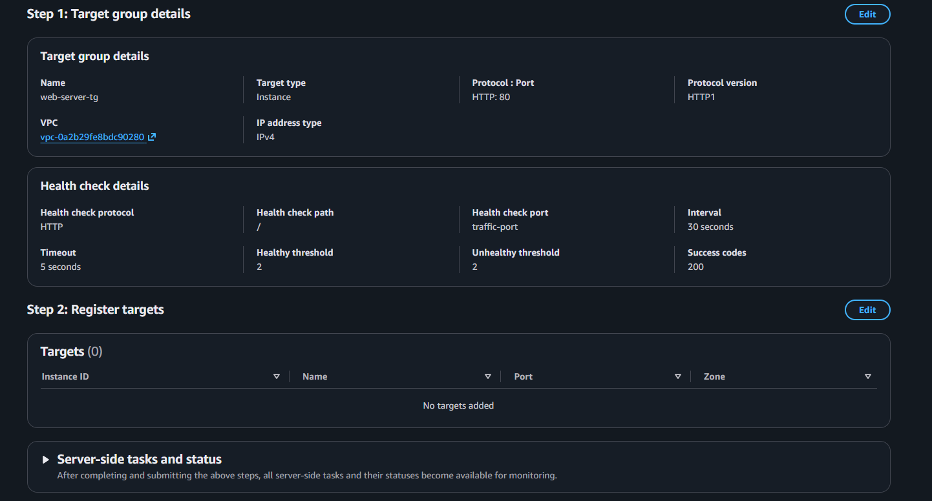At creation time, the Target Group showed:
Targets: 0
This was intentional.
The EC2 instances were not manually registered. Instead, the Auto Scaling Group was configured to automatically register newly launched EC2 instances with web-server-tg.

7.2 Health Checks
The Target Group continuously checks the health of registered EC2 instances by requesting:
HTTP://<EC2-IP>/
A successful HTTP response with status code 200 indicates that the application is responding correctly.
The flow is:
Target Group
│
│ HTTP GET /
▼
EC2 :80
│
│ HTTP 200
▼
Healthy ✅
If an instance fails the configured health checks, the ALB stops routing new traffic to that instance.
The Target Group therefore provides an important layer between the ALB and EC2 instances:
ALB
↓
Target Group
↓
Health Check
↓
Healthy EC2 → Receive traffic
Unhealthy EC2 → No new traffic

7.3 Automatic Target Registration
Once the Auto Scaling Group launched the EC2 instances, they were automatically registered with the Target Group.
The final flow was:
Auto Scaling Group
↓
Launch EC2
↓
Register with Target Group
↓
Health Check
↓
Healthy
↓
ALB can route traffic
This becomes particularly important during self-healing. When the ASG launched a replacement instance after an instance was terminated, the replacement was automatically registered with the Target Group and eventually reached a Healthy state.

8. Application Load Balancer Configuration
The Application Load Balancer was configured as the public entry point for the web application.

8.1 ALB Configuration
The following configuration was used:
Name: web-app-alb
Type: Application Load Balancer
Scheme: Internet-facing
IP Address Type: IPv4
VPC: Default VPC
Availability Zones:
ap-south-1a
ap-south-1b
Security Group: SG-ALB
The ALB was deployed across two Availability Zones to provide availability at the load-balancer layer.
Screenshot — Application Load Balancer configuration
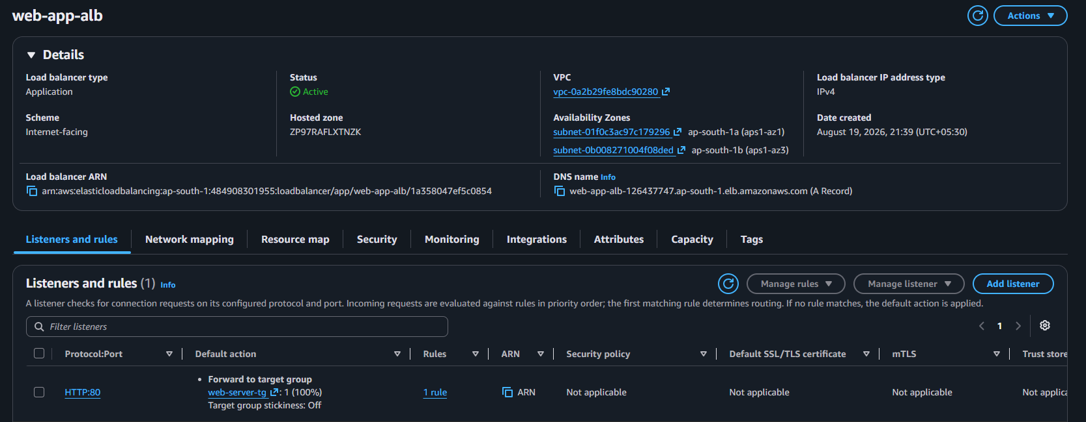

8.2 Listener Configuration
The ALB was configured with an HTTP listener:
Protocol: HTTP
Port: 80

Default Action:
Forward traffic → web-server-tg
Therefore, when a user accesses the ALB DNS name:
http://<ALB-DNS-name>
the request follows:
User
↓
ALB :80
↓
web-server-tg
↓
Healthy EC2 :80
The ALB does not directly select an arbitrary EC2 instance. It forwards traffic to the healthy targets registered in the Target Group.

8.3 ALB and Multi-AZ Architecture
The ALB was configured using subnets in two different Availability Zones:
Internet
│
▼
┌─────────────┐
│ ALB │
└──────┬──────┘
│
┌─────────┴─────────┐
▼ ▼
ap-south-1a ap-south-1b
│ │
EC2 EC2
This allows the ALB to route requests to healthy backend instances across Availability Zones.

8.4 ALB Verification
After the ALB became active and the EC2 instances were healthy, the ALB DNS name was accessed through a web browser.
The custom application page displayed the instance-specific information generated by the Launch Template's User Data script.
By refreshing the ALB endpoint multiple times while both instances were healthy, requests were observed reaching different EC2 instances.
The changing Instance ID and Availability Zone provided visible evidence that the ALB was distributing requests across the backend instances.
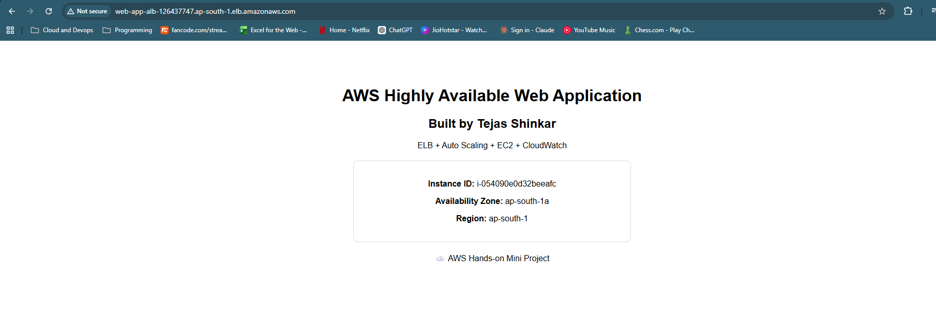This verified the complete request path:
Internet
↓
Application Load Balancer
↓
Target Group
↓
Healthy EC2
↓
Apache Web Server
↓
Application Response

9. Auto Scaling Group Configuration
The Auto Scaling Group was responsible for managing the EC2 instance fleet and maintaining the required application capacity.

9.1 ASG Configuration
The Auto Scaling Group was created with:
Name: web-app-asg
Launch Template: web-server-lt
Launch Template Version: Latest / Version 2

Desired Capacity: 2
Minimum Capacity: 1
Maximum Capacity: 4
The ASG used the same VPC and the two subnets selected for the application infrastructure:
ap-south-1a
ap-south-1b
This allowed the EC2 instances to be distributed across multiple Availability Zones.
Screenshot — Auto Scaling Group configuration
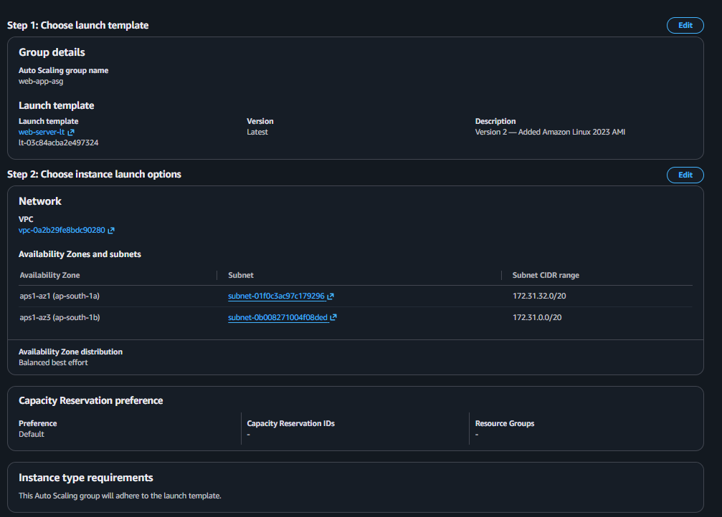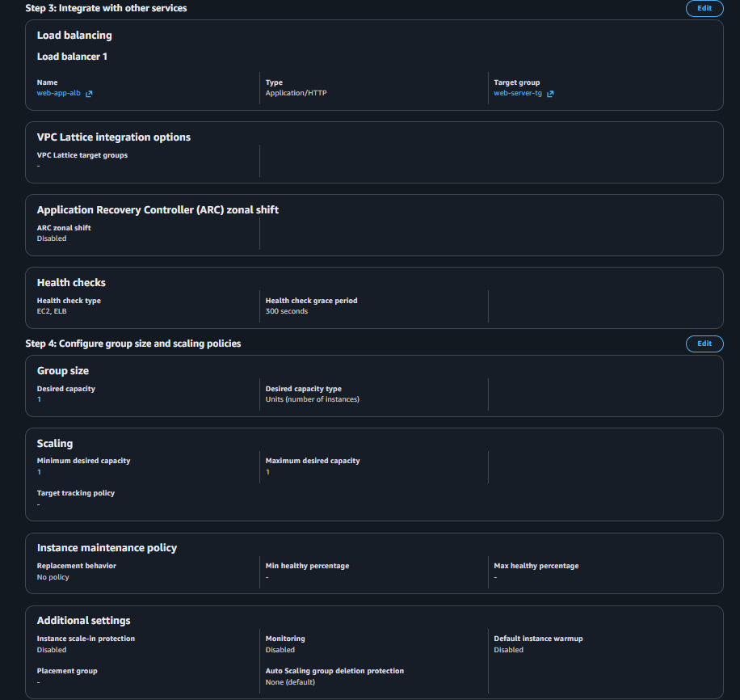

9.2 Load Balancer Integration
The ASG was attached to the existing Target Group:
web-server-tg
This means EC2 instances launched by the ASG were automatically registered with the Target Group.
The ASG was configured to use ELB health checks in addition to EC2 health checks.
EC2 Health Check
+
ELB Health Check
↓
Auto Scaling Group
The ELB health check is important because an EC2 instance can be running at the infrastructure level while the application itself may not be responding correctly.
The ASG therefore works with the load balancer's health information to help maintain healthy application capacity.

9.3 Health Check Grace Period
A 300-second health check grace period was configured.
This gives a newly launched EC2 instance time to:
- Boot the operating system.
- Execute the User Data script.
- Install Apache.
- Start the web server.
- Become ready to respond to the Target Group health checks.
This is particularly important because the application configuration is performed automatically through User Data during instance startup.

9.4 Initial Deployment
When the ASG was created with:
Desired Capacity = 2
it automatically launched two EC2 instances using the Launch Template.
The resulting architecture was:
Auto Scaling Group
│
┌────────┴────────┐
▼ ▼
EC2 #1 EC2 #2
ap-south-1a ap-south-1b
│ │
└────────┬────────┘
▼
Target Group
│
▼
ALB
Both instances were successfully registered with the Target Group and reached a Healthy state.
Screenshot — ASG-launched EC2 instances and Target Group health

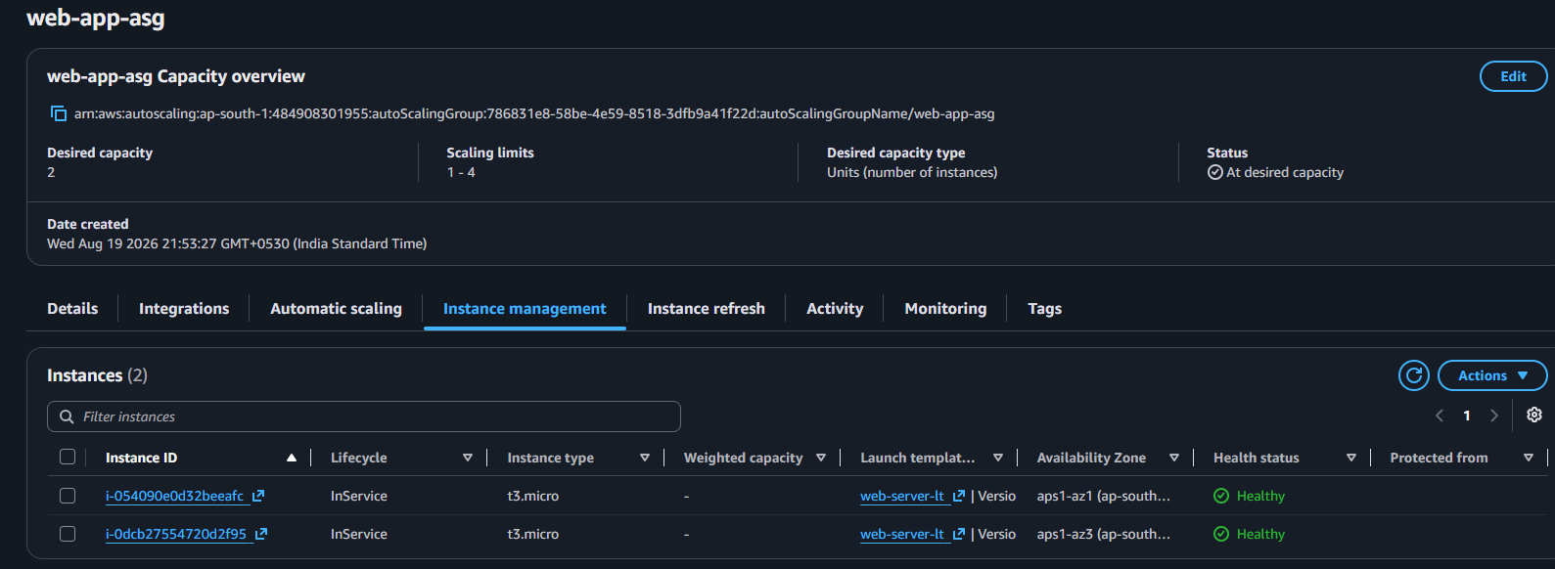
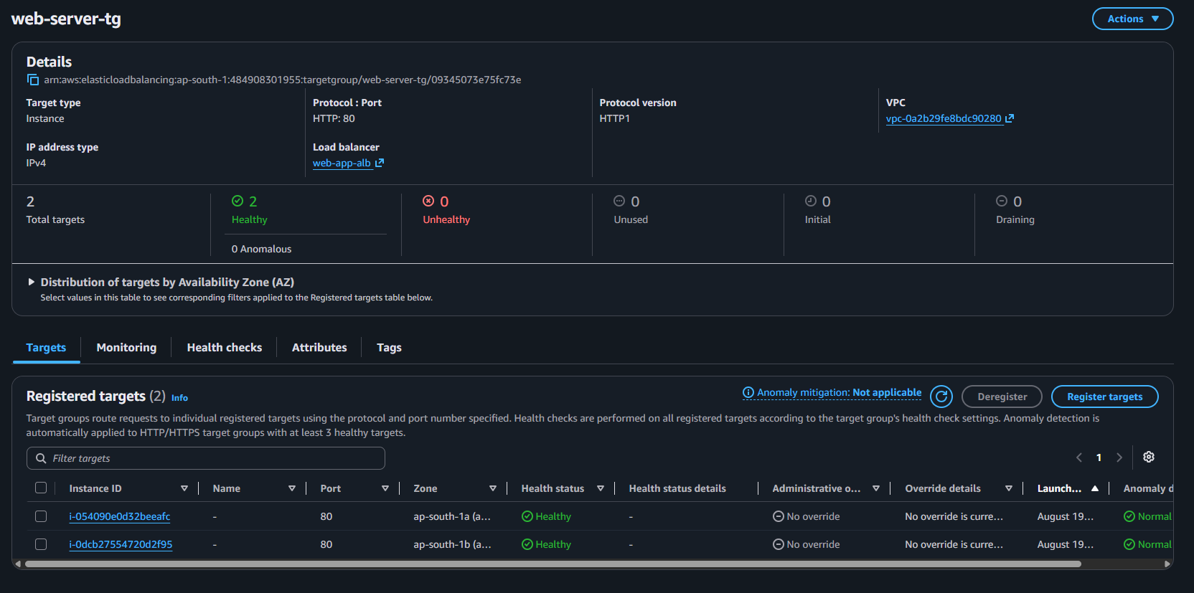
This verified that the Launch Template, Auto Scaling Group, Target Group, and health-check configuration were working together correctly.
10. Target Tracking Auto Scaling Policy
After verifying that the initial EC2 deployment and ALB routing were working correctly, a Target Tracking Scaling Policy was configured for the Auto Scaling Group.

10.1 Scaling Policy Configuration
The policy was configured with:
Policy Type: Target Tracking Scaling
Policy Name: cpu-target-tracking
Metric: Average CPU Utilization
Target Value: 50%
Instance Warmup: 300 seconds
Scale In: Enabled
Scale Out: Enabled
Screenshot — Target Tracking Scaling Policy
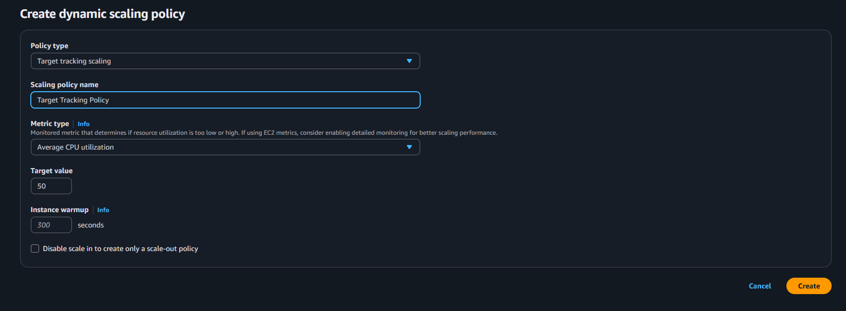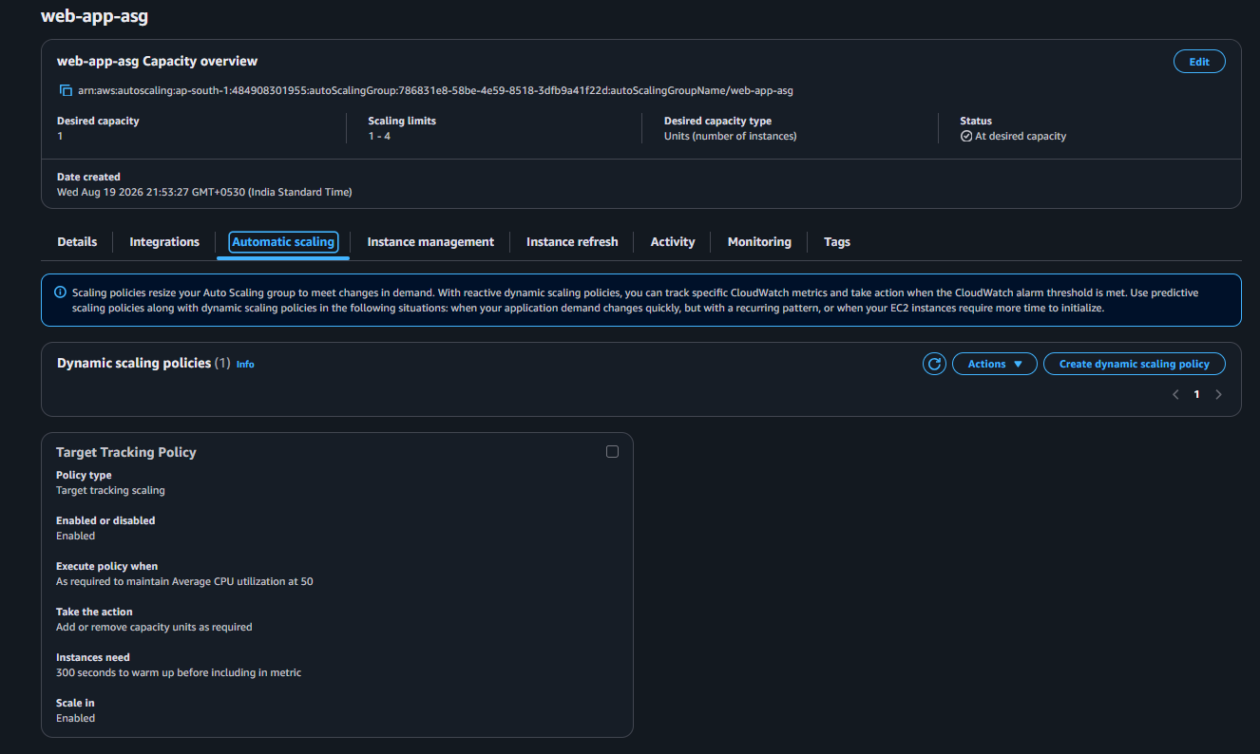

10.2 How Target Tracking Works
The purpose of Target Tracking is to maintain the average CPU utilization of the Auto Scaling Group around the configured target.
In this project, the target was:
Average CPU Utilization = 50%
The general behavior is:
CPU Utilization
│
┌────────┴────────┐
▼ ▼
Above Target Below Target
│ │
▼ ▼
Scale Out Scale In
│ │
▼ ▼
Add EC2 instances Remove EC2 instances
The Auto Scaling Group uses CloudWatch metrics to determine when the application capacity needs to change.

10.3 Scale-In Behavior Observed
After enabling the Target Tracking policy, the workload on the instances was low.
The ASG therefore reduced the desired capacity from the initial deployment level.
The instance being removed entered the Draining state in the Target Group before termination.
Healthy EC2
│
▼
ASG decides to scale in
│
▼
Target Group → Draining
│
▼
Instance terminates
This demonstrated that scale-in does not simply remove an instance from active traffic immediately. The load-balancing layer handles the target transition before the instance is terminated.
Screenshot — Instance draining / scale-in
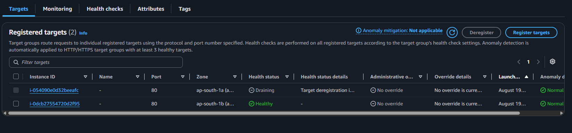

10.4 Resulting Capacity
After the scale-in operation completed, the environment reached:
Desired Capacity: 1
Healthy Targets: 1
This confirmed that the Auto Scaling Group was able to automatically reduce the number of running instances when additional capacity was not required.
The scaling policy therefore demonstrated both sides of the desired behavior:
- Scale out when workload increases.
- Scale in when workload decreases.

11. Application Verification and Testing
After deploying the infrastructure, the application was tested at multiple levels to verify that the EC2 configuration, load balancer, and backend routing were functioning correctly.

11.1 EC2 Web Server Verification
SSH access was temporarily enabled from the test environment's public IP for instance-level verification.
Inside the EC2 instance, the Apache web server was checked using:
sudo systemctl status httpd
The service was confirmed to be:
active (running)
This verified that the Apache web server installed through the Launch Template's User Data script was running correctly.
The application was then tested locally using:
curl localhost
The command returned the custom HTML application, confirming that the EC2 instance was successfully serving the webpage.
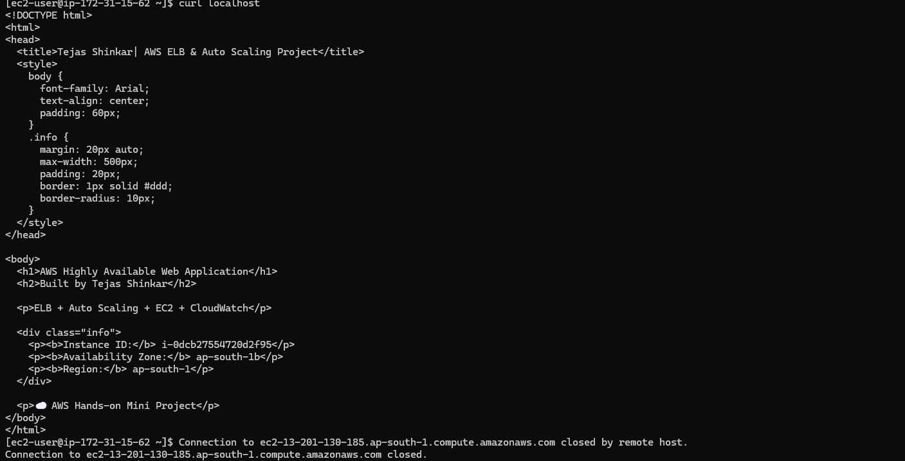
Screenshot — Local application verification

11.2 ALB Application Verification
The application was then accessed through the Application Load Balancer DNS name rather than directly through the EC2 instance.
The webpage displayed:
AWS Highly Available Web Application

Built by Tejas

ELB + Auto Scaling + EC2 + CloudWatch

Instance ID: ...
Availability Zone: ...
Region: ...
This verified the complete application path:
Browser
↓
ALB
↓
Target Group
↓
EC2
↓
Apache
↓
Application

11.3 Load Balancing Verification
When both backend instances were healthy, the ALB was accessed repeatedly through its DNS endpoint.
Refreshing the application resulted in different Instance IDs and Availability Zones being displayed.
For example:
Request 1 → EC2 in ap-south-1a
Request 2 → EC2 in ap-south-1b
Request 3 → EC2 in ap-south-1a
This provided a simple visual demonstration that the ALB was distributing requests between healthy backend instances.
The Instance ID displayed on the webpage was generated dynamically from EC2 instance metadata by the User Data script, making the change directly observable.

11.4 Target Group Health Verification
The Target Group was monitored during deployment and after instance replacement.
A healthy target appeared as:
Target
↓
HTTP :80
↓
GET /
↓
HTTP 200
↓
Healthy
This confirmed that the ALB was not simply checking whether the EC2 machine was running; it was checking whether the web application was responding successfully.

11.5 Testing Summary
The following components were successfully verified:
Test | Result
Apache service running | ✅
Local curl localhost | ✅
ALB DNS access | ✅
Target Group health checks | ✅
ALB → EC2 routing | ✅
Instance ID/AZ visibility | ✅
Multi-AZ backend deployment | ✅
Auto Scaling integration | ✅
The testing confirmed that the application infrastructure was functioning as an integrated system rather than as a collection of independently configured AWS services.

12. Self-Healing and Failure Simulation
One of the most important parts of the project was testing what happens when an EC2 instance unexpectedly disappears.
Instead of only verifying that the infrastructure works under normal conditions, an active EC2 instance was deliberately terminated to simulate an instance failure.

12.1 Failure Simulation
An EC2 instance managed by the Auto Scaling Group was manually terminated.
Before the failure, the ASG was responsible for maintaining the required application capacity.
The sequence was:
Active EC2 Instance
│
▼
Instance manually terminated
│
▼
ASG detects capacity loss
│
▼
Replacement EC2 launched
Screenshot — Instance termination / failure simulation

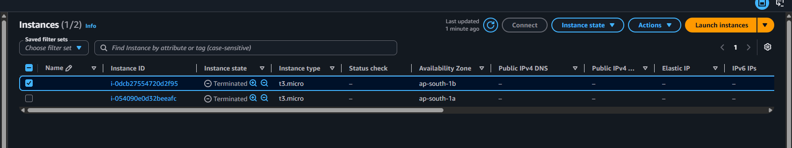
12.2 Automatic Replacement
After the instance was terminated, the Auto Scaling Group detected that the number of running instances had fallen below its required capacity.
The ASG automatically launched a replacement EC2 instance using the configured Launch Template.
The replacement instance therefore received the same:
- Amazon Linux 2023 AMI
- Instance type
- Security Group
- Key pair configuration
- User Data automation
- Apache web server configuration
The replacement instance successfully completed its EC2 status checks.

12.3 Target Group Registration
After the replacement instance became operational, the Auto Scaling Group automatically registered it with the existing Target Group.
The Target Group then performed its configured HTTP health check:
Replacement EC2
│
▼
HTTP GET /
│
▼
HTTP 200
│
▼
Healthy
The replacement instance eventually appeared as Healthy in web-server-tg.
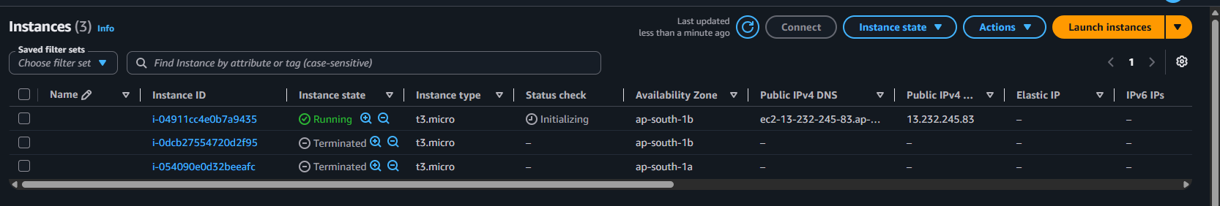
Screenshot — Replacement EC2 instance launched
The project documentation records this sequence: the original server was terminated, a new instance was automatically added, and the new instance became healthy in the Target Group.

12.4 Self-Healing Result
The complete recovery sequence was successfully demonstrated:
EC2 Instance
│
│ Failure / Termination
▼
Auto Scaling Group
│
│ Detects capacity loss
▼
Launch Template
│
│ Creates replacement
▼
New EC2 Instance
│
▼
Target Group Registration
│
▼
Health Check
│
▼
Healthy ✅
│
▼
ALB can route traffic
This demonstrated the self-healing capability of the architecture.

13. Troubleshooting & Issues Encountered
During implementation, a few configuration issues were encountered and resolved. Documenting these is useful because they reflect realistic AWS troubleshooting rather than a perfectly linear deployment.

13.1 Launch Template AMI Configuration
The initial Launch Template version did not contain the expected AMI configuration.
A new Launch Template version was created with the Amazon Linux 2023 AMI, and Version 2 was made the default version.
Version 1
↓
AMI configuration issue identified
↓
Version 2 created
↓
Amazon Linux 2023 configured
↓
Version 2 set as Default
This ensured that instances launched by the Auto Scaling Group used the correct AMI.

13.2 SSH Connectivity
The initial EC2 Security Group did not allow SSH because the intended application architecture allowed HTTP traffic only from the ALB Security Group.
When instance-level testing was required, SSH access was temporarily added:
SSH :22
Source: <Public IP>/32
The source was restricted to the testing machine's public IP rather than exposing SSH to the entire internet.
This allowed:
SSH → EC2
for troubleshooting and application verification while keeping the rule narrowly scoped.

13.3 Auto Scaling Capacity Change
The initial ASG deployment started with:
Desired: 2
Minimum: 1
Maximum: 4
After the Target Tracking policy was enabled, the low workload caused the ASG to scale in.
The environment eventually reached:
Desired: 1
Healthy Targets: 1
This explained why subsequent ALB refreshes showed the same Instance ID—the ALB had only one healthy backend available at that point.

13.4 EC2 Instance Connect / SSH Timeout
An initial SSH connection attempt failed because the EC2 Security Group did not allow inbound TCP port 22.
The issue was traced to the security configuration rather than the application itself.
A temporary SSH rule restricted to the public IP was added, after which SSH connectivity succeeded.
The rule was intended only for testing and was removed during cleanup.
These troubleshooting steps were important because they demonstrated that AWS infrastructure deployment involves validating the interaction between Security Groups, Launch Templates, ASG configuration, Target Groups, and application-level services, rather than simply checking whether individual resources were created successfully.

14. Final Architecture and End-to-End Flow
After completing the configuration and testing, the final architecture consisted of an Internet-facing Application Load Balancer, a Target Group, EC2 instances managed by an Auto Scaling Group, and a reusable Launch Template.

14.1 Final Architecture
Internet
│
│ HTTP :80
▼
┌─────────────────────┐
│ Application Load │
│ Balancer (ALB) │
│ web-app-alb │
└──────────┬──────────┘
│
▼
┌─────────────────────┐
│ Target Group │
│ web-server-tg │
│ HTTP :80 │
│ Health Checks │
└──────────┬──────────┘
│
┌─────────┴─────────┐
▼ ▼
┌─────────────┐ ┌─────────────┐
│ EC2 │ │ EC2 │
│ ap-south-1a │ │ ap-south-1b │
└─────────────┘ └─────────────┘
▲ ▲
└─────────┬─────────┘
│
┌─────────────────────┐
│ Auto Scaling Group │
│ web-app-asg │
└──────────┬──────────┘
│
┌─────────────────────┐
│ Launch Template │
│ web-server-lt │
└─────────────────────┘

14.2 End-to-End Request Flow
When a user accesses the application:
1. User sends HTTP request
↓
2. Request reaches Internet-facing ALB
↓
3. ALB forwards request to web-server-tg
↓
4. Target Group checks available targets
↓
5. Request is sent to a Healthy EC2 instance
↓
6. Apache serves the application
↓
7. Response travels back through the ALB
↓
8. User receives the webpage

14.3 Instance Lifecycle
The Auto Scaling Group controls the lifecycle of the backend EC2 instances:
Launch Template
↓
Auto Scaling Group
↓
EC2 launched
↓
User Data executes
↓
Apache configured
↓
Target Group registration
↓
Health Check
↓
Healthy
↓
ALB receives traffic
If an instance is removed:
EC2 terminated
↓
ASG detects capacity loss
↓
Replacement launched
↓
Launch Template + User Data
↓
Target Group registration
↓
Health Check passes
↓
ALB can route traffic

14.4 Scaling Flow
The scaling policy adds another control loop:
EC2 Instances
↓
CPU Utilization
↓
CloudWatch
↓
Target Tracking Policy
↓
Auto Scaling Group
↓
Scale Out / Scale In
This creates an architecture that combines:
Load Balancing + Multi-AZ Availability + Health Checks + Auto Scaling + Self-Healing
Rather than relying on a single EC2 instance.

15. Key Learnings
This project helped connect several AWS concepts that are often learned separately and demonstrated how they work together in a production-style architecture.

15.1 Load Balancing
An Application Load Balancer provides a single entry point for users while distributing requests across healthy backend instances.
Instead of users accessing individual EC2 instances directly:
User → EC2
the architecture uses:
User → ALB → Target Group → EC2
This provides a cleaner and more resilient application entry point.

15.2 Target Groups
A Target Group is more than simply a list of EC2 instances.
It provides:
- Backend target registration
- Health checks
- Health status
- Integration between the ALB and backend instances
An instance that is unhealthy should not continue receiving application traffic.

15.3 Auto Scaling
Auto Scaling allows infrastructure capacity to change according to application demand.
The important distinction learned during the project was:
Scaling
↓
Change the number of instances

Self-Healing
↓
Replace failed instances
The same Auto Scaling Group can provide both capabilities.

15.4 Launch Templates and Automation
The Launch Template acts as a repeatable blueprint for EC2 instances.
Using User Data made the instance configuration automatic.
Instead of manually:
Launch EC2
↓
Install Apache
↓
Start Apache
↓
Create webpage
the Launch Template automated the configuration whenever a new instance was launched.
This became particularly valuable during the self-healing test because the replacement instance could configure itself automatically.

15.5 Health Checks
The project demonstrated the difference between an instance being running and an application being healthy.
An EC2 instance may be operational at the infrastructure level while its web application is unavailable.
The Target Group's HTTP health check provided an application-level check:
EC2 running
≠
Application healthy
The application needed to successfully respond to the configured HTTP health check.

15.6 Multi-AZ Architecture
Deploying resources across multiple Availability Zones reduces dependence on a single AZ.
In this project:
ap-south-1a
│
EC2

ap-south-1b
│
EC2
The ALB could route traffic to healthy instances across these Availability Zones.

15.7 Self-Healing
The most important practical learning was observing self-healing rather than just reading about it.
The experiment was:
Healthy EC2
↓
Manual termination
↓
ASG detects capacity loss
↓
Replacement EC2 launched
↓
Target Group registration
↓
Health check
↓
Healthy
The replacement instance became healthy without manually recreating the server configuration.

15.8 Production Architecture Is About Service Interaction
The biggest takeaway from the project was that individual AWS services become significantly more powerful when combined.
Launch Template
+
Auto Scaling Group
+
Target Group
+
Application Load Balancer
+
CloudWatch
+
Multi-AZ
↓
Highly Available,
Scalable and Self-Healing
Web Application
The project therefore provided practical experience not only with individual AWS services, but with designing and validating how multiple services interact to provide a resilient application infrastructure.
16. Cleanup and Final State
After completing all testing, the AWS resources created specifically for this project were removed to avoid unnecessary ongoing costs.
Cleanup was performed in dependency order.

16.1 Auto Scaling Group
The Auto Scaling Group web-app-asg was deleted first.
Deleting the ASG also terminated the EC2 instances that it was managing.
Auto Scaling Group
↓
EC2 instances terminated
This prevented the ASG from launching new replacement instances while the remaining infrastructure was being removed.

16.2 Application Load Balancer
After confirming that the ASG and its EC2 instances were gone, the Application Load Balancer was deleted:
web-app-alb

16.3 Target Group
The Target Group was then deleted:
web-server-tg

16.4 Launch Template
The Launch Template created specifically for the project was removed:
web-server-lt
The Launch Template itself does not create running instances; it is simply a reusable configuration. It was deleted after the ASG and instances were removed.

16.5 Security Groups
The project-specific Security Groups were deleted after confirming that no remaining resources were using them:
SG-ALB
SG-EC2
The temporary SSH rule used during testing was therefore no longer present after the project cleanup.

16.6 Final Resource State
The project-specific infrastructure was completely cleaned up:
Auto Scaling Group → Deleted
EC2 Instances → Terminated
Application Load Balancer → Deleted
Target Group → Deleted
Launch Template → Deleted
Project Security Groups → Deleted
The cleanup ensured that the hands-on project did not leave unnecessary AWS resources running after testing.

Cleanup Order Used
1. Auto Scaling Group
↓
2. EC2 instances terminate
↓
3. Application Load Balancer
↓
4. Target Group
↓
5. Launch Template
↓
6. Security Groups
↓
7. Final resource verification
This completed the lifecycle of the project from deployment → testing → failure simulation → recovery → cleanup.

