**LINUX PRACTICAL AWK COMMAND**

1.**cat> carray.txt**

23333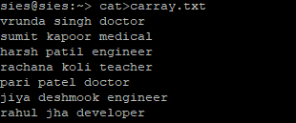

2. **awk ‘{print}’ carray.txt**

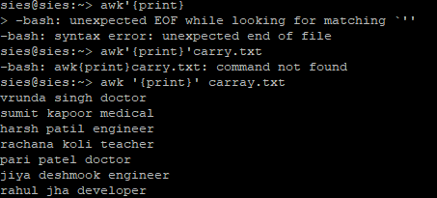

3. **awk ‘{PRINT $1,$3}’ CARRAY.TXT**

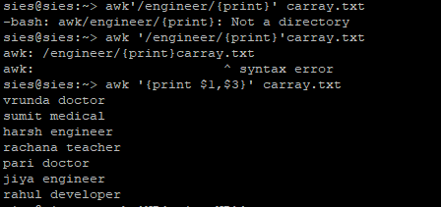

4.**AWK ‘nr{PRINT nr}’ CARRAY.TXT**

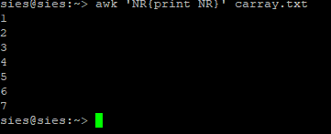

**5.PS –L**

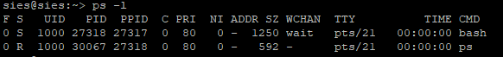

**PS COMMAND CALLED AS PROCESS STATUS**

**IT IS USED TO DISPLAY INROMATION RELATED TO THE PROCESS**

1. **PID :- UNIQ PROCESS ID**
2. **TTY :- TERMIANAL TYPES**
3. **TIME :- AMOUNT OF CPU IN MINUTES & SECOND THAT PROCESS RUN IN**
4. **CMD:- NAON OF COMMAND THAT LUANCH THE PROCESS**

**PS :-**  **to display a list of your processes that are currently running and obtain additional information about those processes.**

**6. ps –A**

