ProcessifyERP — Technical Architecture & Case Study Documentation
Evaluation Target: Fundsroom Interview Technical Assessment (Round 1 Shortlisting Project)
Author: Tejas | Live AWS URL: http://13.48.149.82/
--------------------------------------------------------------------------------

1. Executive Summary & Business Impact
ProcessifyERP is an enterprise-grade, full-stack B2B Wholesale Operations & CRM Portal. Built to streamline B2B distribution operations, the platform integrates multi-role authentication, customer lifecycle management, inventory master tracking, stock movement audit trails, delivery challan generation, GST invoicing, and administrative governance.
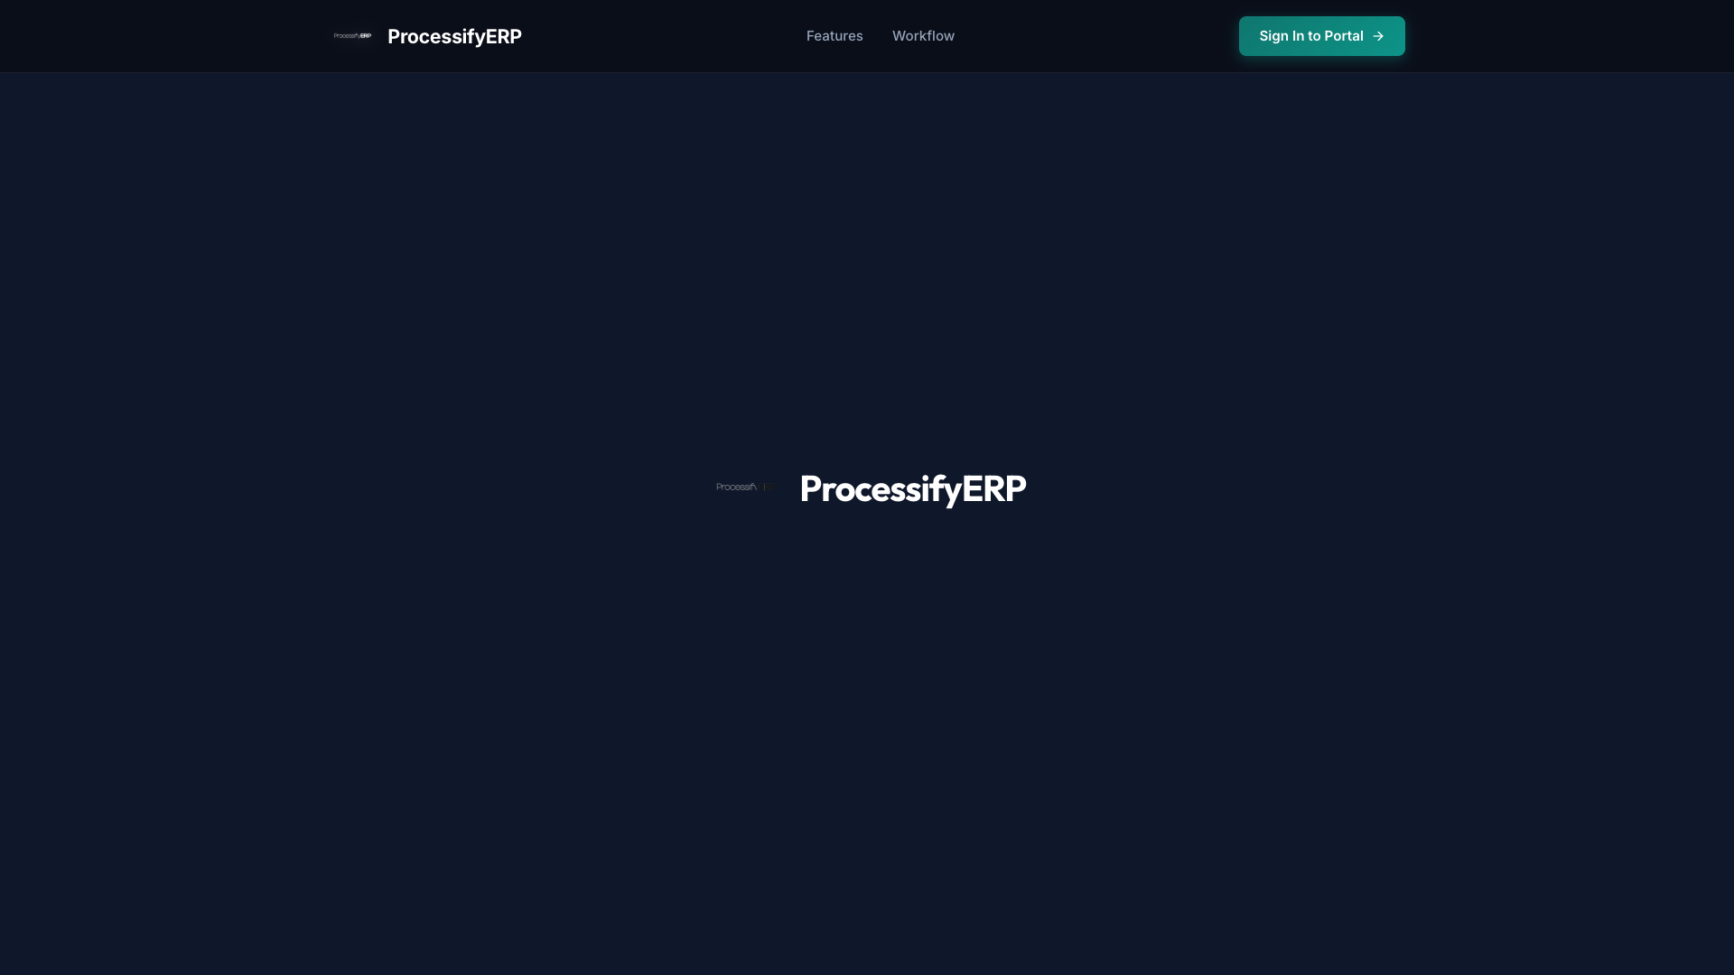
Figure: ProcessifyERP Landing Page & Public Gateway
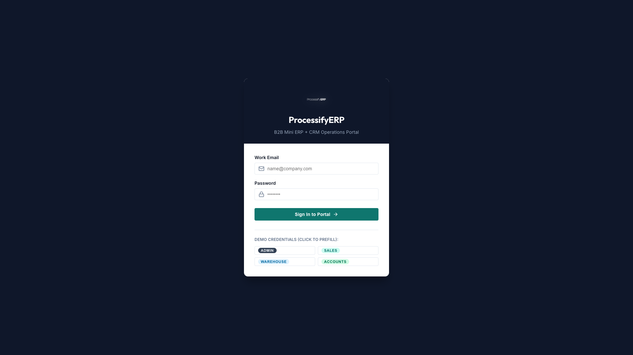
Figure: Authenticated Gateway with Quick Role Prefills

2. Real-World Case Study: B2B Order Fulfillment Workflow
Client Account: ABC Traders Pvt Ltd (Contact: Rahul Sharma - GSTIN: 24AAAAA0000A1Z5)
Order Requirement: 25 Units Dell 4K Monitors (Rs. 32,500/unit) + 50 Units Keychron Keyboards (Rs. 7,490/unit)
Order Grand Total: Rs. 1,187,000 (Triggers High-Value Administrative Approval Gate >= Rs. 1,000,000)

Step 1: Lead Onboarding & Interaction Notes (Sales Manager)
The Sales Manager logs into ProcessifyERP using sales@processify.com, searches for ABC Traders Pvt Ltd in the Customer CRM Portal (/customers), and logs a follow-up interaction note detailing agreed 5% wholesale rebate terms.
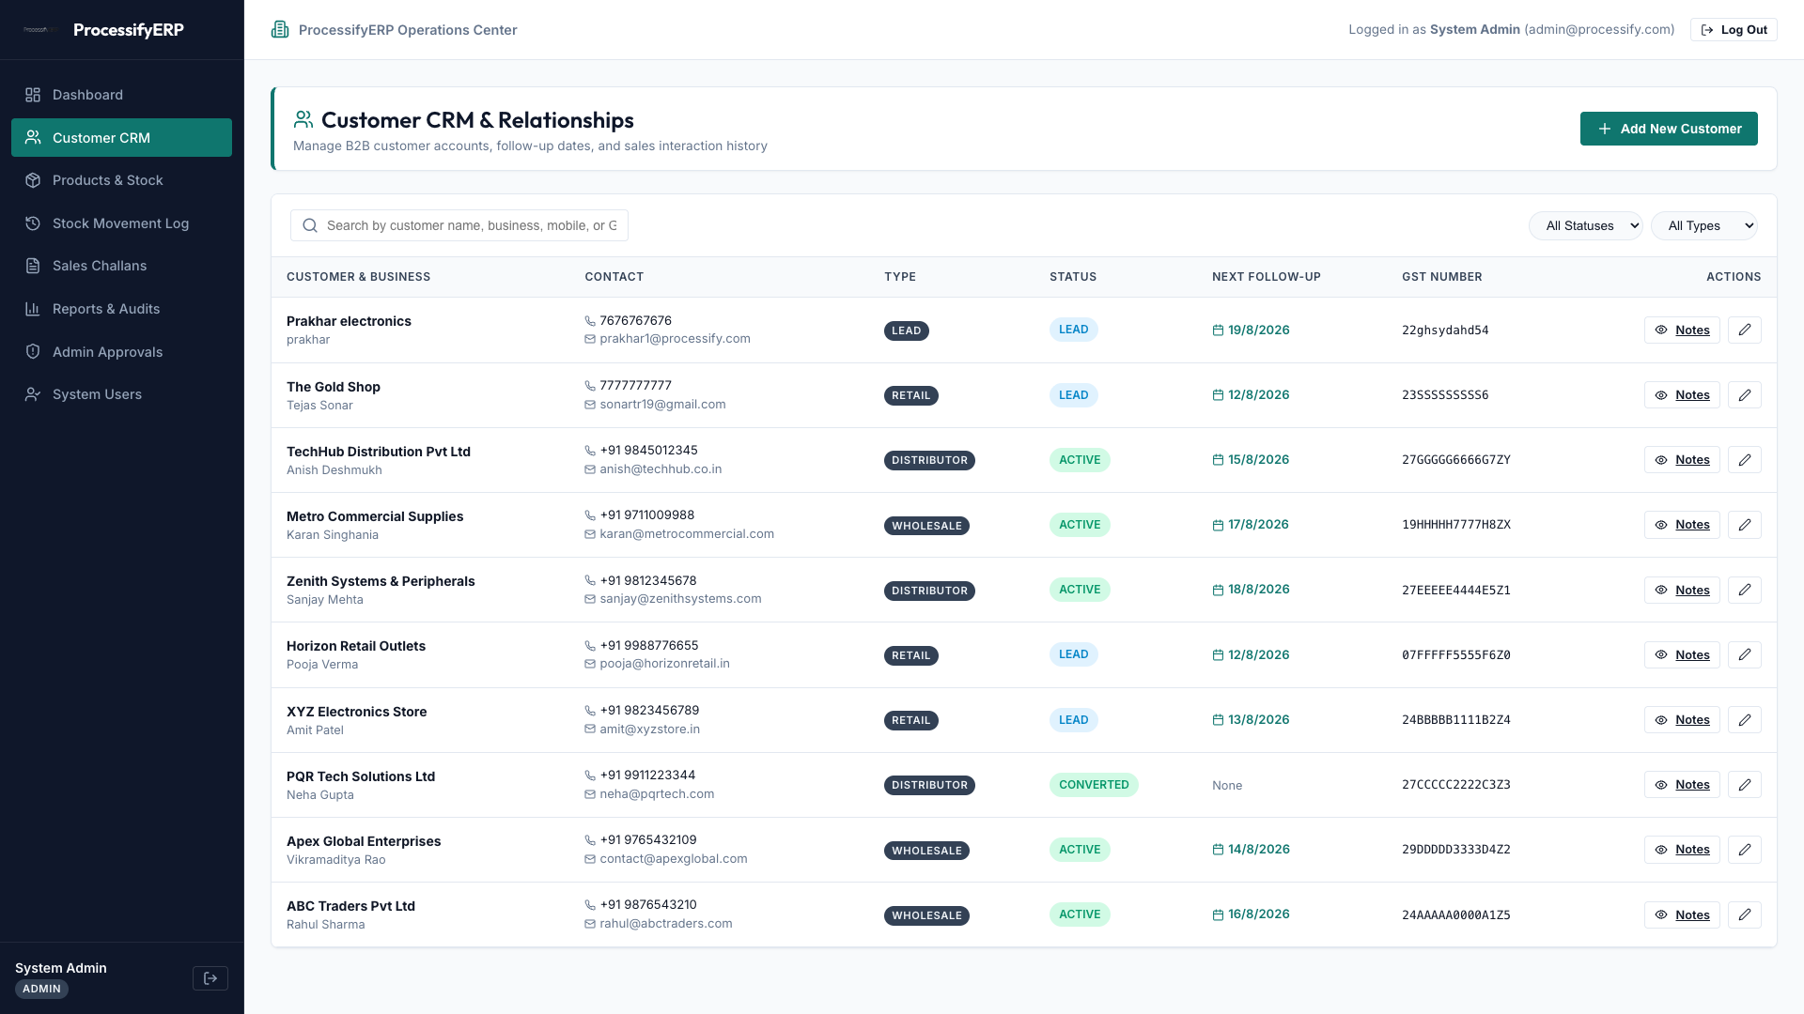
Figure: Step 1: Customer Profile & Interaction Logged

Step 2: Inventory Master & Stock Verification (Warehouse Lead)
The Warehouse Lead checks physical rack availability for SKU MON-DELL-27U (Rack A1) and SKU ACC-KEY-K2 (Rack B4). The system alerts on low-stock items like ACC-LOGI-MX3S (4 units remaining vs min threshold 15).
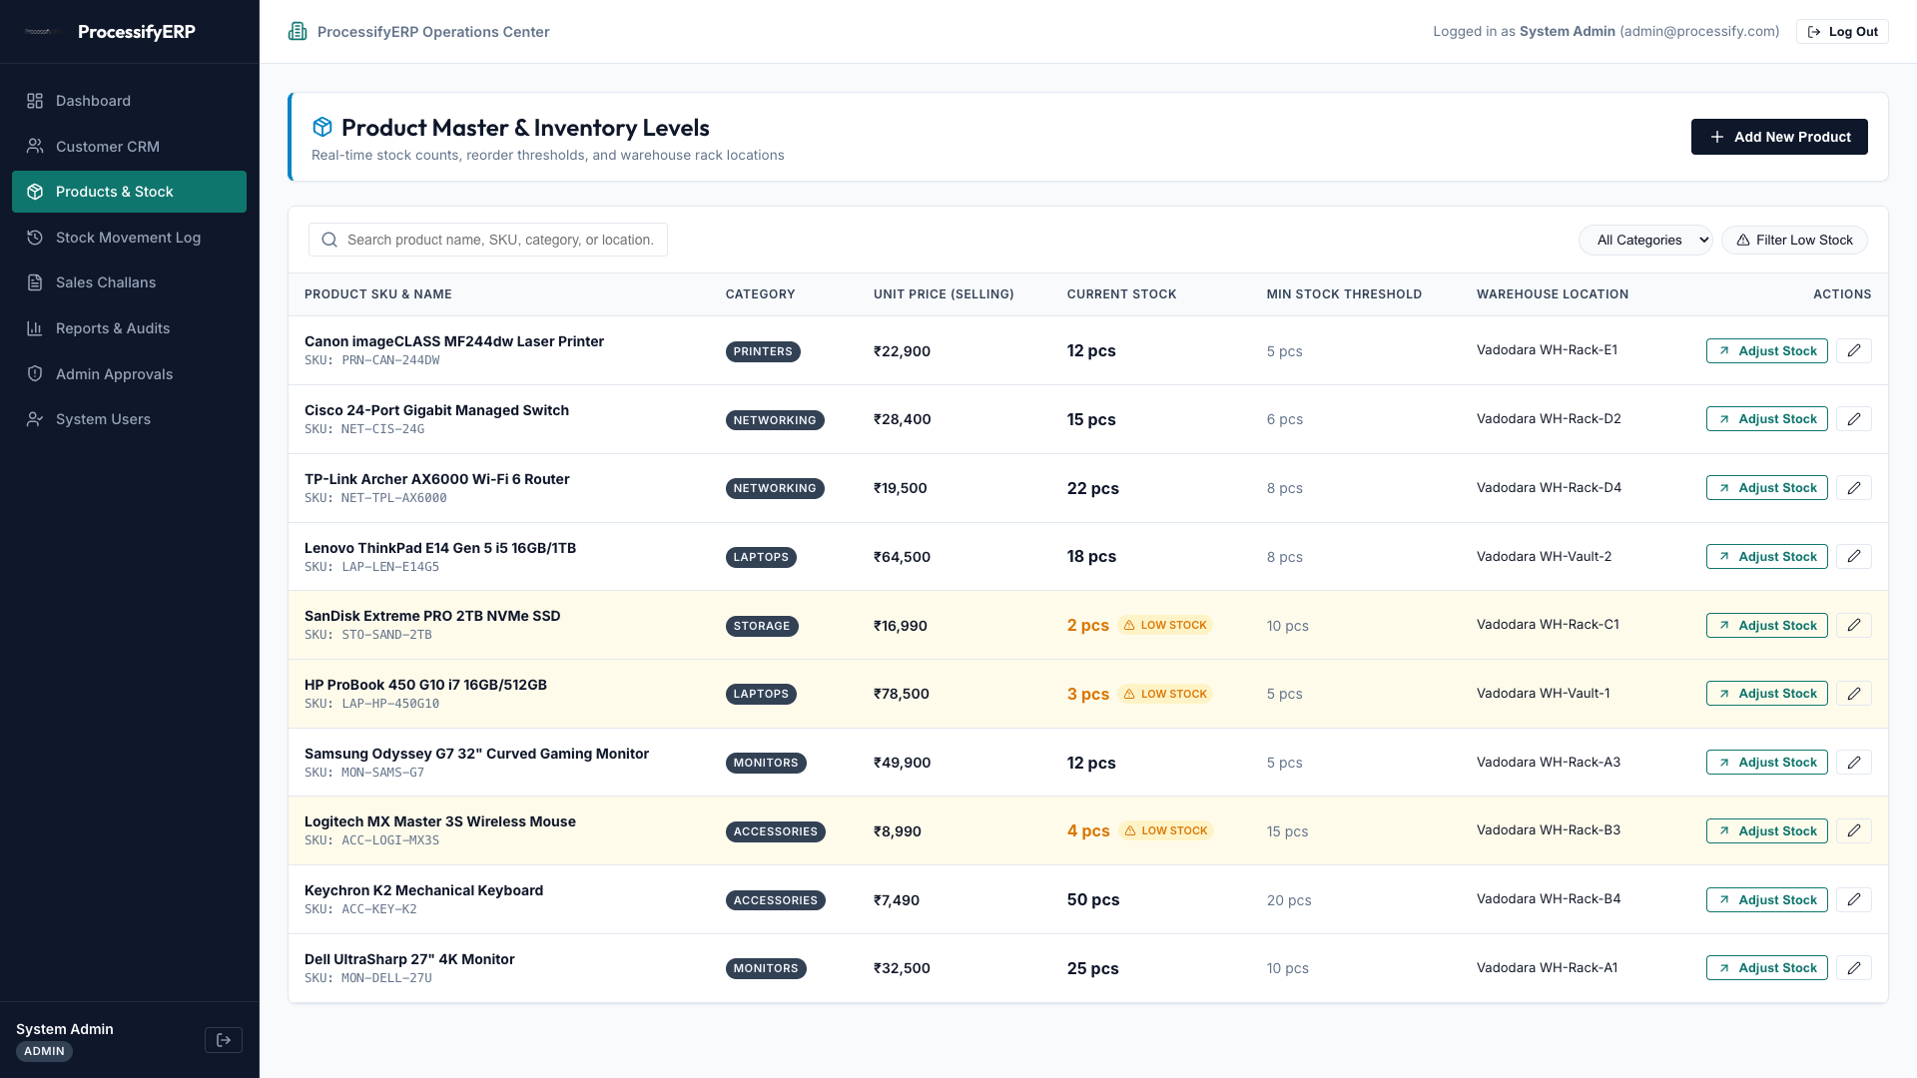
Figure: Step 2: Inventory Master Verification & Reorder Alerts

Step 3: Draft Delivery Challan Creation & High-Value Approval
The Sales Manager creates Challan #CH-2026-0006 for Rs. 1,187,000. Because the order exceeds Rs. 1,000,000, ProcessifyERP routes an ApprovalRequest to Admin Governance (/approvals). The System Admin (admin@processify.com) approves the transaction.

Step 4: Automated Stock Reservation & Dashboard Invoicing Audit
Upon approval, Challan #CH-2026-0006 is automatically CONFIRMED, stock is decremented atomically, stock OUT audit movements are recorded, and confirmed sales revenue updates on the Dashboard.
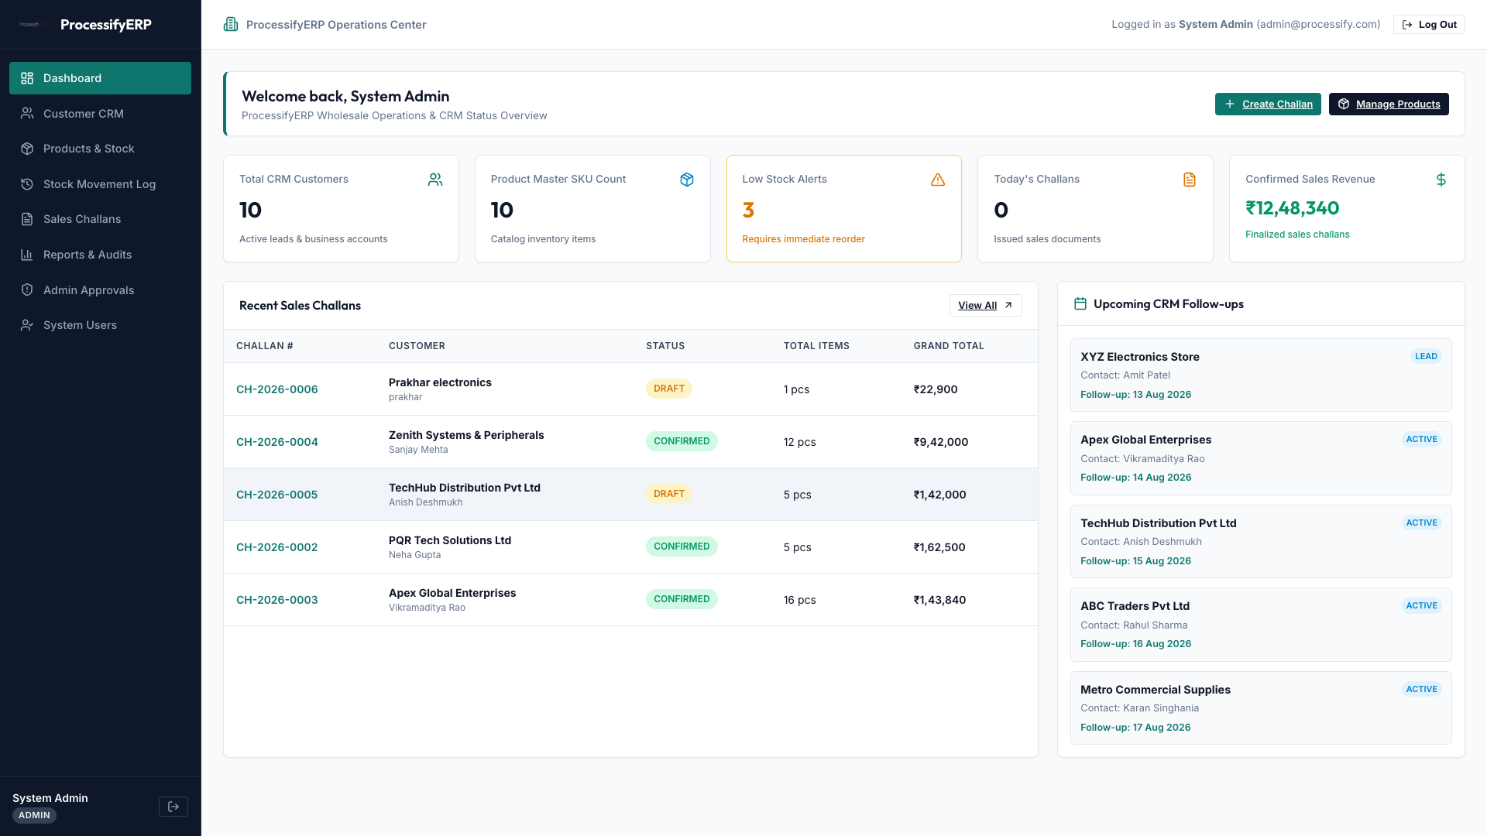
Figure: Step 4: Live Dashboard Updated with Confirmed Revenue & Audit Logs

