Supplementary Figures

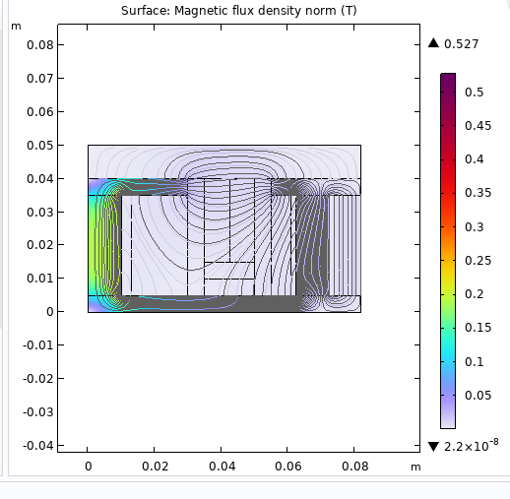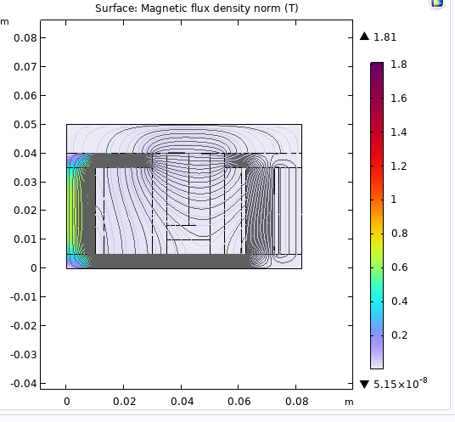
Supplementary Figure A: Cross section of the SPT-100 with 3:1 coil current ratio (left) and 1:3 coil current ratio (right)
Mean
Radius
Mean
Radius
Channel
Width
Channel
Width
Thruster Axis
Thruster Axis
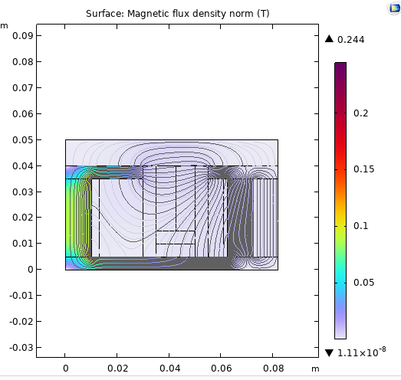 Supplementary Figure B: Cross section of the SPT-100 with 3:1 turn ratio (left) and 1:3 turn ratio (right)
Mean
Radius
Mean
Radius
Thruster Axis
Thruster Axis
Channel
Width
Channel
Width
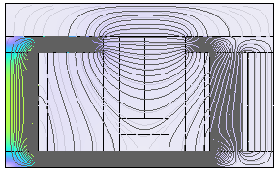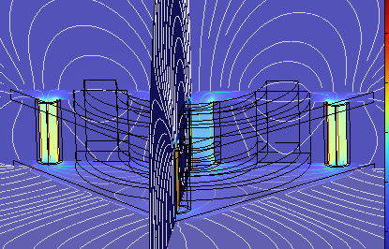
Supplementary Figure C: Symmetric calibrated magnetic field lines in 2D simulation (left) and 3D simulation (right).
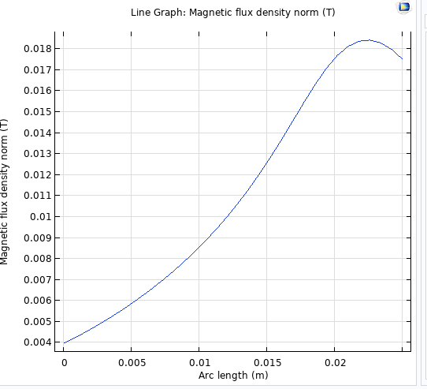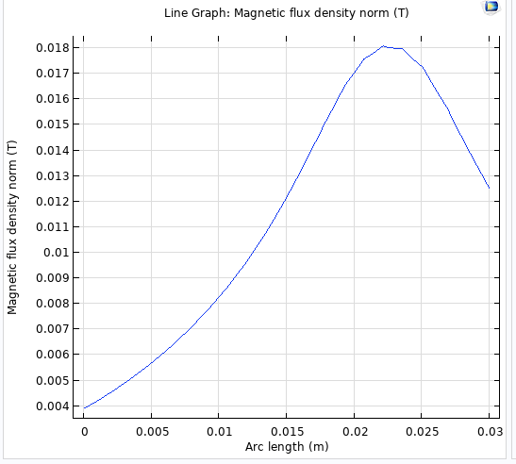
Supplementary Figure D: 2D Magnetic field profile (left) and 3D Magnetic field profile (right)

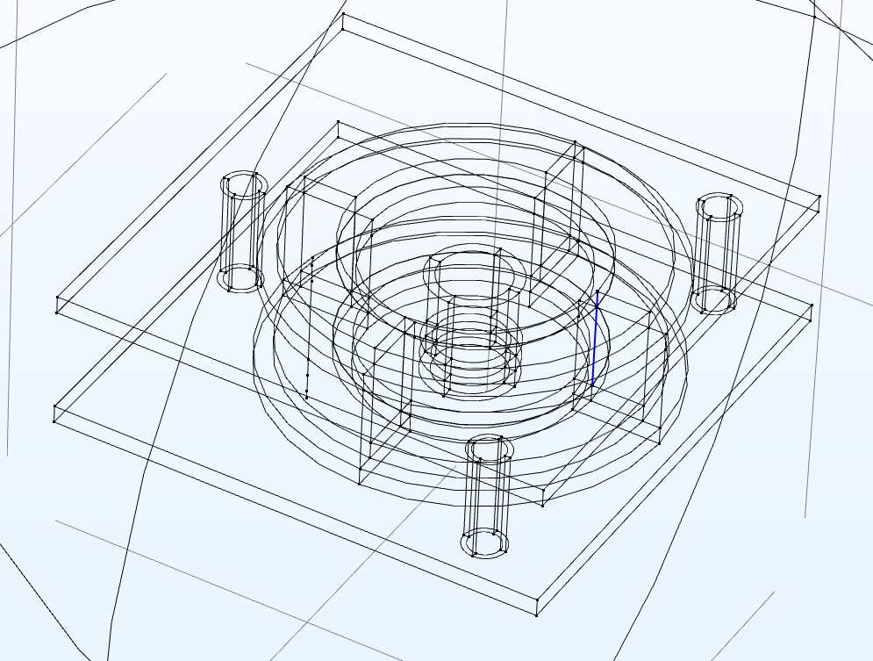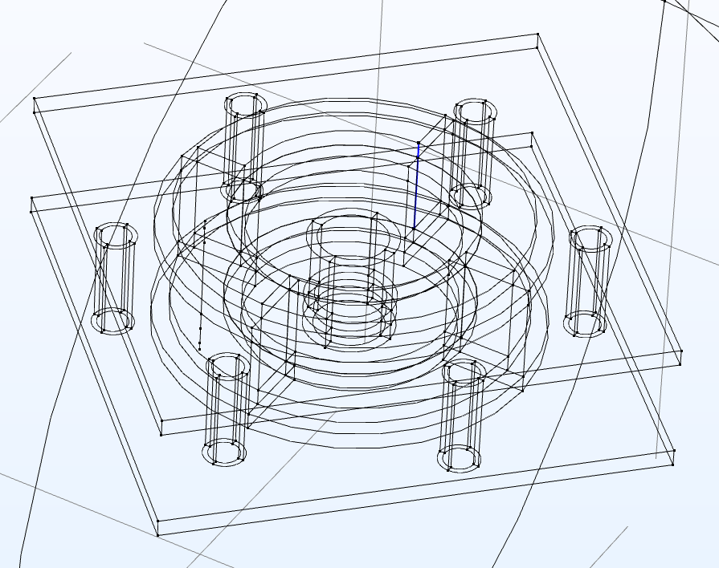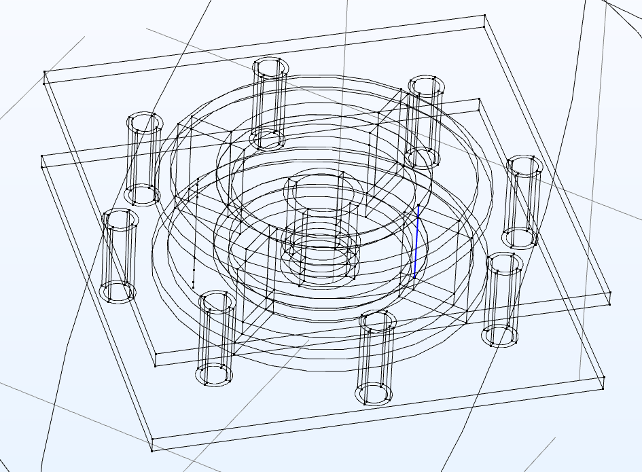
Supplementary Figure E: Wireframe build of SPT-100 with 4, 7 and 9 electromagnets.

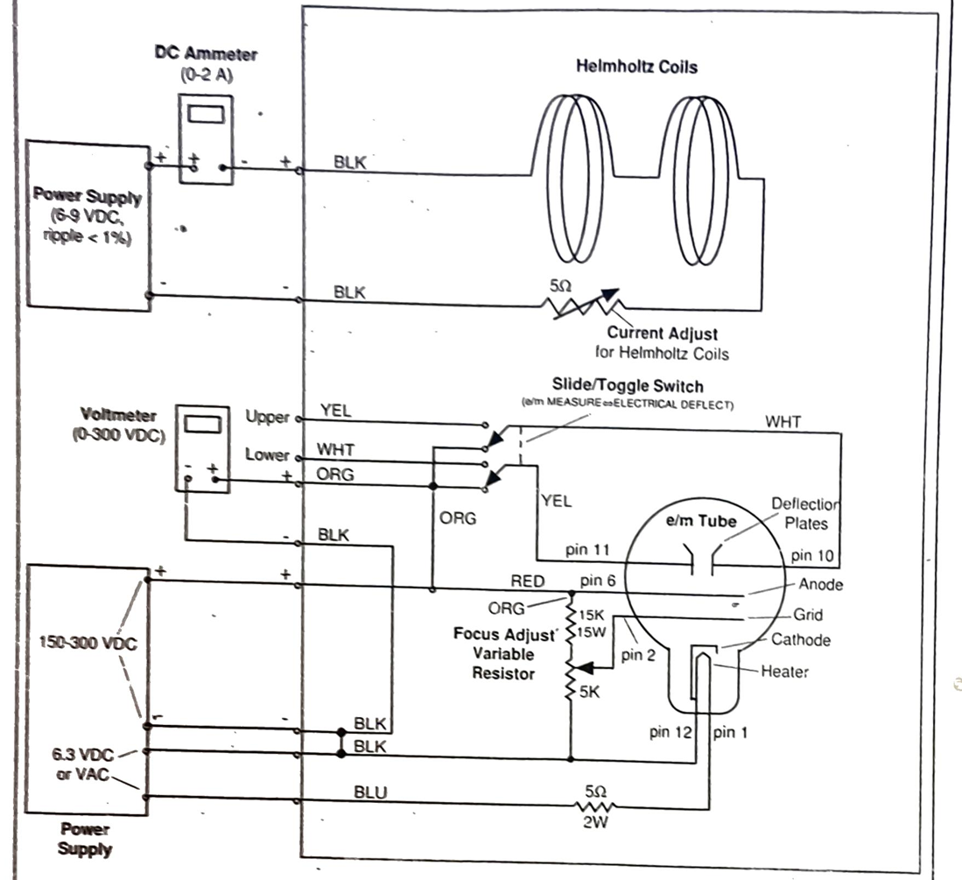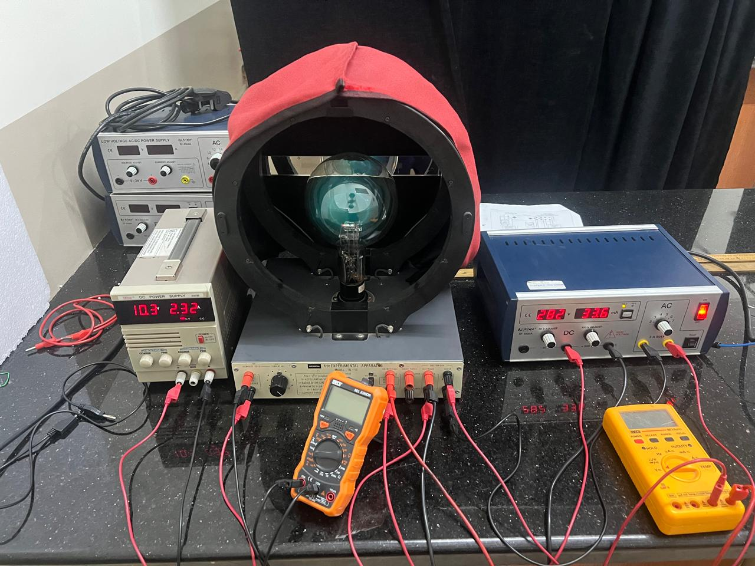
Supplementary Figure F: Helmholtz coil schematic (left) and experimental set up (right).
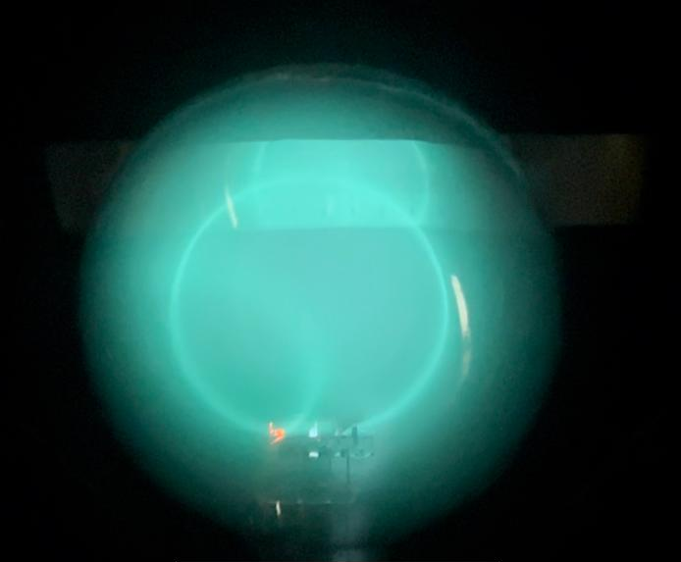
Supplementary Figure G: Floating Electron Loop for SPT-100.
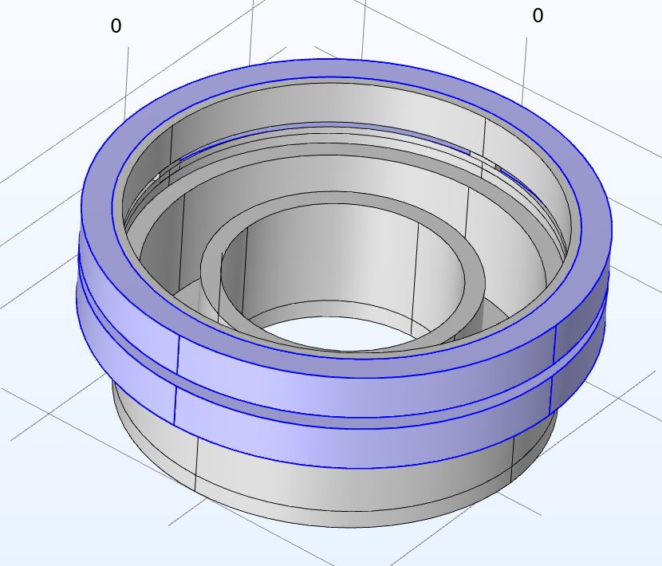
Supplementary Figure H: Geometric model of Helmholtz coil thruster for Magnetic field simulation.
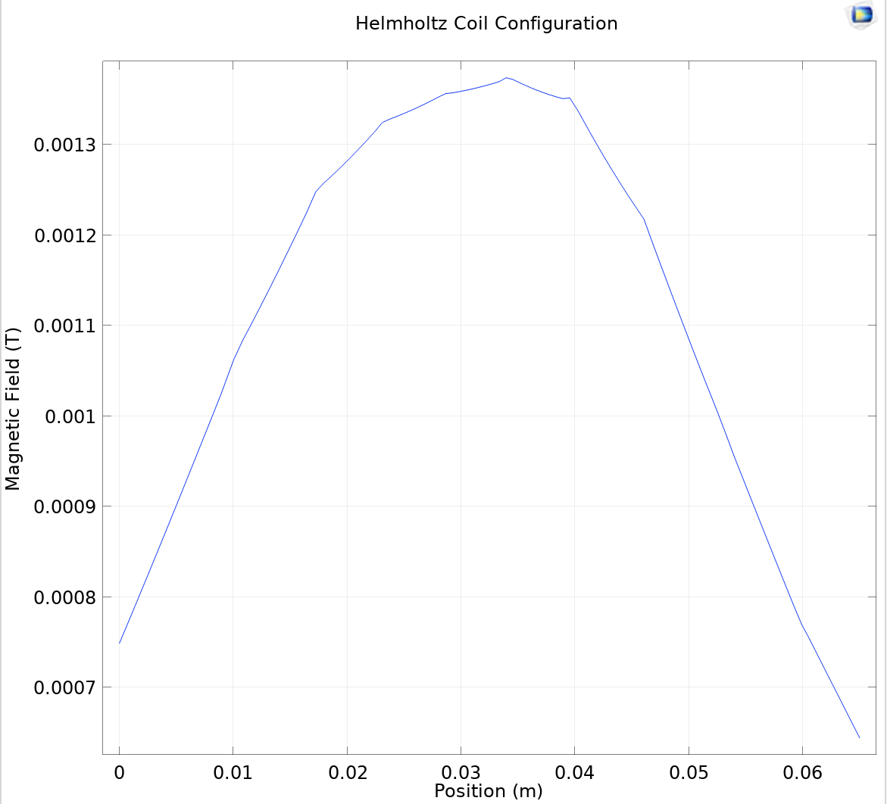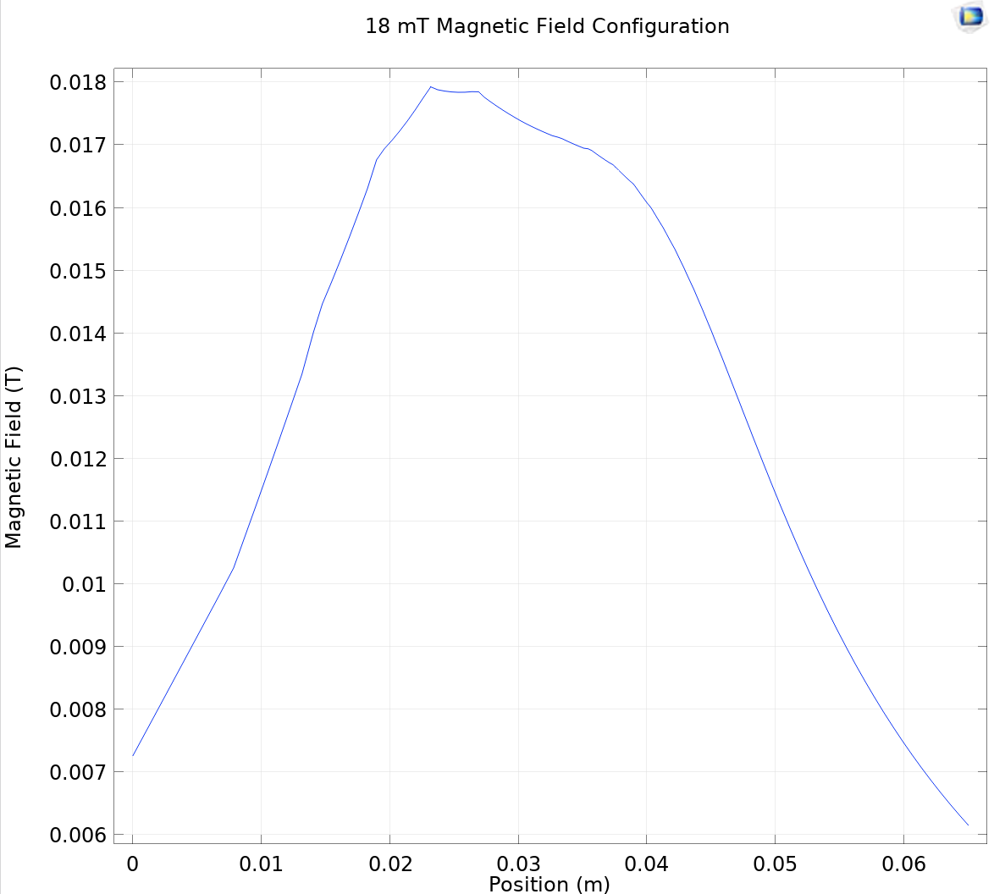
Supplementary Figure I: Magnetic field profile of Helmholtz coil thruster predicting B_{max} = 1.3 mT with 250 windings, maintained at 1.91 A current (left) and B_{max} = 18 mT with 115 turn maintained at 0.41 A. (right).

