Leakage-Aware DT Health Analytics and Failure-Risk Dashboard
for Monthly MDM Transformer Data

1. Cover Page
Team member 1: [Tejas S Trivedi]
Roll number 1: [25280052]
Team member 2: [Krushna K Dhandhal]
Roll number 2: [25280044]
Course title: Programming for Data Science
Date: 10 May 2026
One-sentence project summary: We built an offline ingestion utility, SQLite-backed dashboard, and leakage-aware risk model to prioritize distribution transformers for preventive action before probable failure.

2. Executive Summary
This project addresses a practical electricity distribution problem: monthly MDM health reports contain early signs of transformer stress, but those signals are difficult to operationalize quickly at circle, division, and subdivision level. We designed a reproducible workflow that ingests month-year wise DT health files, derives the two key status fields required by the business problem, stores the data in SQLite with overwrite-safe monthly reloads, and serves a Streamlit dashboard for hierarchy-wise analysis. The dashboard highlights overloaded DTs, unbalanced DTs, and high off-hour DTs, then adds a next-year same-month risk score so managers can prioritize augmentation, de-augmentation, load balancing, and preventive inspection.
The data basis combines two real MDM exports for May 2025 and June 2025 with transparent synthetic backfill for January 2023 to April 2026 excluding those two real months. Synthetic periods are clearly labelled and were generated to create enough same-calendar-month history for a defensible next-year same-month proof of concept. The final database contains 1,226,735 rows across 40 monthly periods, spanning 2023-01 to 2026-04, and covering 12 circles, 45 divisions, and 213 subdivisions. For the latest available dashboard month (2026-04), the same-calendar-month logistic regression model achieved a temporal holdout ROC-AUC of 0.970. We still do not claim this is true transformer-failure accuracy because the source MDM exports do not contain audited failure labels.

Submission Structure Mapping
Submission criterion | Where covered in this report
Business case and problem articulation | Sections 3 and 4
Programming and data challenge | Section 5
Methodological justification | Sections 7 and 8
Solution flowchart | Section 6
Proof-of-concept and embedded links | Sections 9 and 10
Validation, risks, and limitations | Section 11
Report quality and self-contained submission | All sections, especially 1, 2, and 13

3. Business Case
Stakeholder: Operations and Maintenance (O&M) teams at utility circle, division, and subdivision level, along with asset management and planning officers responsible for transformer augmentation, de-augmentation, balancing, and emergency response.
Pain point: Distribution transformers (DTs) that are persistently overloaded, phase-unbalanced, or frequently off for long hours tend to fail reactively, causing outages, service-quality issues, and expensive emergency interventions. The current monthly review process is spreadsheet-heavy and makes it hard to move from raw data to a ranked intervention list.
Decision to improve: At the end of each month, managers need to decide which DTs should be inspected, monitored, load-shifted, augmented, or de-augmented before the same month next year. The workflow supports this prioritization by converting raw meter-health fields into interpretable operational indicators and area-level summaries.
- Baseline decision process: manual spreadsheet review, ad hoc filtering, and localized engineering judgment.
- Value proposition: faster monthly review, hierarchy-wise accountability, and a forward-looking risk list instead of only retrospective reporting.
- Success metric: high recall on future high-stress DTs, fewer unplanned DT failures, and quicker escalation of problematic feeders/substations.
- Cost of wrong decisions: false negatives may allow avoidable failures and outages; false positives may trigger unnecessary field visits or capital expenditure.

4. Problem Statement and Formulation
The problem statement below answers the seven questions required in the brief in a direct and auditable way.
- 1. What is the real-world problem? Monthly transformer-health reports contain early warning signals of overload, phase imbalance, and long outage duration, but the review process is too manual to quickly convert those signals into preventive action.
- 2. Who is the decision-maker or user? The primary users are utility O&M managers and engineers at circle, division, and subdivision level, along with planning teams responsible for augmentation and de-augmentation.
- 3. What decision will your workflow support? The workflow supports monthly prioritization of which DTs should be inspected, load-shifted, balanced, augmented, de-augmented, or monitored before conditions worsen.
- 4. What data would be needed? Month-year wise MDM DT health reports with hierarchy fields, DT identifiers, KVA rating, maximum KVA, energy consumption, power factor, phase currents, phase-unbalance values, and power on/off hours. For a production-grade model, true transformer failure labels and maintenance history would also be needed.
- 5. What is the programming challenge? The challenge is to ingest repeated monthly Excel files, overwrite the same month safely, derive consistent operational status fields, support hierarchy-level drilldown in a dashboard, and create a leakage-safe year-ahead prediction workflow.
- 6. What could go wrong if the analysis is done poorly? Poor analysis could leak future information into training, overstate confidence from synthetic or proxy labels, mis-rank transformers because of outliers or duplicate records, and trigger unnecessary field action while missing truly risky DTs.
- 7. How will you validate whether your solution is useful? Use time-ordered holdout validation for the prediction layer, inspect whether high-risk DTs align with future stress conditions, review hotspot rankings with domain experts, and check whether the dashboard shortens the path from monthly report to intervention list.

5. Data and Programming Challenge
Data basis: the source is the Meter Data Management (MDM) portal from which month-year wise DT health reports are downloaded as Excel workbooks. Two real files were available during the hackathon: May 2025 and June 2025. To support strict same-calendar-month year-ahead modelling, synthetic months were generated for January 2023 to April 2026 excluding the two real months. Synthetic periods remain explicitly flagged in the database and report, and they are used only as proof-of-concept historical backfill rather than as a claim of production-grade field truth.

Table: Period-wise data basis used in the prototype (We have live data for all period but for demo purpose, we have taken only two months live data from our MDM portal)
Period | Rows | Data basis | Source file
2026-04 | 30776 | Synthetic backfill anchored to real May/June 2025 | synthetic_backfill_from_may_june_2025
2026-03 | 30776 | Synthetic backfill anchored to real May/June 2025 | synthetic_backfill_from_may_june_2025
2026-02 | 30776 | Synthetic backfill anchored to real May/June 2025 | synthetic_backfill_from_may_june_2025
2026-01 | 30776 | Synthetic backfill anchored to real May/June 2025 | synthetic_backfill_from_may_june_2025
2025-12 | 30776 | Synthetic backfill anchored to real May/June 2025 | synthetic_backfill_from_may_june_2025
2025-11 | 30776 | Synthetic backfill anchored to real May/June 2025 | synthetic_backfill_from_may_june_2025
2025-10 | 30776 | Synthetic backfill anchored to real May/June 2025 | synthetic_backfill_from_may_june_2025
2025-09 | 30776 | Synthetic backfill anchored to real May/June 2025 | synthetic_backfill_from_may_june_2025
2025-08 | 30776 | Synthetic backfill anchored to real May/June 2025 | synthetic_backfill_from_may_june_2025
2025-07 | 30776 | Synthetic backfill anchored to real May/June 2025 | synthetic_backfill_from_may_june_2025
2025-06 | 30281 | Real MDM export | DT Health Report June-2025.xlsx
2025-05 | 26966 | Real MDM export | DT Health Report May-2025.xlsx
2025-04 | 30776 | Synthetic backfill anchored to real May/June 2025 | synthetic_backfill_from_may_june_2025
2025-03 | 30776 | Synthetic backfill anchored to real May/June 2025 | synthetic_backfill_from_may_june_2025
2025-02 | 30776 | Synthetic backfill anchored to real May/June 2025 | synthetic_backfill_from_may_june_2025
2025-01 | 30776 | Synthetic backfill anchored to real May/June 2025 | synthetic_backfill_from_may_june_2025
2024-12 | 30776 | Synthetic backfill anchored to real May/June 2025 | synthetic_backfill_from_may_june_2025
2024-11 | 30776 | Synthetic backfill anchored to real May/June 2025 | synthetic_backfill_from_may_june_2025
2024-10 | 30776 | Synthetic backfill anchored to real May/June 2025 | synthetic_backfill_from_may_june_2025
2024-09 | 30776 | Synthetic backfill anchored to real May/June 2025 | synthetic_backfill_from_may_june_2025
2024-08 | 30776 | Synthetic backfill anchored to real May/June 2025 | synthetic_backfill_from_may_june_2025
2024-07 | 30776 | Synthetic backfill anchored to real May/June 2025 | synthetic_backfill_from_may_june_2025
2024-06 | 30776 | Synthetic backfill anchored to real May/June 2025 | synthetic_backfill_from_may_june_2025
2024-05 | 30776 | Synthetic backfill anchored to real May/June 2025 | synthetic_backfill_from_may_june_2025
2024-04 | 30776 | Synthetic backfill anchored to real May/June 2025 | synthetic_backfill_from_may_june_2025
2024-03 | 30776 | Synthetic backfill anchored to real May/June 2025 | synthetic_backfill_from_may_june_2025
2024-02 | 30776 | Synthetic backfill anchored to real May/June 2025 | synthetic_backfill_from_may_june_2025
2024-01 | 30776 | Synthetic backfill anchored to real May/June 2025 | synthetic_backfill_from_may_june_2025
2023-12 | 30776 | Synthetic backfill anchored to real May/June 2025 | synthetic_backfill_from_may_june_2025
2023-11 | 30776 | Synthetic backfill anchored to real May/June 2025 | synthetic_backfill_from_may_june_2025
2023-10 | 30776 | Synthetic backfill anchored to real May/June 2025 | synthetic_backfill_from_may_june_2025
2023-09 | 30776 | Synthetic backfill anchored to real May/June 2025 | synthetic_backfill_from_may_june_2025
2023-08 | 30776 | Synthetic backfill anchored to real May/June 2025 | synthetic_backfill_from_may_june_2025
2023-07 | 30776 | Synthetic backfill anchored to real May/June 2025 | synthetic_backfill_from_may_june_2025
2023-06 | 30776 | Synthetic backfill anchored to real May/June 2025 | synthetic_backfill_from_may_june_2025
2023-05 | 30776 | Synthetic backfill anchored to real May/June 2025 | synthetic_backfill_from_may_june_2025
2023-04 | 30776 | Synthetic backfill anchored to real May/June 2025 | synthetic_backfill_from_may_june_2025
2023-03 | 30776 | Synthetic backfill anchored to real May/June 2025 | synthetic_backfill_from_may_june_2025
2023-02 | 30776 | Synthetic backfill anchored to real May/June 2025 | synthetic_backfill_from_may_june_2025
2023-01 | 30776 | Synthetic backfill anchored to real May/June 2025 | synthetic_backfill_from_may_june_2025

Expected schema includes geographic hierarchy fields (Zone, Circle, Division, Subdivision), transformer identifiers, KVA ratings, energy fields, power factor, currents, phase-unbalance fields, loading fields, and power on/off hours. The ingestion challenge is that the same month may be re-uploaded later, the same DT code is not strictly unique within a month, and the raw source may contain extreme outlier values.
- Offline import utility: `python import_monthly_data.py <excel files>`.
- Monthly overwrite rule: on re-upload, the matching period is deleted and reloaded in SQLite.
- Storage grain: `period + source_row_number`, because `DT Code` alone is not unique within a monthly file.
- Synthetic generation assumption: May/June 2025 define the anchor population, while seasonal multipliers, geographic bias terms, and controlled noise create realistic but clearly synthetic stress patterns for earlier and later months. This extended backfill was added specifically so the selected dashboard month can use only same-calendar-month history across years during training and validation.

6. Solution Flowchart
Figure 1 is written to satisfy the brief’s flowchart requirement explicitly. It includes the problem and decision objective, data source and generation label, ingestion method, cleaning and preprocessing, exploratory analysis and statistical reasoning, model and decision rule, validation plan and metric, final output, and reproducibility plan.
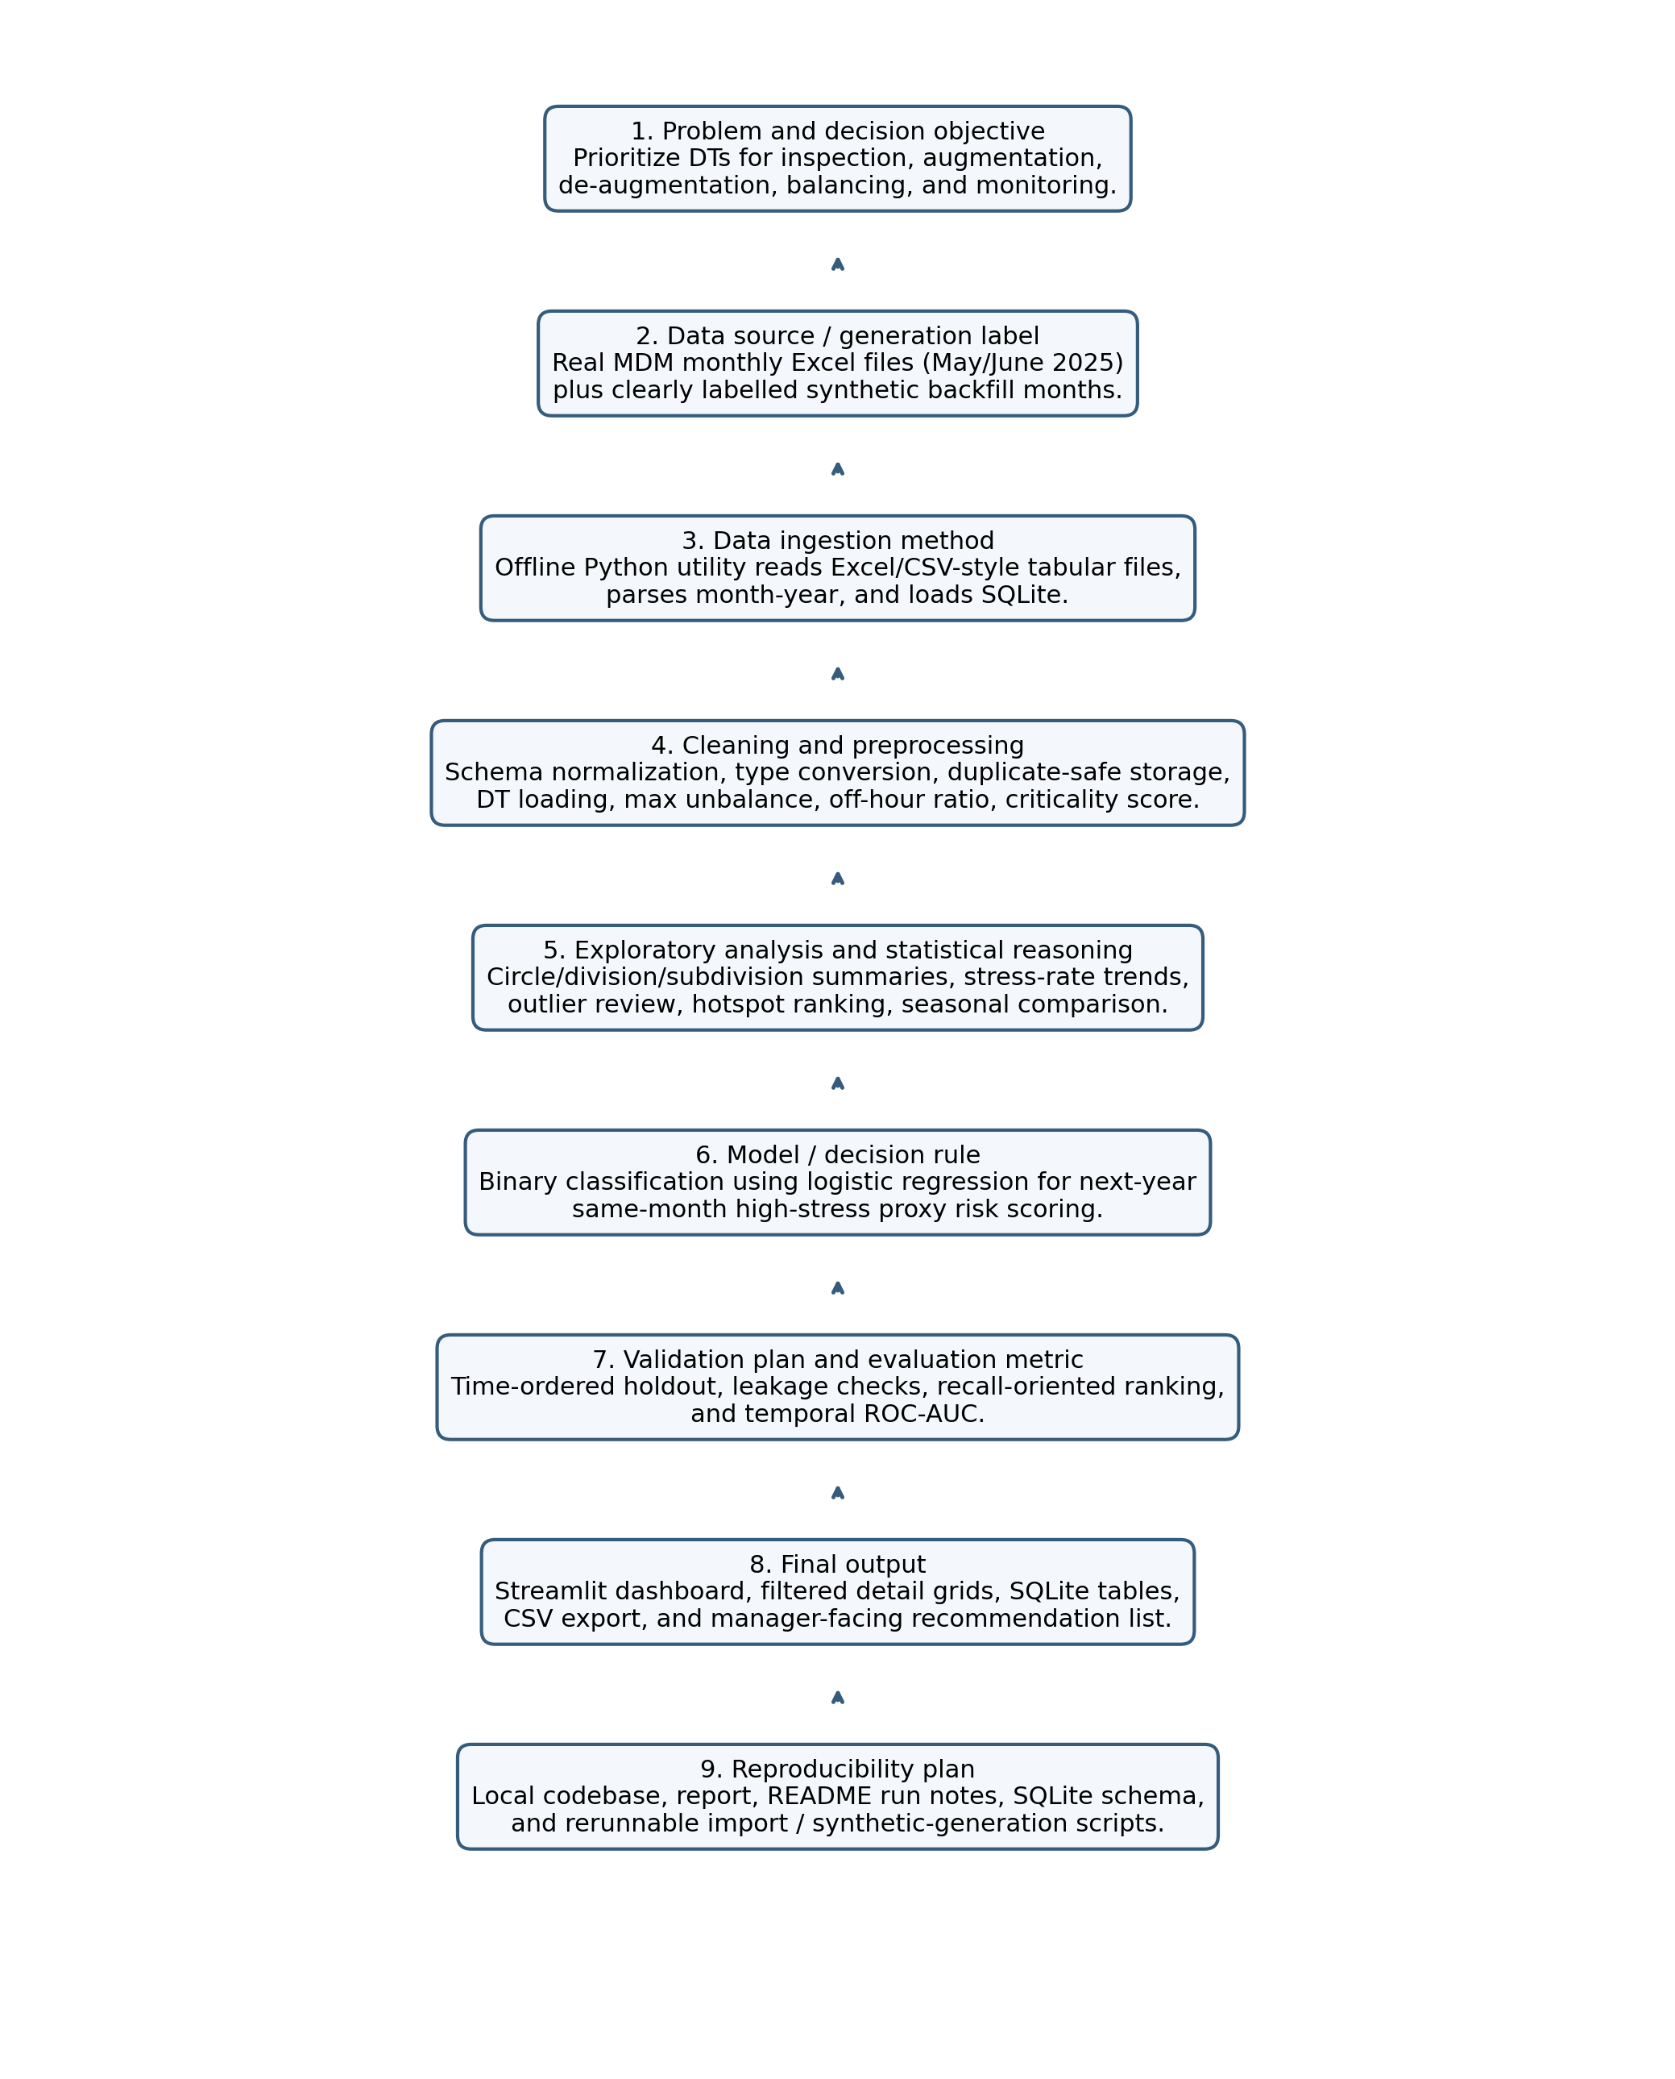
Figure 1. End-to-end DT health analytics workflow.
- Problem and decision objective: identify which DTs should be inspected, balanced, augmented, de-augmented, or monitored.
- Data source and generation label: real MDM monthly Excel exports plus transparently labelled synthetic backfill used only for proof-of-concept coverage.
- Ingestion method: offline Python Excel ingestion into SQLite.
- Cleaning and preprocessing: schema normalization, type conversion, derived loading/unbalance fields, and duplicate-safe monthly overwrite logic.
- Exploratory analysis and statistical reasoning: monthly stress-rate trends, hotspot ranking, hierarchy summaries, and outlier review.
- Model or decision rule: binary logistic-regression classification for next-year same-month stress proxy risk.
- Validation plan and metric: time-ordered holdout with leakage checks and temporal ROC-AUC, interpreted alongside recall-oriented prioritization.
- Final output: dashboard, detail grid, CSV export, SQLite tables, and manager-facing intervention shortlist.
- Reproducibility plan: local source code, README run notes, database schema, and rerunnable utility scripts referenced in the report.

7. Methodological Justification
- SQLite is appropriate because the dashboard needs queryable monthly state with simple overwrite behavior and no external server dependency.
- Streamlit is appropriate because the user’s main need is an internal operational dashboard rather than a public product website.
- Deterministic status derivation is necessary because business action is attached directly to status categories and source values should be recomputed rather than trusted blindly.
- A recall-oriented next-year risk score is appropriate because missing a likely high-stress DT is operationally costlier than inspecting one extra transformer.
- Temporal validation is necessary because random splitting would leak future monthly behavior into model evaluation.
- Synthetic data are justified only as a transparent proof-of-concept device for the hackathon; they are not used to claim causal or production-grade failure accuracy.

8. Technical Method
The system contains four main components. First, the importer reads each monthly MDM workbook, normalizes the schema, and derives the two required dashboard fields. Second, the SQLite layer stores both monthly DT records and an import-history table so that the same month can be safely overwritten. Third, the dashboard filters by month-year, circle, division, subdivision, and analysis focus, then shows hierarchy summaries and detailed DT lists. Fourth, the prediction layer constructs a next-year same-month target proxy and trains a supervised classification model using only the same calendar month across years for the selected prediction month.

8.1 Data Preprocessing Steps
Preprocessing step | Purpose
Schema standardization | Rename raw workbook columns into a stable machine-friendly schema used by the importer, SQLite, and dashboard.
Type conversion | Convert numeric fields such as KVA, kWh, power factor, currents, unbalance values, and power-off hours to numeric types; parse maximum KVA date to datetime.
Text cleanup | Trim hierarchy and identifier fields such as circle, division, subdivision, feeder, and DT identifiers.
Month tagging | Attach `year`, `month`, `period`, and `month_year_label` from the month-year file context.
Derived status fields | Recompute DT loading, maximum unbalance, loading status, unbalance status, power-off ratio, and criticality score instead of trusting source status fields blindly.
Overwrite-safe monthly storage | Delete and reload the same period in SQLite so repeated monthly uploads do not create duplicates.
Outlier handling for synthetic backfill | Cap impossible or extreme source values before using them as anchors for synthetic month generation.

8.2 Feature Selection and Feature Engineering
Feature selection was guided by operational relevance and leakage safety. Only fields available at or before the decision month were retained as model inputs. Future-period fields were used only to build the target label, never as predictors.
Feature group | Description
Core direct features | kva_rating, kwh, kvah, power_factor, avg_kva, maximum_kva, phase currents, max_unbalance, dt_loading, load_factor, utilization_factor, total_hours, power_off_hours, power_on_hours, power_off_ratio, criticality_score
Lag features | prev_dt_loading, prev_max_unbalance, prev_power_off_hours
Rolling-history features | rolling3_dt_loading_mean, rolling3_unbalance_mean, rolling3_power_off_mean
Categorical features | zone, circle, division, subdivision encoded for the classifier
History-depth feature | history_row_count to indicate how much prior information exists for each DT entity
Excluded from final model | Raw source status text columns were not used as predictive features because the workflow recomputes statuses deterministically.

8.3 Target Definition
Because true transformer failure events were not available in the source MDM exports, the project defines a next-year same-month failure proxy. For each DT entity in month t, the future month t+12 is located. A proxy stress score is then computed from future loading status, future unbalance status, and future power-off-hours. The target becomes 1 when that future stress score exceeds the chosen risk threshold and 0 otherwise. This creates a supervised label for classification while remaining explicit about the limitation that the target is not an audited failure log.

8.4 Model Type and Training Logic
The predictive task is binary classification, not regression. The chosen model is a same-calendar-month logistic regression classifier with balanced class weights. If the user selects April 2026, then the prediction for April 2027 is trained only on available April records across years such as April 2023, April 2024, April 2025, and April 2026. Logistic regression was selected because it is transparent, fast to train on tabular data, and produces calibrated intervention-oriented probabilities for the dashboard.
Categorical geography fields are one-hot encoded. Numeric features are median-imputed and standardized inside a scikit-learn pipeline. Training and evaluation are time-separated within the selected calendar month so that earlier years train the model and later same-month years provide validation, which directly addresses the leakage risk highlighted in the brief.
Core derivation logic used by both importer and dashboard:
DT Loading = (Maximum KVA / KVA Rating) * 100

DT Loading Status:
low if loading < 20
normal if 20 <= loading < 80
medium if 80 <= loading <= 100
high if loading > 100

Max Unbalance = max(Unbalance(RY), Unbalance(YB), Unbalance(BR))

DT Unbalance Status:
normal if max_unbalance <= 0.10
low if 0.101 to 0.20
medium if 0.201 to 0.30
high if > 0.30

Table: Leakage-aware prediction setup
Item | Value
Prediction target | Whether the same DT is likely to enter a high-stress failure-proxy state in the same month next year.
Learning setup | Supervised binary classification.
Model family | Same-calendar-month logistic regression classifier with balanced class weights and one-hot encoded geography.
Target variable | Binary next-year same-month failure proxy derived from future loading, unbalance, and off-hours stress.
Leakage control | Only current and lagged features are used; next-year labels are joined only after feature generation, and training is restricted to the same calendar month across years.
Training rows | 61,552 (for latest available month 2026-04)
Positive proxy labels | 18,533 (for latest available month 2026-04)
Temporal holdout ROC-AUC | 0.970 (for latest available month 2026-04)

Supervised next-year same-month proxy model trained with time-separated holdout periods. All lag features use only the current and earlier months to avoid data leakage.

9. Proof-of-Concept Evidence
The prototype is not just a design sketch. The ingestion utility, synthetic backfill script, SQLite database, and dashboard were all executed locally. The database now contains 1,226,735 rows across 40 periods, of which 57,247 rows come from real MDM exports and 1,169,488 rows are transparently marked synthetic historical backfill.
Table: Example proof-of-concept summary for May 2025
Metric | Value
Rows in the month | 26,966
Distinct DT codes | 26,477
Overloaded DTs (>100% loading) | 2,722
Near-overload DTs (80-100% loading) | 2,191
Unbalanced DTs (>0.30 max phase unbalance) | 16,372
High off-hours DTs (>=24 hours) | 3,582
Average predicted failure probability for May 2026 | 35.42%

Table: Top circle-level hotspots in May 2025 by overload and unbalance counts
Circle | Rows | Overloaded | Unbalanced | Avg failure probability (%)
SURENDRANAGAR_OM | 2445 | 498 | 1495 | 48.13
RAJKOT CITY | 7620 | 409 | 3873 | 27.44
MORBI | 2216 | 301 | 1466 | 39.69
JUNAGADH_OM | 2432 | 281 | 1587 | 36.22
RAJKOT_2_OM | 3237 | 247 | 2064 | 33.40
JAMNAGAR_OM | 2331 | 224 | 1519 | 39.70
BHAVNAGAR_OM | 2090 | 197 | 1156 | 32.36
KACHCHH_OM | 1615 | 182 | 1107 | 39.12

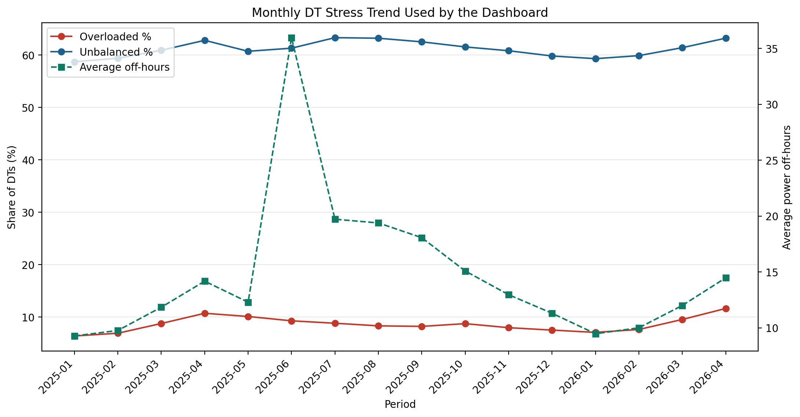
Figure 2. Monthly stress trend visible to the dashboard across the current database.
Representative commands executed during the proof-of-concept:
python import_monthly_data.py "DT Health Report May-2025.xlsx" "DT Health Report June-2025.xlsx"
python generate_synthetic_history.py
python -m streamlit run app.py

10. Website or Prototype Link
Type: local Streamlit dashboard plus local code repository. Login requirement: none for local use. Evaluator should inspect the dashboard filters, hierarchy summaries, detail grids, SQLite importer, and the risk score column for the same month in the following year.
Local project folder: C:/Users/ACER/Desktop/Hackethon
Dashboard source entry point: app.py
Run notes: README.md
Fallback note: no public hosted URL was created within the one-day hackathon window. The report remains understandable without opening the local demo because the technical workflow, summary tables, and validation details are embedded directly here.

11. Validation, Risks, and Limitations
- Validation plan: evaluate only on later target periods rather than random rows to preserve time order.
- Primary decision metric: recall-oriented ranking quality for operational prioritization, with temporal holdout ROC-AUC used as supporting evidence rather than as a business metric by itself.
- Leakage control: lagged and rolling features are computed from earlier months only; the next-year proxy label is joined after feature preparation.
- Source risk: June 2025 contains extreme loading outliers; these were preserved in the real database for honesty but were clipped when generating synthetic months so anomalies would not cascade.
- Label limitation: the model predicts a high-stress failure proxy, not an audited true transformer failure event.
- Synthetic-data limitation: monthly backfill improves demonstration coverage but cannot substitute for actual year-over-year failure history.
- Confounding risk: planned maintenance, feeder shutdown schedules, seasonal demand, meter malfunction, or reporting gaps may affect off-hours and loading without reflecting imminent failure.

12. Implementation Plan
The smallest deployable version already exists: monthly Excel upload, overwrite-safe storage, hierarchy dashboard, and predictive scoring. The next technical steps to turn it into a stronger operational system are:
- Integrate actual transformer failure labels and work-order history so the target becomes real failure probability rather than a stress proxy.
- Add authenticated file upload inside the dashboard so business users do not need to run the offline script manually.
- Implement outlier rules and data-quality alerts for impossible loads, duplicate entities, and suspicious off-hour spikes before scoring.

