AirLock — Architecture Diagrams

Diagram 1 — System Architecture
All three workstreams, the MQTT broker, and how they connect.
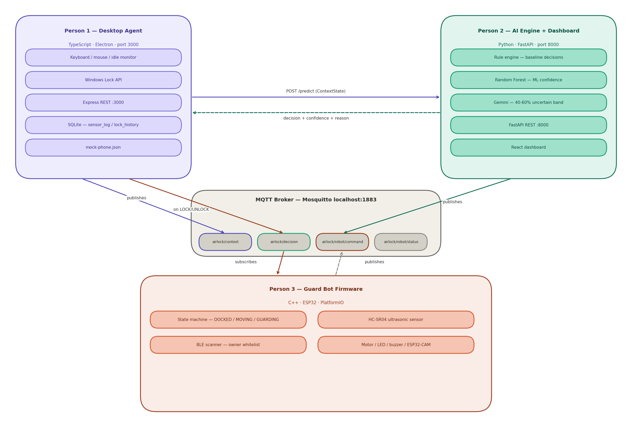

Diagram 2 — Runtime Message Flow
The sequence of messages at runtime — every-second loop, lock event, and robot response.
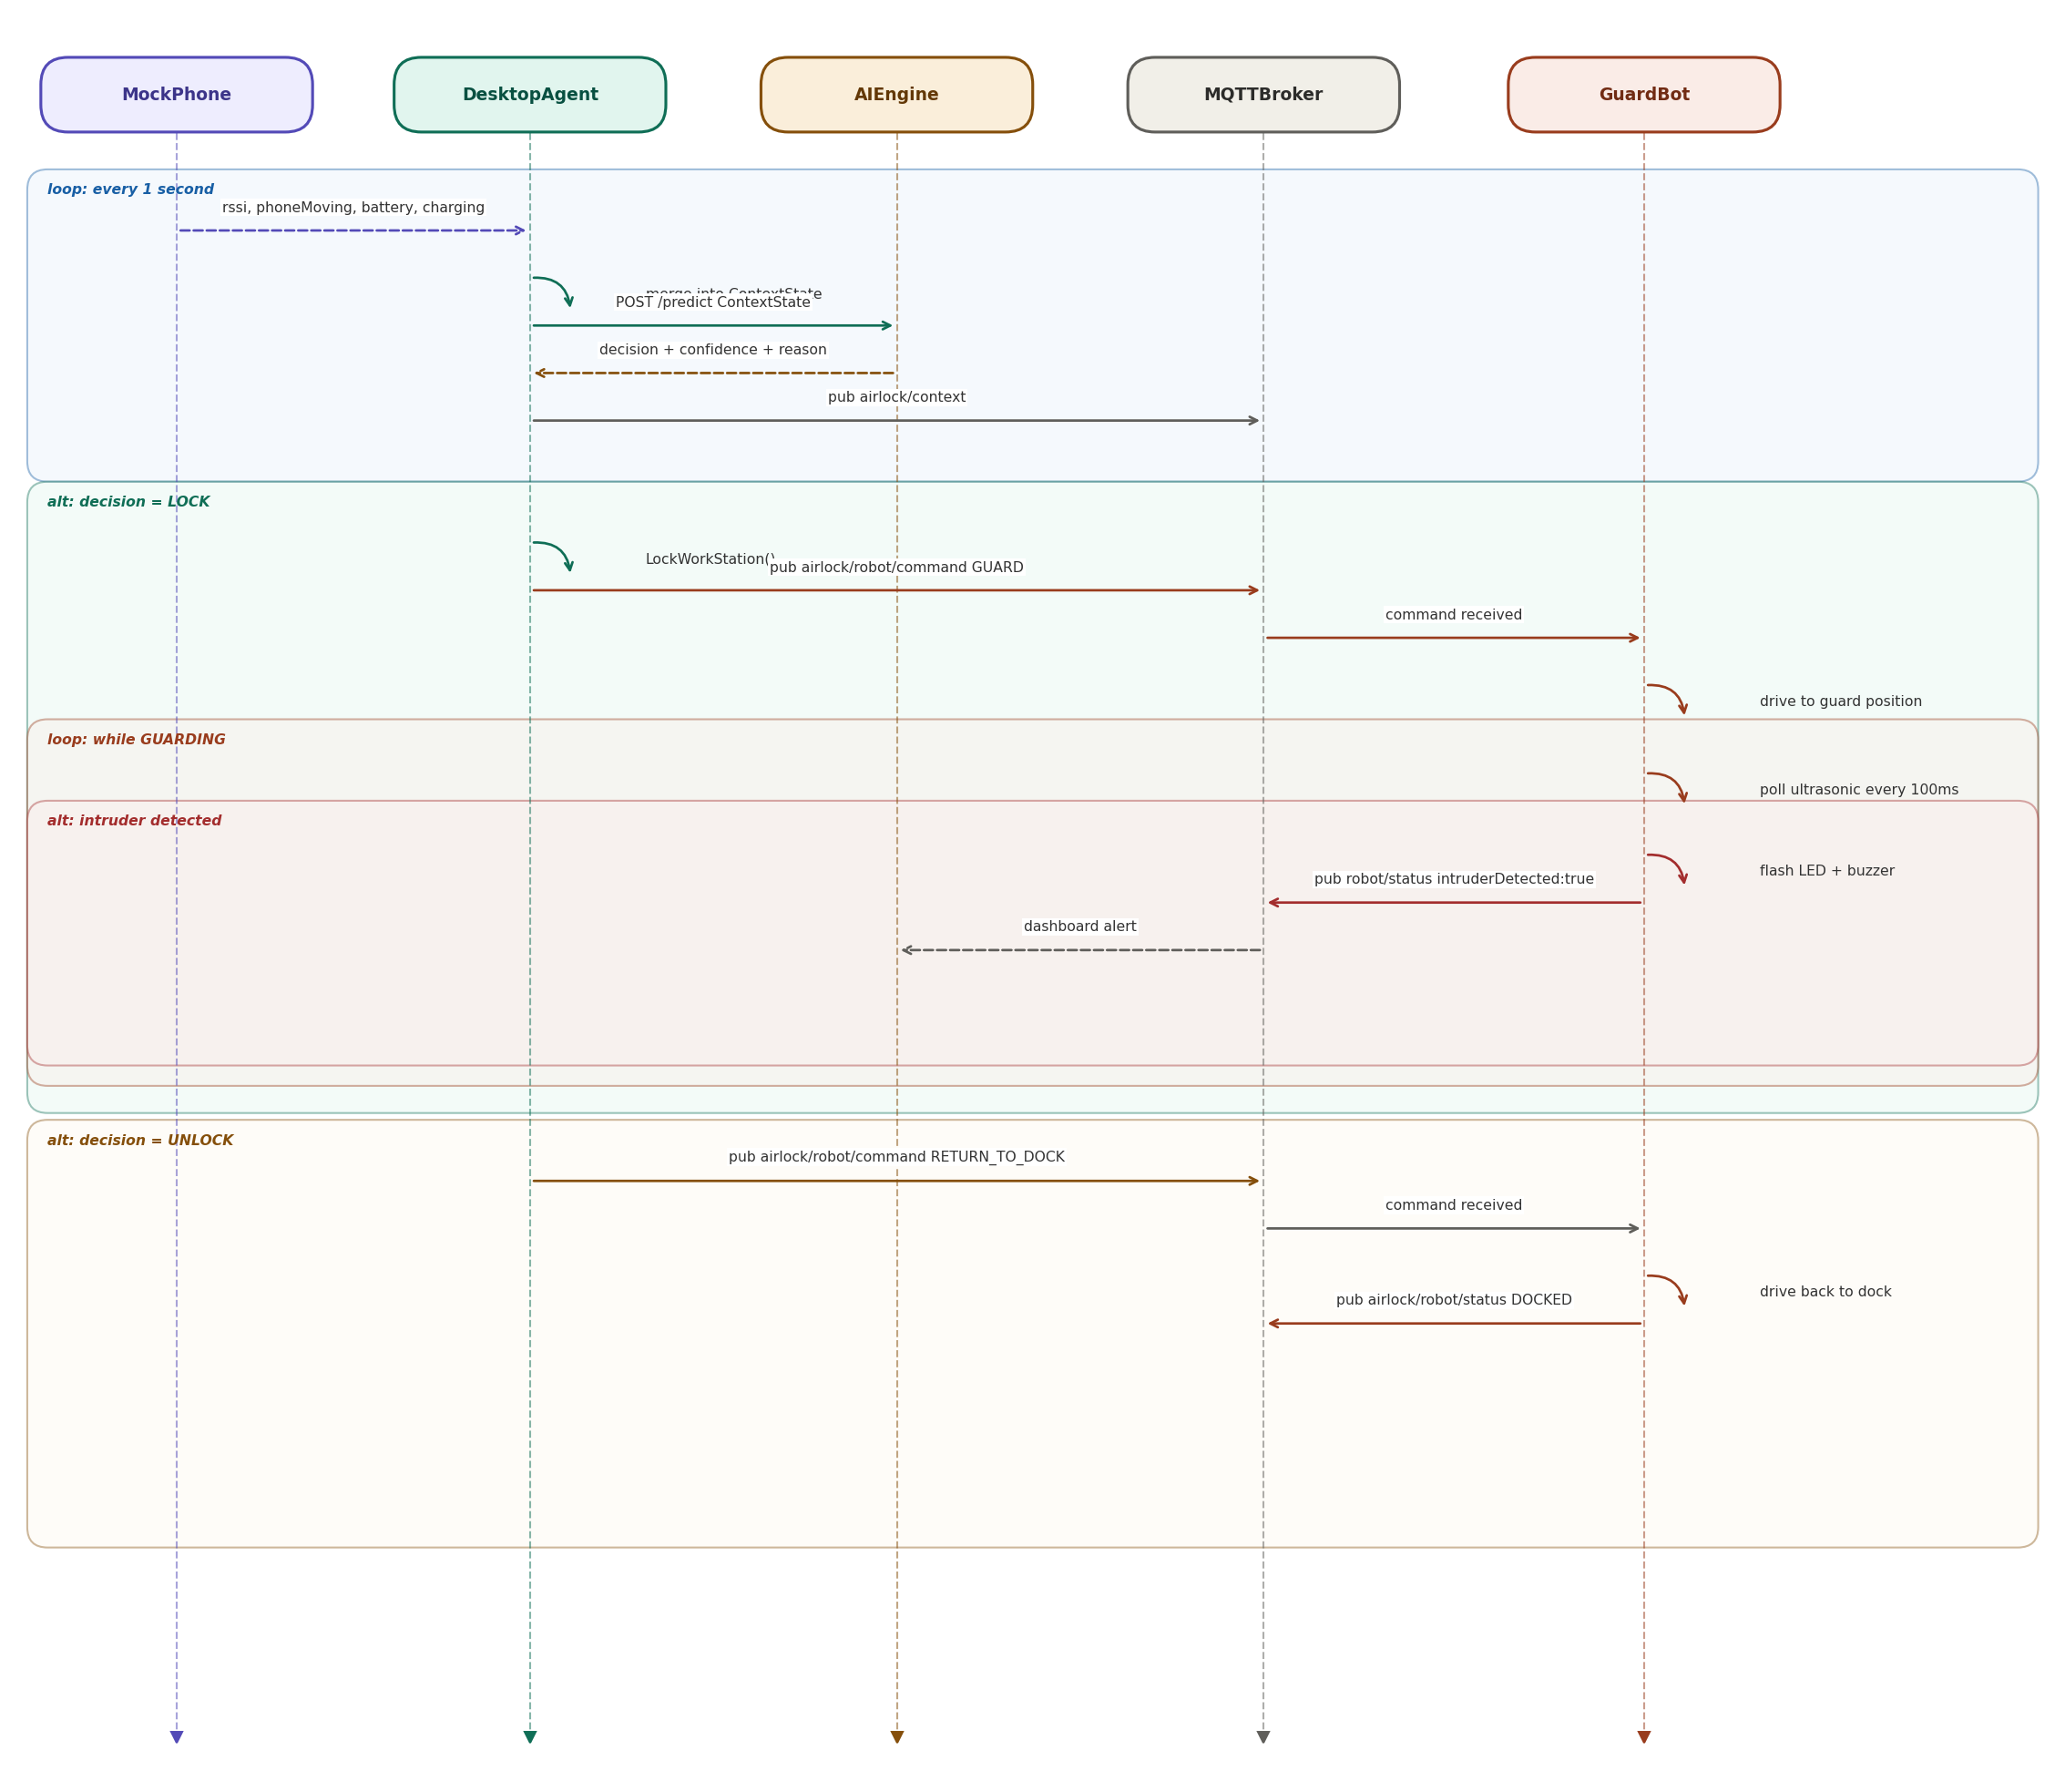

Diagram 3 — AI Decision Pipeline
How a ContextState is processed inside the AI engine on every /predict call.
