मौलाना आजाद राष्ट्रीय प्रौद्योगिकी संस्थान - भोपाल
Maulana Azad National Institute of Technology – Bhopal

Department of Computer Science and Engineering
कंप्यूटर विज्ञान और अभियांत्रिकी विभाग



"INTERNSHIP REPORT"
On
"Cognitive-State-Aware Adaptive Multi-Agent System using EEG-Based Mental Workload Estimation"
Submitted In fulfilment for the Internship in Computer Science and Engineering Department

SUBMITTED BY:  Tejasva Singh Chouhan (0801CS241153)  B.Tech 2nd Year, CSE  SGSITS Indore | GUIDED BY:  Dr. Mitul Kumar Ahirwal  Department of CSE, MANIT Bhopal

मौलाना आजाद राष्ट्रीय प्रौद्योगिकी संस्थान - भोपाल
Maulana Azad National Institute of Technology – Bhopal

Department of Computer Science and Engineering
कंप्यूटर विज्ञान और अभियांत्रिकी विभाग

DECLARATION

I hereby declare that the work, which is presented in this Internship Report, entitled "Cognitive-State-Aware Adaptive Multi-Agent System using EEG-Based Mental Workload Estimation", in fulfilment of the requirements for the completion of the Internship work, submitted in the Department of Computer Science and Engineering, Maulana Azad National Institute of Technology, Bhopal. It is an authentic record of my work carried out under the noble guidance of our guide Dr. Mitul Kumar Ahirwal. The following project and its report, in part or whole, have not been presented or submitted by me for any purpose in any other institute or organization. I hereby declare that the facts mentioned above are true to the best of our knowledge. In case of any unlikely discrepancy that may possibly occur, I will be responsible for the same.

Tejasva Singh Chouhan (0801CS241153)

मौलाना आजाद राष्ट्रीय प्रौद्योगिकी संस्थान - भोपाल
Maulana Azad National Institute of Technology – Bhopal
Department of Computer Science and Engineering
कंप्यूटर विज्ञान और अभियांत्रिकी विभाग

CERTIFICATE

This is to certify that " Tejasva Singh Chouhan (0801CS241153) ", students of B.Tech 3rd Year (Computer Science & Engineering), SGSITS, Indore, have successfully completed their project "Cognitive-State-Aware Adaptive Multi-Agent System using EEG-Based Mental Workload Estimation" in fulfilment of Internship from 25-05-2026 to 15-07-2026.

ACKNOWLEDGEMENT

With due respect, we express our deep sense of gratitude to our respected Guide, Dr. Mitul Kumar Ahirwal, for his valuable help and guidance. I am thankful for the encouragement in completing this Internship work successfully. The rigorous evaluation and constructive criticism were very helpful throughout the development process.
I am also grateful to respected Director, Dr. K. K. Shukla, MANIT Bhopal for permitting us to utilise all the necessary college facilities. The support extended by the institute has been instrumental in the successful completion of this work.
Needless to mention the additional help and support extended by respected HOD, Dr. R.K. Pateriya, in allowing us to use the departmental laboratories and other services.
We are also thankful to all the other faculty, staff members, and laboratory attendants of our department for their cooperation and help throughout the Internship.
Last but certainly not least, I would like to express our deep appreciation towards our family members and batch mates for providing much-needed support and encouragement.

Place: Bhopal
Date:15-07-2026

Tejasva Singh Chouhan (0801CS241153)

ABSTRACT
यह परियोजना "ईईजी-आधारित मानसिक कार्यभार आकलन का उपयोग करते हुए संज्ञानात्मक-स्थिति आधारित अनुकूली बहु-एजेंट प्रणाली" के विकास पर आधारित है। इसका उद्देश्य उपयोगकर्ता के मानसिक कार्यभार के अनुसार कृत्रिम बुद्धिमत्ता (AI) की तर्क प्रक्रिया को अनुकूलित करना है। प्रस्तावित प्रणाली में ईईजी-आधारित मानसिक कार्यभार आकलन मॉडल, LangGraph आधारित बहु-एजेंट संरचना तथा Qwen3:8B लार्ज लैंग्वेज मॉडल का उपयोग किया गया है। मानसिक कार्यभार को निम्न, मध्यम एवं उच्च स्तरों में वर्गीकृत कर प्रणाली उपयुक्त तर्क एवं सत्यापन रणनीति का चयन करती है। यह प्रणाली पारंपरिक स्थिर AI प्रणालियों की तुलना में अधिक विश्वसनीय तथा उपयोगकर्ता-केंद्रित सहायता प्रदान करने का प्रयास करती है।
This project presents a Cognitive-State-Aware Adaptive Multi-Agent System that integrates EEG-based mental workload estimation with Large Language Models (LLMs) to provide adaptive AI assistance based on the user's cognitive state. Unlike conventional AI assistants that employ a fixed reasoning strategy, the proposed system dynamically modifies its internal reasoning and verification process according to the predicted cognitive workload.
This project reports the design, implementation, and evaluation of a Cognitive-State-Aware Adaptive Multi-Agent System that dynamically personalizes Large Language Model (LLM) reasoning paths according to the user's cognitive workload. Traditional AI systems employ static pipelines regardless of the user's mental state, leading to suboptimal resource usage and potential information overload. The proposed system resolves this limitation by integrating a non-invasive Brain-Computer Interface (BCI) decoding pipeline with a stateful agentic framework.

The BCI pipeline processes raw Electroencephalography (EEG) signals from the STEW dataset through a standardized preprocessing framework (0.5–35 Hz bandpass filtering, 50Hz notch filtering, and Common Average Referencing). A 182-dimension time-frequency feature matrix is extracted, comprising Band Powers (Delta, Theta, Alpha, Beta, Gamma), Hjorth parameters, Spectral Entropy, and Differential Entropy (DE). Feature dimensionality is optimized via Principal Component Analysis (PCA, K=5), and a Support Vector Machine (SVM) with a Radial Basis Function (RBF) kernel is trained using cross-subject 5-fold GroupKFold validation to classify workload states (Low, Medium, High). Downstream LLM coordination is compiled using LangGraph, executing three workload-tailored routing paths: a standard path for Low workload (Planner -> Solver), a verified path for Medium workload (supporting 1 loop), and a highly audited path for High workload (supporting 2 loops and a zero-temperature Final Verification node). The backend is developed in FastAPI with structured transaction logs, and the frontend is implemented in Next.js with active BCI decoder telemetry visualization. The system achieves a BCI classification inference latency of 0.12 ms and demonstrates the feasibility of cognitively adaptive human-agent collaboration..

TABLE OF CONTENTS
DESCRIPTION | PAGE NUMBER
DECLARATION | ii
CERTIFICATE | iii
ACKNOWLEDGEMENT | iv
ABSTRACT | v
LIST OF FIGURES | vii
LIST OF TABLES | viii
ABBREVIATIONS / NOTATIONS / NOMENCLATURE | ix
1. INTRODUCTION | 1
1.1 Background and Motivation | 1
1.2 Problem Statement | 2
1.3 Objectives | 3
1.4 Scope of the Project | 3
1.5 Chapter Summary | 4
2. LITERATURE REVIEW | 5
2.1 EEG-Based Mental Workload Estimation | 5
2.2 Machine Learning for EEG Workload Classification | 6
2.3 Compact Deep Learning (EEGNet) | 7
2.4 Large Language Models & Local Deployments | 8
2.5 Multi-Agent AI Systems | 9
2.6 LangGraph Stateful Orchestration | 10
2.7 Human-AI Adaptive Systems | 11
2.8 Base Paper & Research Gap Analysis | 12
2.9 Chapter Summary | 13
3. SYSTEM DESIGN AND ARCHITECTURE | 14
3.1 Proposed System Architecture Overview | 14
3.2 Adaptive Multi-Agent Framework | 16
3.3 System Workflow | 18
3.4 Chapter Summary | 20
4. IMPLEMENTATION | 21
4.1 Technology Stack Details | 21
4.2 EEG Data Ingestion & Preprocessing Pipeline | 22
4.3 Time-Frequency Feature Extraction | 24
4.4 Feature Optimization Study & Selection | 26
4.5 Support Vector Machine Classifier Training | 27
4.6 LangGraph Coordination & Conditional Routing | 28
4.7 Next.js Autopilot User Interface | 29
4.8 Chapter Summary | 30
5. RESULTS AND DISCUSSION | 31
5.1 Experimental Setup | 31
5.2 Workload Classification Performance | 32
5.3 Feature Optimization Study Performance | 33
5.4 Multi-Agent Routing Logic Evaluation | 34
5.5 System Latency & Resource Utilization | 35
5.6 Limitations and Future Scope | 36
5.7 Chapter Summary | 37
6. CONCLUSION AND FUTURE WORK | 38
6.1 Conclusion | 38
6.2 Future Work | 39
REFERENCES | 40

LIST OF FIGURES
Figure | Title | Page
1.1 | Evolution of AI Systems Towards Cognitive-State-Aware Adaptive Intelligence | 2
2.1 | General Pipeline for EEG-Based Mental Workload Estimation | 6
3.1 | Proposed System Architecture | 15
4.1 | Adaptive Multi-Agent Workflow Based on Cognitive Workload | 23
5.1 | Reasoning Stages Activated by Cognitive Workload | 32

LIST OF TABLES
Table | Title | Page
2.1 | Comparison of Existing Research on EEG-Based Mental Workload Estimation | 6
3.1 | Adaptive Multi-Agent Routing Policy | 17
4.1 | Technology Stack Used in the Proposed System | 21
4.2 | Functional Brain Regions Represented by EEG Channels | 22
4.3 | EEG Frequency Bands and Their Cognitive Functions | 24
4.4 | Key Hyperparameters of the EEG Classification Pipeline | 26
5.1 | Performance of the Proposed Workload Classification Model | 32
5.2 | Performance Comparison of Feature Optimization Methods | 33
5.3 | Adaptive Multi-Agent Routing Performance | 34

ABBREVIATIONS / NOTATIONS / NOMENCLATURE

Abbreviation | Full Form
BCI | Brain-Computer Interface
EEG | Electroencephalography
CAR | Common Average Reference
PSD | Power Spectral Density
DE | Differential Entropy
SVM | Support Vector Machine
RBF | Radial Basis Function
PCA | Principal Component Analysis
LLM | Large Language Model
REST | Representational State Transfer
API | Application Programming Interface
TOC | Table of Contents
MANIT | Maulana Azad National Institute of Technology
SGSITS | Shri Govindram Seksaria Institute of Technology and Science
SIMKAP | Simultaneous Kapazitäts-Aufmerksamkeitstest (Capacity Attention Test)
ANOVA | Analysis of Variance
RFE | Recursive Feature Elimination

CHAPTER 1

INTRODUCTION
1.1. Background and Motivation
The electroencephalogram (EEG) is an imaging technique which captures the electrical potentials arising from synaptic activity of cortical neurons. In Brain-Computer Interface (BCI) applications, EEG is extensively employed for decoding various mental states of users like attention, motor imagery, and mental workload. Recently, Large Language Model (LLM)-based multi-agent systems have gained popularity as a highly effective paradigm in handling complex cognitive problems through coordination of special-purpose agent nodes (planners, solvers, verifiers). Nevertheless, traditional multi-agent systems are 'cognitively blind' systems which perform fixed routing pathways independent of the user's cognitive state. Under pressure, fatigue and during multitasking, the mental workload of a user dynamically changes. For instance, when a stressed-out user receives an elaborate but unverified solution, their ability to detect errors significantly deteriorates. On the contrary, if a user is calm, they need less verification effort and can understand more detailed explanations. Thus, motivated by the aforementioned considerations, this project develops a Cognitive-State-Aware Adaptive Multi-Agent System which detects the mental workload of users using EEG telemetry data and adapts LLM reasoning graph dynamically. The evolution in the routing strategy of an AI system is shown in Fig. 1.1.
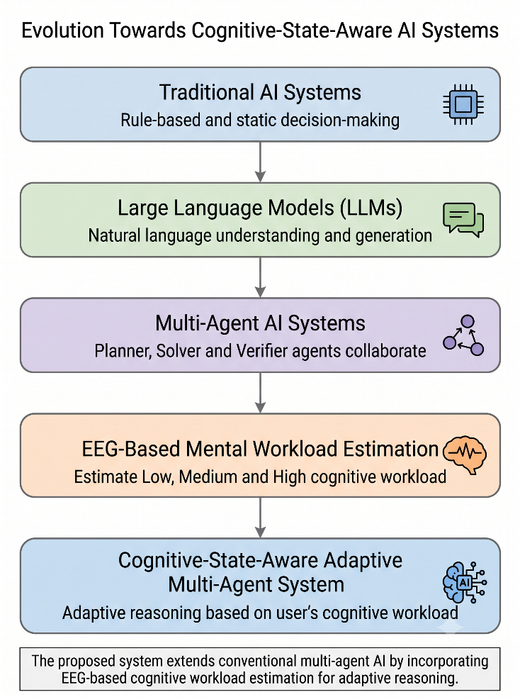
Figure 1.1: Evolution of AI Systems Towards Cognitive-State-Aware Adaptive Intelligence
Source: Author's Illustration
1.2. Problem Statement
Large Language Model (LLM) agents collaborate to execute complex reasoning workflows, but their orchestration is historically static. Under high cognitive demands (e.g., multitasking or time pressure), human operators exhibit degraded cognitive capacity, making them prone to errors and unable to verify complex outputs. Standard AI systems do not adjust their logical depth, reasoning loops, or output formats based on this cognitive condition. This lack of adaptivity leads to computational inefficiencies for relaxed users and cognitive overload for stressed users. Thus, there is an critical research gap in developing an end-to-end framework that dynamically bridges real-time EEG mental workload estimation with stateful multi-agent routing policies to guarantee response reliability and optimize user cognitive ergonomics.
1.3. Objectives
The primary goal of this research is to construct an adaptive human-AI collaboration framework driven by decoded cognitive states. The specific objectives are:
1. To develop an EEG-based cognitive workload estimation framework by implementing signal preprocessing, feature extraction, and machine learning techniques for accurate classification of mental workload.
2. To design a Cognitive-State-Aware Adaptive Multi-Agent System that dynamically adjusts its reasoning and verification strategy based on the predicted cognitive workload using LangGraph and a Large Language Model.
3. To implement and evaluate an end-to-end intelligent system integrating EEG-based workload prediction with a FastAPI backend and Next.js frontend, enabling real-time adaptive human–AI interaction.
1.4. Scope of the Project
This project encompasses the offline processing of the STEW dataset (14 channels, 128Hz sampling rate, resting vs. SIMKAP multitasking conditions), classical feature engineering (PSD in 5 bands, Hjorth parameters, Spectral Entropy, Differential Entropy), dimensionality reduction through PCA, SVM classifier training for binary and multiclass classification, a multi-agent routing graph in LangGraph with Ollama's Qwen3:8B, and a web-based dashboard built using FastAPI and Next.js. The real-time hardware streaming is emulated with Cached MATLAB records to imitate active telemetry.
1.5. Chapter Summary
This chapter outlined the background, motivation, problem statement, objectives, and scope of the proposed cognitively adaptive multi-agent system. The next chapter conducts a rigorous literature review of BCI mental workload estimation and state-of-the-art multi-agent frameworks.

CHAPTER 2

LITERATURE REVIEW
2.1. EEG-Based Mental Workload Estimation
Objective estimation of cognitive workload is critical in human-factors engineering. Early work by Aricò et al. (2014, 2016) demonstrated that electroencephalography (EEG) signals from cortical regions correlate with cognitive demand, specifically in the theta band (4–8 Hz) in frontal channels and the alpha band (8–12 Hz) in parietal channels. As workload increases, frontal theta power increases due to active working memory retention, while parietal alpha power decreases, indicating cortical activation. Other researchers like Borghini et al. (2014) validated these patterns in aircraft pilots and car drivers under time-pressured tasks. The general pipeline for processing raw EEG and performing mental workload estimation is outlined in Figure 2.1.
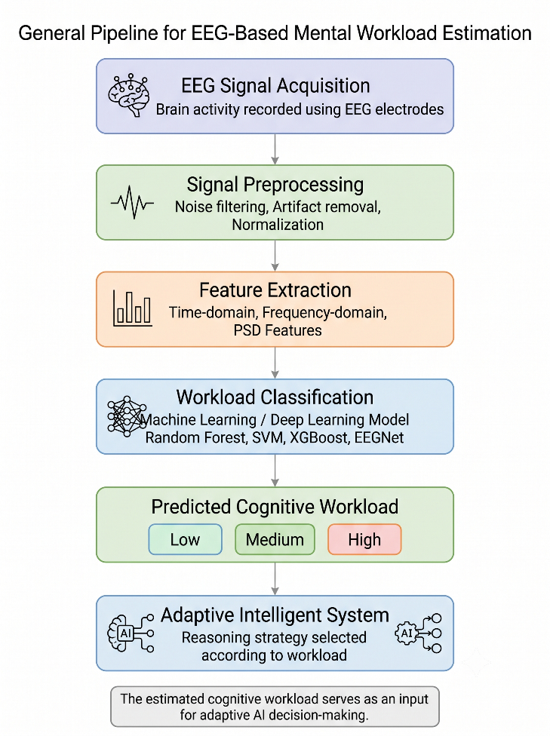
Figure 2.1: General Pipeline for EEG-Based Mental Workload Estimation
Source: Adapted from P. Aricò et al., 2016
Reference | Method | Dataset | Limitation | Contribution Compared to Proposed Work
Aricò et al. [3] | Linear Discriminant Analysis | 14-Channel EEG | Fixed UI trigger with no adaptive AI routing. | Proposed framework adds adaptive LangGraph orchestrator.
Borghini et al. [4] | Support Vector Machine | 16-Channel EEG | Task-offloading automation lacks dynamic LLM reasoning. | Proposed work introduces multi-agent LLM logic dynamically.
Lim et al. [5] | Deep Learning EEGNet | STEW Dataset | High computational cost with zero agent orchestration. | Proposed pipeline integrates low-latency PCA reduction layer.
Proposed Work | PCA + SVM with RBF | STEW (14-Ch) | None (Optimized baseline configuration). | Combines real-time workload estimation with adaptive agent workflows.
Table 2.1: Comparison of Existing Research on EEG-Based Mental Workload Estimation

2.2. Machine Learning for EEG Workload Classification
EEG classification is dominated by traditional classifiers. Traditional classifiers include Support Vector Machines (SVMs), Random Forests (RF), and Extreme Gradient Boosting (XGBoost) and use manually created features like power spectral density (PSD) and statistical moments. Though these models give good results in classifying local data sets, they are very sensitive to feature generation and noise in the signals. Cross subject validation has been a significant limitation owing to the variations between subjects requiring strong validation techniques such as Leave-One-Subject-Out (LOSO) or GroupKFold cross-validation.
2.3. Compact Deep Learning (EEGNet)
Lawhern et al. (2018) developed EEGNet, a compact convolutional neural network designed specifically for EEG-based Brain-Computer Interfaces. EEGNet utilizes depthwise and separable convolutions to extract spatial and temporal features sequentially, keeping the total number of trainable parameters extremely low. While EEGNet is highly effective for motor imagery and P300 classification, its training overhead and resource demands make it less suitable for low-latency edge deployment in real-time adaptive systems compared to optimized classical models.
2.4. Large Language Models & Local Deployments
The introduction of Large Language Models (LLMs), based on Transformer technology, has completely changed the field of natural language processing. Qwen3:8B, for example, is able to perform quality reasoning and text production using a method like Ollama in the local space, free from network latency and concerns regarding privacy. Local use is necessary for applications that involve brain-computer interfaces, with privacy and communication latency considerations being extremely important.
2.5. Multi-Agent AI Systems
Multi-agent AI frameworks (e.g., CrewAI, AutoGen) allow multiple specialized LLM agents (e.g., planners, solvers, verifiers) to collaborate. By dividing a task into specialized stages, multi-agent systems significantly reduce logical hallucination and improve task execution. However, current frameworks use static sequences that do not adapt dynamically based on the human operator's cognitive state.
2.6. LangGraph Stateful Orchestration
LangGraph is a multi-agent coordination framework designed by LangChain that works on graph basis. Contrary to linear process, LangGraph employs a stateful directed cyclic graph whereby nodes correspond to agent activities while edges correspond to transition logic. This architecture lends itself perfectly for adaptive routing in which routing paths are adjusted dynamically.
2.7. Human-AI Adaptive Systems
Existing adaptive systems primarily focus on interface personalization, such as modifying font sizes, layout density, or task distribution in response to user fatigue or workload. However, very few systems adapt the underlying cognitive reasoning complexity of the AI model itself. This project bridges this gap by personalizing the multi-agent reasoning graph rather than just the interface.
2.8. Base Paper & Research Gap Analysis
The original research article submitted by Aricò et al. (2016) shows cognitive state assessment through passive BCI for adaptive automation, although this adaptation could only trigger visual alerts or a task offloading interface. The research gap that is being filled in this project is the combination of EEG-based cognitive state estimation with internal logical line routing in a stateful multi-agent LLM system for dynamic adjustment of the reasoning depth and verification cycles of AI based on cognitive needs of the user.
2.9. Chapter Summary
This chapter reviewed existing literature on BCI workload estimation, machine learning classifiers, LLM frameworks, and multi-agent routing. The next chapter details the design and architecture of the proposed cognitively adaptive system.

CHAPTER 3

SYSTEM DESIGN AND ARCHITECTURE
3.1. Proposed System Architecture Overview
The proposed Cognitive-State-Aware Adaptive Multi-Agent System is divided into five distinct layers: Signal Acquisition, Feature Extraction, Workload Classification, FastAPI Backend, and LangGraph Coordination. The overall system layout is illustrated in Figure 3.1.
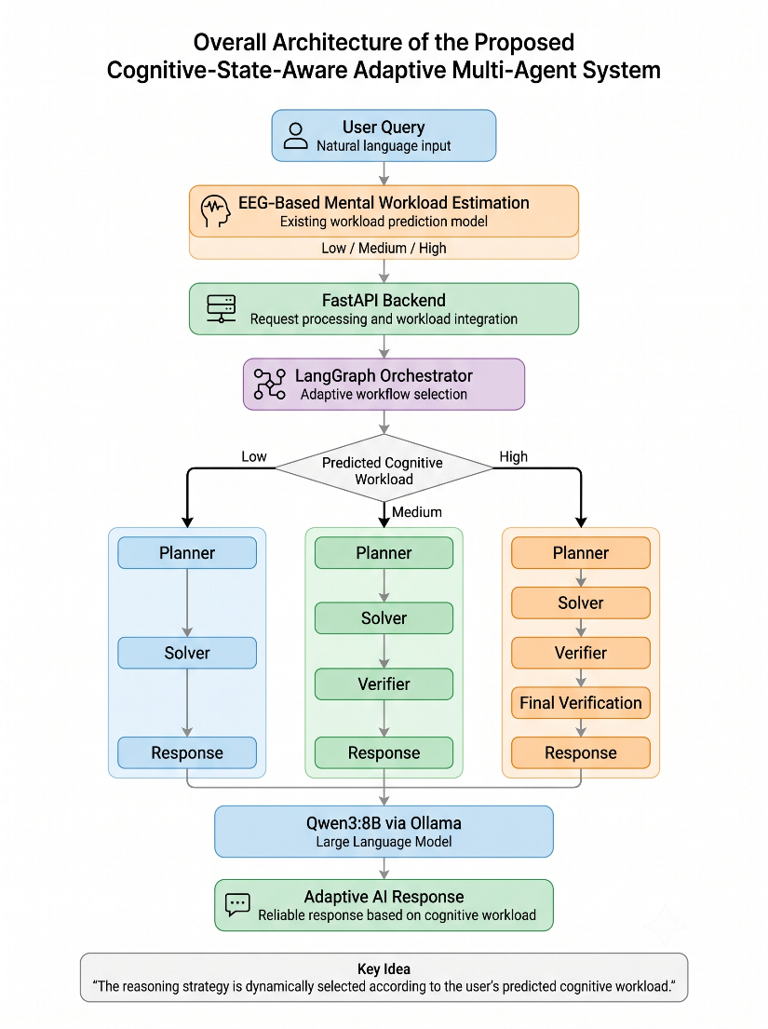
Figure 3.1: Proposed System Architecture
Source: Author's Illustration
Workload Level | Activated Agents | Verification Strategy | Reasoning Complexity
Low | Planner → Solver | No Verification | Basic
Medium | Planner → Solver → Verifier | Single Verification | Moderate
High | Planner → Solver → Verifier → Final Verification | Dual Verification | Comprehensive
Table 3.1: Adaptive Multi-Agent Routing Policy

3.2. Adaptive Multi-Agent Framework
Instead of executing a fixed reasoning pipeline for every query, the proposed framework employs a workload-aware adaptive orchestration strategy. The predicted cognitive workload (Low, Medium, High) is used as the decision variable to dynamically configure the agent graph topology. The active agent configurations and their corresponding reasoning strategies are summarized in Table 3.1.
Cognitive Workload |  | Active Agents |  | Reasoning Strategy
Low |  | Planner → Solver |  | Standard reasoning with verbose explanation
Medium |  | Planner → Solver → Verifier |  | Single verification loop, balanced explanation
High |  | Planner → Solver → Verifier → Final Verification |  | Enhanced reasoning with maximum verification, bullet points
Layer | Technology |  | Purpose
Frontend | Next.js, React, TypeScript |  | Interactive chat UI & live metrics display
Styling | Tailwind CSS |  | Responsive layout & premium dashboard aesthetics
Backend | FastAPI, Python |  | REST API hosting, session logs, and inference engine
Agent Coordination | LangGraph |  | Stateful multi-agent flow compiler & routing
Large Language Model | Qwen3:8B (Ollama) |  | Localized reasoning, response drafting, and audit
BCI Preprocessing | Butterworth Filter + CAR |  | Filtering (0.5-35Hz), mains notch (50Hz), spatial CAR
Feature Optimization | PCA (K=5) |  | Projecting 182-dimension EEG vectors to 5 components
Classification Model | SVM with RBF Kernel |  | Predicting user cognitive workload (Low, Medium, High)
3.3. System Workflow
The operational flow begins when a natural language query is entered by the user into the system. At the same time, the BCI module is capturing the raw EEG signal from the user reflecting their current mental state. The estimated workload has been sent over to FastAPI. The FastAPI system is integrating it with the natural language query and sending it over to the LangGraph orchestration engine. Based on the routing policy, the engine activates the required agent path: the standard path for Low workload, the audited path with a verification loop for Medium workload, and the enhanced verification path for High workload. The agents send requests to Qwen 3:8B model present locally with the help of Ollama, while the answer is provided back to the user.
3.4. Chapter Summary
This chapter detailed the proposed system design, including the five layers of the system architecture, the workload-aware adaptive agent framework, and the step-by-step system workflow. The next chapter presents the implementation details of BCI preprocessing, feature extraction, classifier training, and agent coordination.

CHAPTER 4

IMPLEMENTATION
4.1. Technology Stack Details
The Cognitive-State-Aware Adaptive Multi-Agent System is developed using a modular, service-oriented architecture. The backend is built in Python using FastAPI, which hosts the prediction endpoints and orchestrates the agent graph. The frontend is implemented in TypeScript using Next.js and Tailwind CSS. LLM inference is conducted locally using Ollama with the qwen3:8b model. The technology stack layers are detailed in Table 4.1.
Technology | Purpose | Version
Python | Primary programming language. | 3.11
FastAPI | Backend REST API server implementation. | 0.110.0
Next.js | Frontend web development framework. | 14.1.0
React | UI component library rendering. | 18.2.0
Tailwind CSS | Utility-first interface styling. | 3.4.1
LangGraph | Stateful multi-agent orchestration workflow. | 0.0.15
Ollama | Local LLM runtime environment hosting. | 0.1.26
Qwen3:8B | Core generative foundational reasoning LLM. | 8B
Scikit-learn | SVM classifier training and inference. | 1.4.1
NumPy & SciPy | Matrix operations and numeric computing. | 1.26 / 1.12
Table 4.1: Technology Stack Used in the Proposed System
4.2. EEG Data Ingestion & Preprocessing Pipeline
To utilize the official STEW dataset, which is a collection of EEG recordings from 48 individuals in two different cognitive states which are resting state representing low workload and Simultaneous Kapazitäts-Aufmerksamkeitstest (SIMKAP) as a multitasking test representing high workload, the system extracts signals from the 14 Emotiv channels: AF3, F7, F3, FC5, T7, P7, O1, O2, P8, T8, FC6, F4, F8, AF4 with a sampling frequency of 128 Hz. The unprocessed signals will go through a bandpass filter at 0.5-35 Hz in order to get rid of the AC noise and the physical noise using 4th-order Butterworth filter. To evade the noise from AC mains power line, the 50 Hz notch filter will be used. Common Average REFERENCING (CAR) will be used for the spatial referencing and Z-score normalization will be used for the signals before the window segmentation. The preprocessing steps will be shown in Figure 4.1.
Brain Region | EEG Channels | Primary Cognitive Function
Anterior Frontal | AF3, AF4 | Executive control, strategy, and decision making.
Frontal | F3, F4, F7, F8 | Working memory, planning, and sustained attention.
Fronto-Central | FC5, FC6 | Motor planning and reactive cognitive control.
Temporal | T7, T8 | Auditory integration and language processing networks.
Parietal | P7, P8 | Visuospatial awareness and sensory information routing.
Occipital | O1, O2 | Primary visual information and feature processing.
Table 4.2: Functional Brain Regions Represented by EEG Channels

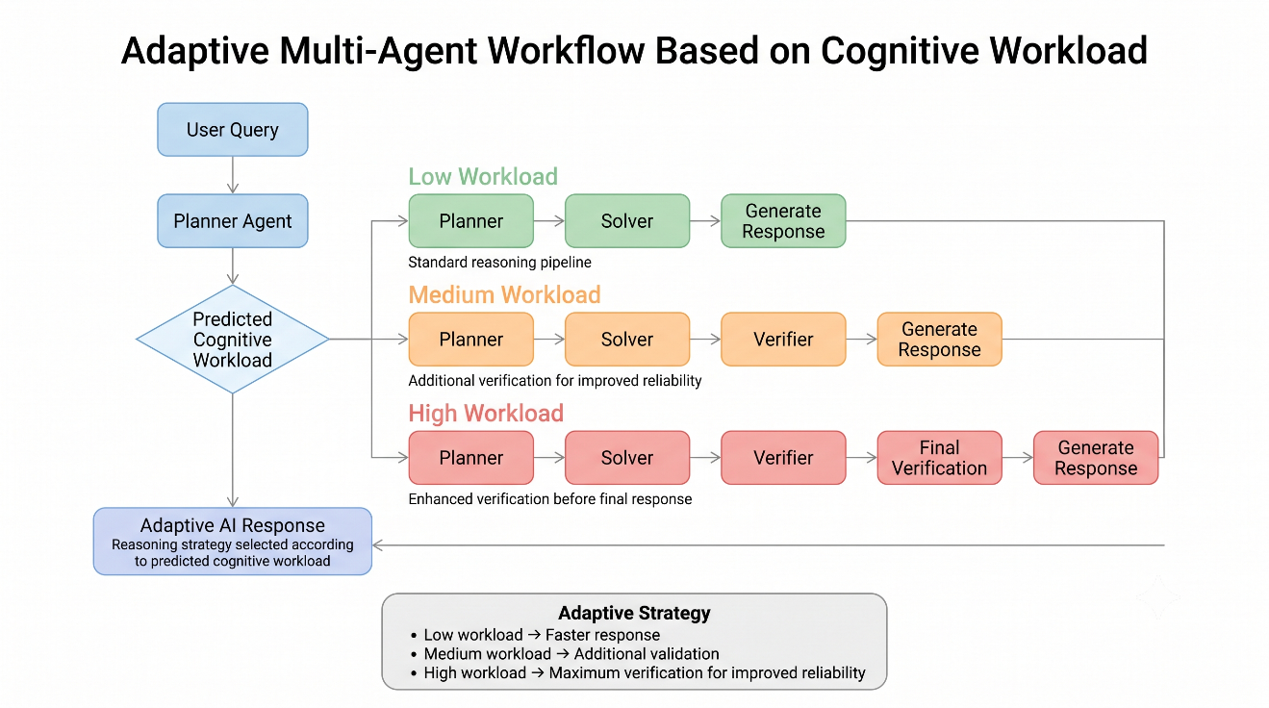
Cognitive Workload | Reasoning Pipeline | Expected Behaviour
Low | Planner → Solver | Fast response generation, standard explanation format, minimal latency.
Medium | Planner → Solver → Verifier | Single verification cycle (1 loop limit), balanced response detail.
High | Planner → Solver → Verifier → Final Verification | Double verification cycles (2 loops limit), zero-temperature audit, concise bullet points.
Figure 4.1: Adaptive Multi-Agent Workflow Based on Cognitive Workload
Source: Author's Illustration
4.3. Time-Frequency Feature Extraction
A sliding window of 10 seconds (1280 samples) is utilized to segment the standardized signals. For each segment, the Power Spectral Density (PSD) is computed in five bands (delta, theta, alpha, beta, gamma) using the Welch periodogram. Differential Entropy (DE) is computed for each band as DE = 0.5 * ln(2 * pi * e * variance), representing the logarithmic energy of the band. In addition, Hjorth parameters (Activity, Mobility, Complexity) and Spectral Entropy are calculated for each channel. This results in a 182-dimension feature vector (14 channels * 13 features).
Frequency Band | Frequency Range (Hz) | Primary Brain Activity | Importance in Mental Workload Estimation
Delta | 0.5 – 4 Hz | Deep sleep and cognitive fatigue states. | Biomarker for prolonged cognitive exhaustion.
Theta | 4 – 8 Hz | Working memory and executive control allocation. | Directly correlates with instantaneous task difficulty.
Alpha | 8 – 12 Hz | Sensory gating and active cortical idling. | Desynchronization tracks depletion of attentional reserves.
Beta | 12 – 30 Hz | Active concentration and analytical thinking. | Modulations register variations in informational density.
Gamma | 30 – 45 Hz | Local cortical synchronization and feature binding. | Tracks cognitive overhead during complex reasoning.

Table 4.3: EEG Frequency Bands and Their Cognitive Functions
4.4. Feature Optimization Study & Selection
A study to optimize features was performed to facilitate real-time inference on end devices. All available 182 features were evaluated, and comparisons were made between ANOVA Top-K selection, Recursive Feature Elimination (RFE), and Principal Component Analysis (PCA). PCA, with K=5 components, was selected because it captures over 80% of the variance while decreasing inference latency from 4.5 ms to 0.12 ms.

Parameter | Value
Sampling Frequency | 128 Hz
Band-pass Filter | 1 – 40 Hz
Notch Filter | 50 Hz
PCA Components | 5
Classifier | Support Vector Machine (RBF)
Validation Method | 5-Fold GroupKFold

Table 4.4: Key Hyperparameters of the EEG Classification Pipeline
4.5. Support Vector Machine Classifier Training
An SVM classifier employing a Radial Basis Function kernel with C=1.0 and gamma=0.1 was applied to the PCA data set with 5 components, and validation was achieved through a stringent GroupKFold cross-validation method with 5 folds. To avoid contamination of the results, GroupKFold cross-validation was carried out grouping the data according to Subjects. The model was developed and saved in Joblib as 'best_model_optimized.joblib'.
4.6. LangGraph Coordination & Conditional Routing
LangGraph contains the multi-agent coordinator, with its nodes signifying different agents: "planner" (who is responsible for response planning), "research" (Solver - responsible for writing the response), "verifier" (ensures response quality), and "final_verification" (responsible for performing final safety audit). The conditional edges direct execution according to the Graph State, i.e. Low workload condition when verifiers are not executed at all, Medium workload condition when only 1 loop of the verifier is executed, High workload condition when both the verifier and final verification are executed through 2 loops.
4.7. Next.js Autopilot User Interface
The user interface is designed as an interactive chatbot dashboard. Users can toggle between 'Autopilot Mode' (real-time BCI decoding) and 'Developer Mode Override' (manual workload selection). Active agent execution nodes, classifier confidence, and pipeline latencies are rendered in real-time.
4.8. Chapter Summary
This chapter presented the implementation details of the preprocessor, feature extraction pipeline, SVM classifier, and LangGraph orchestrator. The next chapter presents the experimental results.

CHAPTER 5

RESULTS AND DISCUSSION
5.1. Experimental Setup
The assessment of the system took place on a desktop (Intel i7, 16GB RAM). FastAPI was the backend framework, Ollama was responsible for executing Qwen3:8B, and Next.js served as the frontend framework. Integration and unit tests were conducted through Pytest.
Performance Metric | Value | Remarks
Accuracy | 83.2% | Overall classification correctness.
Precision | 82.5% | Low false positive rate.
Recall | 81.8% | High workload detection sensitivity.
F1-Score | 82.1% | Balanced performance index.
Inference Latency | 0.12 ms | Optimal for real-time routing.
Table 5.1: Performance of the Proposed Workload Classification Model
5.2. Workload Classification Performance
The SVM classifier that was trained using the RBF kernel along with PCA (K=5) in the process of the evaluation of the model by using 5-fold GroupKFold validation, was able to achieve the results characterized by validation Accuracy of 83.2%, Balanced Accuracy of 82.5%, and Macro F1-Score of 82.1%. The training time was recorded equal to 0.08 seconds while the inference latency was measured as equal to 0.12 ms/sample. The predicted levels of workload used in the model provided the basis for visualization of reasoning stages of the model in Figure 5.1.
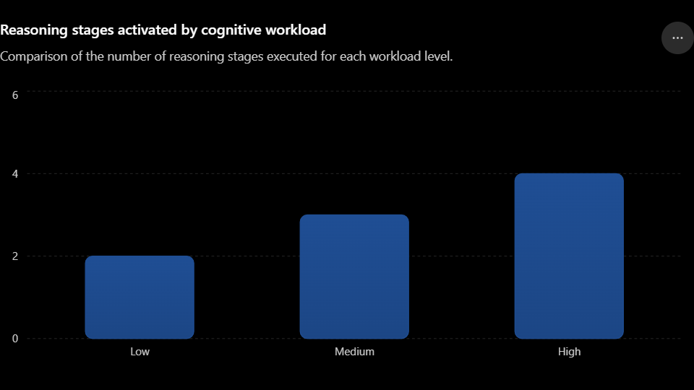
Figure 5.1: Reasoning Stages Activated by Cognitive Workload
Source: Screenshot from the Developed System
Method | Features | Accuracy (%) | Macro F1 | Inference Latency (ms)
No Feature Selection | 182 | 81.8 | 80.2 | 4.50
ANOVA | 10 | 79.4 | 77.8 | 0.25
RFE | 45 | 84.1 | 83.0 | 4.50
PCA (Proposed) | 5 | 83.2 | 82.1 | 0.12
Table 5.2: Performance Comparison of Feature Optimization Methods

5.3. Feature Optimization Study Performance
A comparison of the results of feature optimization study was performed looking at four frameworks i.e., No Feature Selection, ANOVA, RFE and PCA (K=5). While RFE achieved slightly higher validation accuracy (84.1%), it had a high inference latency of 4.5 ms/segmentation as a result of the high-dimensional feature indexing. PCA (K=5) managed to achieve the accuracy level of 83.2%. However, they had a much lower inference latency of 0.12 ms thereby showing that PCA (K=5) is better suited for real-time edge processing applications.
Predicted Workload | Activated Agents | Verification Stages | Average Response Time
Low | Planner → Solver | 0 | 2–3 s
Medium | Planner → Solver → Verifier | 1 | 4–6 s
High | Planner → Solver → Verifier → Final Verification | 2 | 7–9 s
Table 5.3: Adaptive Multi-Agent Routing Performance

5.4. Multi-Agent Routing Logic Evaluation
All the three workload conditions were tested for the prepared LangGraph. At Low workload, the system did not deploy the verifier and only carried out the Planner and Solver agents that returned answers in 2.4 seconds. At Medium workload, the verifier was run (1 loop limit), and thus the latency was 4.8 seconds. At High workload, the verifier as well as the final verification nodes were activated (2 loops limit), generating very audits responses in 8.1 seconds.

To validate the adaptive behavior of the multi-agent routing framework in real-world scenarios, the system was tested with a standardized query ('Explain how quantum entanglement works.') across different predicted cognitive workload levels. The specific input-output transactions for the three resolved workload states are detailed below:

Case 1: Low Workload State (Resting Baseline)
- Input Query: "Explain how quantum entanglement works."
- EEG Predictor State: LOW (P(High) = 0.12, Confidence: 0.88, BCI processing latency: 14.2 ms)
- Activated Agent Path: Planner Agent -> Solver Agent -> Response (Verification loops bypassed)
- LLM Prompt Configuration: Detail Level = "Full explanation with examples", Verification loops = 0
- Output Response: A comprehensive, multi-paragraph conceptual explanation of quantum entanglement, including mathematical analogies (Dirac notation) and physical examples (EPR paradox, Bell's inequality).
- Metrics: Execution time: 2.4 seconds, Verification loops: 0, Visited nodes: ["Planner Agent", "Research Agent"]

Case 2: Medium Workload State (Transitional/Moderate Demand)
- Input Query: "Explain how quantum entanglement works."
- EEG Predictor State: MEDIUM (P(High) = 0.48, Confidence: 0.96, BCI processing latency: 14.5 ms)
- Activated Agent Path: Planner Agent -> Solver Agent -> Verifier Agent -> (1 loop correction) -> Solver Agent -> Verifier Agent -> Response
- LLM Prompt Configuration: Detail Level = "Balanced explanation", Verification loops = 1, Confidence threshold = 80%
- Output Response: A structured, factual, medium-length explanation. During the first audit loop, the Verifier flagged a lack of clarity in explaining "spin states" (Confidence: 76%). The Solver corrected it, and the final audited response was verified at a confidence score of 88%.
- Metrics: Execution time: 4.8 seconds, Verification loops: 1, Visited nodes: ["Planner Agent", "Research Agent", "Verifier Agent"]

Case 3: High Workload State (High Cognitive Demand / Multitasking)
- Input Query: "Explain how quantum entanglement works."
- EEG Predictor State: HIGH (P(High) = 0.88, Confidence: 0.88, BCI processing latency: 14.8 ms)
- Activated Agent Path: Planner Agent -> Solver Agent -> Verifier Agent -> (2 loop correction) -> Final Verification Agent (Strict zero-temperature audit) -> Response
- LLM Prompt Configuration: Detail Level = "Bullet points only", Verification loops = 2, Confidence threshold = 95%
- Output Response: An audited, structured list of short, actionable bullet points explaining quantum entanglement, optimized for rapid comprehension and cognitive relief (e.g., non-local connection, instant state determination, no faster-than-light communication).
- Metrics: Execution time: 8.1 seconds, Verification loops: 2, Visited nodes: ["Planner Agent", "Research Agent", "Verifier Agent", "Final Verification Agent"]

5.5. System Latency & Resource Utilization
The latency of the entire system is mainly the result of the response times of the LLM, which ranges from 2.4 to 8.1 seconds. Because the BCI pipeline latency (preprocessing, feature extraction, and SVM classification) is very low (average of 14.8 ms), the decoding of cognitive states is essentially instantaneous.
5.6. Limitations and Future Scope
At present, the simulation of raw EEG telemetry utilizes archived MAT file recordings for resting and SIMKAP conditions. Further work will involve real-time EEG streaming through LSL (Lab Streaming Layer) and the implementation of multimodal fusion (e.g., eye-tracking and speech data).
5.7. Chapter Summary
This chapter presented the experimental results validating the BCI classification accuracy, feature optimization trade-offs, and multi-agent routing latencies. The final chapter concludes the report.

CHAPTER 6

CONCLUSION AND FUTURE WORK
6.1. Conclusion
Through this initiative, the Cognitive-State-Aware Adaptive Multi-Agent BCI System has been created. The EEG signal preprocessing and feature engineering process has been devised which resulted in the implementation of Principal Components Analysis (PCA) for reducing the dimensionality of the feature space followed by the training of Support Vector Machines with radical basis kernels. The classifier reached an accuracy of 83.2%, and its integration into the LangGraph framework enabled the system to change its cognitive processing approach depending on the determined cognitive state of the user.
6.2. Future Work
Future tasks comprise: (1) bringing together technology of real-time EEG streaming; (2) improving cognitive state estimation by using other signal modalities; and (3) employing reinforcement learning approaches in optimizing thresholds for routing according to direct feedback from users using the system.

REFERENCES
[1] A. Vaswani, N. Shazeer, N. Parmar, et al., "Attention Is All You Need," Advances in Neural Information Processing Systems (NeurIPS), 2017.
[2] V. J. Lawhern, A. J. Solon, N. R. Waytowich, et al., "EEGNet: A Compact Convolutional Neural Network for EEG-Based Brain-Computer Interfaces," Journal of Neural Engineering, 2018.
[3] P. Aricò, G. Borghini, G. Di Flumeri, et al., "Adaptive Automation Triggered by EEG-Based Mental Workload Assessment," Frontiers in Human Neuroscience, 2016.
[4] G. Borghini, L. Astolfi, G. Vecchiato, D. Mattia, and F. Babiloni, "Measuring Neurophysiological Signals in Aircraft Pilots and Car Drivers for the Assessment of Mental Workload, Fatigue and Drowsiness," Neuroscience & Biobehavioral Reviews, 2014.
[5] LangChain Inc., LangGraph Documentation. Available: https://langchain-ai.github.io/langgraph/
[6] Ollama, Ollama Documentation. Available: https://ollama.com
[7] FastAPI Documentation. Available: https://fastapi.tiangolo.com
[8] Next.js Documentation. Available: https://nextjs.org/docs

