House Price Prediction
Project Report
AICTE | IBM SkillsBuild — Data Analytics with AI Internship 2026 (BharatCares)
Submitted by: [Your Name Here]
Institution: [Your Institution Name]
Branch/Stream: [Your Branch/Stream]

1. Introduction
Predicting house prices accurately is a common real-world problem in the real estate industry. Buyers, sellers, and agents benefit from data-driven price estimates that account for property characteristics rather than relying purely on manual valuation. This project applies supervised machine learning — specifically Linear Regression — to predict house prices based on measurable property features.

2. Problem Statement
Given a dataset containing house attributes (area, number of rooms, and age of the property), the goal is to build a regression model that can predict the market price of a house with reasonable accuracy, and to evaluate the model using standard regression metrics.

3. Objectives
- Perform exploratory data analysis (EDA) to understand relationships between features and price.
- Preprocess and split the dataset into training and testing sets.
- Train a Linear Regression model to predict house prices.
- Evaluate the model using MAE, RMSE, and R² score.
- Save the trained model for reuse and build a simple prediction function.

4. Technologies & Libraries Used
Category | Tool / Library
Programming Language | Python 3
Data Handling | Pandas, NumPy
Visualization | Matplotlib, Seaborn
Machine Learning | Scikit-learn (Linear Regression)
Development Environment | Jupyter Notebook
Model Persistence | Pickle

5. Dataset Description
The dataset (house_price.csv) contains 300 records with the following columns:
Column | Description
area | Built-up area of the house (in square feet)
rooms | Number of rooms in the house
age | Age of the property (in years)
price | Market price of the house (target variable)

6. Exploratory Data Analysis
Scatter plots were used to examine the relationship between each feature and the target variable (price). Area shows the strongest positive relationship with price, followed by the number of rooms, while age shows a mild negative relationship.
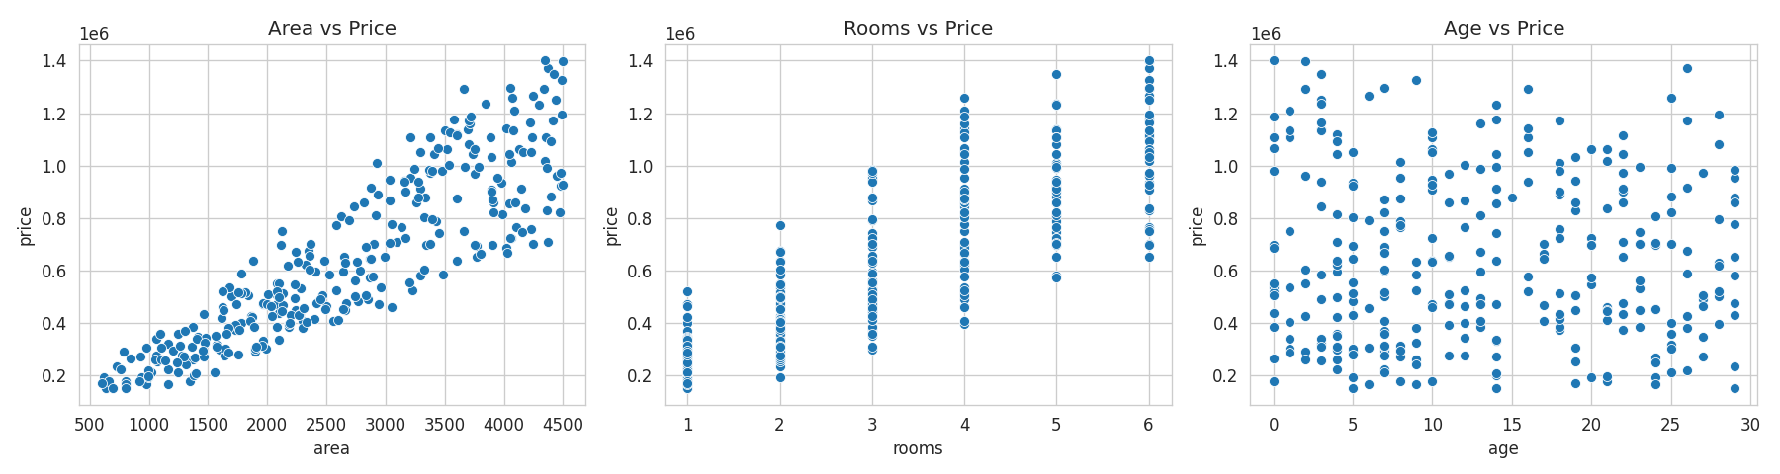
A correlation heatmap was also generated to quantify these relationships numerically.
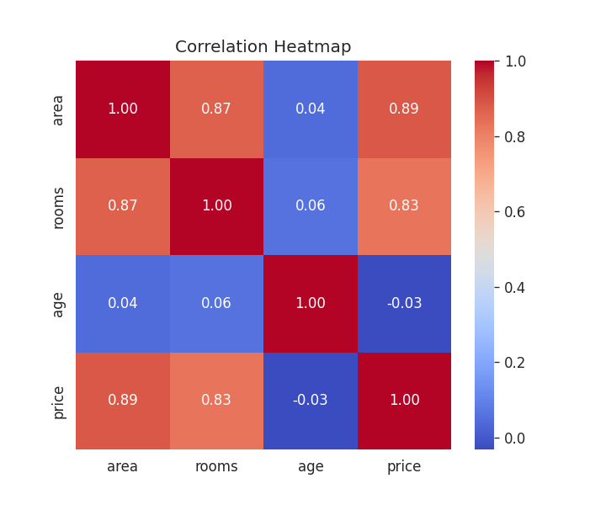

7. Model Building
The dataset was split into training (80%) and testing (20%) sets. A Linear Regression model from scikit-learn was trained on the features area, rooms, and age to predict price.

7.1 System Architecture (Backend & Frontend)
Beyond the notebook-based experimentation, the trained model was deployed as a small full-stack application with a clear separation between the model, the backend, and the frontend:
- model/train_model.py — standalone script that loads the dataset, trains the Linear Regression model, evaluates it, and saves it as house_price_model.pkl.
- backend/app.py — a Flask REST API that loads the saved model and exposes three endpoints: GET / (health check), GET /model-info (model coefficients/metadata), and POST /predict (accepts area, rooms, age as JSON and returns the predicted price).
- frontend/streamlit_app.py — a Streamlit web application providing a simple form (area, rooms, age) for users to get an instant price prediction, either by loading the model directly or by calling the backend API.
This structure mirrors a typical production ML deployment pattern: a training pipeline that produces a model artifact, a backend service that serves predictions over HTTP, and a frontend that end users interact with.

8. Model Evaluation
The trained model was evaluated on the test set using the following metrics:
Metric | Value
Mean Absolute Error (MAE) | ≈ 116,635
Root Mean Squared Error (RMSE) | ≈ 141,389
R² Score | ≈ 0.79
An R² score of approximately 0.79 indicates that the model explains about 79% of the variance in house prices using just three features, which is a strong result for a simple linear model.
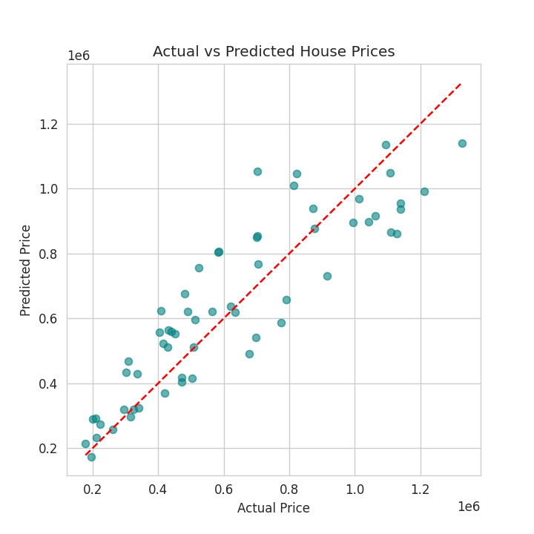

9. Prediction Example
Using the trained model, a sample prediction was made for a house with 2,200 sq. ft. area, 3 rooms, and 5 years of age, producing an estimated price consistent with the trends observed in the dataset.

10. Conclusion
This project successfully demonstrates the end-to-end machine learning workflow — from data exploration to model deployment-readiness — applied to the problem of house price prediction. The Linear Regression model performed well given the simplicity of the feature set. Future improvements could include additional features (location, amenities, proximity to city center), advanced algorithms (Random Forest, XGBoost, Ridge/Lasso Regression), and hyperparameter tuning to further improve accuracy.

11. References
- Scikit-learn Documentation — https://scikit-learn.org/
- Pandas Documentation — https://pandas.pydata.org/
- AICTE | IBM SkillsBuild Data Analytics with AI Internship Program Guidelines

