

**M. V. P. SAMAJ’S**

**K. R. T ARTS, A. M. SCIENCE AND B. H. COMMERCE**

**COLLEGE, GANGAPUR ROAD**

**NASHIK.**

**A PROJECT REPORT**

**ON**

**“City Guide Android Application”**

**Developed by**

Prathamesh Chetan Shinde

Krushna Vishnu Shinde

Parth Prashant Kokil

**B.C.A. (Science)**

**(2022-2023)**

Under the guidance of

Prof. Jyoti Mahatme

**SAVITRIBAI PHULE PUNE UNIVERSITY**



**M. V. P. SAMAJ’S**

**K. R. T ARTS, A. M. SCIENCE AND B. H. COMMERCE**

**COLLEGE, GANGAPUR ROAD**

**NASHIK.**

**CERTIFICATE**

This is to certify that

Mr. **__________________________, (**Seat No: **_________),**

Mr. **______________________, (**Seat No: **________) &**

Mr. **_______________________, (**Seat No: **_________)**

of T.Y.B.C.A(Science) have / has successfully completed project titled **______________________** satisfactorily as partial fulfillment of curriculum for T.Y.B.C.A.(Science) Semester-VI during academic year 2022-2023.

**Project Guide Head,**

**Dept. of Computer Science**

**Internal Examiner External Examiner**

Acknowledgement

I would like to take this opportunity to express my sincere gratitude and appreciation to all those who have contributed to the success of this project. First and foremost, I would like to thank our Project guide ***Prof. Jyoti Mahatme*** mam for their valuable guidance, advice, and support throughout the project. Their insight and expertise have been instrumental in shaping this work. I would also like to thank “K.R.T. Arts, B.H. Commerce and A.M. Science (KTHM) College, Nashik” for providing the necessary resources, including and access to their facilities, which enabled me to carry out this project. I am grateful to my colleagues and friends who provided their valuable feedback, comments, and suggestions during the project. Their insights and support were invaluable in shaping this work.

I would also like to thank “K.R.T. Arts, B.H. Commerce and A.M. Science (KTHM) College, Nashik” for providing the necessary resources, including and access to their facilities, which enabled me to carry out this project.

I am grateful to my colleagues and friends who provided their valuable feedback, comments, and suggestions during the project. Their insights and support were invaluable in shaping this work.

*Prathamesh Chetan Shinde*

*Krushna Vishnu Shinde*

*Parth Prashant Kokil*

INDEX

|  |  |  |
| --- | --- | --- |
| **Sr. No.** | **Title** | **Page NO.** |
|  | Introduction | **6** |
|  | Problem Statement & Definition | **7** |
|  | Objectives of goals | **8** |
|  | Project Scope | **10** |
|  | Proposed System | **12** |
|  | Existing System | **14** |
|  | Feasibility study | **15** |
|  | H/w and s/w requirement | **17** |
|  | ERD | **19** |
|  | DFD | **20** |
|  | Data Dictionary | **23** |
|  | Sample I/O Screen | **29** |
|  | Limitation | **42** |
|  | Conclusion | **43** |
|  | Advantages | **44** |
|  | Bibliography | **46** |



City Guide

**Introduction:**

"Welcome to our City Guide app for Nashik, Maharashtra! Nashik is a vibrant city known for its rich cultural heritage, historical landmarks, and natural beauty. Whether you're a local resident or a first-time visitor, our app is you’re here to guide you for discovering the best that Nashik has to offer.

Our app features have a user-friendly interface that allows you to easily navigate through the Nashik city's various Tourist Places, restaurants and more. From ancient temples and forts to each and every Restaurants, our app ensures that you'll never run out of things to do in Nashik.

This documentation provides a guide on how to use the City Guide Application, outlining its features, how it work, and how users can get the most out of the application. **Problem Statement:**

Navigating a new city can be overwhelming, especially for first-time visitors. Tourists often struggle to find reliable information about local attractive tourist places, restaurants, and hotels, while there are some local people which are also unaware of information of there own city. A user-friendly City Guide app can address these issues and provide a seamless experience for both tourists and locals to make there exploration easy and make them know they have a lot to visit and enjoy in Nashik.

**Definition:**

A City Guide app is a mobile application that provides information about tourist places, restaurants, and other points of interest in a Nashik city. The app provide a one-stop-solution for tourists and locals by offering detailed information about the Nashik City to help users navigate the city more efficiently. A City Guide app also offer additional features, such as maps, ratings, and images of tourist places, restaurants and hotels with travelling information for better user experience. **Objectives Of Goals:**

1. **Provide up-to-date guide to the city:**

One of the primary objectives of a city guide app is to provide users with a complete and accurate guide to the city. This includes information about tourist places, restaurants, hotels, travel stations, and other points of interest.

1. **Help user’s discover new places:**

A city guide app not only provide information about popular tourist spots in the Nashik City but also help users by providing there images, information and location to make there exploration amazing and easy.

1. **Enhance the user’s experience:**

The ultimate goal of a city guide app is to enhance the user's experience of a city, whether they are exploring as a tourist or seeking out new adventures as a local by providing useful information like emergency contacts, travelling information with there location and much more.

1. **Increase user’s engagement:**

A City Guide app gives uninterrupted, seamless experience to user and provide some functionalities like ‘add to favorites’ option for every user to make a list of places, restaurants and hotels which user like most.

**Installation:**

To install the City Guide Android Application, the user needs to install it for Android devices. Once downloaded, the user can launch the app and create an account. The app requires access to the internet to work properly.

**Project Scope:**

1. **User interface**:

The city guide app have a user-friendly interface that is easy to understand for a user. This includes a dashboard, search function, categories, favorite section, profile section, and other features that help users quickly find the information they need.

1. **Attractions**:

The app provides a proper guide to tourist places, including there images, information, and link for location. Each section has a button to put that location in favorite list of a particular user.

1. **Restaurants**:

The app also provide a guide to local restaurants, cafes, and hotels, including there information, images and location.

1. **Maps**:

The app provides maps or location of the tourist places, restaurants, and hotels of the city that are easy to use and can help users navigate.

1. **Feedback:**

The app allow users to leave there feedback by using contacts provide in the application to ask there queries and suggest changes.

1. **Search and Discovery**:

The user can search for different tourist places, Restaurants through the specific categories.

**Proposed System:**

**1. Places of Interest:**

The app provides a broad list of places of interest in Nashik, including popular tourist places, restaurants, and hotels. Each place of interest has a detailed description, and images.

**2. Restaurants and Hotels:**

The app provides information about restaurants and hotels in Nashik, including images, categories, ratings, and location. Users should be able to search restaurants by its name and category.

**3. Maps and Navigation:**

The app should provide maps and location link, features to help users navigate through the city.

**4. Weather:**

The app includes a temperature feature to help users plan their activities and prepare for weather conditions in Nashik.

**5. Local** T**ransport:**

The app also provides information about local transport options in Nashik, including bus terminal, train station, and airport location and contact details.

**Existing Systems:**

**1. Pune Guide App:**

This app provides information on tourist attractions, restaurants, hotels, shopping destinations, and events in Pune. It also includes a feature for booking local tours.

**2. Bangalore Guide App:**

This app provides information on tourist attractions, restaurants, hotels, shopping destinations, and events in Bangalore. It also includes a feature for booking local tours and cabs.

**3. Mumbai Guide App:**

This app provides information on tourist attractions, restaurants, hotels, shopping destinations, and events in Mumbai. It also includes a feature for booking local tours and cabs.

**Feasibility Study:**

A feasibility study of the City Guide application shows that it has the potential to succeed in the market. This is due to the high demand for tourism among users, as well as advancements in technology and the ability to generate revenue through various means

1. T**echnical Feasibility:**

The app is developed with a user-friendly interface, search functionality, and a database of information about tourist places, restaurants, hotels, and emergency details. The technical feasibility of the app depends the use of appropriate technology, such as mobile app development platforms and APIs with various dependencies for proper view.

1. **Economic Feasibility:**

To develop the application, we used Android studios which is free software and do run the developed application user must have android device with 8.0 and above android version

1. **Operational feasibility:**

To operate this system user requires Android version of 8.0(Oreo) and above. A team will be working at the backend to maintain the database and update it regularly. We use Firebase as our base to store data and fetch it in application. **Hardware And Software Requirement:**

* **Hardware requirements:**
  1. **Mobile devices**:

The city guide app should be compatible with a range of mobile devices, including smartphones and tablets. The minimum hardware requirements for these devices should include a multi-core processor, sufficient RAM, and a high-quality display.

* **Software Requirements:**

1. **Operating system:** The app should be compatible with popular mobile operating systems such as Android.
2. **Development tools:** The app should be developed using appropriate software development tools, such as Android Studio, depending on the target platform.
3. **APIs:** The app may require integration with third-party APIs like OpenWeather.com for services such as weather-temperature.
4. **Database:** The app should have a database to store information about local attractions, restaurants, shops, and events.

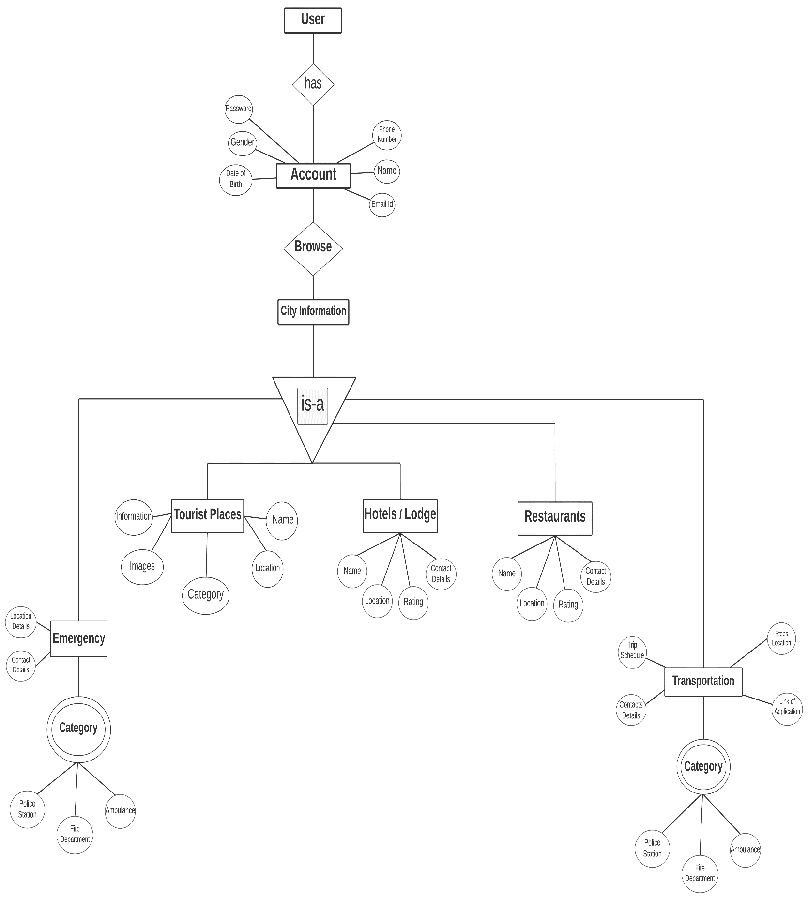**Entity-Relationship Diagram:**

**Data Flow Diagram:**

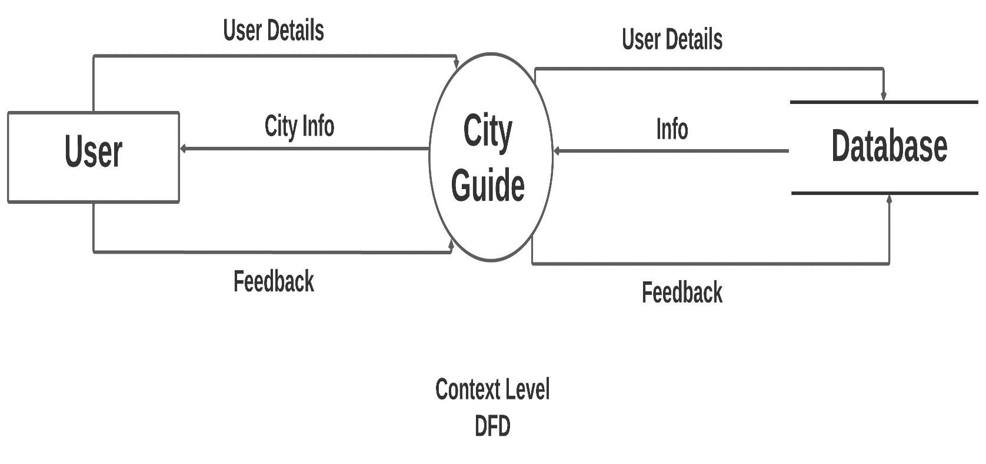

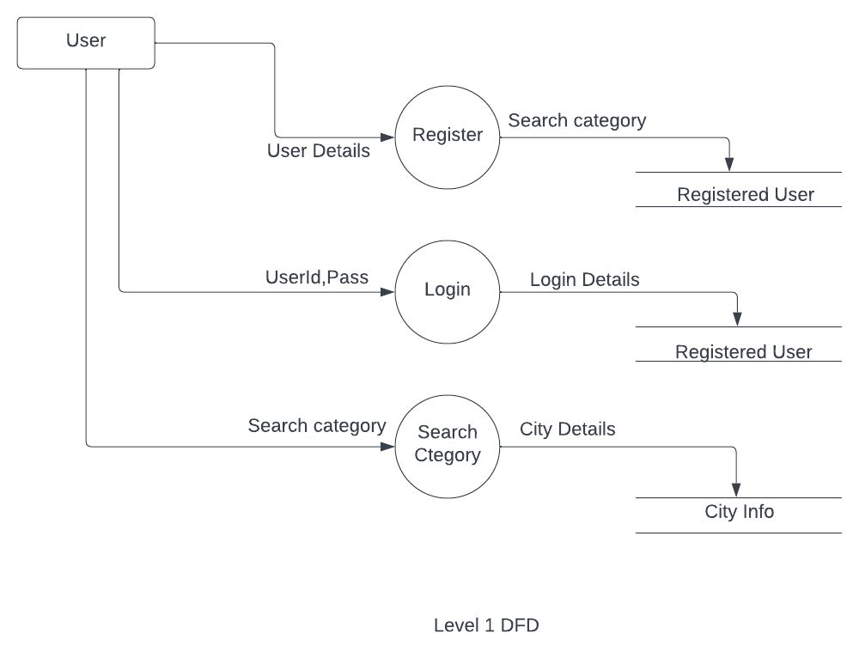

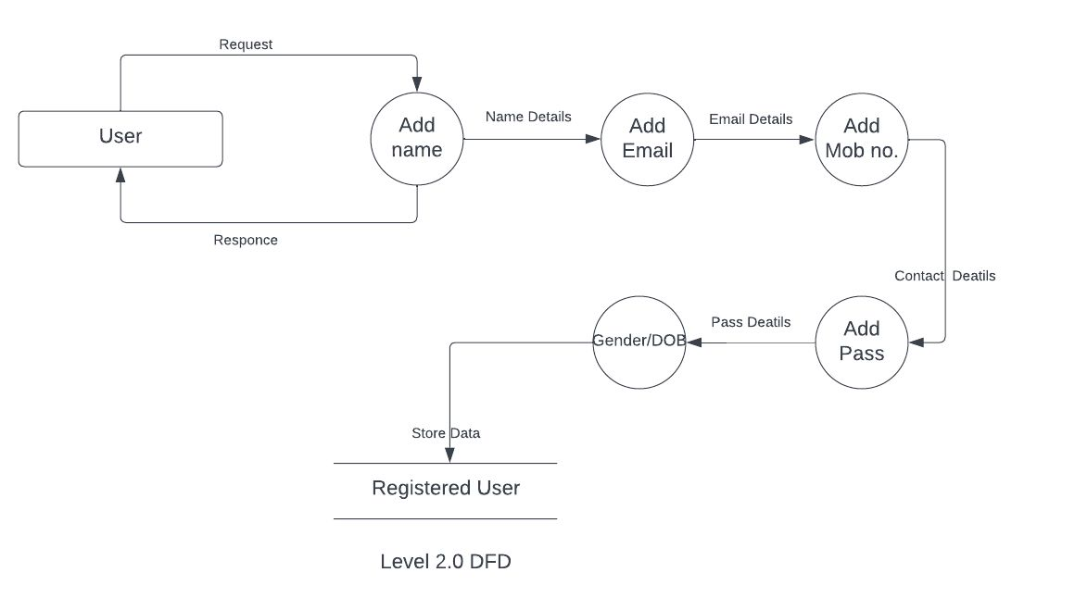

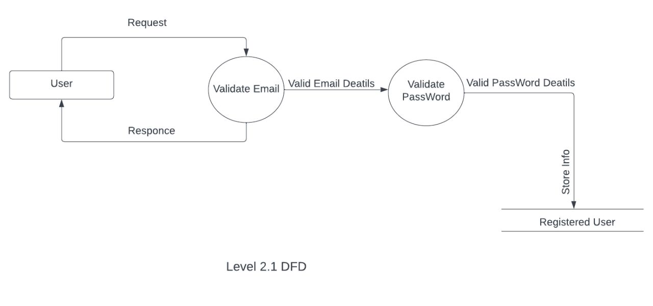

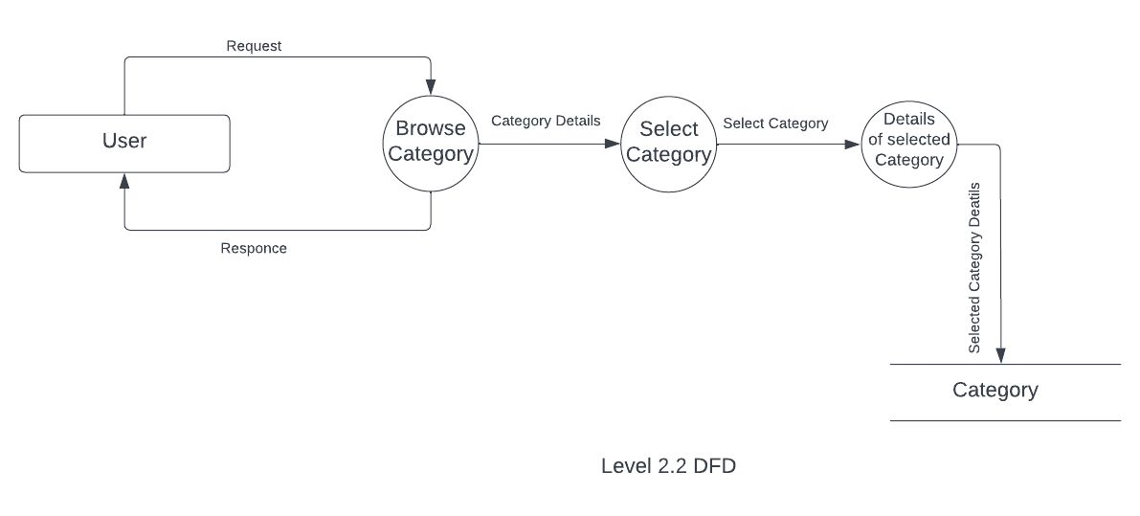

**Data Dictionary Diagram:**

* **User Database:**

|  |  |  |
| --- | --- | --- |
| **Field Name** | **Data Type** | **Description** |
| name | String | Name of User |
| email | String | Email id of user |
| pass | String | Password of user |
| mobile | String | Phone number of user |
| dob | String | Dob of user |
| gender | String | Gender of user |

* **Hotel Database:**

|  |  |  |
| --- | --- | --- |
| **Field Name** | **Data Type** | **Description** |
| name | String | Name of the beverages |
| address | String | Address of the beverages |
| gmlink | String | Google map location of hotel |
| rating | String | Rating of hotel |
| price | String | Price of hotel’s room. |

### Restaurant Database:

|  |  |  |
| --- | --- | --- |
| **Field Name** | **Data Type** | **Description** |
| name | String | Name of the restaurant |
| address | String | Address of the restaurant |
| cat1 | String | Category 1 |
| cat2 | String | Category 2 |
| desc | String | Description of restaurant |
| rating | String | Rating of restaurant |
| timing | String | Opening Closing Time of Restaurant |
| gmlink | String | Google Map location link of restaurant |

### Place Database:

|  |  |  |
| --- | --- | --- |
| **Field Name** | **Data Type** | **Description** |
| title | string | Name of the place |
| address | string | Address of the place |
| desc | string | Description of place |
| Timing | string | Open and close Timing of place |
| gmlink | string | Google map location of place |
| cat | string | Category of place |

### Ambulance Database:

|  |  |  |
| --- | --- | --- |
| **Field Name** | **Data Type** | **Description** |
| name | string | Name of the ambulance  Ambulance service |
| phone_number | string | Phone number of the ambulance service |

### Police Database:

|  |  |  |
| --- | --- | --- |
| **Field Name** | **Data Type** | **Description** |
| name | string | Name of the police station |
| phone_number | string | Phone number of the police station |
| gmlink | String | Google map location link of police station |

### Fire Department Database:

|  |  |  |
| --- | --- | --- |
| **Field Name** | **Data Type** | **Description** |
| name | string | Name of the fire department |
| phone_number | string | Phone number of the fire department |
| gmlink | String | Google map location link of fire department |

### Flights Database:

|  |  |  |
| --- | --- | --- |
| **Field Name** | **Data Type** | **Description** |
| cname | string | Name of the flight |
| arr | string | Arrival time of flight |
| dept | String | Departure time of flight |
| dest | string | Destination of flight |
| origin | string | Origin of flight |
| freq | string | Frequency of flight |

**Sample I/O Screen:**

1. **Splash Screen**

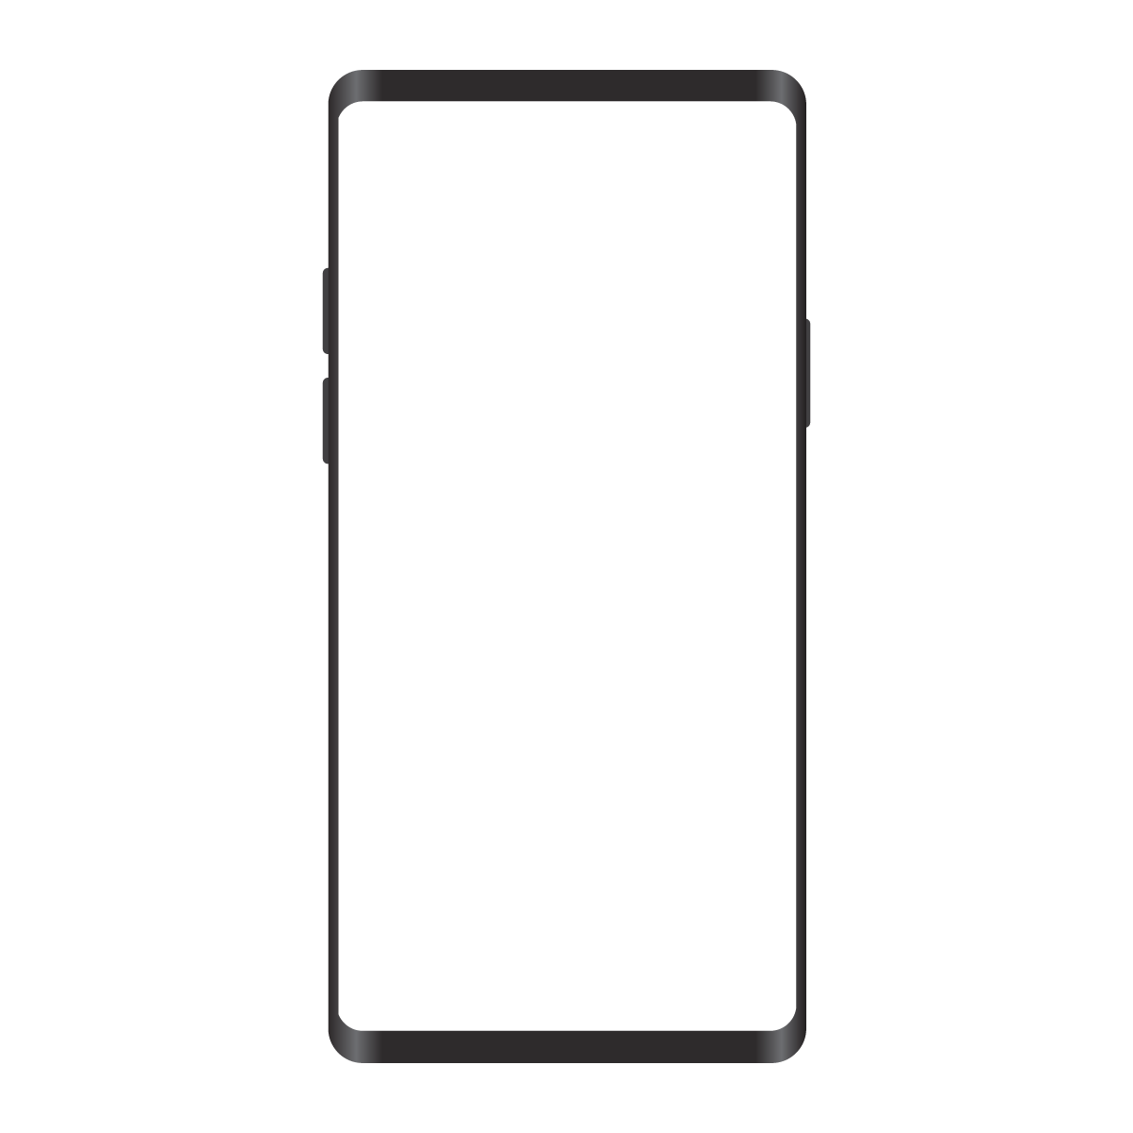



**2.Sign-in Screen**



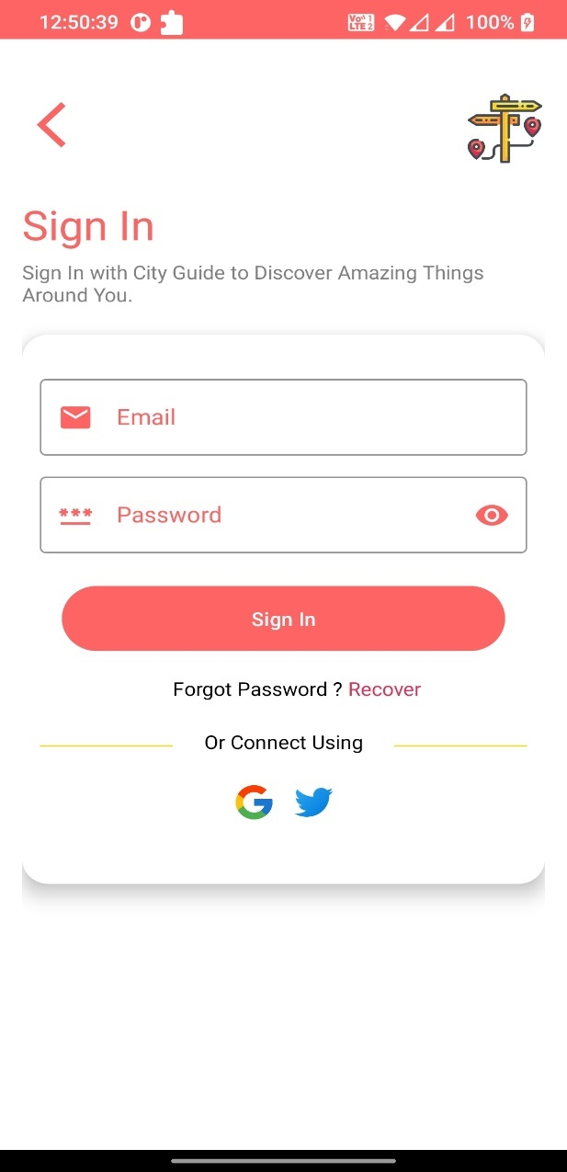

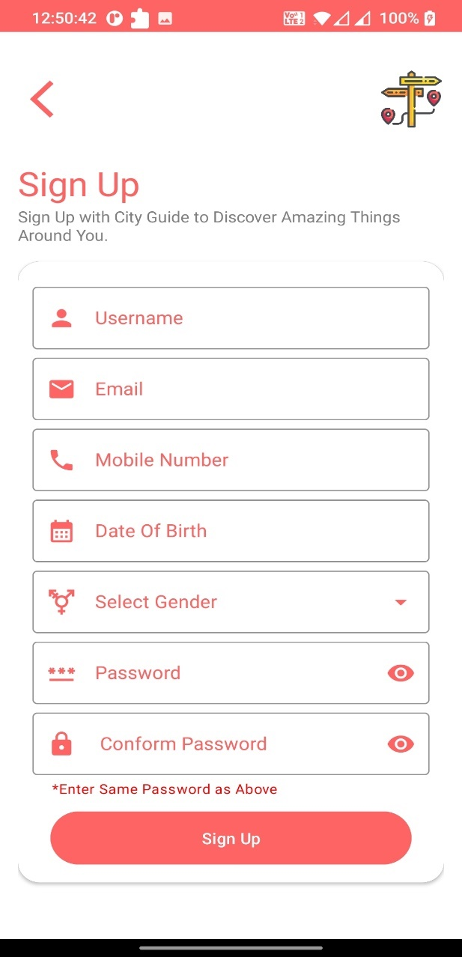**3.Sign-Up Screen**

**4.Dashboard Screen**

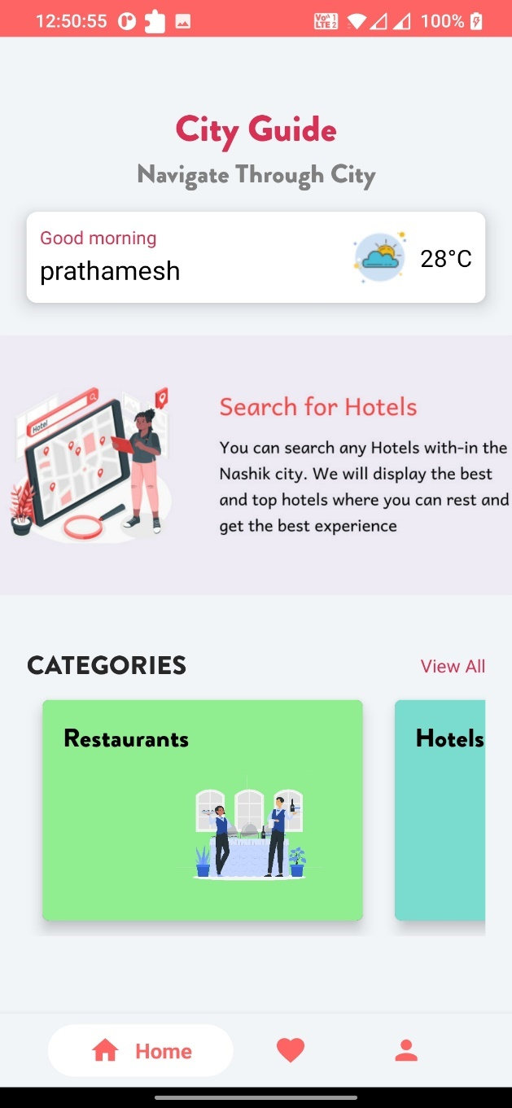

**5.Categories Screen**

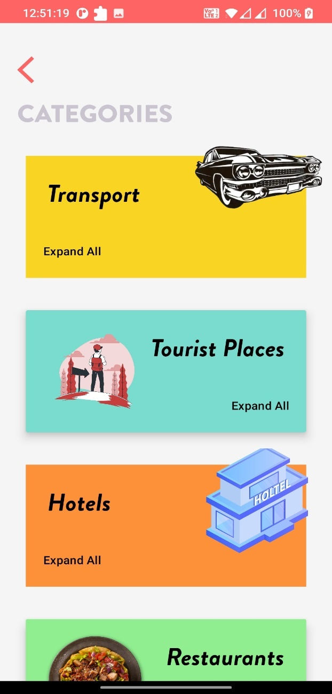

**6.Tourist-Place Screen**

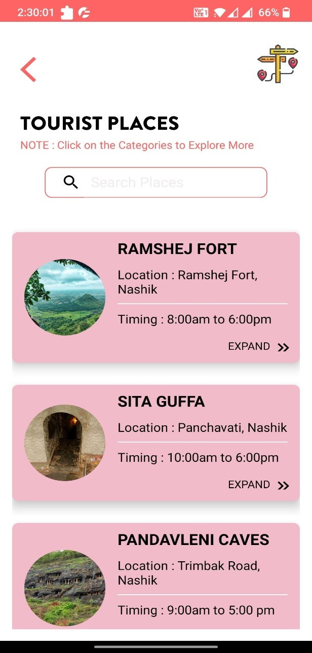

**7.Tourist-Place Info. Screen**

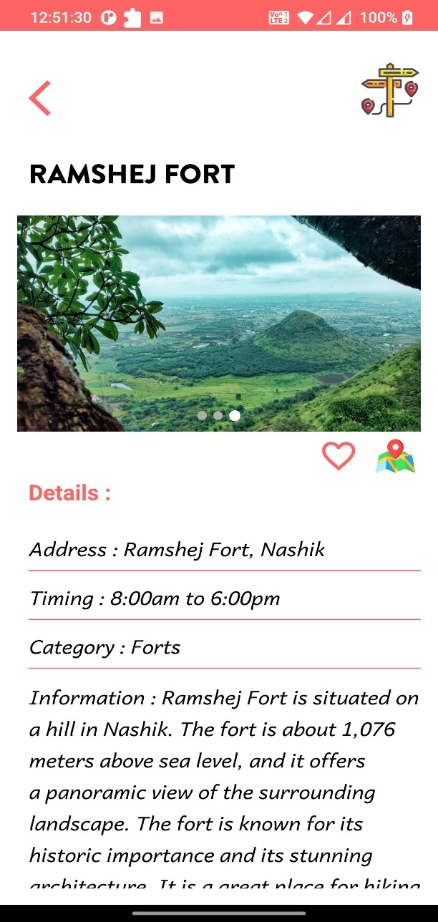

**8.Favorites Screen**

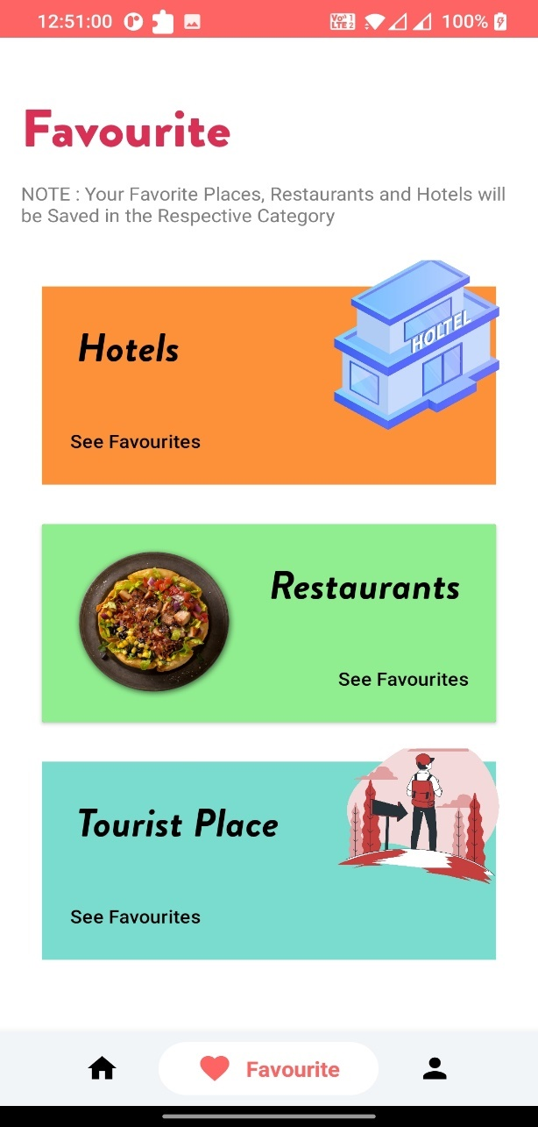

**9.Favorite Tourist-Place Screen**

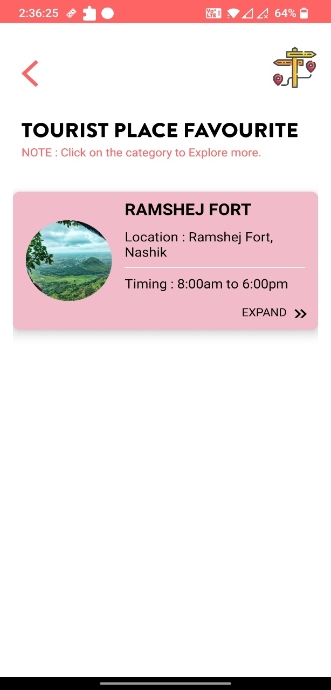

**10.User Profile Screen**

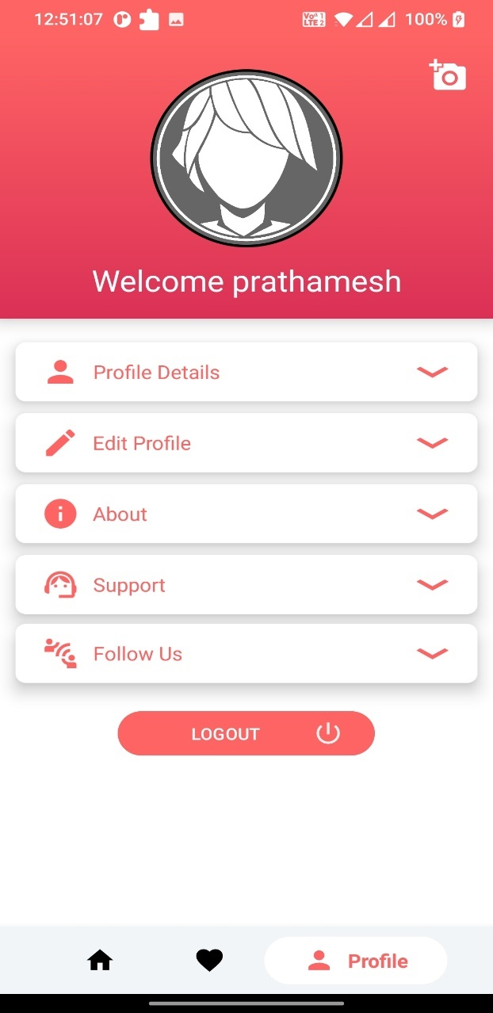

**11.User Details**

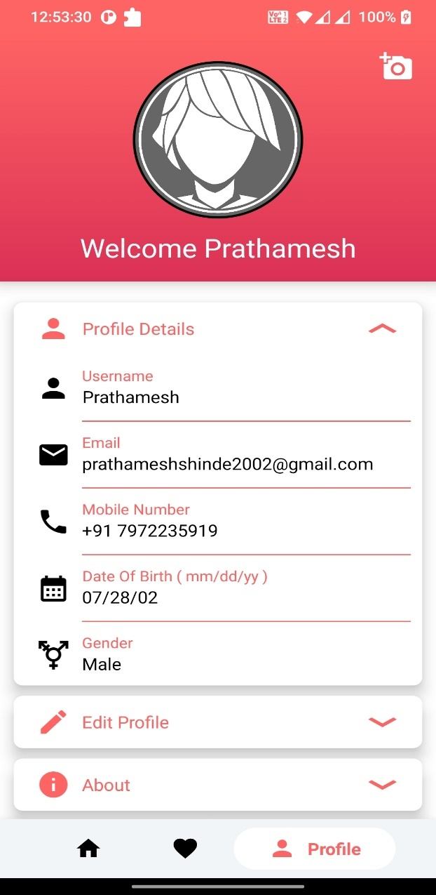

**12.Password Change Screen**

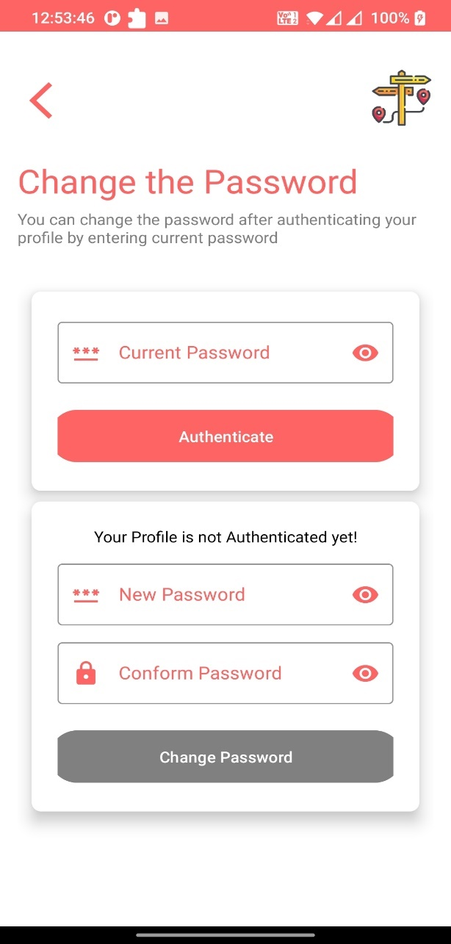

**13.Password Change Successful Screen** 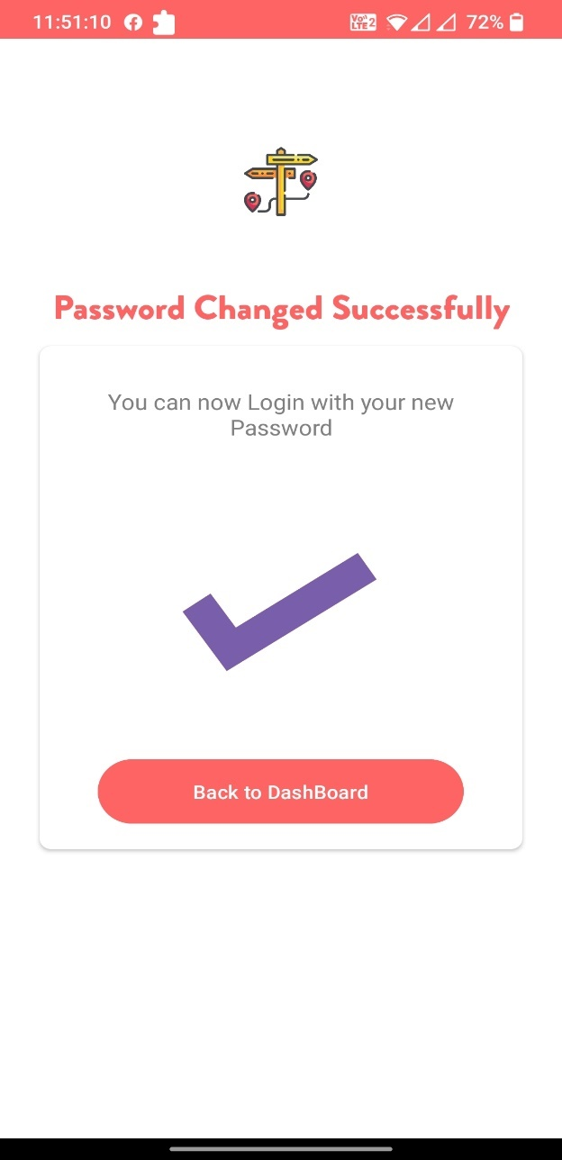

**Limitation:**

1. **Limited coverage:**

The city guide app may not cover all the tourist places, restaurants, and hotels in Nashik city, because human capable to add least known places around Nashik in app’s database.

1. **Limited accuracy:**

The information provided in the app may not always be up-to-date or accurate.

1. **Limited user engagement:**

The city guide app may struggle to engage users because the user only needs this app when the user wants to explore Nashik city.

**Conclusion:**

A city guide app for Nashik city can be a valuable tool for both tourists and locals. It can provide convenient access to information about local tourist places, restaurants, and hotels, add-to-favorite option based on user preferences, and real-time updates. It can also help promote Nashik city as a tourist destination and generate revenue for local businesses. However, the app may have limitations in terms of coverage, accuracy, user engagement, accessibility, and integration. Overall, the success of the city guide app will depend on the quality of its content, user experience, and marketing strategy, as well as its ability to adapt and improve over time based on user feedback and changing market conditions.

**Advantages:**

* 1. **Convenience:**

The city guide app provides a convenient way for users to access information about tourist places, restaurants, hotels, and contacts. Users can easily search for and find relevant information using their mobile devices, without the need for printed guides or maps.

* 1. **Personalization:**

The city guide app can provide add-to-favorite feature which will allow user to save their favorite tourist places, restaurants and hotels.

* 1. **Real-time updates:**

The city guide app can provide real-time updates about local events, weather, and other relevant information that can improve the user's experience.

* 1. **Social sharing:**

The city guide app can provide social sharing features that allow users to share their experiences and recommendations with friends and family. This can increase the app's reach and promote Nashik city as a tourist destination.

**Bibliography:**

1. [**https://www.figma.com**](https://www.figma.com)**(Designing)**
2. [**https://lucid.app/lucidspark**](https://lucid.app/lucidspark)**(Diagrams)**
3. [**https://console.firebase.google.com**](https://console.firebase.google.com)**(Database)**
4. [**https://developer.android.com/(Coding**](https://developer.android.com/(Coding) **(Reference)**
5. [**https://github.com/**](https://github.com/)**(Dependencies)**
6. [**https://www.youtube.com/**](https://www.youtube.com/)**(Reference)**