Q1. Implement following function to delete element from specified position in given array.
The function should return the updated logical size of array.
int deleteFromPosition(int[] arr, int n, int pos);

package org.cdac.day2;

import java.util.Scanner;

public class DeleteElementFromArray{
private static int logicalSize = 0;
private static int deleteFromPosition(int arr[],int n,int pos) throws Exception{
//1,2,3,4,5,6,7
if(pos > logicalSize) {
throw new Exception("Position is greater than logical size of array...");
}

for(int i=pos-1;i<logicalSize-1;i++) {
arr[i] = arr[i+1];
}
return --logicalSize;
}

public static void main(String[]args) {
Scanner scanner = new Scanner(System.in);
System.out.println("Enter the number of elements : ");
int n = scanner.nextInt();

int arr[] = new int[n];
arr[logicalSize] = 1;
++logicalSize;
arr[logicalSize] = 2;
++logicalSize;
arr[logicalSize] = 3;
++logicalSize;
arr[logicalSize] = 4;
++logicalSize;
arr[logicalSize] = 5;
++logicalSize;

System.out.println("Before deletion...");
for(int i=0;i<logicalSize;i++) {
System.out.print(arr[i]+" ");
}

System.out.println();

System.out.println("Logical size of array is : "+logicalSize+"\n");

System.out.println("Enter the position of element : ");
int pos = scanner.nextInt();

try {
deleteFromPosition(arr,n,pos);
}
catch(Exception e) {
System.out.println(e + "\n");
}

System.out.println("After deletion...");
for(int i=0;i<logicalSize;i++) {
System.out.print(arr[i]+" ");
}
System.out.println();
System.out.println("Logical size of array is : "+logicalSize+"\n");
} }

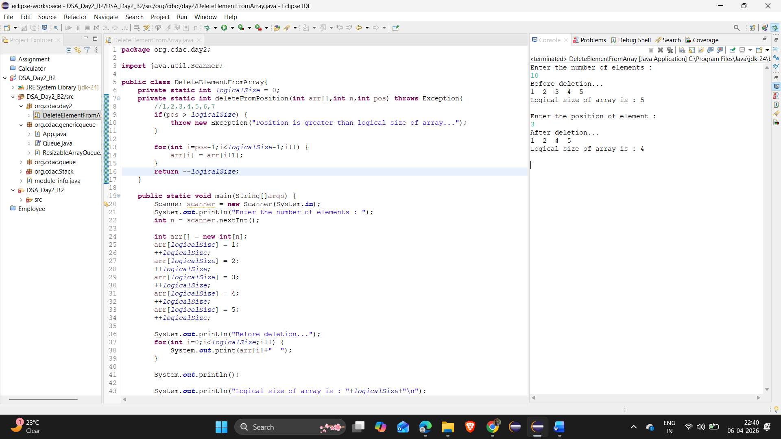

Q4. Implement a Generic Queue class using array that implements the Queue interface defined in Q1.
Throw appropriate exception when required.

package org.cdac.genericqueue;

public class App {
public static void main(String[] args) {
Queue<String> q = new ResizableArrayQueue<>(3);

try {
q.enqueue("A");
q.enqueue("B");
q.enqueue("C");
q.enqueue("D");
} catch (Exception e) {
e.printStackTrace();
}

try {
System.out.println("Front element: " + q.peek());
} catch (Exception e) {
e.printStackTrace();
}

while (!q.isEmpty()) {
try {
System.out.println("Dequeued: " + q.dequeue());
} catch (Exception e) {
e.printStackTrace();
}
}
}
}

package org.cdac.genericqueue;

public interface Queue<T> {
void enqueue(T element) throws Exception;
T dequeue() throws Exception;
T peek() throws Exception;
boolean isEmpty();
boolean isFull();
}

package org.cdac.genericqueue;

import java.util.NoSuchElementException;

public class ResizableArrayQueue<T> implements Queue<T> {
private T[] arr;
private int front;
private int rear;
private int size;

@SuppressWarnings("unchecked")
public ResizableArrayQueue(int initialCapacity) {
if (initialCapacity <= 0) {
throw new IllegalArgumentException("Capacity must be positive");
}
arr = (T[]) new Object[initialCapacity];
front = 0;
rear = -1;
size = 0;
}

@Override
public void enqueue(T element) {
if (isFull()) {
resize();
}
rear = (rear + 1) % arr.length;
arr[rear] = element;
size++;
}

@Override
public T dequeue() {
if (isEmpty()) {
throw new NoSuchElementException("Queue is empty");
}
T element = arr[front];
arr[front] = null; // optional: helps garbage collection
front = (front + 1) % arr.length;
size--;
return element;
}

@Override
public T peek() {
if (isEmpty()) {
throw new NoSuchElementException("Queue is empty");
}
return arr[front];
}

@Override
public boolean isEmpty() {
return size == 0;
}

@Override
public boolean isFull() {
return size == arr.length;
}

@SuppressWarnings("unchecked")
private void resize() {
int newCapacity = arr.length * 2;
T[] newArr = (T[]) new Object[newCapacity];

// Copy elements in correct order
for (int i = 0; i < size; i++) {
newArr[i] = arr[(front + i) % arr.length];
}

arr = newArr;
front = 0;
rear = size - 1;
}
}

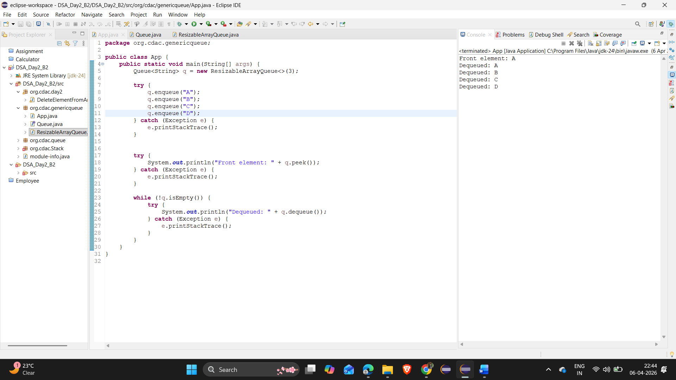

Q3. Define Queue as ADT (Refer to class notes).

package org.cdac.queue;

public interface Queue {
void enqueue(int element) throws Exception;
int dequeue() throws Exception;
int peek() throws Exception;
boolean isEmpty();
boolean isFull();
}

package org.cdac.queue;

public class App {
public static void main(String[] args) {
Queue q = new FixedSizeQueue(3);

try {
q.enqueue(10);
q.enqueue(20);
q.enqueue(30);

System.out.println("Front element: " + q.peek());

while (!q.isEmpty()) {
System.out.println("Dequeued: " + q.dequeue());
}

// Uncomment to see exception
// q.dequeue();
} catch (Exception e) {
System.out.println("Error: " + e.getMessage());
}
}
}

package org.cdac.queue;

import java.util.NoSuchElementException;

public class FixedSizeQueue implements Queue {
private int[] arr;
private int front;
private int rear;
private int size;

public FixedSizeQueue(int capacity) {
if (capacity <= 0) {
throw new IllegalArgumentException("Capacity must be positive");
}
arr = new int[capacity];
front = 0;
rear = -1;
size = 0;
}

@Override
public void enqueue(int element) throws Exception {
if (isFull()) {
throw new Exception("Queue is full");
}
rear = (rear + 1) % arr.length;
arr[rear] = element;
size++;
}

@Override
public int dequeue() {
if (isEmpty()) {
throw new NoSuchElementException("Queue is empty");
}
int element = arr[front];
front = (front + 1) % arr.length;
size--;
return element;
}

@Override
public int peek() {
if (isEmpty()) {
throw new NoSuchElementException("Queue is empty");
}
return arr[front];
}

@Override
public boolean isEmpty() {
return size == 0;
}

@Override
public boolean isFull() {
return size == arr.length;
}
}

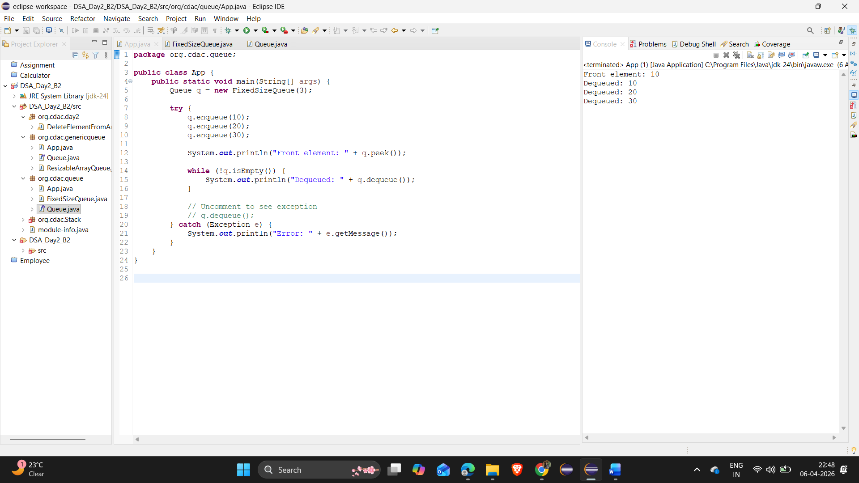

Q2. Implement a Stack class using resizable array that implements the Stack interface defined in class.
Throw appropriate exception when required.

package org.cdac.Stack;

public interface Stack {
void push(int element);
int pop() throws Exception;
boolean isEmpty();
boolean isFull();
int peek();
}

package org.cdac.Stack;

public class App {
public static void main(String[]args) {
testPushSilentFail();

}

public static void testPushSilentFail() {
Stack s1 = new FixedSizeStack(5);
for(int i=0;i<100;i++) {
s1.push(i);
}

while(!s1.isEmpty()) {
try {
System.out.println("Popped - "+s1.pop());
} catch (Exception e) {
System.out.println(e);
}
}
}
}

package org.cdac.Stack;

public class FixedSizeStack implements Stack{
private int top;
private int[] stackData;

public FixedSizeStack(int n) {
stackData = new int[n];
top = -1;
}

private void resize() {
int arr[] = new int[stackData.length*2];
for(int i=0;i<stackData.length;i++) {
arr[i] = stackData[i];
}
stackData = arr;
}

@Override
public void push(int element) {
if(isFull()) {
resize();
}
top = top+1;
stackData[top] = element;

}

@Override
public int pop() throws Exception {
if(isEmpty()) {
throw new Exception("stack is empty...");
}
int result = stackData[top];
top = top-1;
return result;
}

@Override
public boolean isEmpty() {
if(top == -1) {
return true;
}
return false;
}

@Override
public boolean isFull() {
if(top == stackData.length-1) {
return true;
}
return false;
}

@Override
public int peek() {
if(isEmpty()) {
return -1;
}
return stackData[top];
}
}

