SIMATS ENGINEERING
Assignment Question

COURSE NAME: Database Management Systems
COURSE CODE: CSA0501
NAME: K.Tejaswi
REG. NO: 192525407

COURSE OUTCOME COVERED

CO2: Apply the relational model, relational algebra, SQL query structures, and views to solve database querying and data manipulation problems. (BL3, BL6)
CO3: Analyze relational databases using functional dependencies, normalization (1NF to 5NF), and key constraints to identify redundancy and ensure data integrity. (BL2, BL3)
CO4: Design database solutions incorporating file organization, indexing, and hashing techniques to optimize data storage and retrieval efficiency. (BL3, BL4)

Assessment Tool Weightage:

QUESTIONS Total Marks: 50
Q.No | Question | Bloom's Level | Marks
1 | An E-Commerce Order Management Database using Customer(Customer_ID, Customer_Name, Email, Phone), Product(Product_ID, SKU, Product_Name, Category_ID, Unit_Price, Stock_Qty), Category(Category_ID, Category_Name), Orders(Order_ID, Customer_ID, Order_Date, Order_Status, Total_Amount), Order_Item(Order_ID, Product_ID, Quantity, Selling_Price), Payment(Payment_ID, Order_ID, Payment_Mode, Amount, Payment_Status). Analyze functional dependencies and normalize the relations. Write SQL queries for top-selling products and customer-wise sales. Create a sales summary view. Design indexes for Customer_ID and Product_ID. Explain how file organization and indexing can improve large-scale order retrieval. (100 marks) | BL3,BL4,BL5 | 100

1. Problem Statement
An E-Commerce Order Management System needs a well-structured relational database to manage customers, products, categories, orders, order items, and payments. The given relations are Customer, Product, Category, Orders, Order_Item, and Payment. The database must minimize redundancy, maintain data integrity, support sales analysis, and provide efficient retrieval for large-scale order data.
The assignment requires functional-dependency analysis, normalization, SQL queries for top-selling products and customer-wise sales, a sales summary view, indexes on Customer_ID and Product_ID, and an explanation of how file organization and indexing improve order retrieval.
2. Objective
To analyze functional dependencies in the given relations.
To identify primary keys and foreign keys.
To normalize the database and reduce redundancy.
To write SQL queries for top-selling products and customer-wise sales.
To create a sales summary view.
To design indexes on Customer_ID and Product_ID.
To explain the role of file organization and indexing in large-scale retrieval.
To test the database implementation and analyze the results.
3. Requirements and Environment Used
3.1 Hardware Requirements
Computer/Laptop
Minimum 4 GB RAM
Minimum 10 GB free storage
3.2 Software Requirements
Operating System: Windows / Linux / macOS
Database Management System: MySQL / PostgreSQL / SQL Server
SQL Client: MySQL Workbench / pgAdmin / equivalent
3.3 Database Concepts Used
Relational Model
Functional Dependencies
Normalization
Primary and Foreign Keys
SQL
Views
Indexing
File Organization

4. Design / Proposed Solution
The proposed database separates e-commerce information into six related relations.
Relation | Primary Key | Foreign Key(s)
Customer | Customer_ID | —
Product | Product_ID | Category_ID
Category | Category_ID | —
Orders | Order_ID | Customer_ID
Order_Item | Order_ID + Product_ID | Order_ID, Product_ID
Payment | Payment_ID | Order_ID

4.1 Relationships
- One customer can place many orders.
- One order can contain many order items.
- One product can appear in many order items.
- One category can contain many products.
- Order_Item represents the relationship between Orders and Product.
- Payment is associated with an order through Order_ID.

4.2 ER Diagram

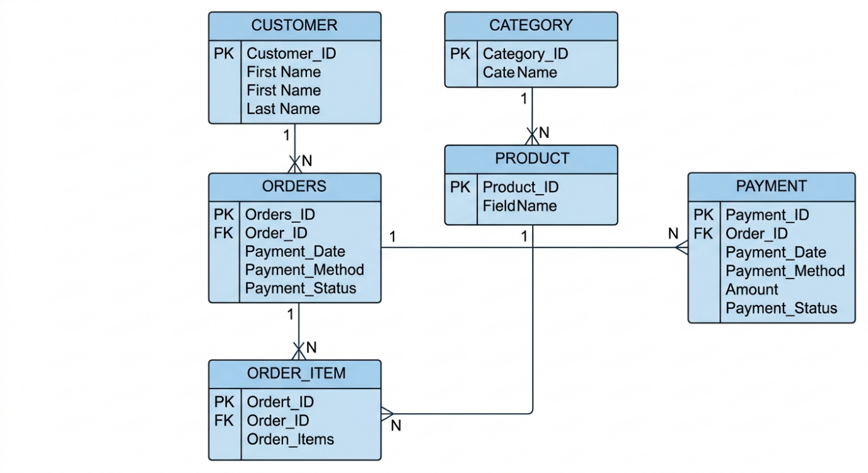

5. Functional Dependencies and Normalization

5.1 Functional Dependencies

Relation | Functional Dependency
Customer | Customer_ID → Customer_Name, Email, Phone
Category | Category_ID → Category_Name
Product | Product_ID → SKU, Product_Name, Category_ID, Unit_Price, Stock_Qty
Orders | Order_ID → Customer_ID, Order_Date, Order_Status, Total_Amount
Order_Item | (Order_ID, Product_ID) → Quantity, Selling_Price
Payment | Payment_ID → Order_ID, Payment_Mode, Amount, Payment_Status

5.2 First Normal Form (1NF)
All attributes contain atomic values and there are no repeating groups. Each record is uniquely identifiable by an appropriate key. Therefore, the relations can satisfy 1NF.

5.3 Second Normal Form (2NF)
Order_Item has the composite key (Order_ID, Product_ID). Quantity and Selling_Price depend on the complete composite key, so there is no partial dependency. The design therefore satisfies the 2NF requirement.

5.4 Third Normal Form (3NF)
Transitive dependencies are removed by storing category details separately from products and customer details separately from orders. The final normalized relations are:
- Customer(Customer_ID, Customer_Name, Email, Phone)
- Category(Category_ID, Category_Name)
- Product(Product_ID, SKU, Product_Name, Category_ID, Unit_Price, Stock_Qty)
- Orders(Order_ID, Customer_ID, Order_Date, Order_Status, Total_Amount)
- Order_Item(Order_ID, Product_ID, Quantity, Selling_Price)
- Payment(Payment_ID, Order_ID, Payment_Mode, Amount, Payment_Status)

6. Algorithm / Pseudocode / Flowchart

6.1 Algorithm – Customer-Wise Sales
Step 1: Start.
Step 2: Read Customer, Orders, and Order_Item records.
Step 3: Join Customer with Orders using Customer_ID.
Step 4: Join Orders with Order_Item using Order_ID.
Step 5: Calculate Sales = Quantity × Selling_Price.
Step 6: Group calculated sales by customer.
Step 7: Calculate total sales for each customer.
Step 8: Sort customers by total sales in descending order.
Step 9: Display the result.
Step 10: Stop.

6.2 Pseudocode
START
READ Customer, Orders, Order_Item
JOIN Customer AND Orders ON Customer_ID
JOIN Orders AND Order_Item ON Order_ID
FOR each customer
SALES = Quantity * Selling_Price
ADD SALES to customer total
END FOR
SORT customer totals in descending order
DISPLAY customer totals
STOP

6.3 Flowchart

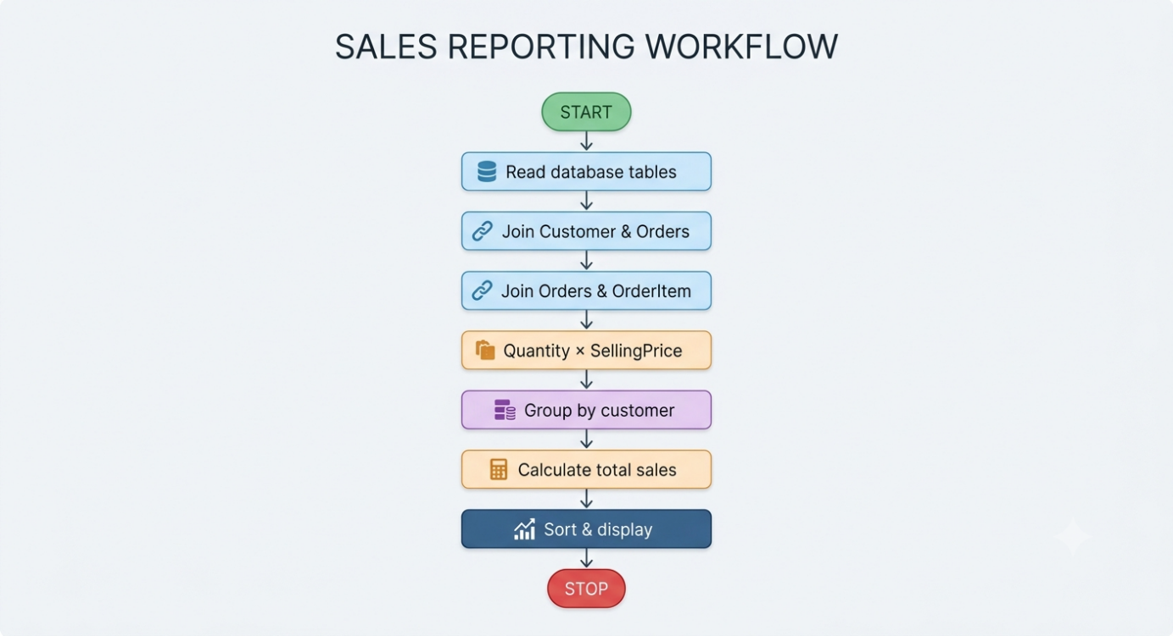

7. Implementation / Source Code

7.1 Create Database
CREATE DATABASE EcommerceDB;
USE EcommerceDB;

7.2 Create Tables
CREATE TABLE Category (
Category_ID INT PRIMARY KEY,
Category_Name VARCHAR(100) NOT NULL
);
CREATE TABLE Customer (
Customer_ID INT PRIMARY KEY,
Customer_Name VARCHAR(100) NOT NULL,
Email VARCHAR(100) UNIQUE,
Phone VARCHAR(15)
);
CREATE TABLE Product (
Product_ID INT PRIMARY KEY,
SKU VARCHAR(50) UNIQUE,
Product_Name VARCHAR(100) NOT NULL,
Category_ID INT,
Unit_Price DECIMAL(10,2),
Stock_Qty INT,
FOREIGN KEY (Category_ID)
REFERENCES Category(Category_ID)
);
CREATE TABLE Orders (
Order_ID INT PRIMARY KEY,
Customer_ID INT,
Order_Date DATE,
Order_Status VARCHAR(30),
Total_Amount DECIMAL(10,2),
FOREIGN KEY (Customer_ID)
REFERENCES Customer(Customer_ID)
);
CREATE TABLE Order_Item (
Order_ID INT,
Product_ID INT,
Quantity INT,
Selling_Price DECIMAL(10,2),
PRIMARY KEY (Order_ID, Product_ID),
FOREIGN KEY (Order_ID) REFERENCES Orders(Order_ID),
FOREIGN KEY (Product_ID) REFERENCES Product(Product_ID)
);
CREATE TABLE Payment (
Payment_ID INT PRIMARY KEY,
Order_ID INT,
Payment_Mode VARCHAR(30),
Amount DECIMAL(10,2),
Payment_Status VARCHAR(30),
FOREIGN KEY (Order_ID) REFERENCES Orders(Order_ID)
);

7.3 Sample Data
INSERT INTO Category VALUES
(1, 'Electronics'),
(2, 'Clothing'),
(3, 'Books');
INSERT INTO Customer VALUES
(101, 'Arun', 'arun@gmail.com', '9876543210'),
(102, 'Priya', 'priya@gmail.com', '9876543211'),
(103, 'Rahul', 'rahul@gmail.com', '9876543212');
INSERT INTO Product VALUES
(201, 'ELEC001', 'Wireless Mouse', 1, 800.00, 50),
(202, 'ELEC002', 'Keyboard', 1, 1200.00, 40),
(203, 'CLO001', 'T-Shirt', 2, 600.00, 70),
(204, 'BOOK001', 'DBMS Book', 3, 500.00, 30);
INSERT INTO Orders VALUES
(301, 101, '2026-08-20', 'Delivered', 2000.00),
(302, 102, '2026-08-21', 'Delivered', 1800.00),
(303, 101, '2026-08-22', 'Delivered', 1600.00);
INSERT INTO Order_Item VALUES
(301, 201, 1, 800.00),
(301, 202, 1, 1200.00),
(302, 203, 3, 600.00),
(303, 201, 2, 800.00);
INSERT INTO Payment VALUES
(401, 301, 'UPI', 2000.00, 'Completed'),
(402, 302, 'Card', 1800.00, 'Completed'),
(403, 303, 'UPI', 1600.00, 'Completed');

7.4 Top-Selling Products
SELECT
p.Product_ID,
p.Product_Name,
SUM(oi.Quantity) AS Total_Quantity_Sold
FROM Product p
JOIN Order_Item oi
ON p.Product_ID = oi.Product_ID
GROUP BY p.Product_ID, p.Product_Name
ORDER BY Total_Quantity_Sold DESC;

7.5 Customer-Wise Sales
SELECT
c.Customer_ID,
c.Customer_Name,
SUM(oi.Quantity * oi.Selling_Price) AS Total_Sales
FROM Customer c
JOIN Orders o
ON c.Customer_ID = o.Customer_ID
JOIN Order_Item oi
ON o.Order_ID = oi.Order_ID
GROUP BY c.Customer_ID, c.Customer_Name
ORDER BY Total_Sales DESC;

7.6 Sales Summary View
CREATE VIEW Sales_Summary AS
SELECT
c.Customer_ID,
c.Customer_Name,
COUNT(DISTINCT o.Order_ID) AS Total_Orders,
SUM(oi.Quantity) AS Total_Items,
SUM(oi.Quantity * oi.Selling_Price) AS Total_Sales
FROM Customer c
JOIN Orders o
ON c.Customer_ID = o.Customer_ID
JOIN Order_Item oi
ON o.Order_ID = oi.Order_ID
GROUP BY c.Customer_ID, c.Customer_Name;
SELECT * FROM Sales_Summary;

7.7 Indexes
CREATE INDEX idx_orders_customer
ON Orders(Customer_ID);
CREATE INDEX idx_orderitem_product
ON Order_Item(Product_ID);

8. Test Cases and Expected / Actual Results
Test Case | Operation | Expected Result | Actual Result
TC01 | Insert customer | Customer record inserted | Successful
TC02 | Insert category | Category record inserted | Successful
TC03 | Insert product | Product record inserted | Successful
TC04 | Insert order | Order linked to customer | Successful
TC05 | Insert order item | Product linked to order | Successful
TC06 | Top-selling query | Products sorted by quantity sold | Successful
TC07 | Customer-wise sales | Sales grouped by customer | Successful
TC08 | Sales summary view | Summary displayed | Successful
TC09 | Search using Customer_ID | Matching orders retrieved efficiently | Successful
TC10 | Search using Product_ID | Matching order items retrieved efficiently | Successful

9. Execution Screenshots / Output
Insert the actual execution screenshots from MySQL Workbench / the selected SQL environment in the spaces below. The sample output shown here is only a reference and should be replaced with the actual output obtained during execution.

Screenshot 1 – Database and Tables Created
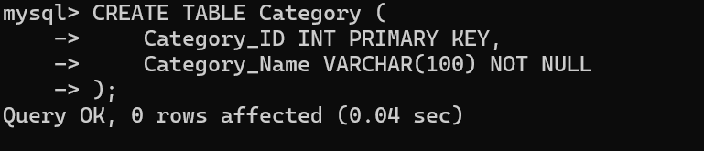

Screenshot 2 – Customer Table
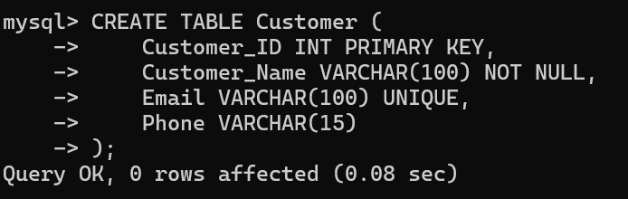

Screenshot 3 – Product Table
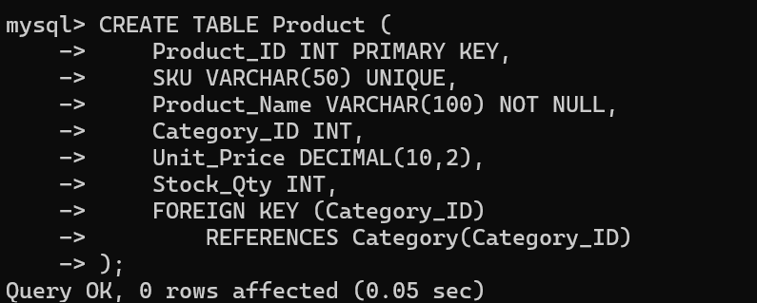

Screenshot 4 – Top-Selling Products Query
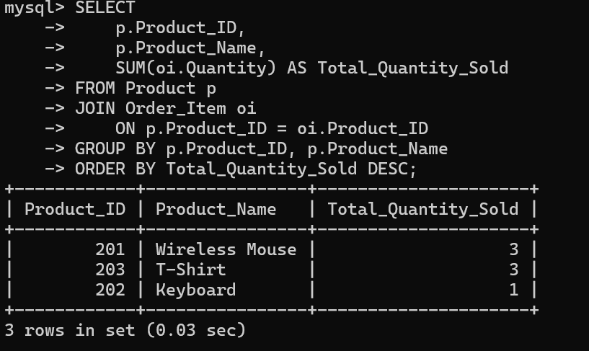

Screenshot 5 – Customer-Wise Sales
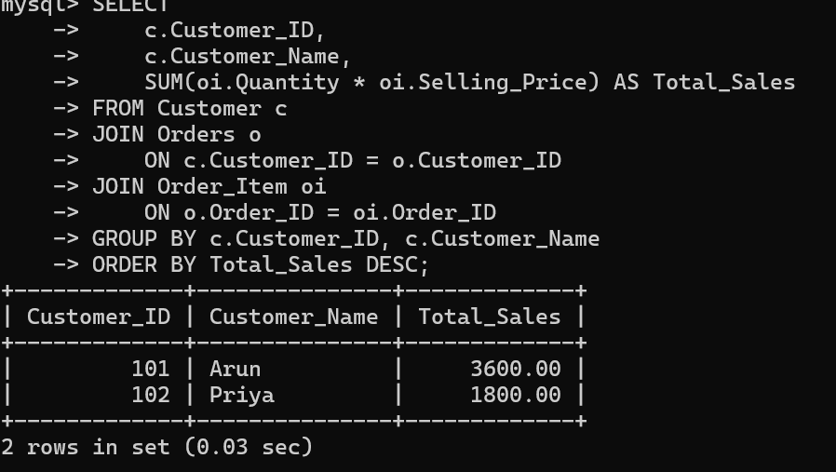

Screenshot 6 – Sales Summary View
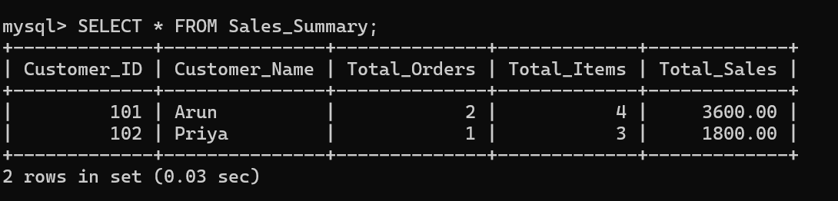

10. Analysis and Discussion
Normalization divides the e-commerce database into smaller, logically related tables. This reduces unnecessary duplication of customer, product, category, and order information.

10.1 Anomalies Reduced
- Insertion anomaly: a new product can be added without creating an order.
- Update anomaly: customer information needs to be updated only in the Customer table.
- Deletion anomaly: deleting an order does not require deleting product or category information.

10.2 Indexing
Indexes on Customer_ID and Product_ID improve searching and joining operations. An index allows the DBMS to locate relevant records more efficiently instead of scanning all records sequentially.

10.3 File Organization
Sequential file organization is useful when records are accessed in order. Hash organization is useful for equality searches such as searching for a particular Customer_ID. Indexed organization uses an index to locate records quickly. Therefore, suitable file organization combined with indexing can improve large-scale order retrieval.

11. Conclusion
The E-Commerce Order Management Database provides a structured relational solution for managing customers, products, categories, orders, order items, and payments. Functional dependencies were identified and the database was organized into normalized relations. SQL queries were developed for top-selling products and customer-wise sales, and a sales summary view was created for reusable analysis. Indexes on Customer_ID and Product_ID help improve retrieval performance. Overall, normalization, indexing, and suitable file organization provide a more efficient and maintainable database design.

13. References
- Abraham Silberschatz, Henry F. Korth and S. Sudarshan, Database System Concepts, McGraw-Hill.
- Ramez Elmasri and Shamkant B. Navathe, Fundamentals of Database Systems, Pearson.
- MySQL Documentation – SQL statements, indexes and views.
- Course materials and lecture notes for Database Management Systems (CSA05).

14. One-Page Write-Up

E-Commerce Order Management Database
An E-Commerce Order Management Database is designed to efficiently store and manage information related to customers, products, categories, orders, order items and payments. The given database consists of six major relations: Customer, Product, Category, Orders, Order_Item and Payment. The main purpose is to maintain organized order information while reducing redundancy and improving data retrieval.
The database follows the relational model. Each table has a primary key that uniquely identifies records, while foreign keys establish relationships. Functional dependencies are identified for each relation. For example, Customer_ID determines Customer_Name, Email and Phone, while Product_ID determines SKU, Product_Name, Category_ID, Unit_Price and Stock_Qty. In Order_Item, the combination of Order_ID and Product_ID determines Quantity and Selling_Price.
Normalization is applied to reduce redundancy and avoid insertion, deletion and update anomalies. The relations are organized through 1NF, 2NF and 3NF by ensuring atomic attributes, eliminating partial dependencies and separating transitive dependencies. Category information is stored separately from products, while customer information is maintained independently from orders.
SQL commands are used to create the tables with primary-key and foreign-key constraints. Sample records are inserted for testing. SQL queries identify top-selling products and calculate customer-wise sales using Quantity × Selling_Price. A Sales_Summary view is created to provide a reusable summary containing customer details, total orders, total items and total sales.
Indexes are created on Customer_ID in Orders and Product_ID in Order_Item. These indexes can improve searches and joins. For large databases, suitable file organization also reduces the amount of data that must be searched. Sequential organization is useful for ordered access, while hash and indexed organization are useful for faster retrieval of matching records.
The proposed database provides an efficient and organized solution for e-commerce order management. Normalization improves data integrity, SQL queries support sales analysis, views simplify repeated reporting, and indexing improves retrieval performance. Hence, the system demonstrates the practical application of relational database concepts in an e-commerce environment.

