Azure Data Engineering
HomeWork 7 Nov 3
Write examples on joins
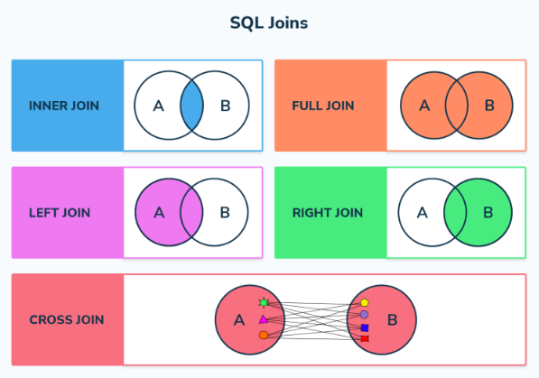
We mostly use Inner, Left and Right joins.
INNER JOIN
An INNER JOIN returns records that have matching values in both tables. It is the most common type of join and is also known as a simple join. If you omit the keyword INNER and just use JOIN, it defaults to an inner join.
Example:
SELECT p.ProductID,
p.Name ProductName,
count(*) NoOfOrders,
sum([unitPrice]) TotalCost
FROM [SalesLT].[SalesOrderDetail] s
inner join [SalesLT].[product] p on s.ProductID = p.ProductID
WHERE P.ProductID = @ProductID
group by p.ProductID,p.Name
This query selects records that have matching values in both the Orders and Customers tables.
LEFT JOIN
A LEFT JOIN (or LEFT OUTER JOIN) returns all records from the left table and the matched records from the right table. If there is no match, the result is NULL on the side of the right table.
Example:
SELECT p.ProductID,
p.Name ProductName,
count(*) NoOfOrders,
sum([unitPrice]) TotalCost
FROM [SalesLT].[SalesOrderDetail] s
left join [SalesLT].[product] p on s.ProductID = p.ProductID
WHERE P.ProductID = @ProductID
group by p.ProductID,p.Name
This query returns all records from the account table and the matched records from the customer table. Unmatched records from the customer table will have NULL values²³.
RIGHT JOIN
A RIGHT JOIN (or RIGHT OUTER JOIN) returns all records from the right table and the matched records from the left table. If there is no match, the result is NULL on the side of the left table.

What is stored procedure and create stored proc
A stored procedure is a set of SQL statements that are compiled and stored in the database. This allows for the code to be reused multiple times without the need to rewrite the SQL queries. Stored procedures enhance efficiency, reusability, and security in database management.
alter procedure [SalesLT].SalesAggregation
( @ProductID int) AS
BEGIN
SELECT p.ProductID,
p.Name ProductName,
count(*) NoOfOrders,
sum([unitPrice]) TotalCost
FROM [SalesLT].[SalesOrderDetail] s
inner join [SalesLT].[product] p on s.ProductID = p.ProductID
WHERE P.ProductID = @ProductID
group by p.ProductID,p.Name
order by p.ProductID

if @@rowcount = 0
begin
print 'No Record Exists with '+cast(@ProductID as varchar)+' productID'
end
END
GO

What is a view and where it will be used
A view in SQL is a virtual table that is created based on the result set of an SQL query. Unlike a physical table, a view does not store data on the disk but dynamically displays data from one or more tables whenever it is queried. This makes views a powerful tool for simplifying complex queries, enhancing data security, and providing a customized representation of data.
Key Uses of Views
1. Restricting Data Access
Views can be used to restrict access to specific rows and columns of a table, providing an additional level of security. For example, a view can be created to show only certain columns of a table to specific users, thereby hiding sensitive information.
2. Simplifying Complex Queries
Views can simplify complex queries by encapsulating them in a single virtual table. This allows users to select information from multiple tables without needing to know how to perform joins or other complex operations.
3. Hiding Data Complexity
Views can hide the complexity of the underlying data structure by presenting a simplified representation of the data. This is particularly useful when dealing with multiple joined tables.
4. Storing Complex Queries
Views can store complex queries that are frequently used, saving time and effort for users who would otherwise have to type out the query each time³.
5. Renaming Columns
Views can be used to rename columns without affecting the base tables. This can help in making the column names more meaningful or consistent across different views¹.
6. Multiple View Facility
Different views can be created on the same table for different users, providing customized data representations based on user requirements¹.

