Azure Data Engineering
HomeWork 8 Nov 4

Load data from sql db to adls gen2 using table
Create a new pipeline and source dataset which links to SQL DB. Sink can be the normal gen2 storage from previous creations. Follow the below steps :
Creation of Source and sink can be looked at the next section.
In the linked service, select the tablename in this case.
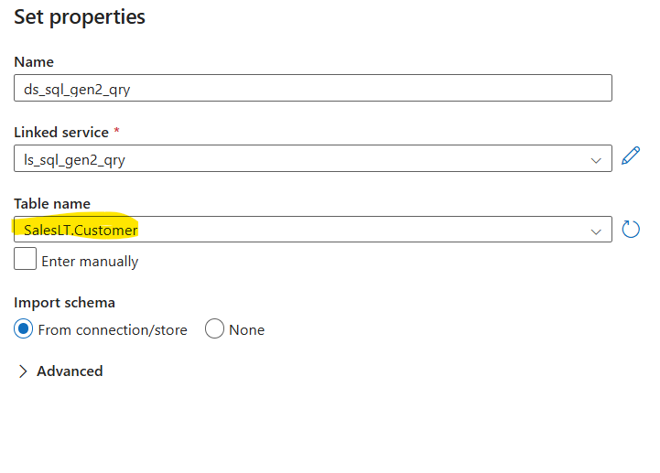
Finally these r the 3 created.
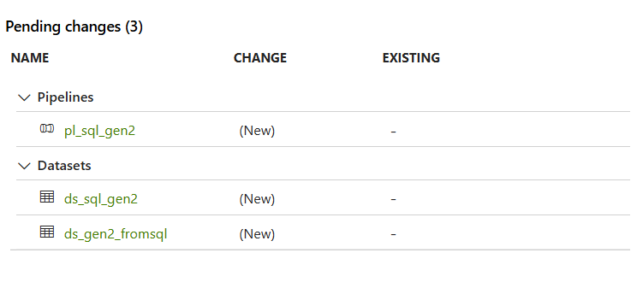
After successful debug, a csv file gets created with the content of the table.
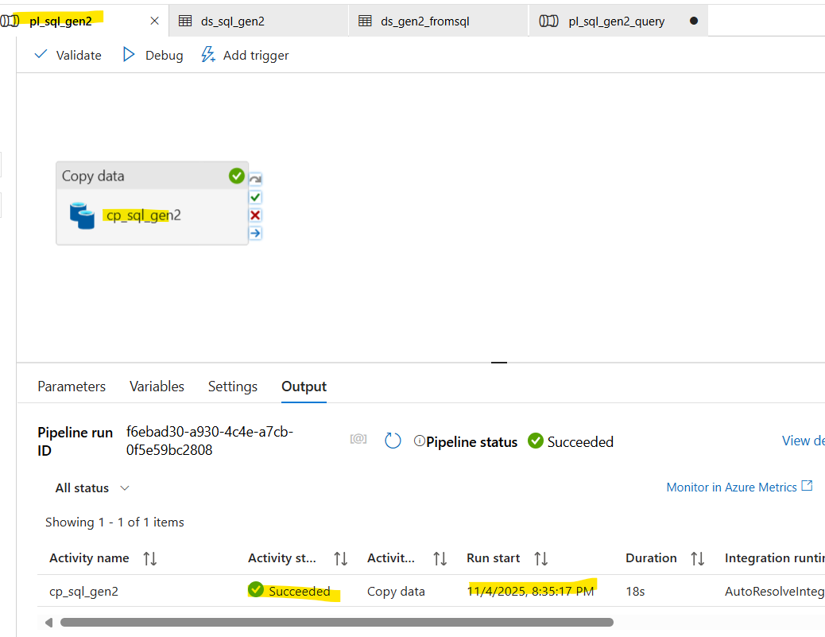
File is created in the destination folder.
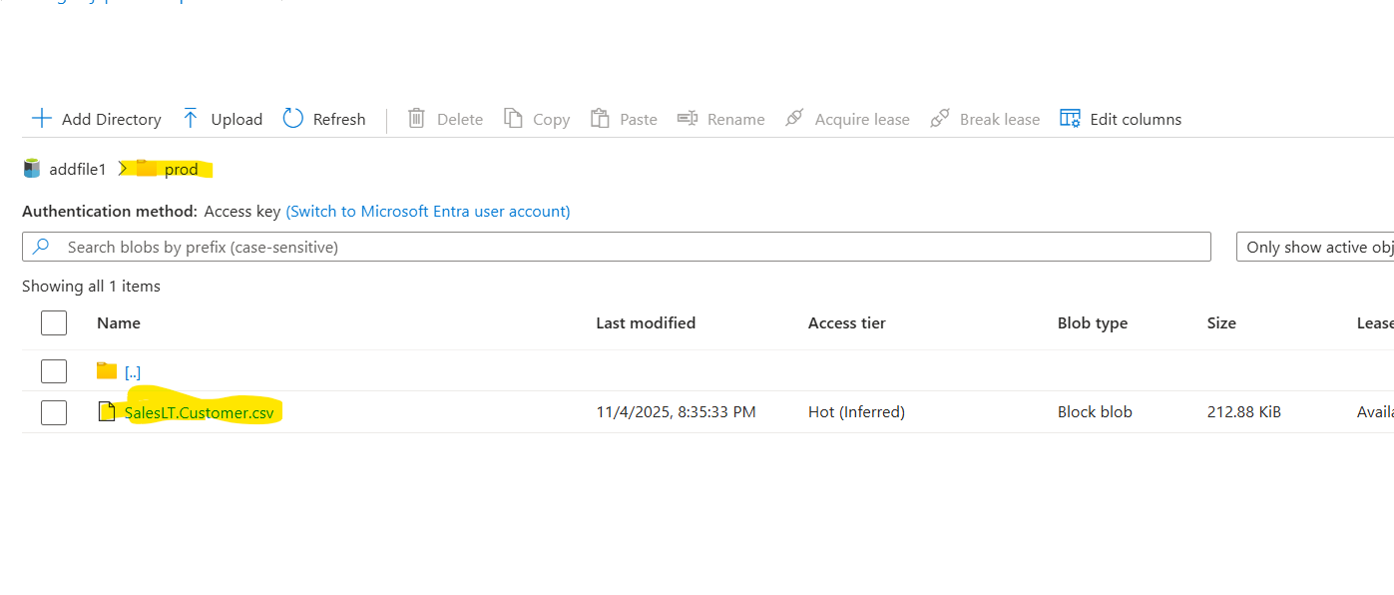
The content of the file has column names as the header and is a delimited text as selected.
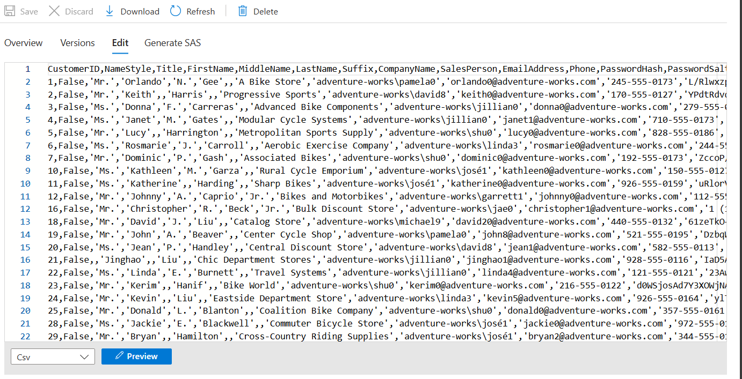
Seems like Boolean and int are not wrapped with ‘ or “.

Load data using Query:
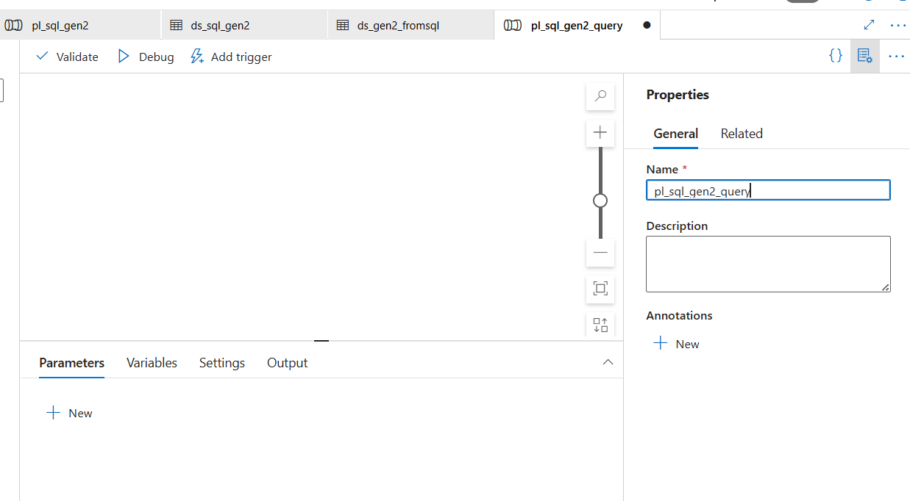
2. 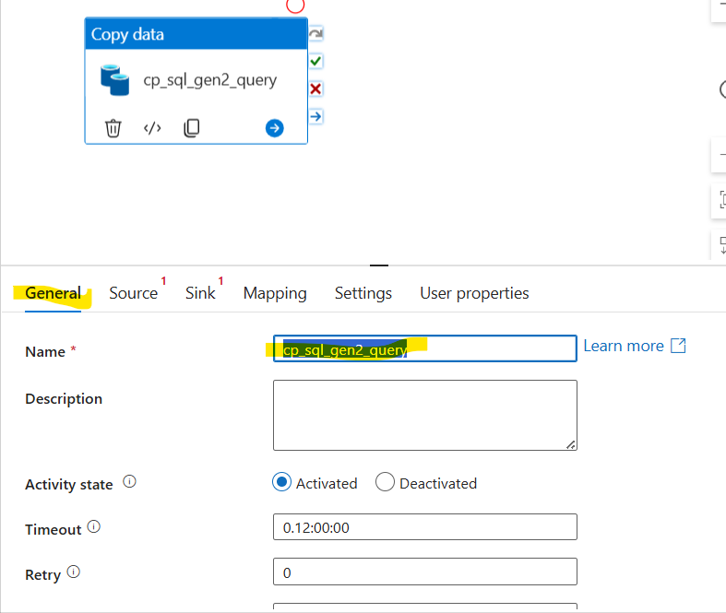
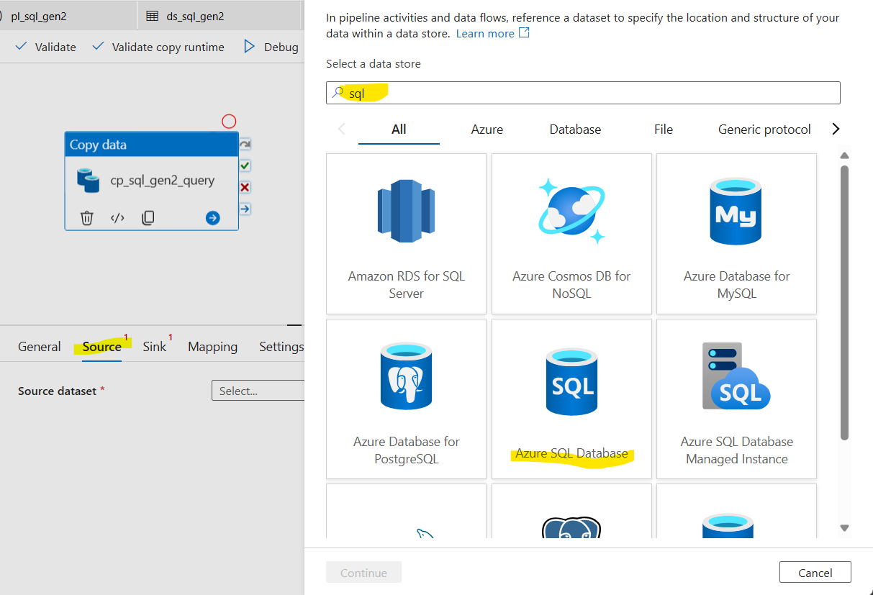
3. 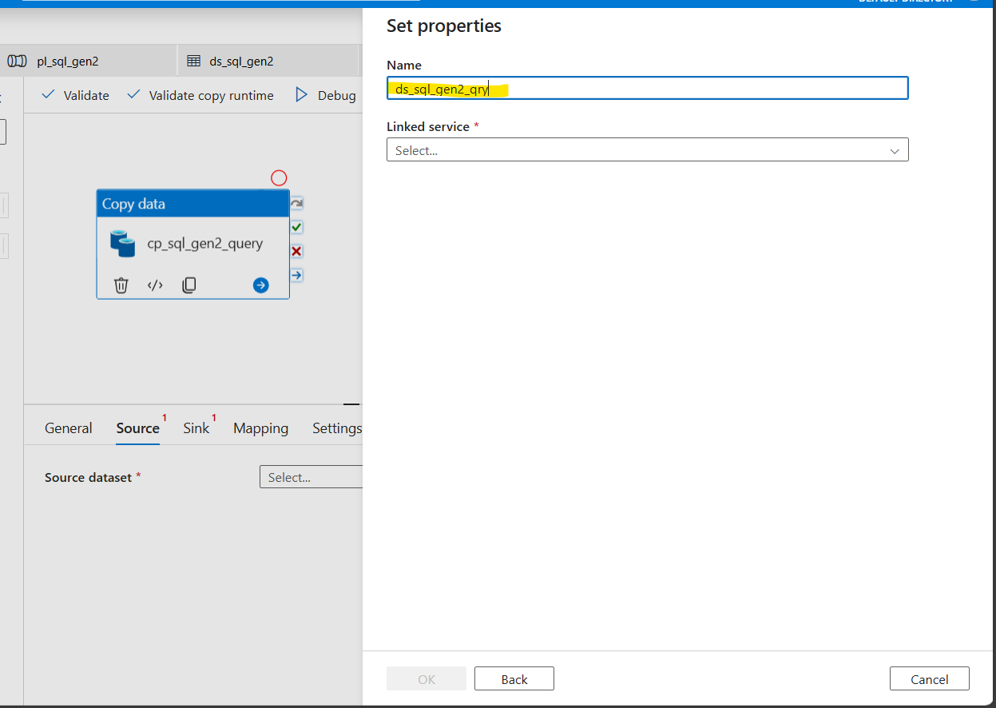
4. create new Linked server as below, we can use the 1st one but for practice creating new one.
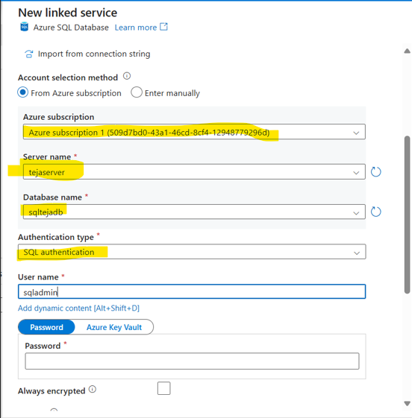

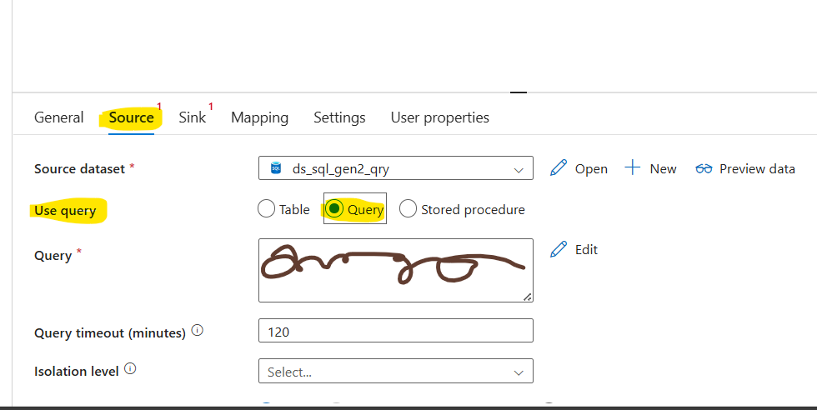
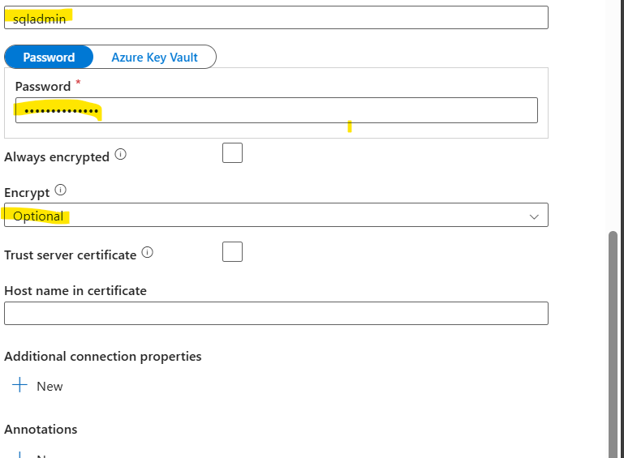
Linked service is created as above.

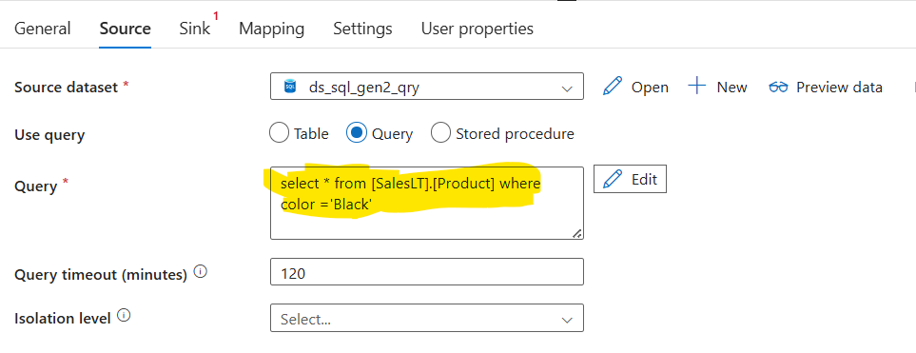

Preview the data to see the output:
Query and dataset works as expected.
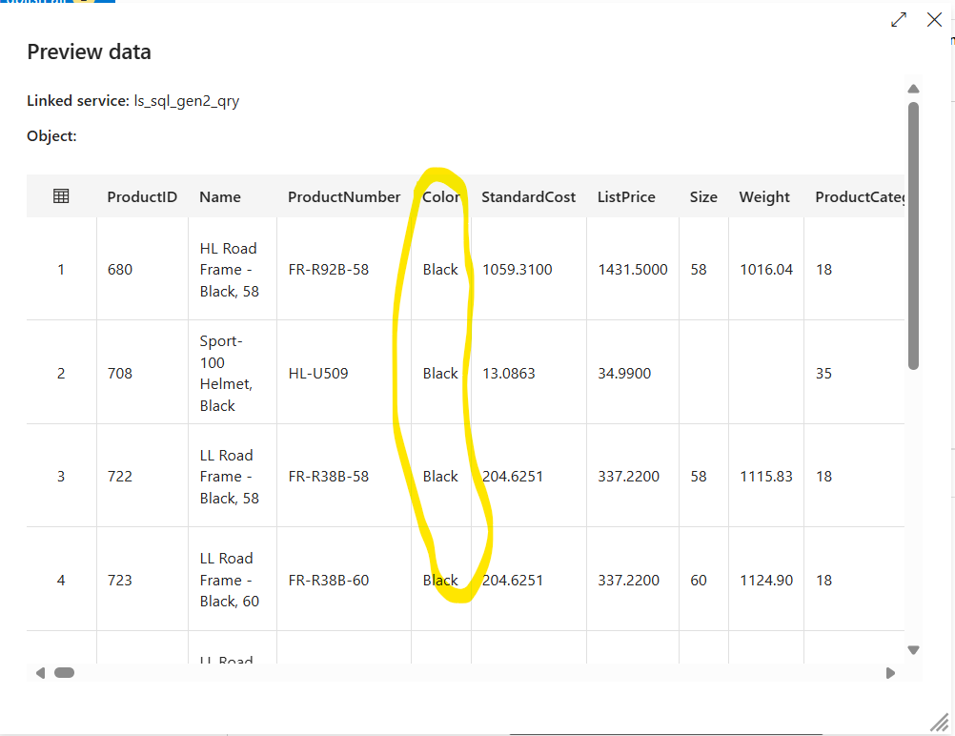
Proceed to create the sink service:
We can use the existing one or create new one to practice. This is the same Gen2 connection to connect to data lake gen2 storage.
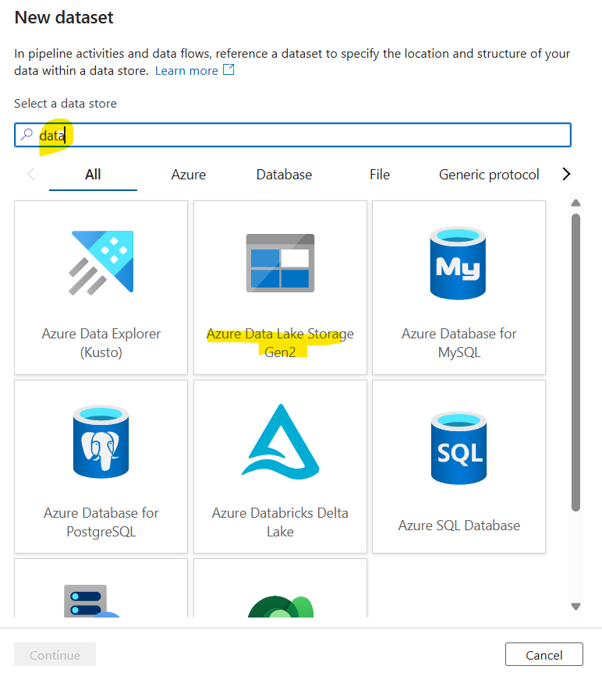

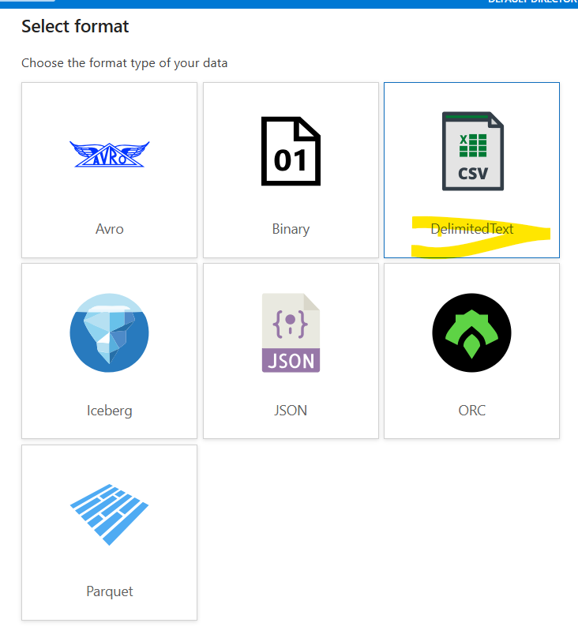

Selected the existing connection. Selected the main folder for now.
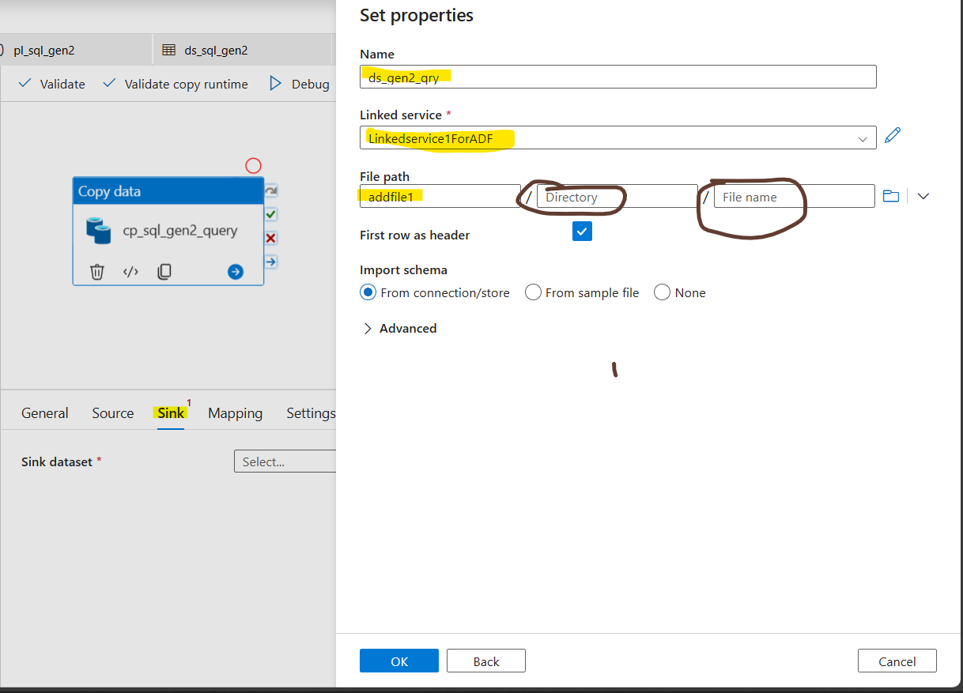
On successful execution of pipeline, file gets created in the main folder with Junk filename.
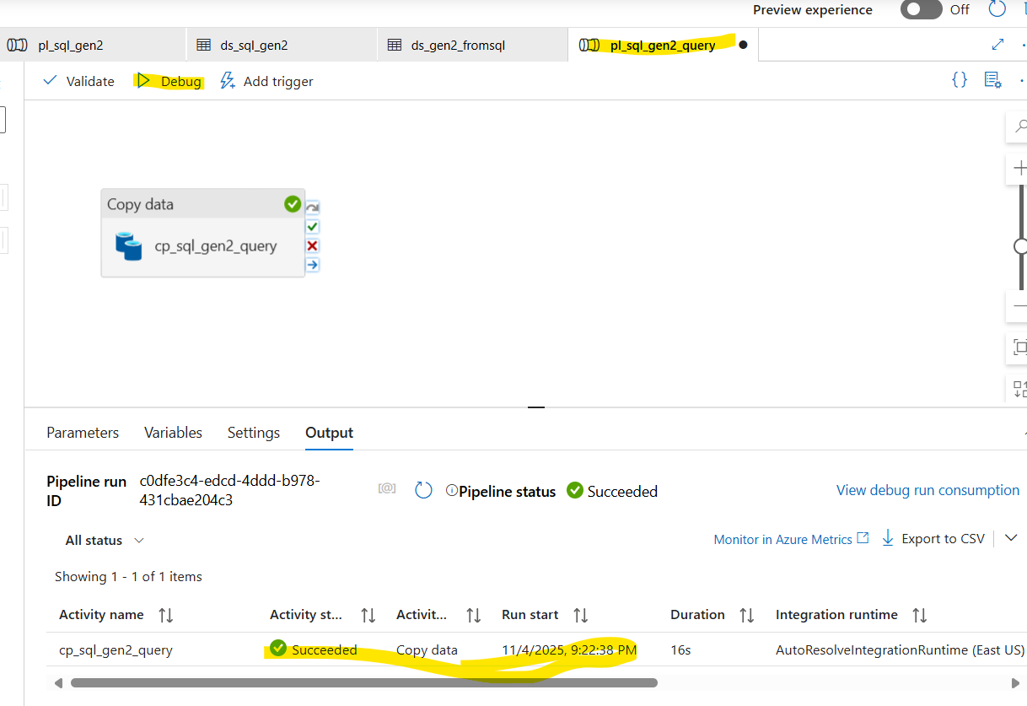
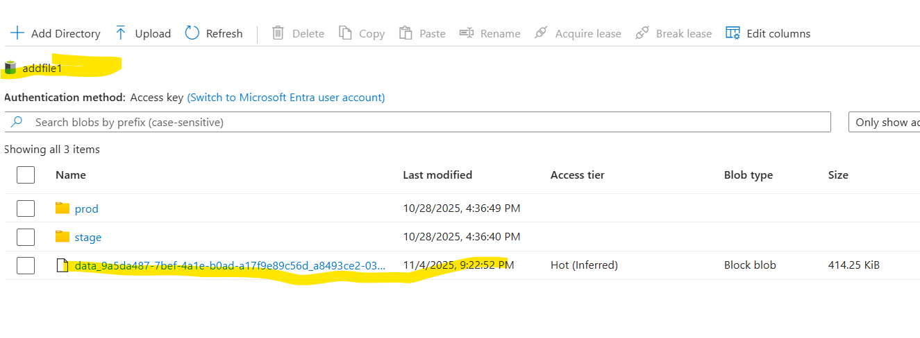
Load data using parameter:
Edit the source data set to accept tablename as a parameter like below:

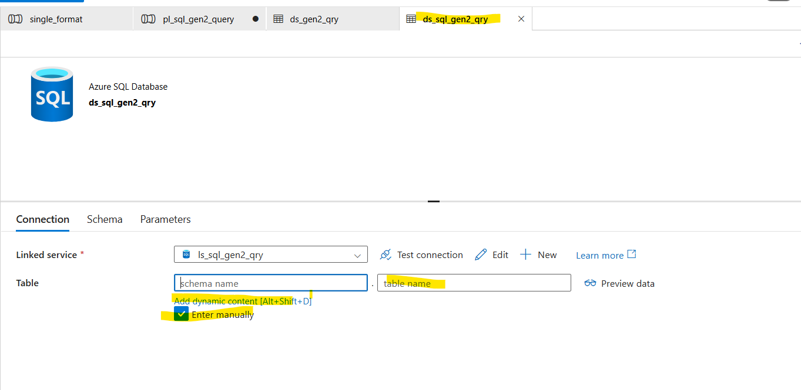
Create new table parameter by hard coding the value inside the creation.
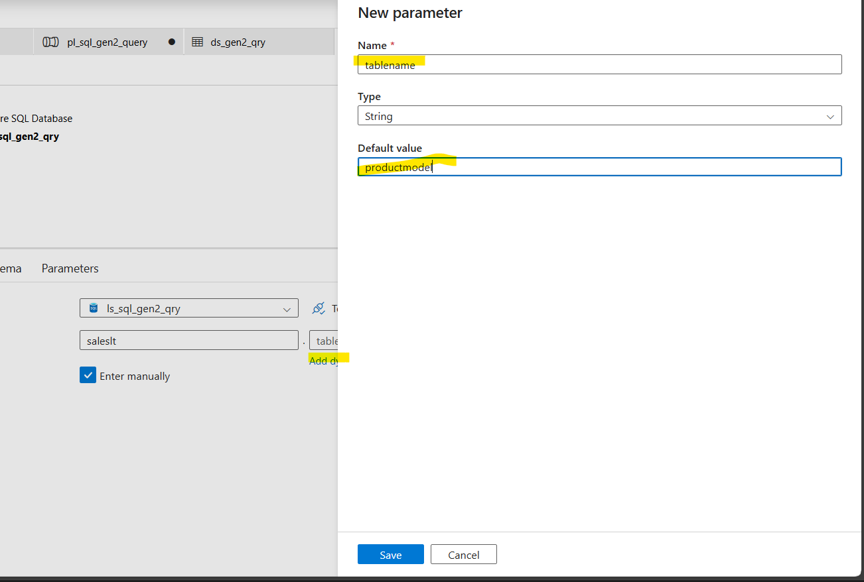
After creation select the same in the expression builder.
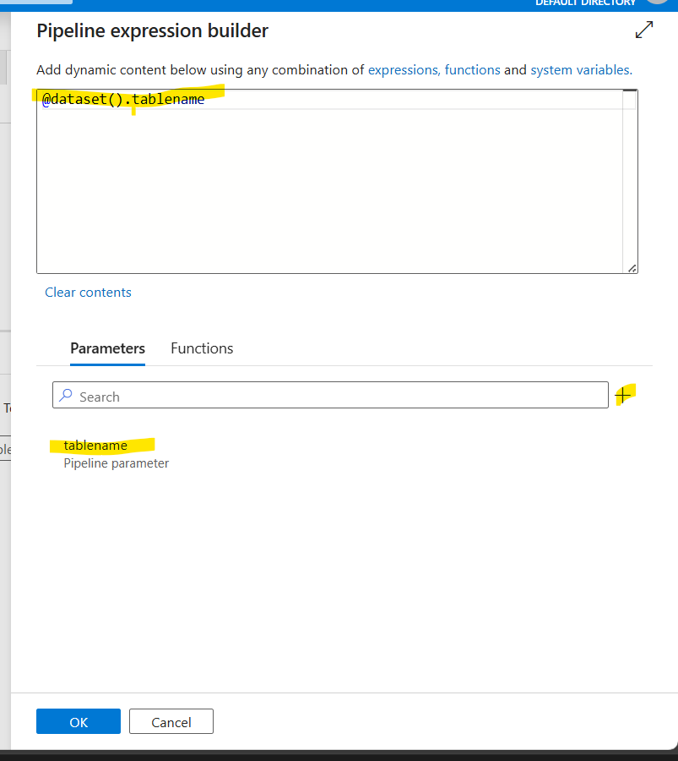
We can preview the table data from the preview option.
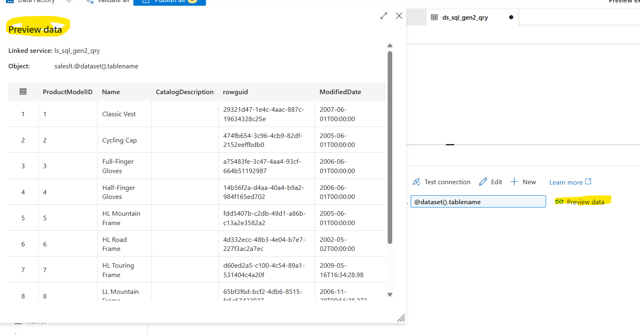
Adding dynamic content for filename:

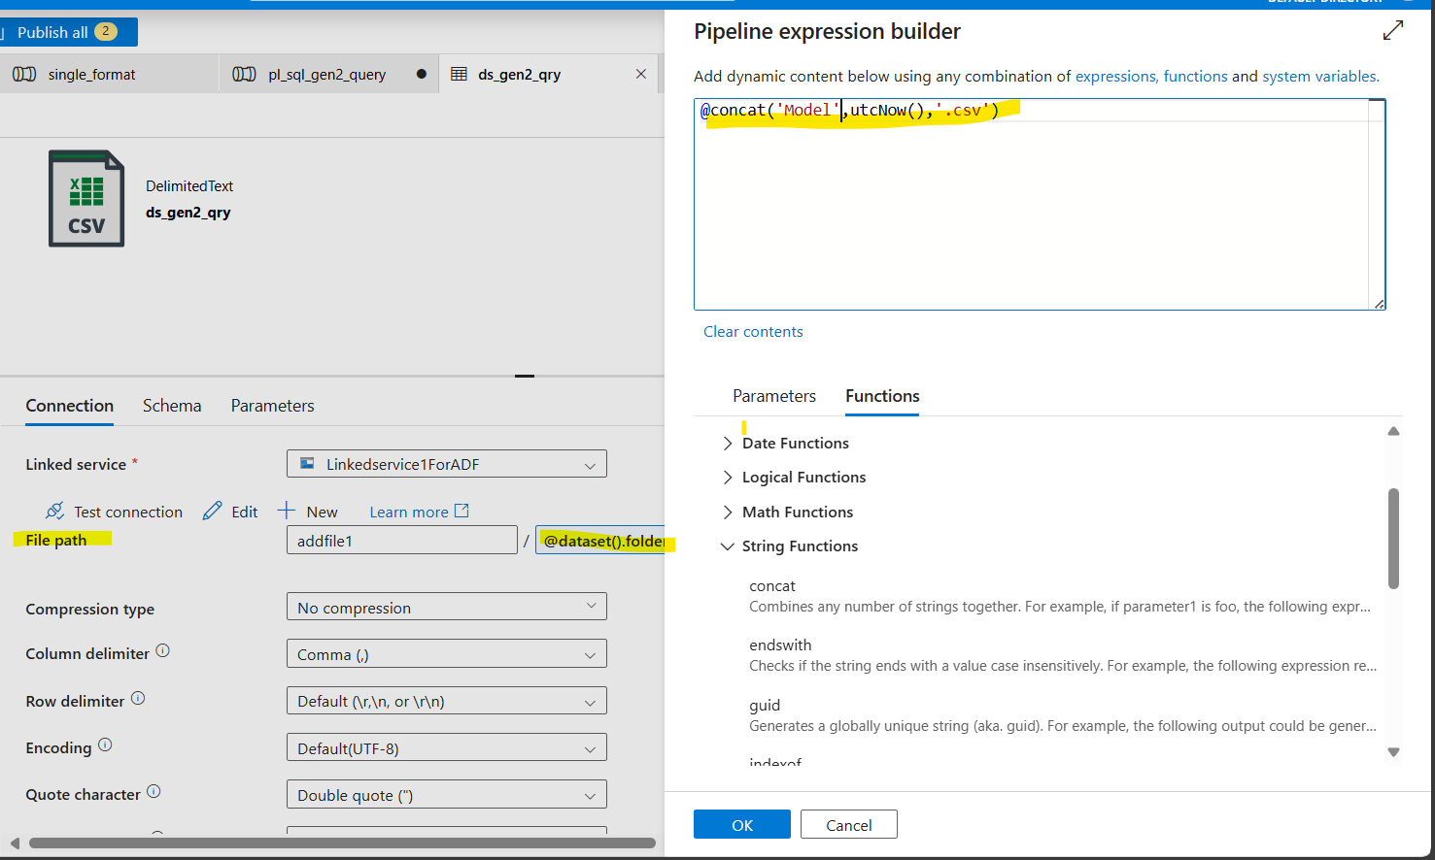

We can use preview to view the data.
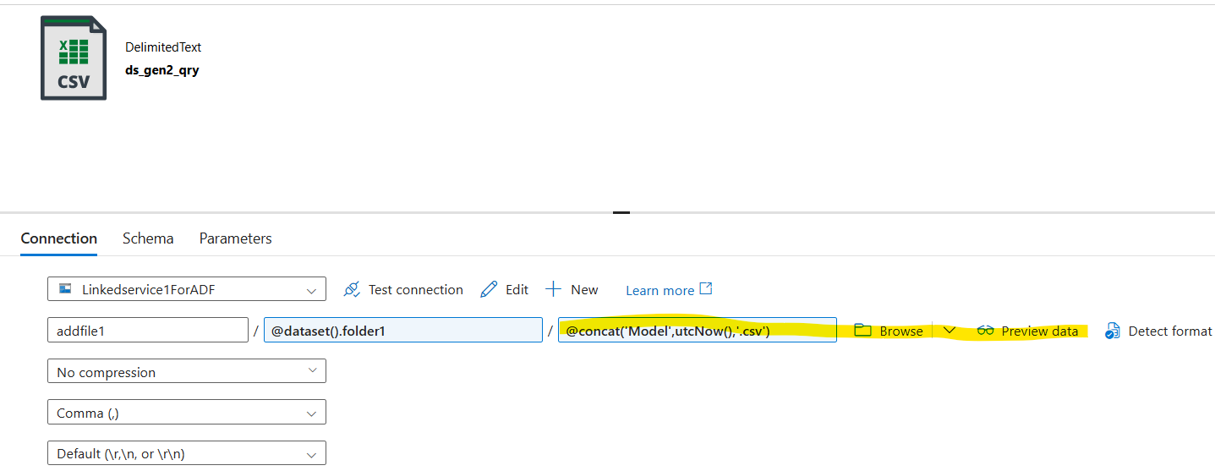
Preview failed as product folder doesn’t exist.
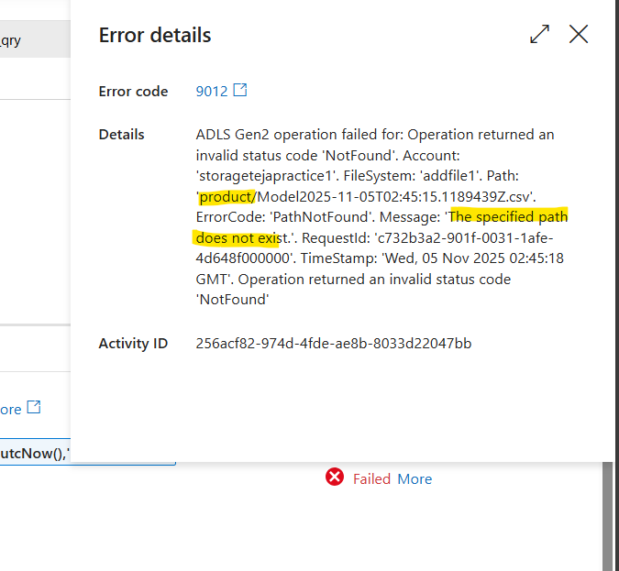
Corrected the folder name in parameter section.
The source and sink parameters will not be auto-refreshed, if there is a change, we need to deselect and select the same dataset again.
As per the flow, folder is created and file naming convention is followed.
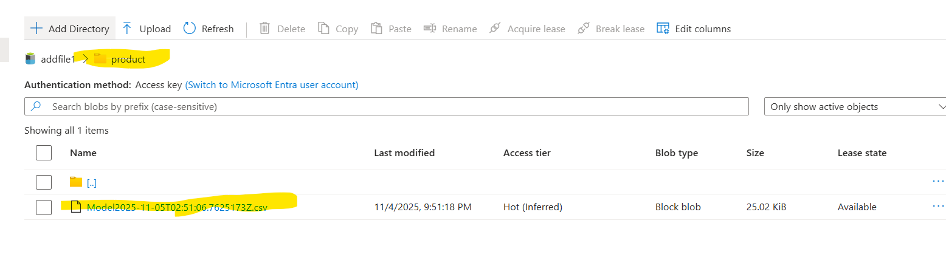
Content of the file is in correspondence with table data.
