Azure Data Engineering
HomeWork 9 Nov 5
The aim of the document is to create a loop, loop in the metadata table containing the table details, load the data from the table into the files and create the folders / files in the path mentioned in metadata.
Supporting SQL:
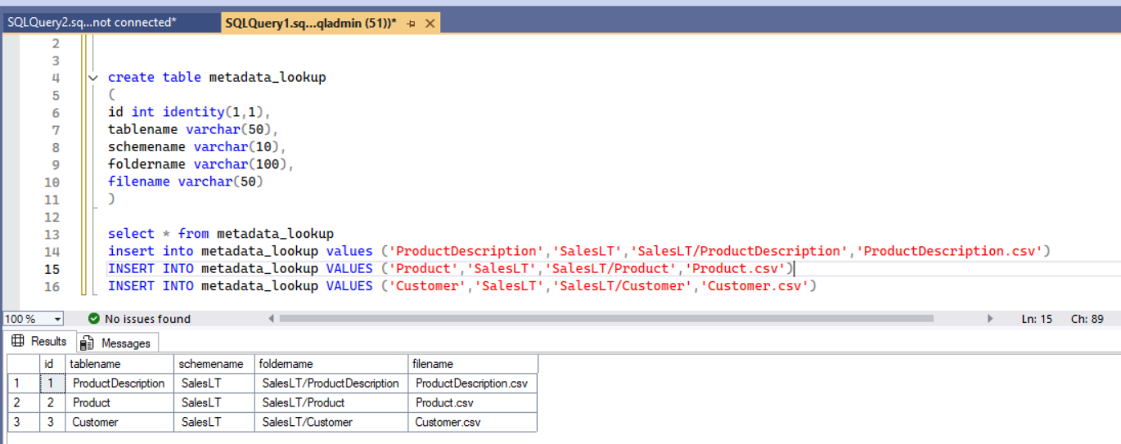

Creating a loop:
Pick and drop a Lookup Activity into a new pipeline
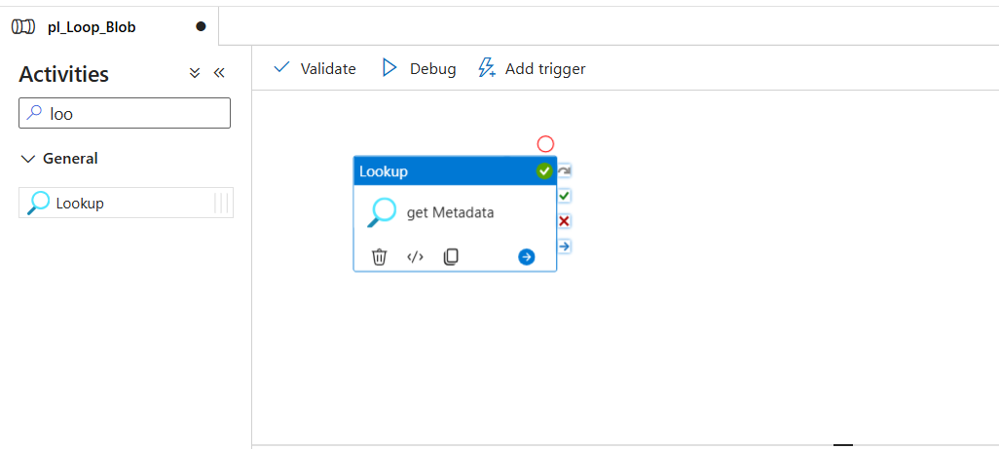
Name the loop up activity
In the settings tab, fill the highlighted fields
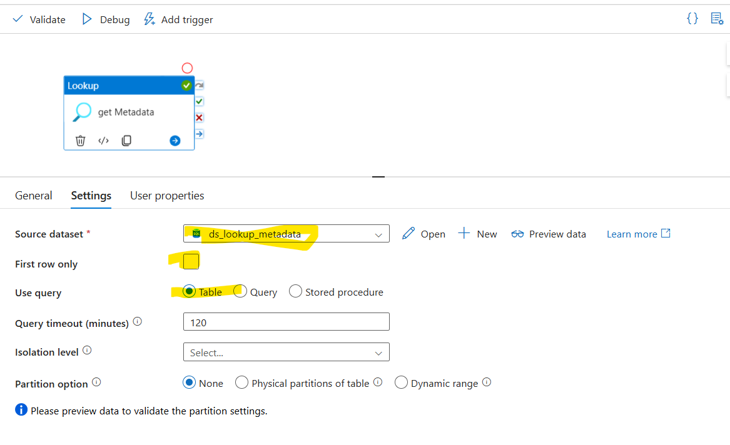
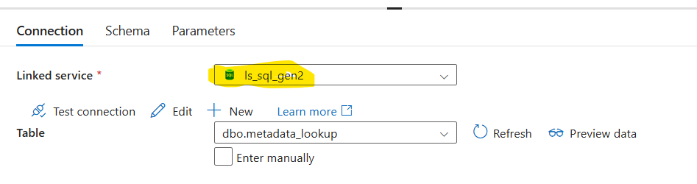
Connection (Linked Service): This is from prev. assignment.
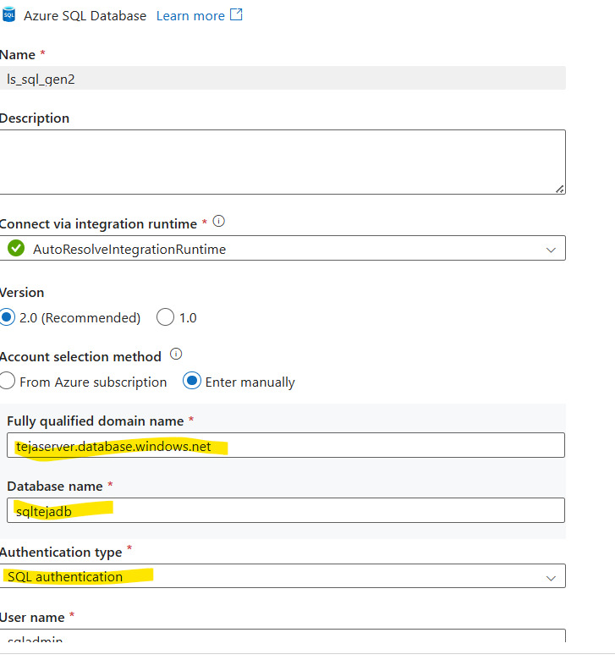
Data Preview:
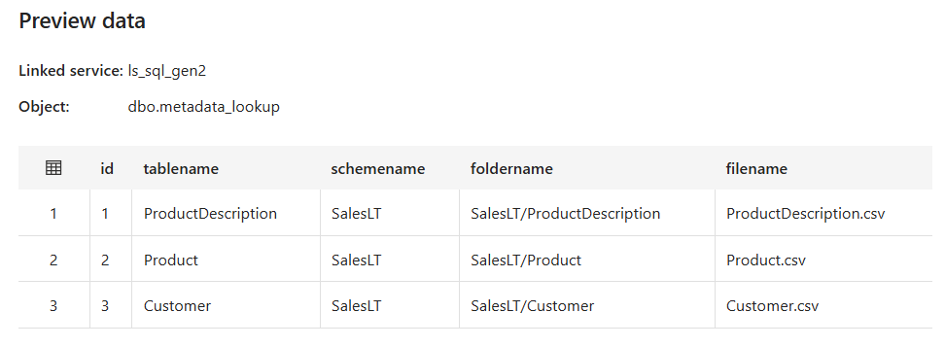
Ones the loop is executed, we can see the table output in an array as below:
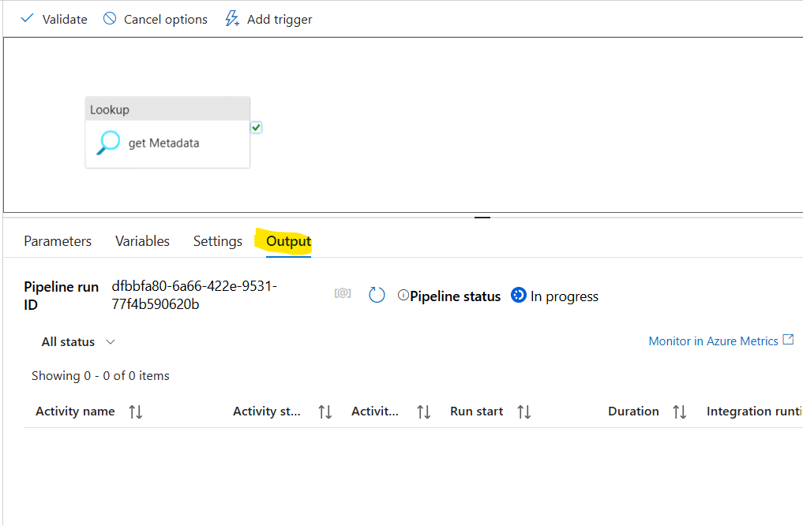
We have the feasibility to check output at the pink section.
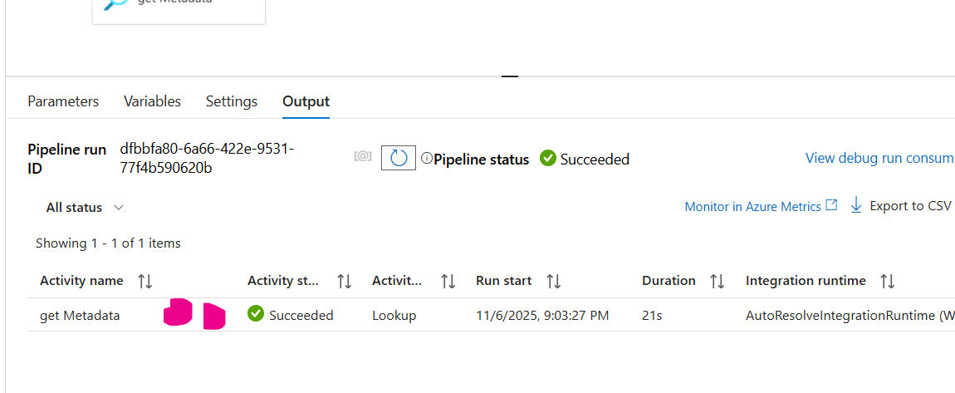
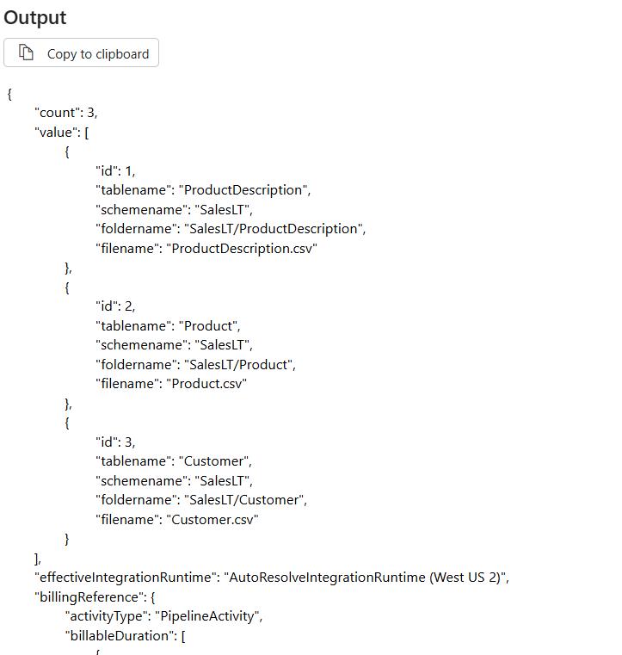
In the below image :
- Drag the forloop activity
- The pipeline would be visible in the right pane
- In the setting section, Item is the mandatory field
- We click on the dynamic content of the file and a popup opens
- We select the array content as we need total data for loop execution
- The logical value is visible on the selected section.
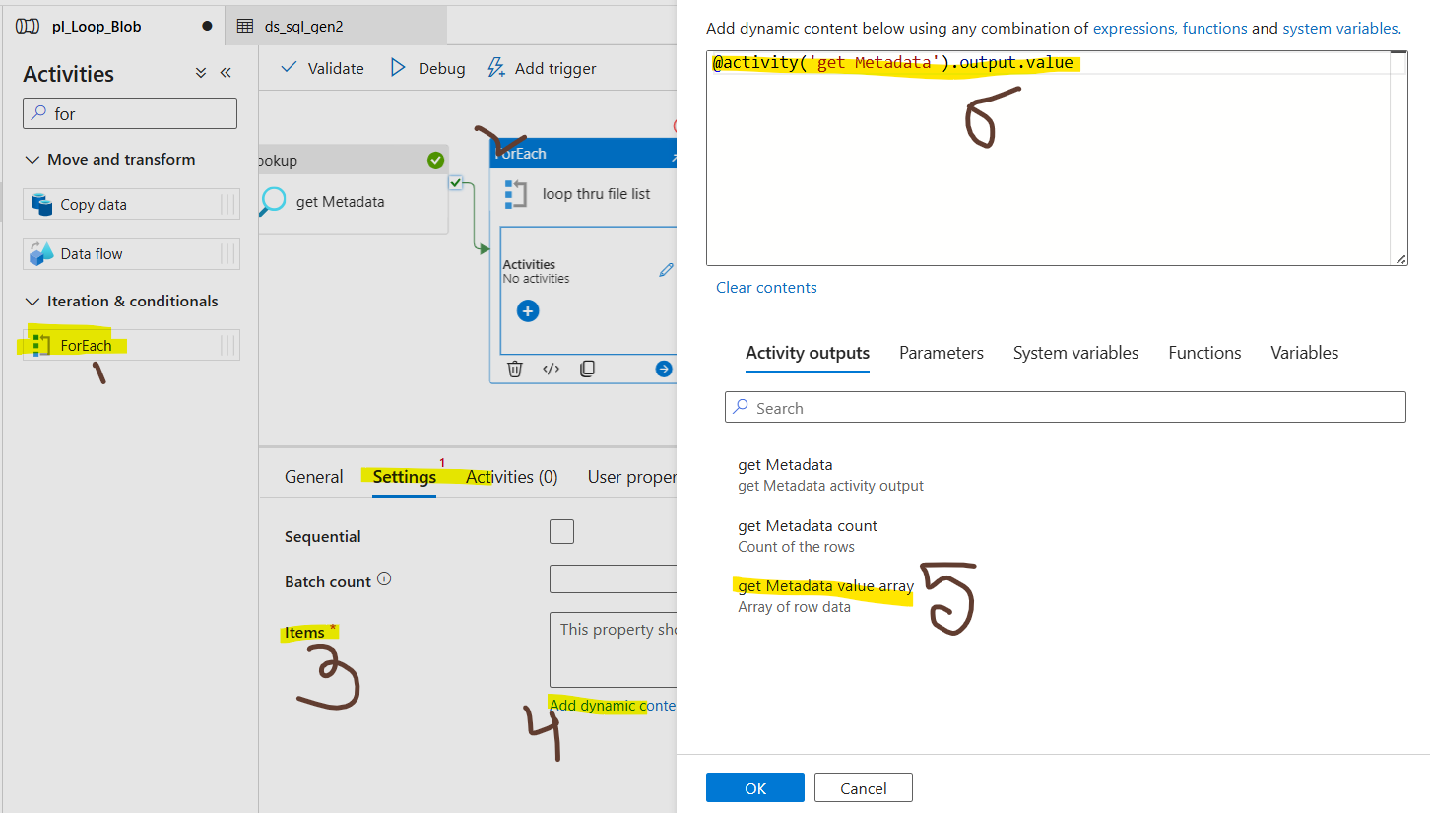
We need to click on the Pen Icon to add the activities that need to run in the loop
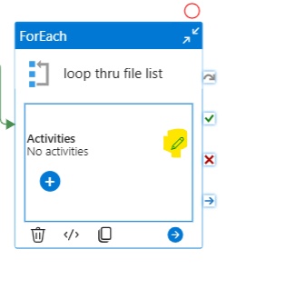
Within the loop, a copy data activity is dropped and below is how it appears.
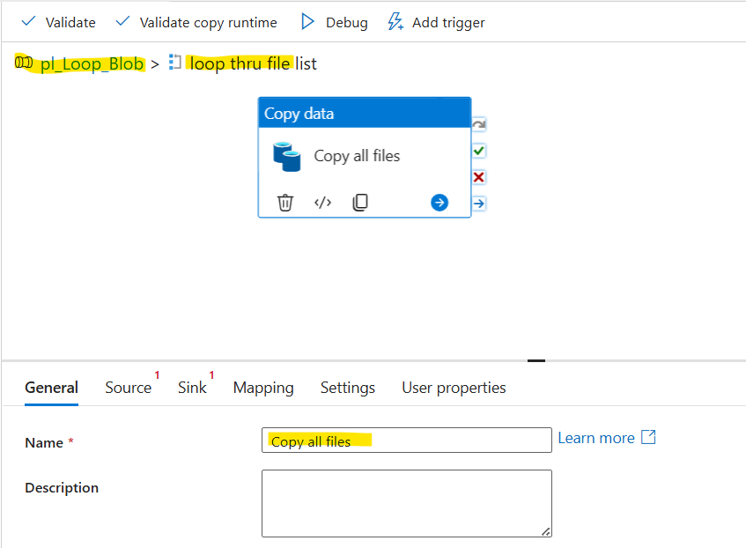
Dataset for the source side:
We select the table and scheme from the metadata output.
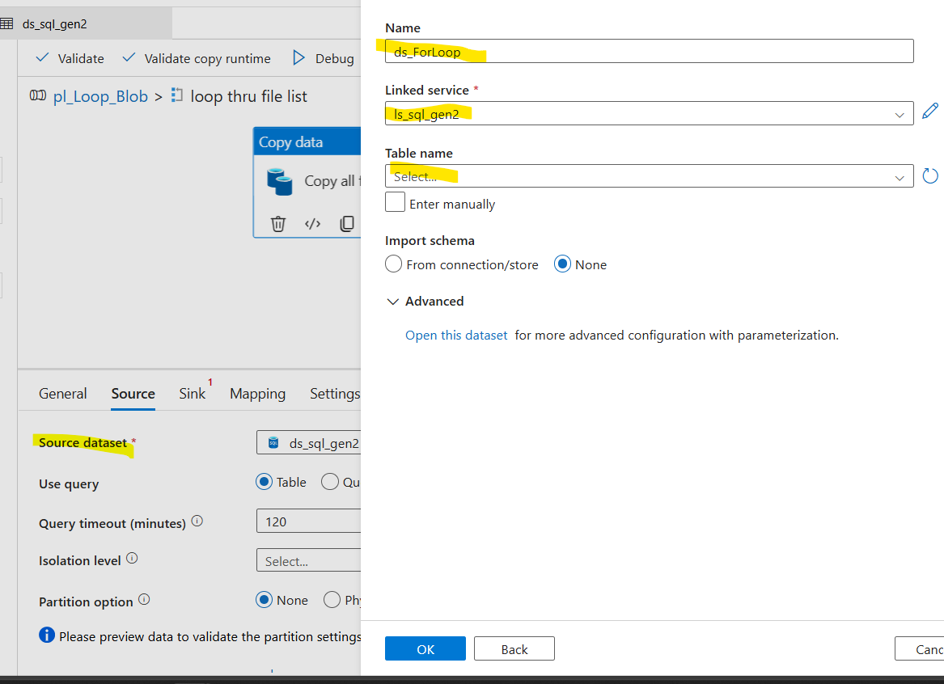
To add the table and scheme details, we open the dataset and add them in the parameters
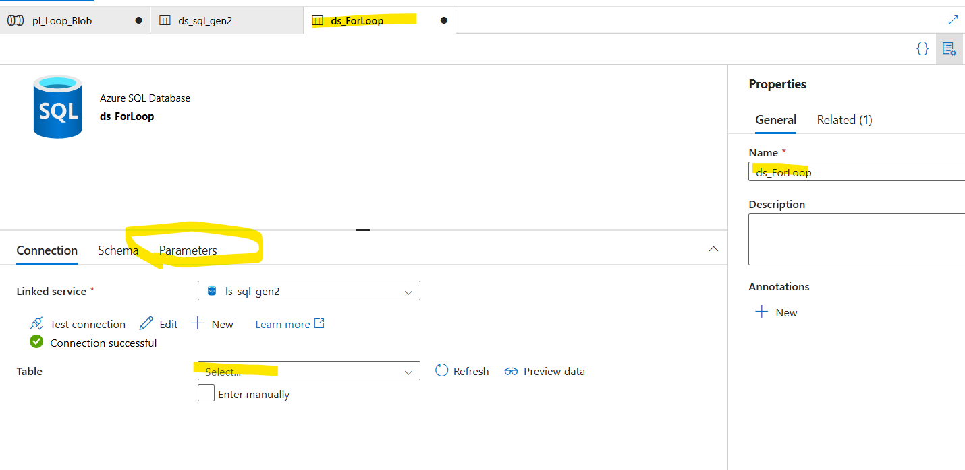
Add the parameters but don’t fill in any values. These changes are in Dataset.
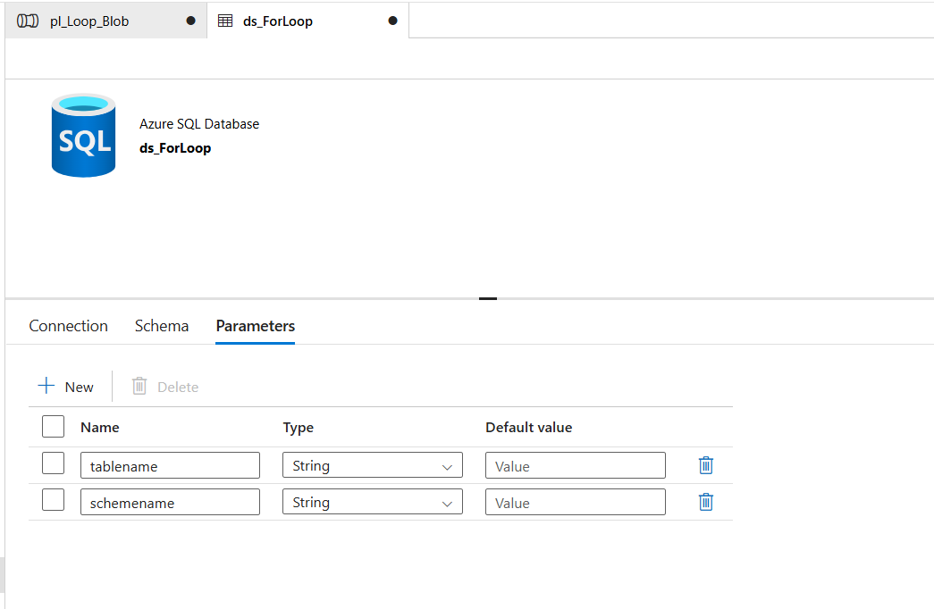
Ones dataset is re-selected in the activity, the 2 added params appear as below:
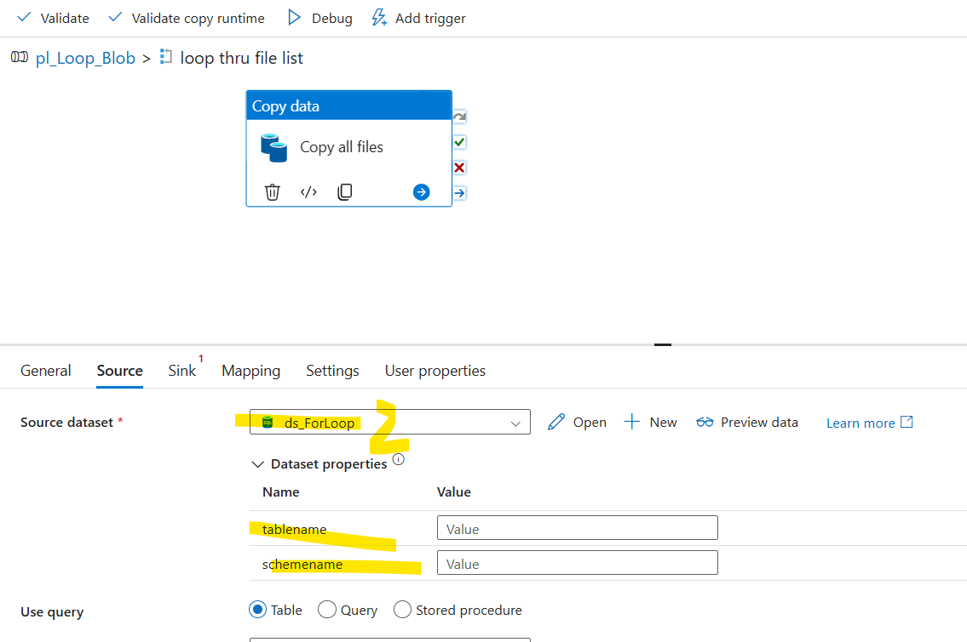
To select the table name, click on dynamic content and select the “loop file data”,
Then type the exact field name.
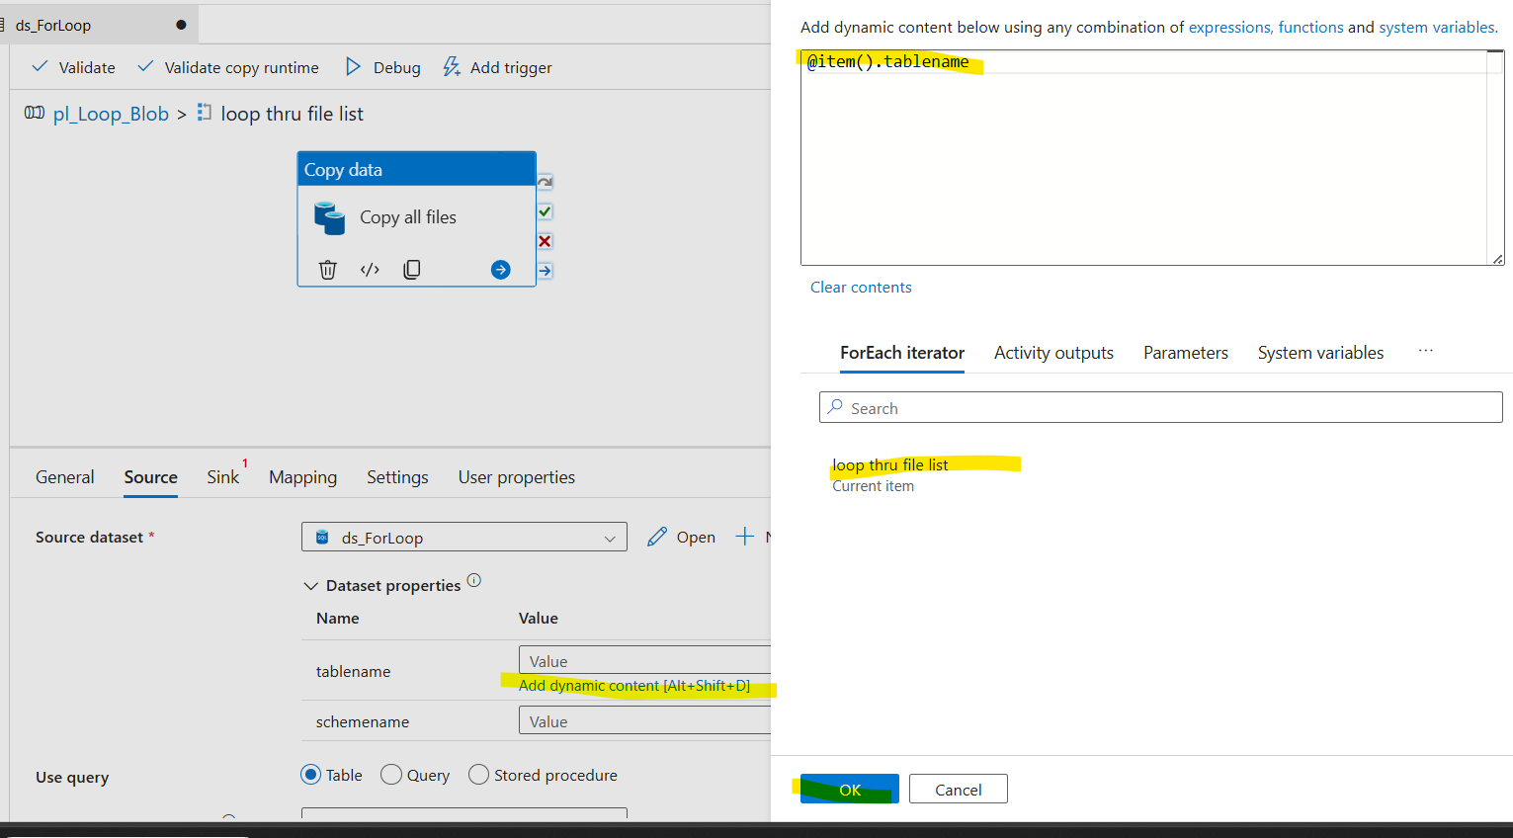
The data is filled for the source side
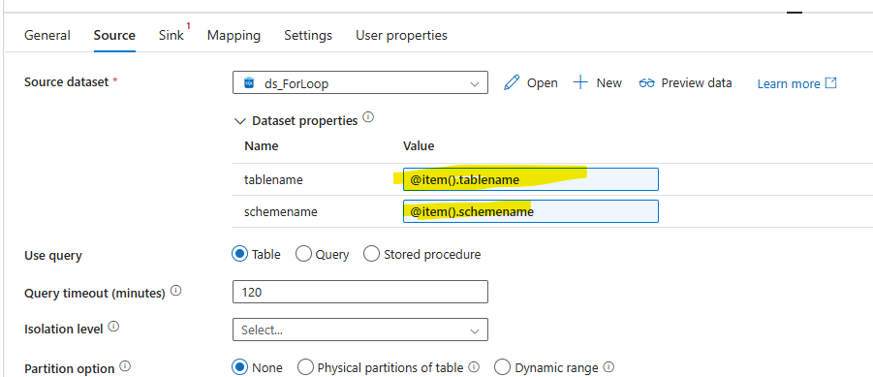
Sink side, create a new dataset and input folder and file parameters from the loop
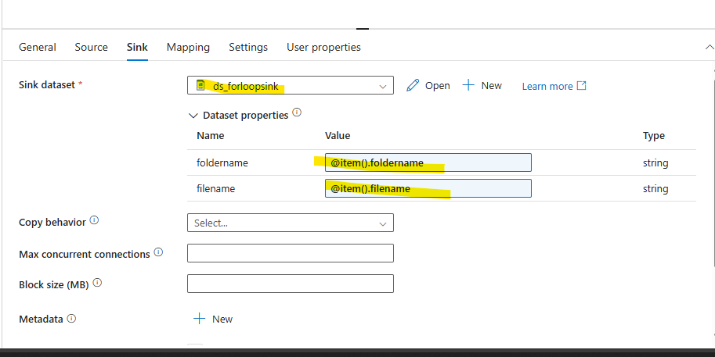
To get the parameter option, open the dataset and add them manually.

As there are 3 records in the table, 3 parallel executions happen and folder/files must be created.
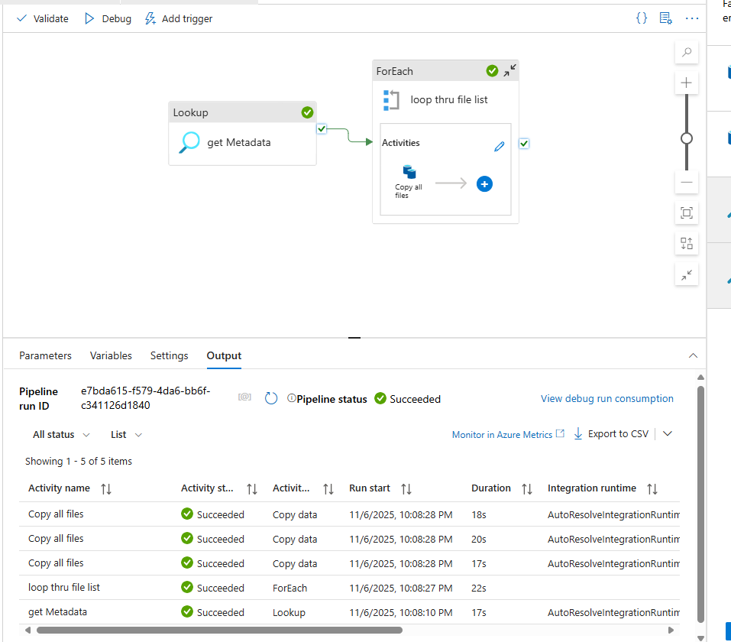
Mission successful.
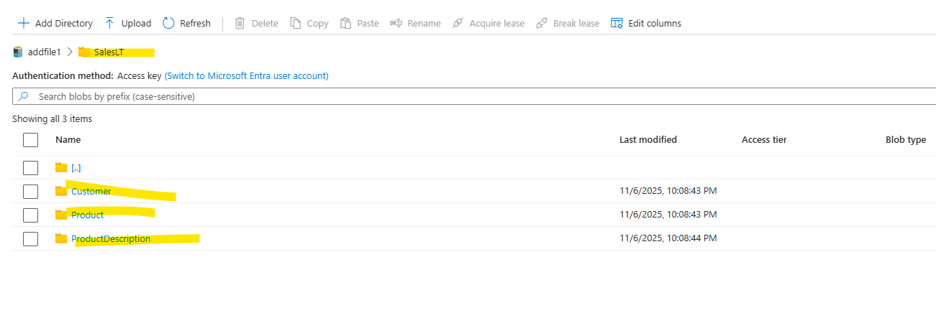

To use the same DS in both metadata and source setting will be like below:
The lookup will use, query option and source will use table name option.
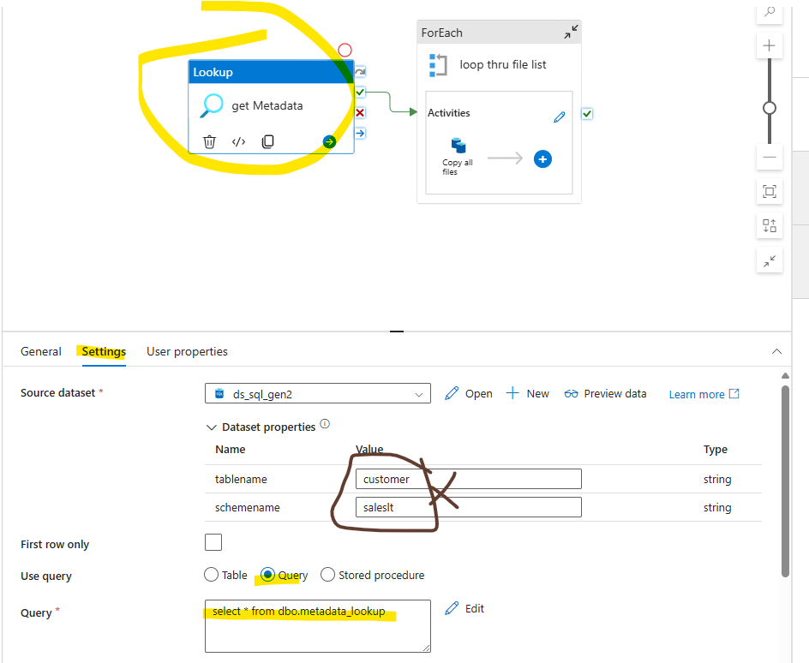
Even though table details are provided, Query takes precedence.
Source side:
