Azure Data Engineering
Homework -3 Oct 24

Explore Roles in storage account
We have specific Azure Role-Based Access Control (RBAC) roles to check existing Azure Storage Accounts. These roles grant the necessary permissions to view storage account details without modifying or deleting the account settings. Below is how we assign roles to individuals on storage account:
Got to IAM -> Role Assignments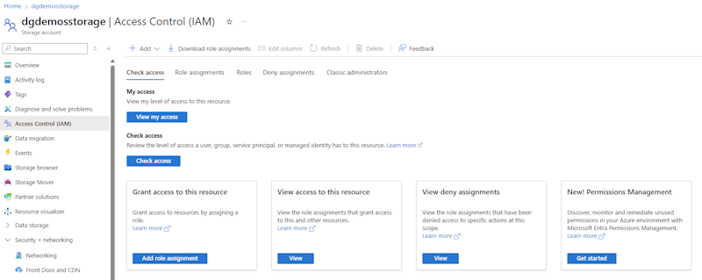
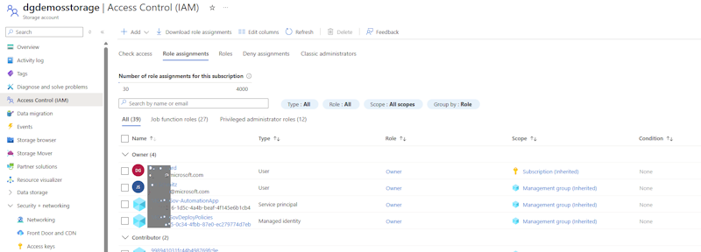
On the "Check Access" tab, click the [Add role assignment] button (Fig. 5) to display the "Add role assignment" dialog “Add role assignment”.
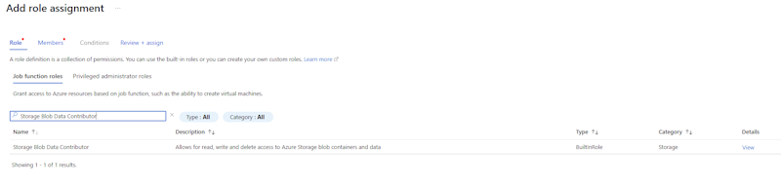
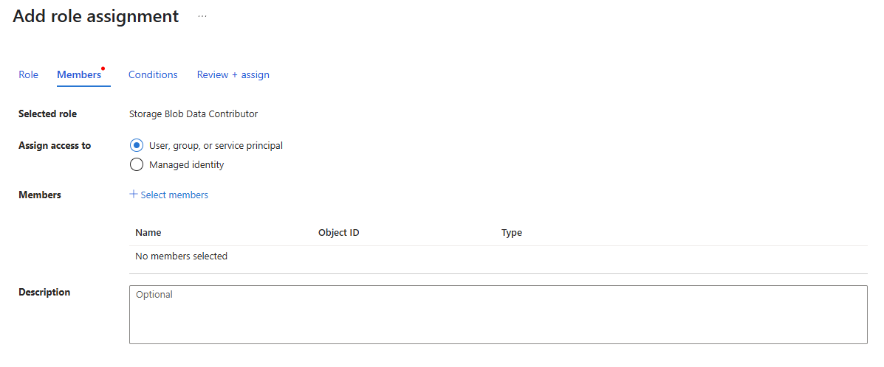
Select the Subscription ID for which the access needs to be granted and on Review and assign
Below are the key roles and their capabilities:
1. Reader Role
This is a built-in Azure role that provides read-only access to all resources within a subscription or resource group, including storage accounts. It allows users to:
View storage account properties.
Access configurations and settings without making changes.
2. Storage Account Contributor
This role provides broader access, including the ability to manage storage accounts. However, for simply checking existing accounts, this role is not strictly necessary unless additional management tasks are required.
3. Storage Account Reader
This role is more specific to storage accounts and allows users to:
View storage account properties. Access monitoring data and metrics.
4. Storage Blob Data Reader
If you need to check the contents of blob containers within a storage account, this role is required. It allows read-only access to blob data.
5. Custom Roles
For more granular control, you can create a custom role with the following permissions:
Microsoft.Storage/storageAccounts/read: Allows reading storage account properties.
Microsoft.Storage/storageAccounts/listKeys/action: Enables listing access keys if required for verification.
Assigning Roles
Roles can be assigned at different scopes:
Subscription Level: Grants access to all storage accounts within the subscription.
Resource Group Level: Limits access to storage accounts within a specific resource group.
Storage Account Level: Restricts access to a single storage account.
What is the difference between ACL and identity access management
Identity Access Management primarily focused on managing user identities and their access rights across Azure resources. It uses RBAC to assign permissions based on roles, allowing for more granular control over access
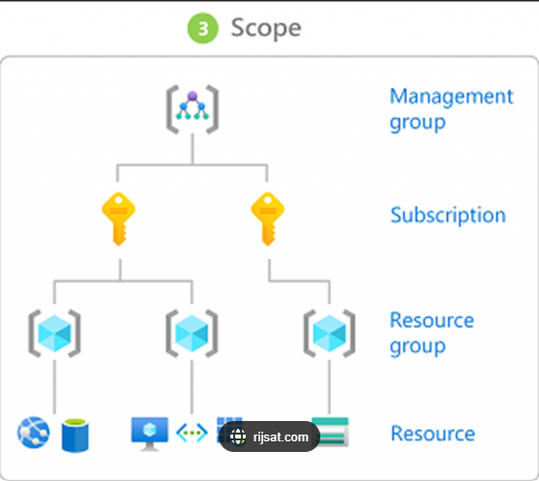
ACLs are used to specify permissions for individual security principals (users, groups, or service principals) on specific resources. They provide more detailed and customized access control compared to IAM. These permissions are explicit, granular, and identity-specific, making ACL an ideal choice for scenarios with nuanced or complex access requirements.
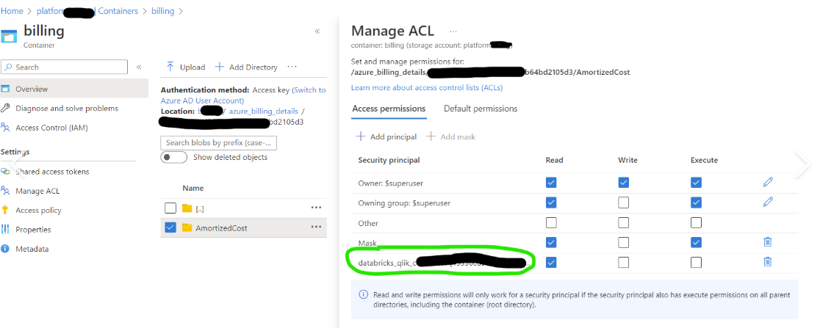
For small teams or highly specialized tasks, ACL builds customized control down to the individual.
For larger organizations and widespread responsibilities, RBAC takes the crown because nobody has the time—or patience—to create permissions for "a thousand individual Tracys."
Create azure accounts
Open Portal.azure.com

