Azure Data Engineering
Homework -4 Oct 27

What is ETL?
- ETL is the process of moving data from multiple sources, cleaning and standardizing it, then loading it into a destination system for analysis.
- ETL stands for Extract, Transform, Load—the three-step process for moving data from source systems into destinations like data warehouses or analytics platforms:
- Copying data from source systems,Cleaning, standardizing, and restructuring the data and Moving the processed data into the target system.
- ETL solves common business data challenges like Data silos (Information trapped in separate systems becomes accessible), Inconsistent formats, Poor data quality, Performance issues
- Common ETL Use Cases: Data warehousing, Business intelligence, Data migration, Compliance reporting.

What is ELT?
- A newer approach called ELT (Extract, Load, Transform) changes the order, Load raw data first, then transform as needed, better for big data and cloud platforms with powerful processing capabilities.
- ELT is most useful for processing the large data sets required for business intelligence (BI) and big data analytics. Nonrelational and unstructured data is more conducive for an ELT approach because the data is copied "as is" from the source.
- Data type conversion may need to be performed as part of the load process if the source and target data stores do not support all the same data types. Such problems can also occur when moving data from one relational database management system (DBMS) to another, such as say Oracle to Db2, because the data types supported differ from DBMS to DBMS.
- With an ELT approach, a data extraction tool is used to obtain data from a source or sources, and the extracted data is stored in a staging area or database.
- Any required business rules and data integrity checks can be run on the data in the staging area before it is loaded into the data warehouse. All data transformations occur in the data warehouse after the data is loaded.

Key differences between ETL and ELT.
Feature | ETL | ELT
Transformation Stage | Before loading | After loading
Processing Power | Limited by ETL tool/server | Enhanced by cloud data warehouse
Scalability | Less scalable | Highly scalable
Flexibility | Limited to predefined transformations | Allows on-demand transformations
Cost | Higher infrastructure costs | Lower costs leveraging cloud

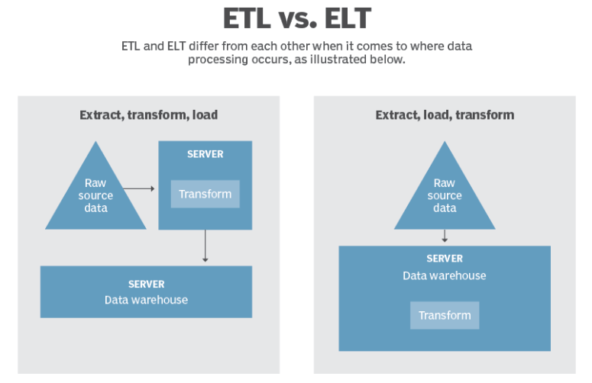

Mention 3 cloud tools that support ELT
ELT is faster performing, scalable, and better align with cloud-native infrastructure than ETL.
Few ELT tools that modern data teams would consider are : Azure Data Factory, FiveTran, Airbyte, Stitch, Matillion, Informatica Cloud Data Integration, Oracle Data Integrator, IBM DataStage, Dataform (by Google Cloud), AWS Glue etc.,
Choosing the right ELT tool in 2025 depends on your team’s size, technical maturity, and integration needs. From open-source platforms like Airbyte and Meltano to enterprise-ready tools like Fivetran, Informatica, and Matillion, there’s a solution for every use case. As data becomes more complex and distributed, investing in the right ELT platform can dramatically enhance your analytics capability and overall digital strategy.

Explain how cloud transformation improves automation and reduces manual effort.
Cloud transformation significantly enhances automation and reduces manual effort by leveraging cloud automation tools and processes. These tools automate manual tasks associated with provisioning, configuring, and managing cloud environments, such as resource allocation, scaling, configuration management, and deployment of applications.
By automating these tasks, organizations can achieve faster deployment times, greater consistency across their IT infrastructure, and a reduction in the potential for human error.
By leveraging cloud automation, organizations can accelerate their digital transformation efforts, allowing them to respond swiftly to changing market demands while optimizing operational costs.

