Azure Data Engineering
Homework -5 Oct 28

Creating a Storage Account, Container, and ADF instance

Storage Account Creation
Step1: search for storage account and select the first option. Then select the create option as highlighted below.
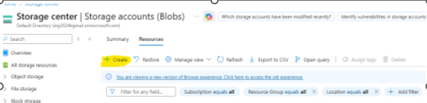
Step2: Fill in the mandatory and key fields highlighted below. A resource group can be created as needed or existing one can be used. Storage account needs to be unique and lower case. Redundancy needs to be selected as preferred. Local is cost effective and sufficient for testing.
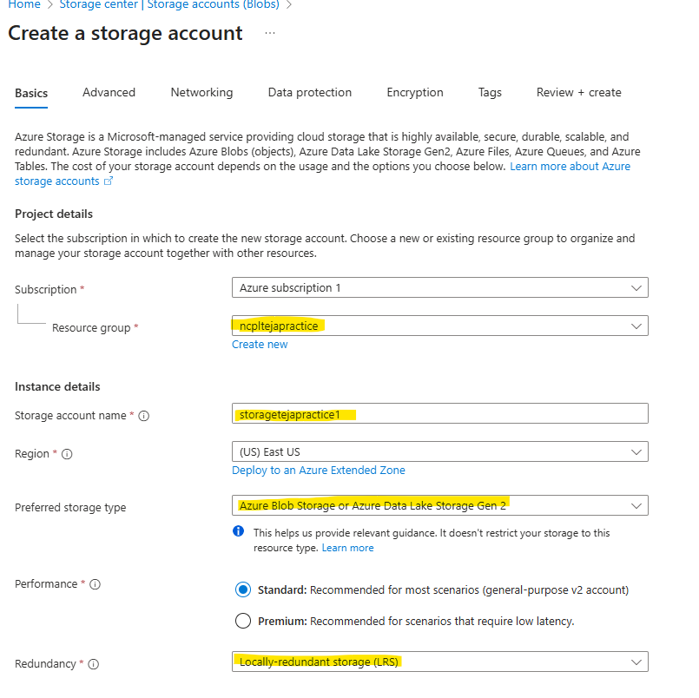
Step3: Select the Enable Hierarchical namespace option for Data Lake Gen2 storage. Then click on Review +Create option.
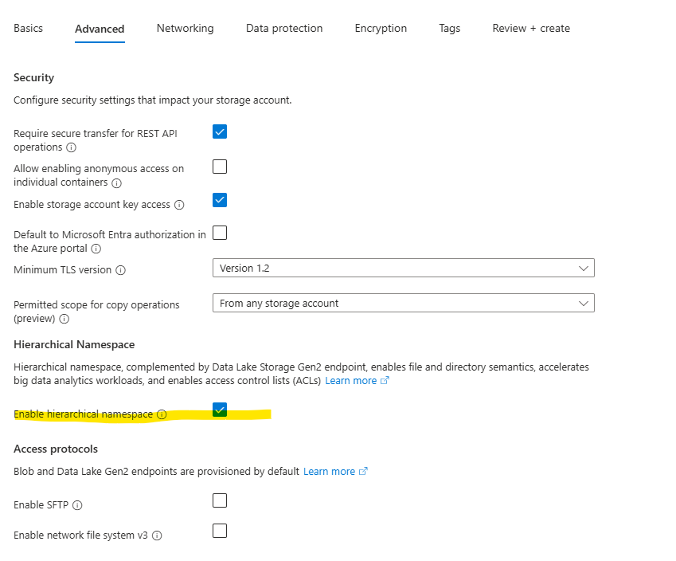
Step4: wait till deployment is completed and the screen as shown below needs to be displayed. This makes the storage account creation complete. We must be able to view this under our list of resources.
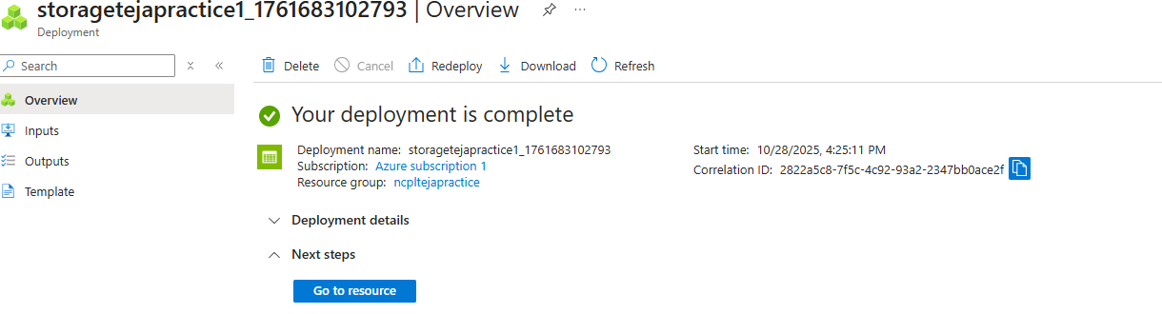
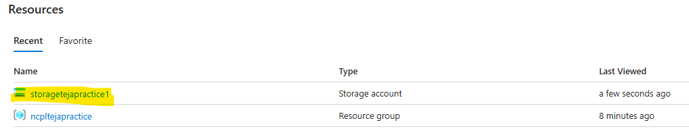

Container Creation
Step1: Open the storage account and select the container from left panel.
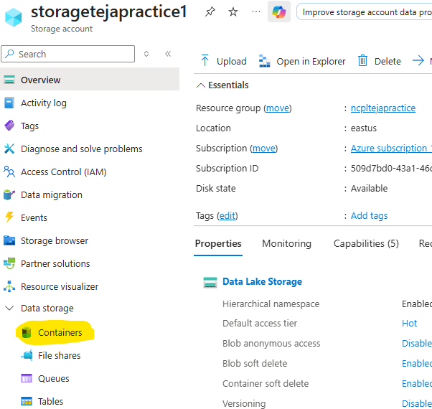
Step2: Container section opens and click on “Add container” button.
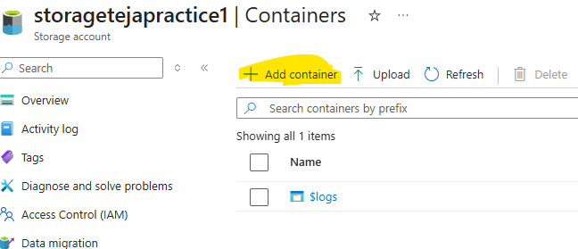

Step3: Give a name to the container and click on create, we can create directories(Folders) in the container like shown below using Add directory option highlighted.
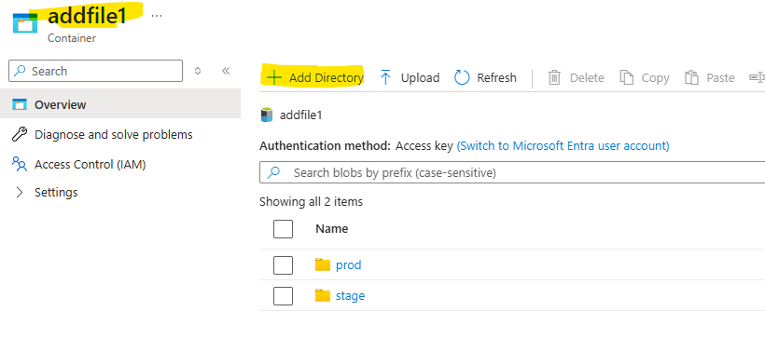

ADF instance Creation
Step1: search for Data Factory and select the first option, icon as shown below would appear and click on the create button, if we have already created ADFs, list would be displayed along with create option.
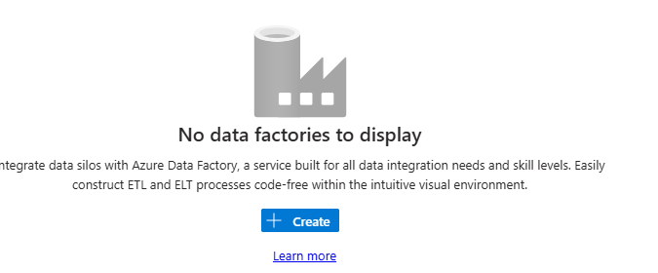

Step2: After clicking on create, below screen gets displayed where we input the mandatory details like ADF instance name, Region where it needs to be created, and click on create as this is for testing purpose. Projects might need GIT config, Tags, Networking options to be filled.
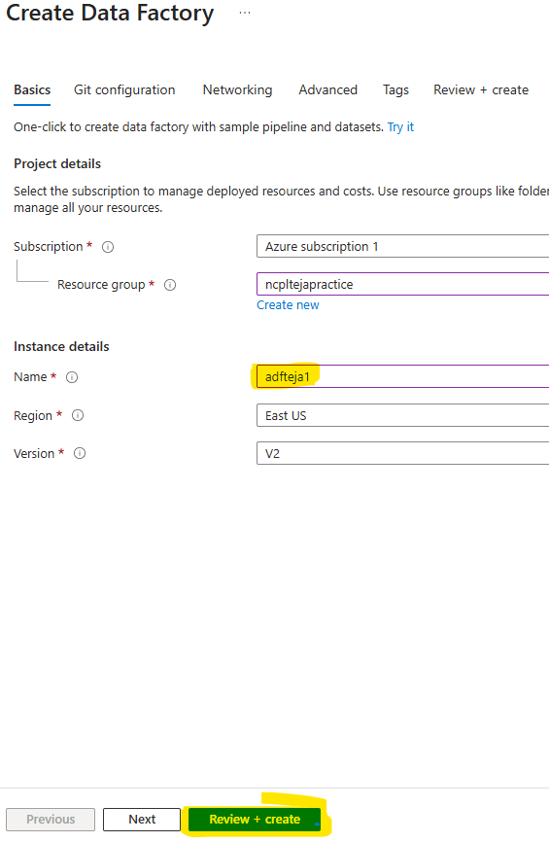
Below successful deployment message would be displayed post creation of ADF resource.
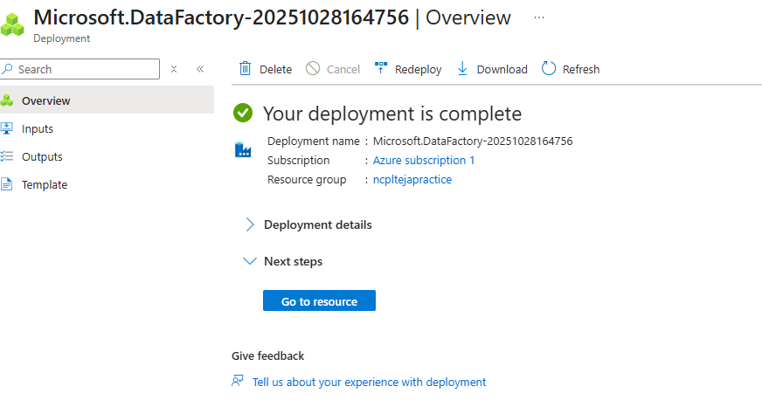

Uploading a CSV file as source data
Ones a directory is created, like stage below, go to the directory by clicking on it and click on upload first, then click on browse button from right popup, then browse the file to be uploaded, click on open to load it and then click on upload it.
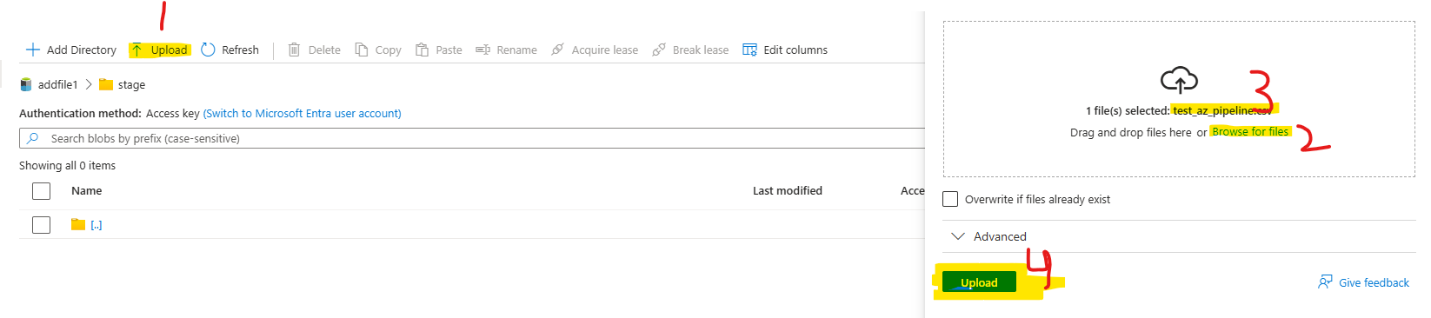
File as shown below will appear in the directory after upload.
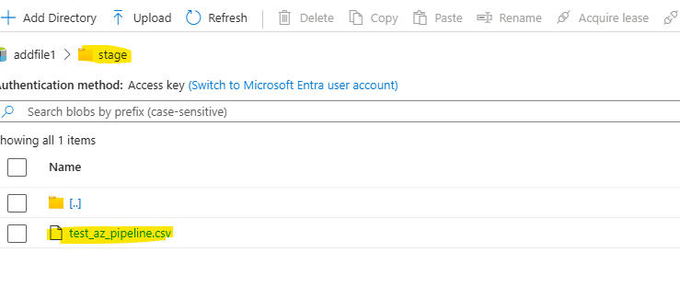

Building a Copy Data pipeline within ADF
Step1: click on Launch studio after option ADF from resources. ADF will be launched in a fresh tab.
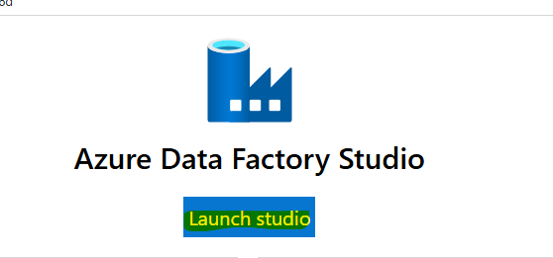
After clicking on Launch Studio, a new tab opens as below for ADF. To create a Data pipeline, we need to flow the steps below, drag n drop the Copy data activity.
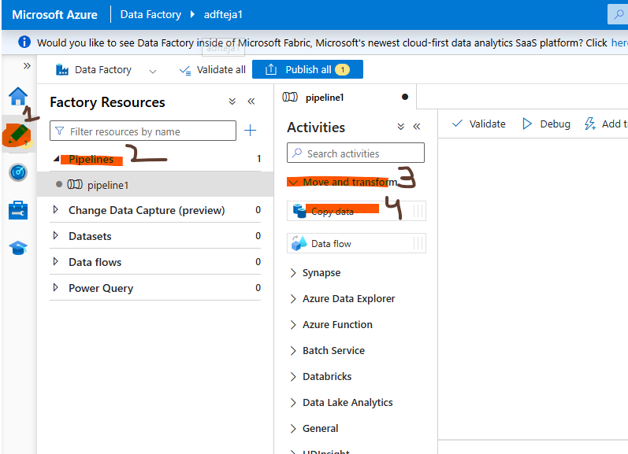
Inside Copy data, we need to fill in details for Source, Sink (destination) sections. In source we need to select the type of source we are connecting to, linked service (type of service used for connection), folder from which file needs to be selected.
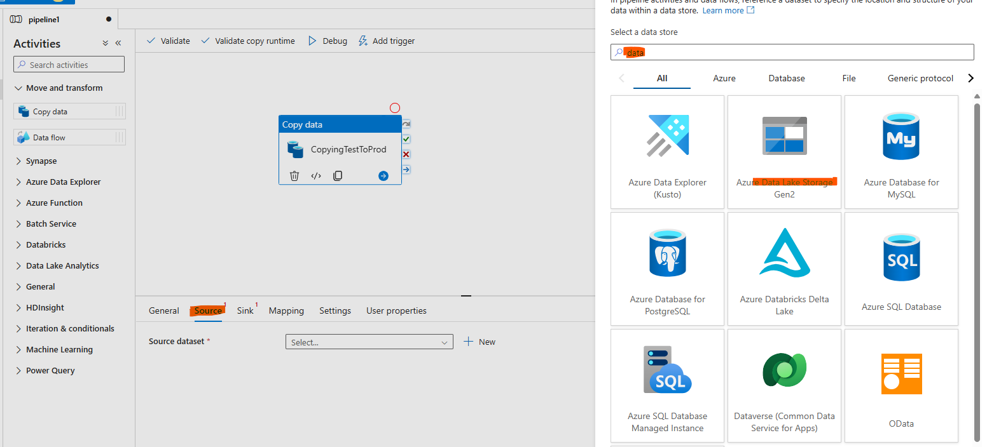
Then select file format as csv. Next option is to select properties

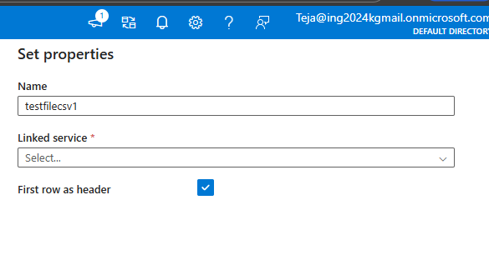

Configuring Linked Services and Datasets for both source and target locations
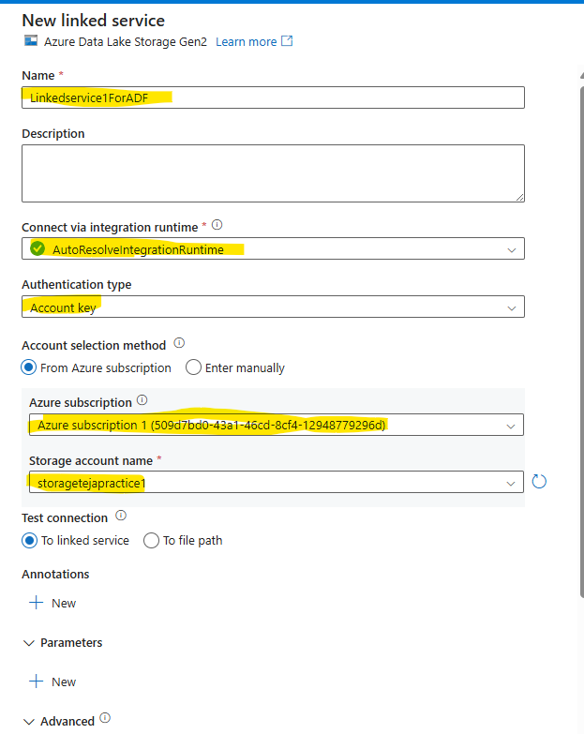
This is set while creating the linked service itself.
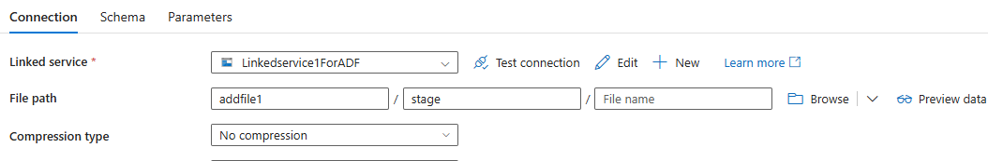
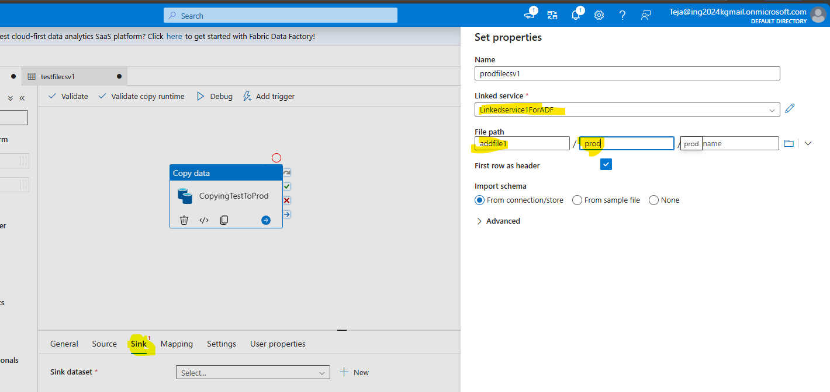
Publishing error: this is an error faced while publishing the changes done as filename was not filled in the source path.
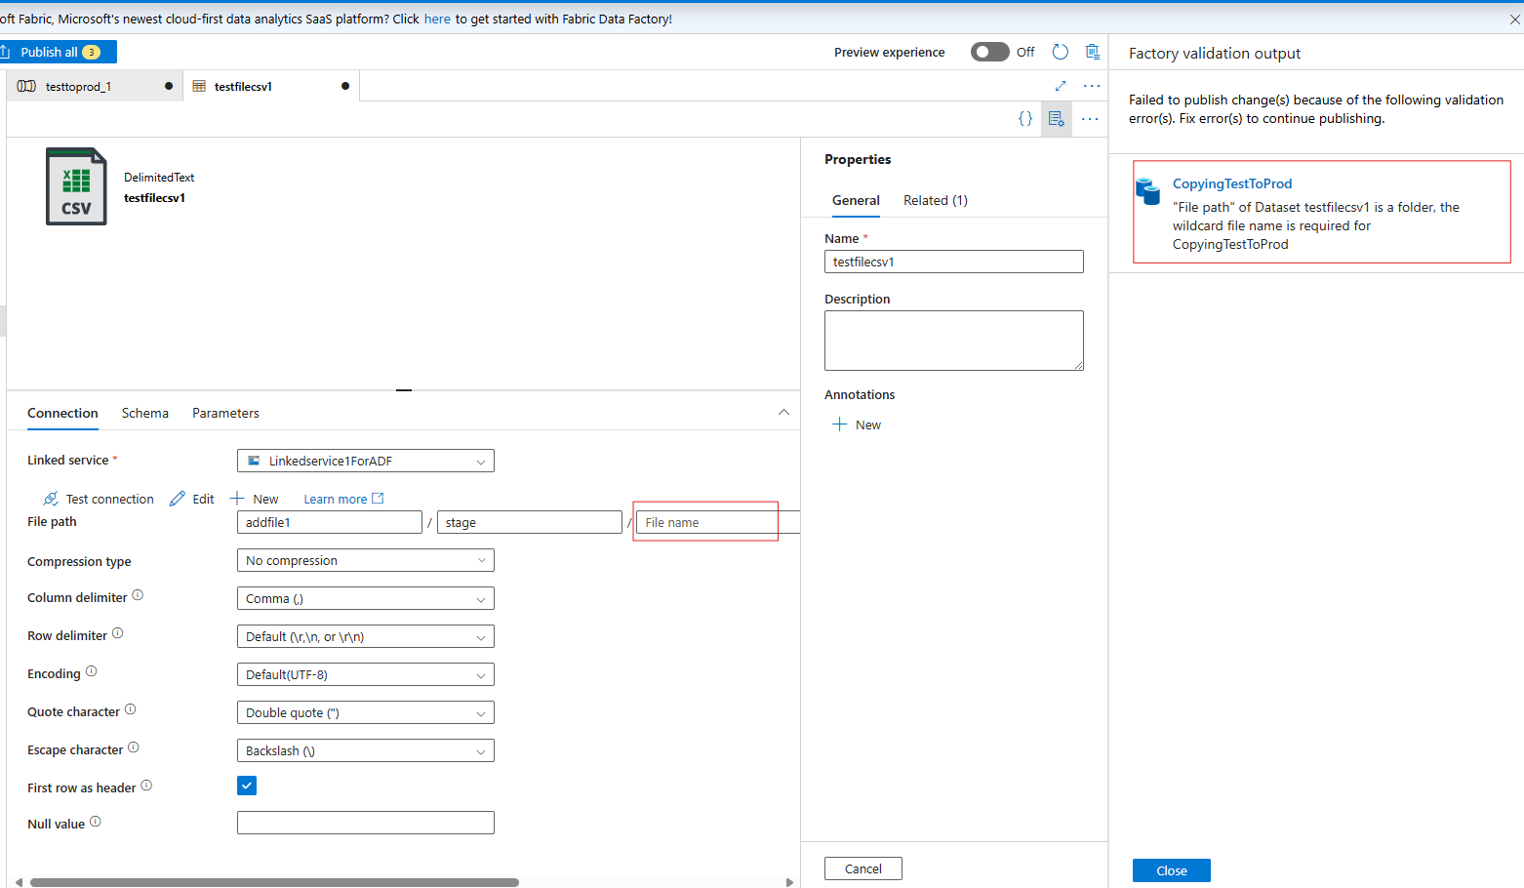
After updating name, able to publish the changes.
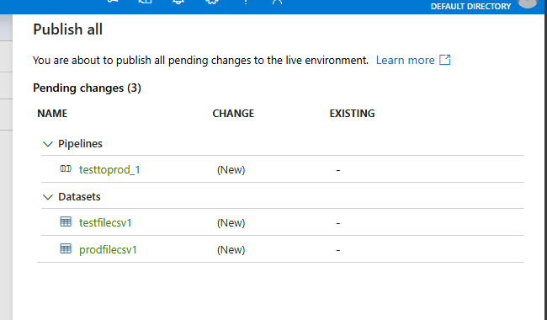

Copying data from one folder to another within the same ADLS Gen2 storage account
Before validating the pipeline, check the destination folder, no file exists in prod folder.
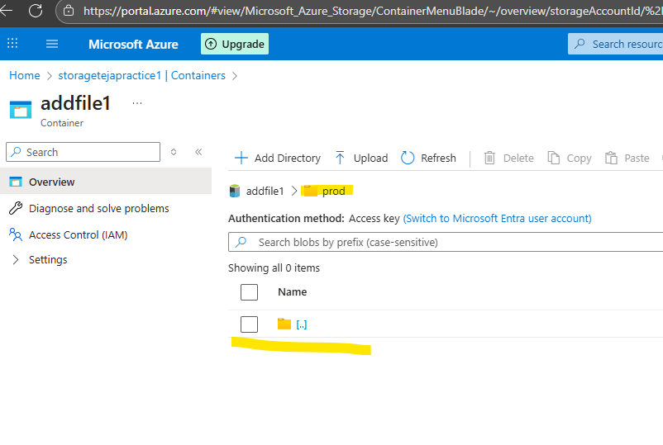
Validation of pipeline has been successful as shown below.
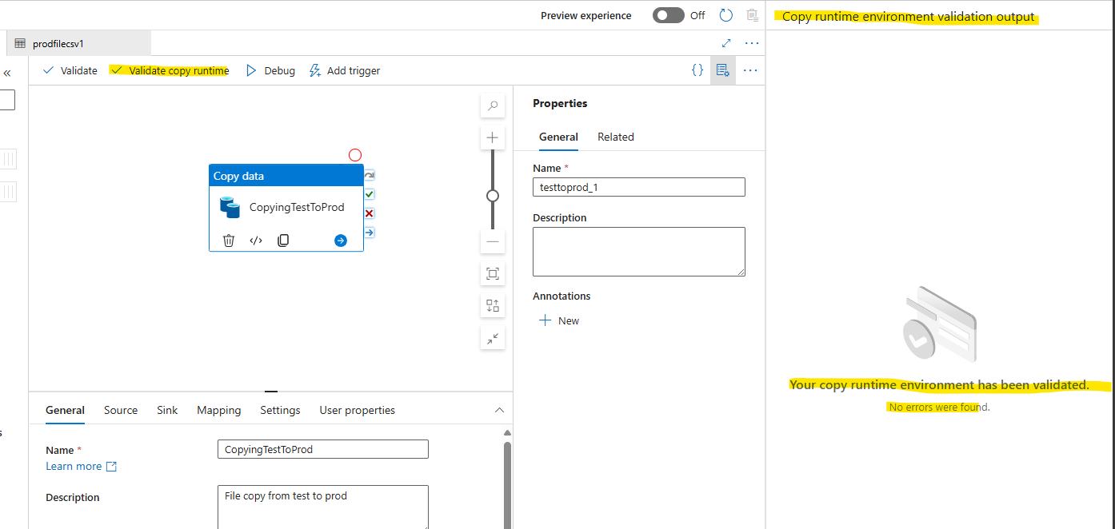
Click on debug of the pipeline (Copy data) Activity to run the same.
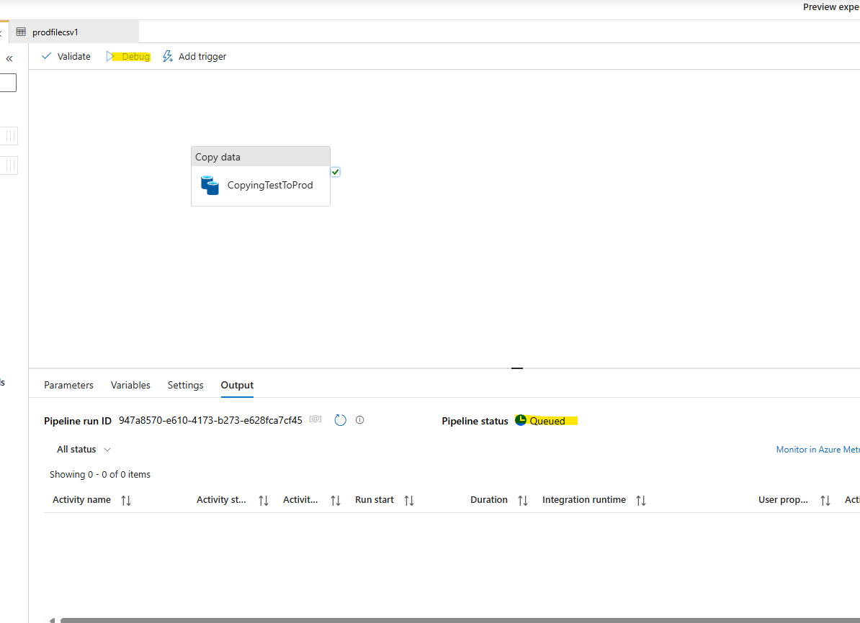
Console shows the status of the run, success message in the output tab.
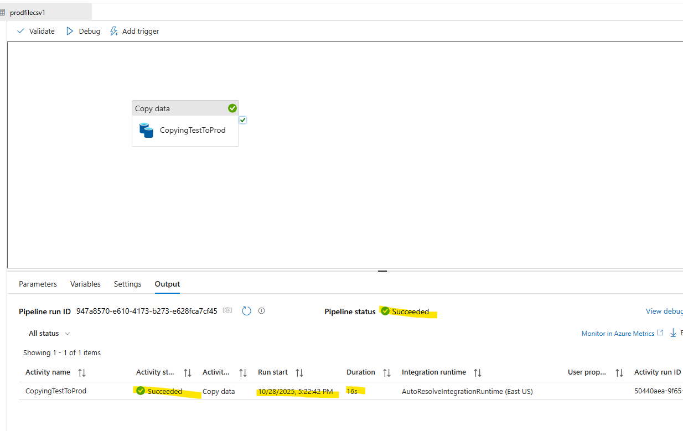
Post successful execution we see that the file is copied to prod folder.
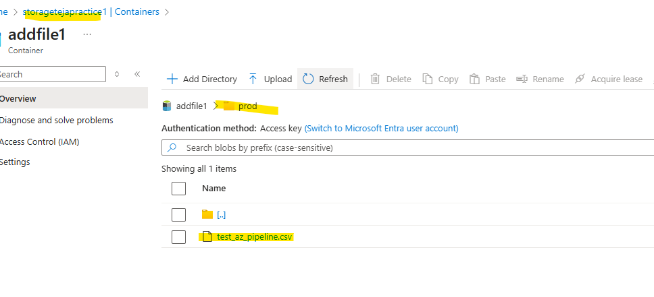
Delete file activity: have added an additional activity to the pipeline to delete the file post copy and tested the same.
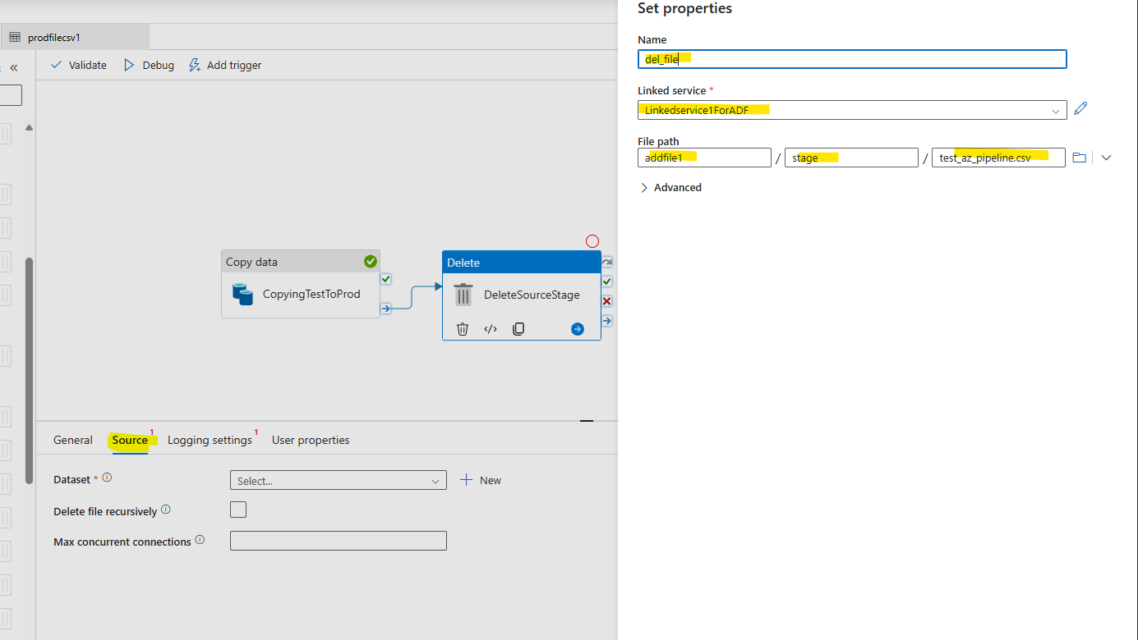

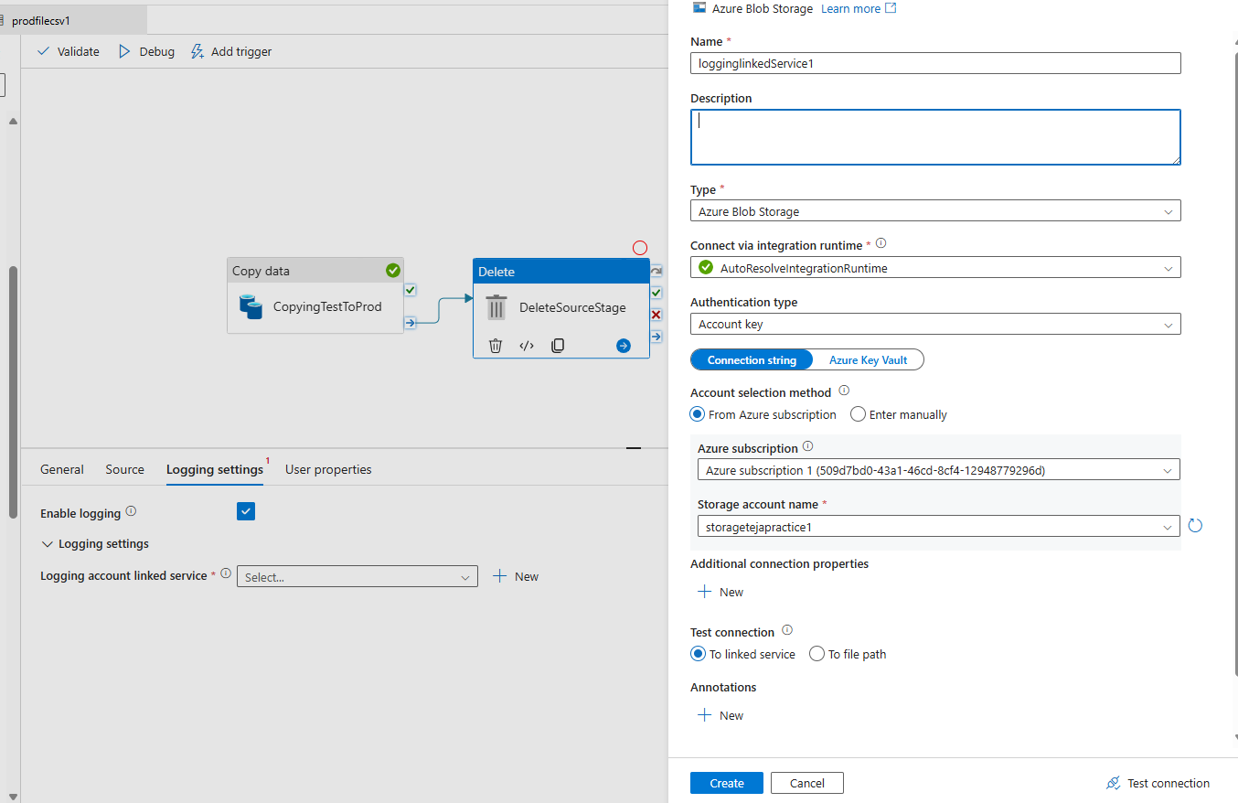

Delete file activity has been configured.
Checking the stage folder before test:
File exists:
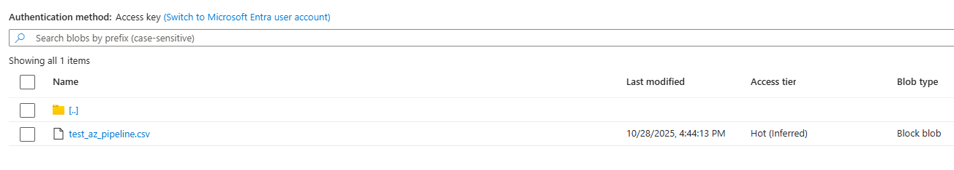
File copied previously into PROD folder:
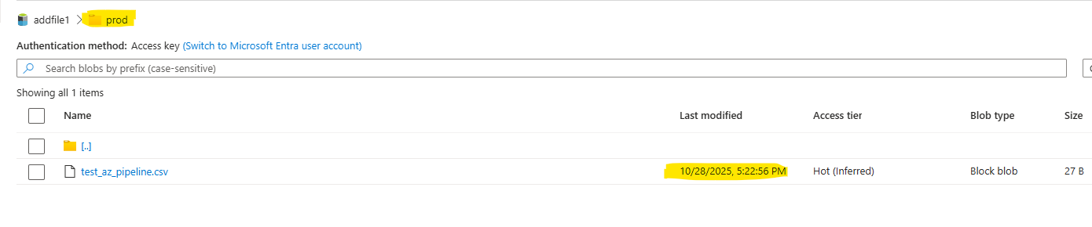
Testing the pipeline again:
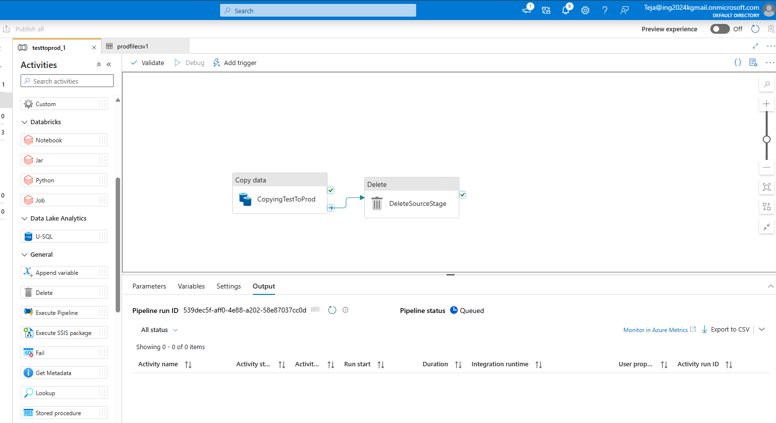
Successful execution of both copy and delete activities
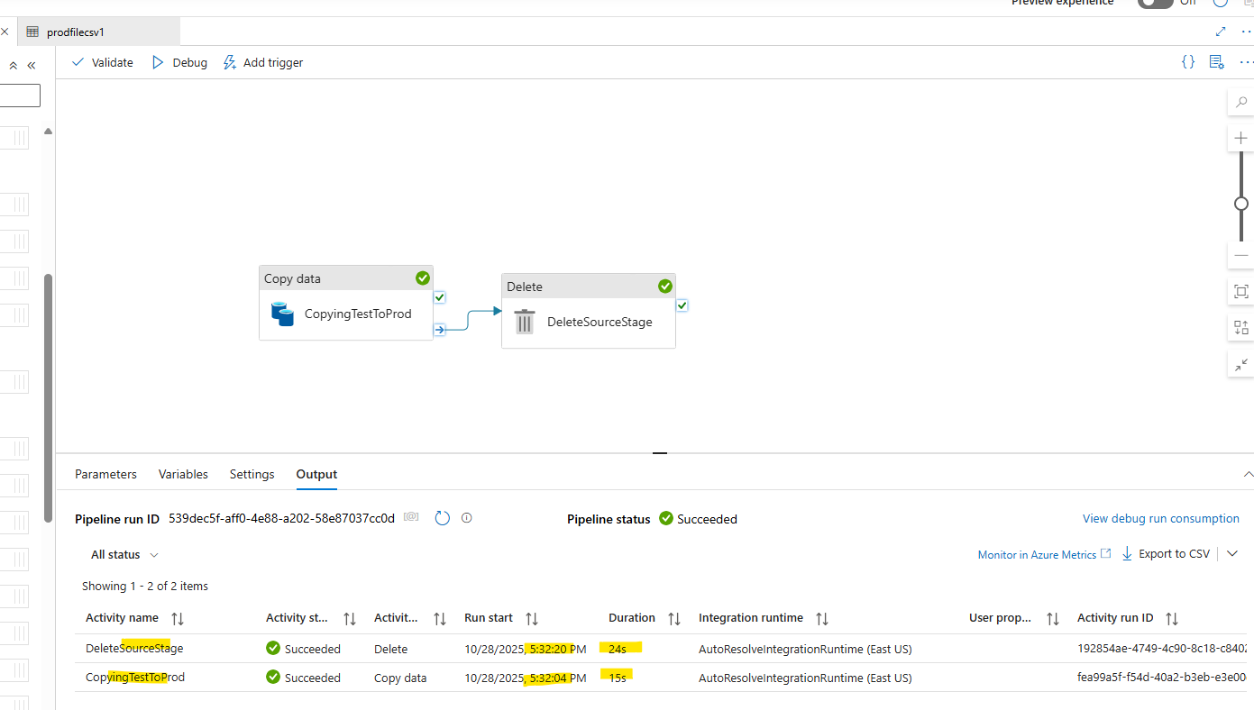
File gets deleted from source (stage folder) and latest file copied to destination (prod folder)
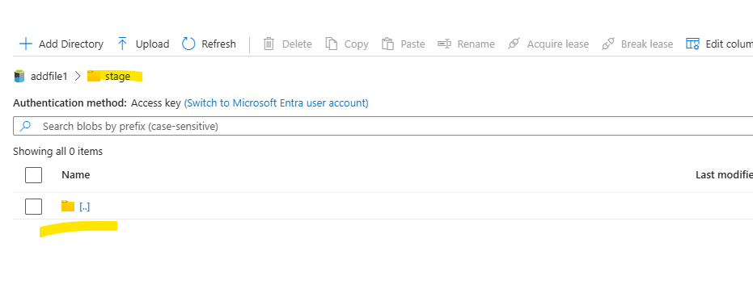
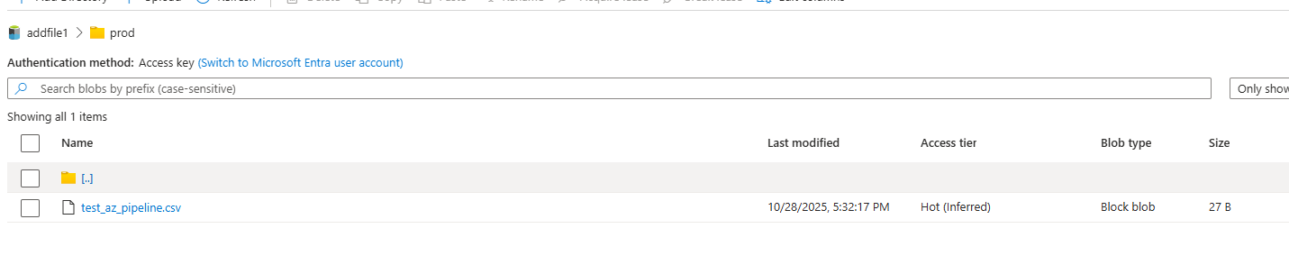
Cost Analysis:
All the resources and activities didn’t cost much in Azure.
