Azure Data Engineering
Homework -6 Oct 29

Copy data for multiple files
Step1: Create a new pipeline using the left pane, drag a copy data activity
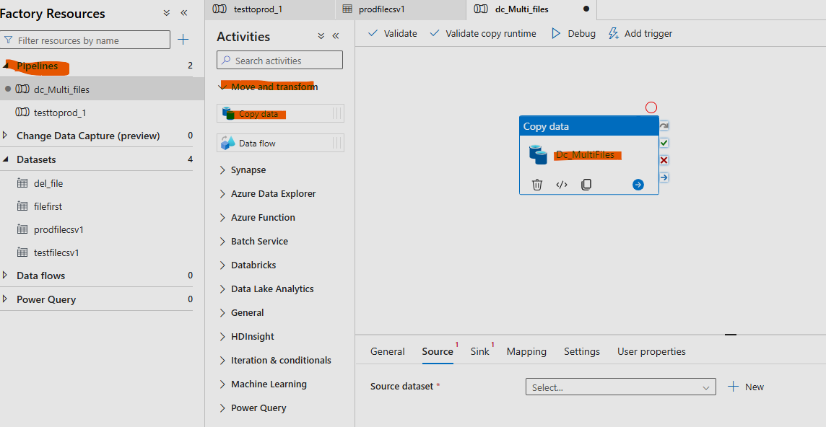
Step2: Go to Source tab at the bottom and fill in Source file details:
Select the linked connection created yesterday and use CSV file option post selecting DataLake Gen2.
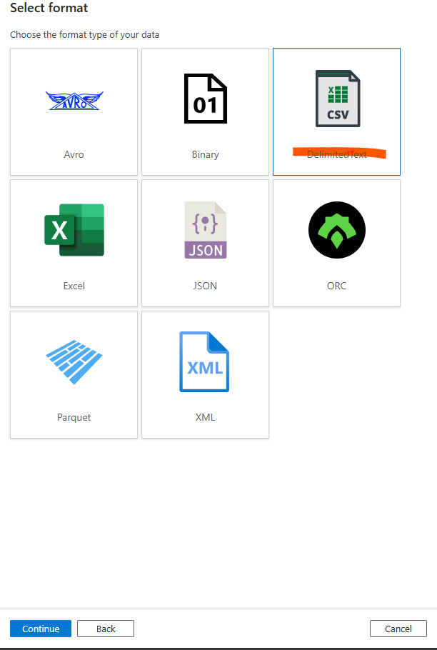
Step3:For multiple files, filename needs to be blank and scheme needs to be None. 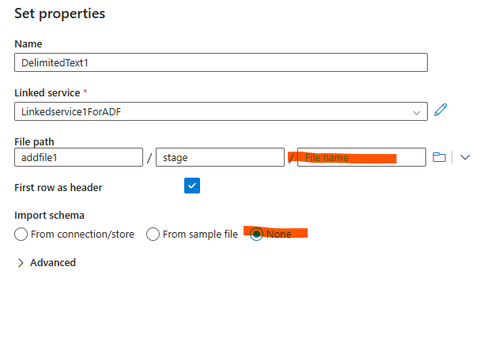

Step4: After clicking ok on popu-up properties, in the source tab, select the below options to fetch all the files.. we are giving * to get all the files in the folder.
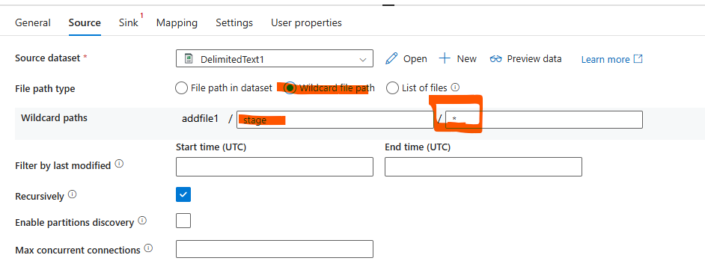
Sink properties are simple as it copies only csv in this activity and from one folder.
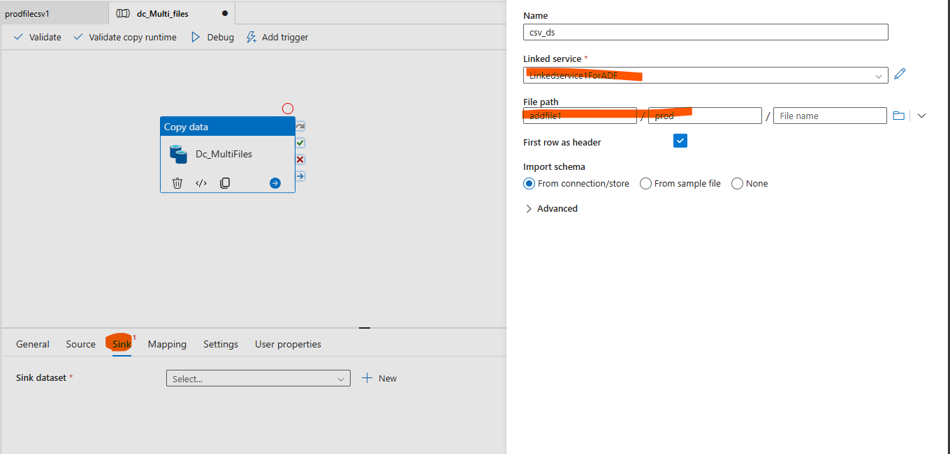
Step5:
Before testing the pipeline, we have 3 files in Stage (source) floder and Prod (Destination ) is blank.
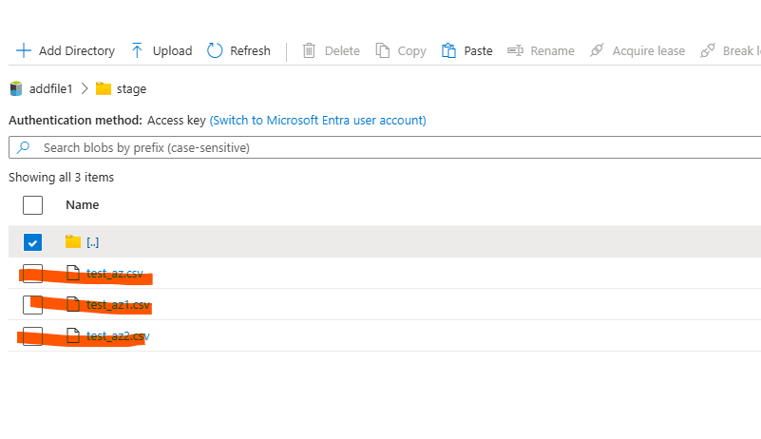
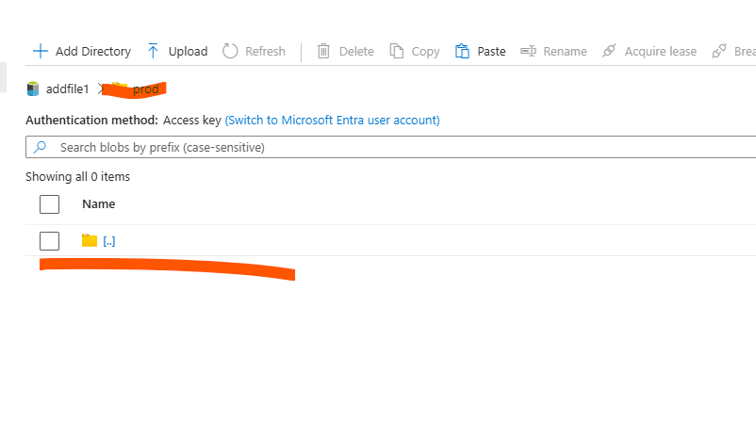
Step6: Execute the pipeline:
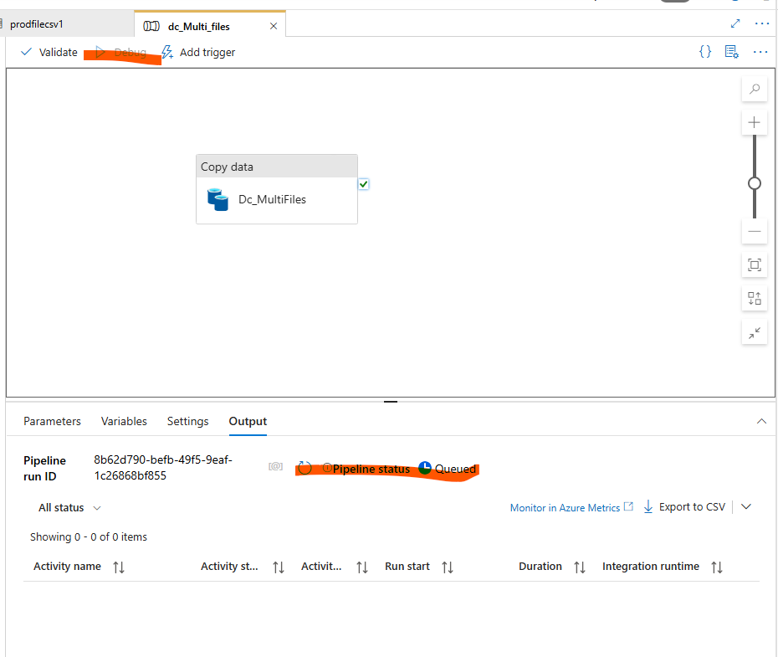
3 csv’s r copied into destination post execution of copy data activity.
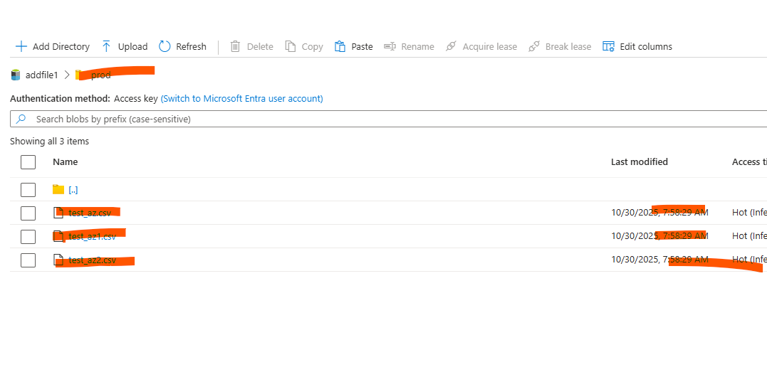

Copy data for multiple file formats
The above settings must work for multi file formats as we have not specified any format or naming convention while copying. We just gave a star. Lets test by uploading multiple formats and debugging copy activity.
Step1: File as shown below are uploaded in the input directory.
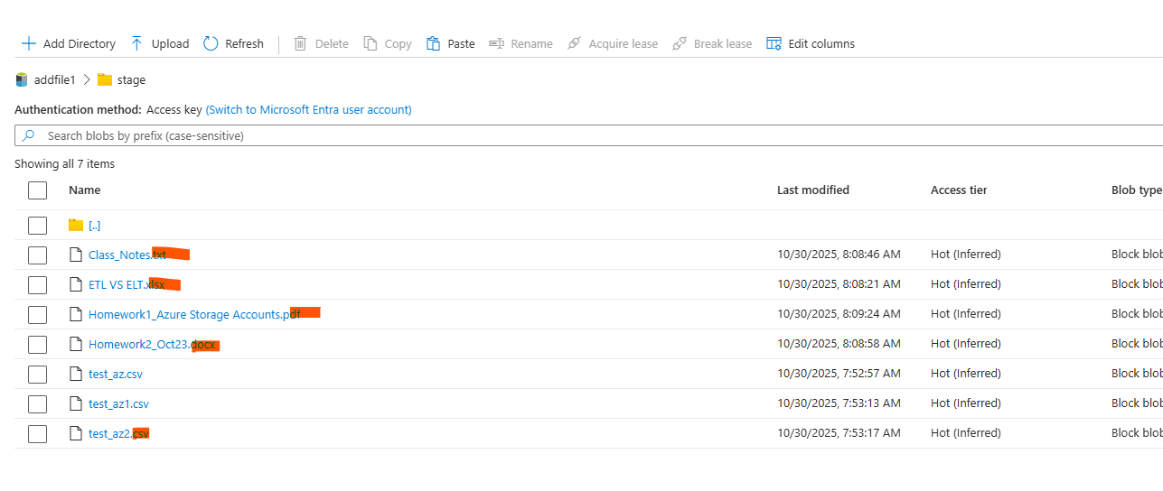
PROD folder still has the old files.
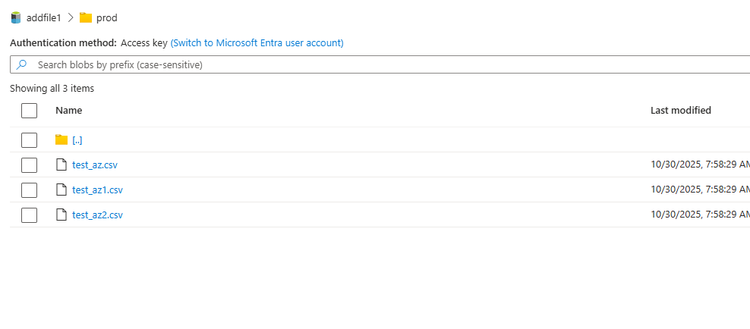
Step2: Pipeline successfully executed.
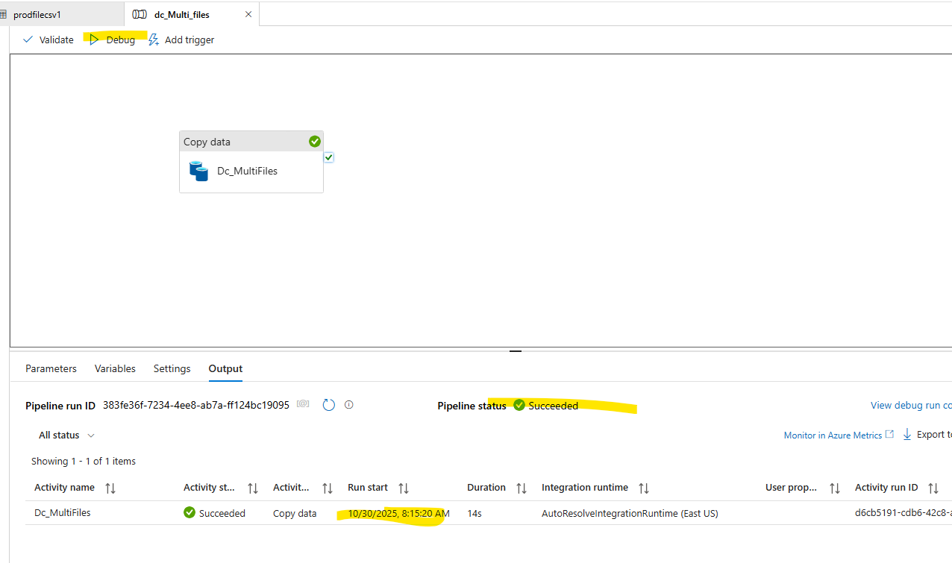
All the files are copied over the destination again. Existing ones are overridden.
As all these are general file formats, csv link supports it. Parquet/ JSON will not be supported with CSV link we will need to create Binary format file.
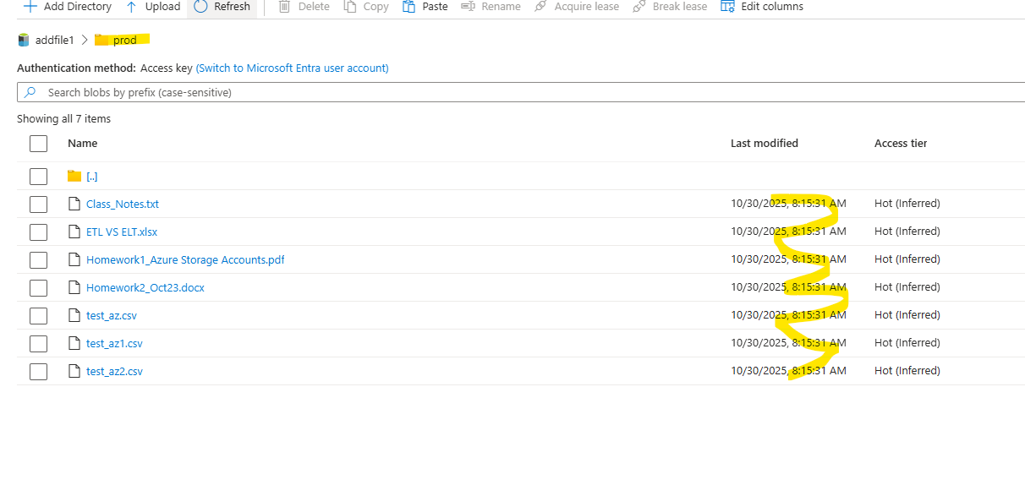

Copy data for specific file format
Even this needs a slight change in Source setting to select the specific format. All the other settings would be as above.
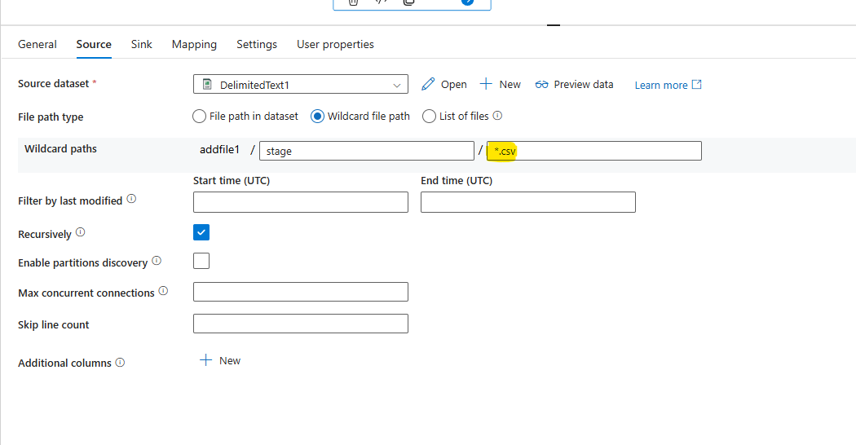
Delete data from destination folder
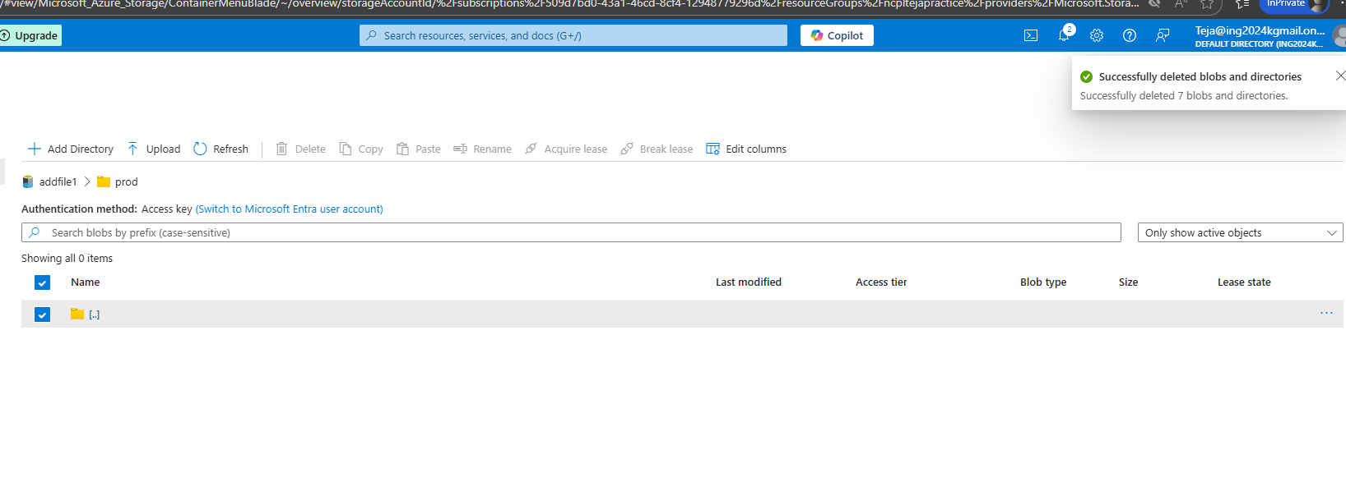
Successful execution of data copy activity
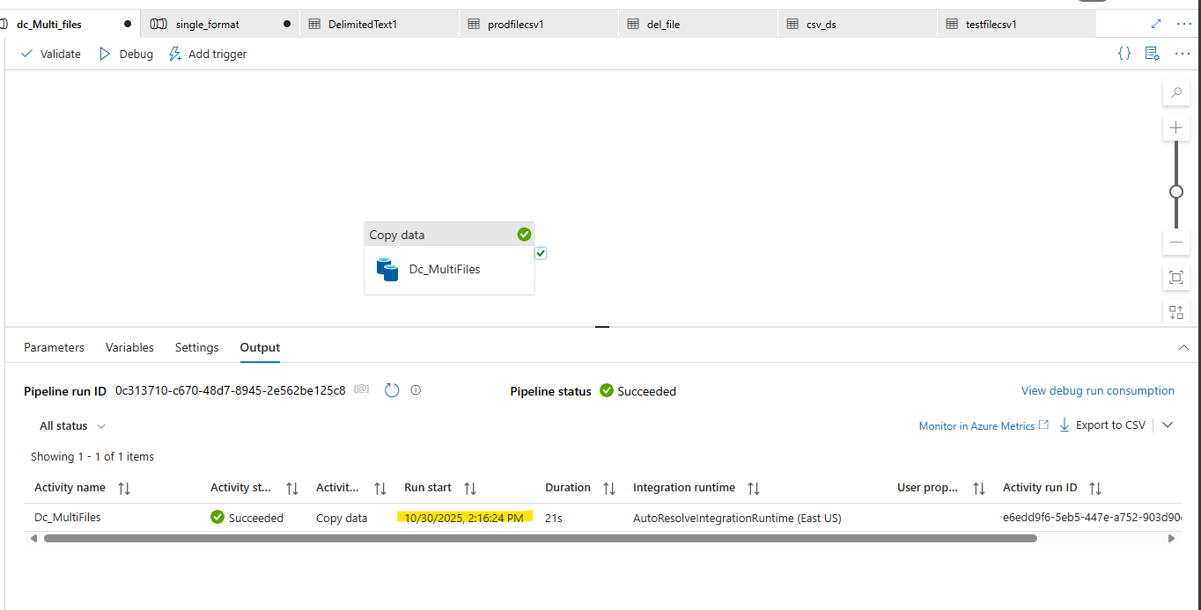
Only CSV files get copied from source to destination.
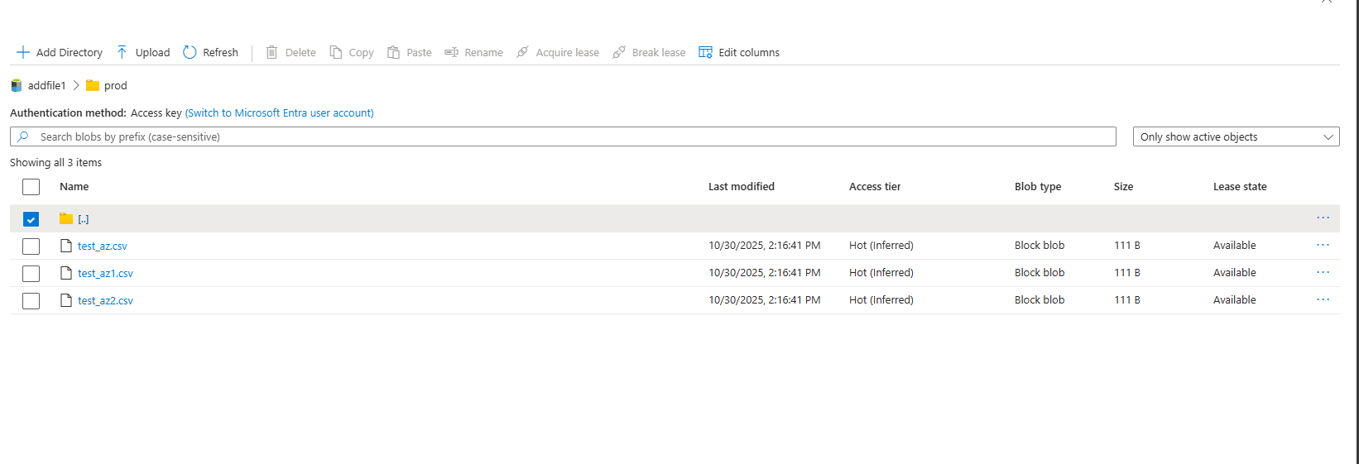

Copy multiple files and merge them
Enable the option below :
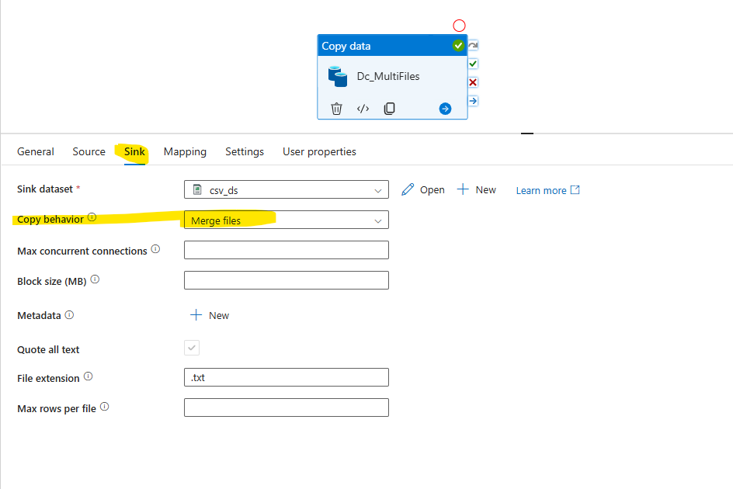
Enable merge option and debug the copy
