**Linux Commands Utilities**

1. **Which command is used to know the current working directory?**

**Ans** : PWD stands for present working directory. It is used to display current working directory.

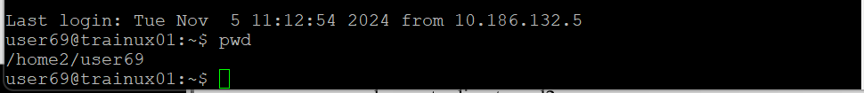

1. **How would you find out its contents?**

**Ans:** Cat command is used to display file contents.

1. **Identify the commands with inputs to do the following**
   1. **create a directory d1**
   2. **create a subdirectory d2 in d1**
   3. **change to directory d2**
   4. **create an empty file “f1.txt”**
   5. **display the contents of “f1.txt”**
   6. **view the contents of d1 from current directory d2**

Ans : mkdir d1

mkdir d1/d2

cd d1/d2

touch f1.txt

cat f1.txt

ls ..

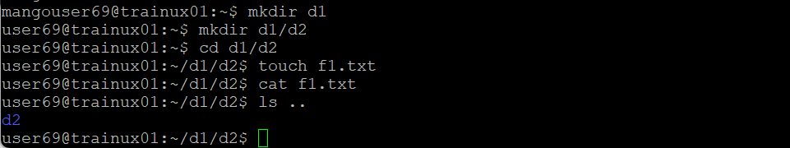

1. **Use the ls command with its options. How will you identify directories from the listing?**

**Ans** : By using “ls -la” command we can identify directories from the listing.

1. **Use ls to do the following** 
   1. **List files with single character names.**
   2. **List hidden files also. [ Note : Hidden files are files having name started with a “.”**
   3. **Suppose there are files tb1.1, tb2.1, tb3.1, ….tb10.1. Write command to list all the files [Hint: use wild card characters]**

Ans : ls ?

ls -la

ls tb*.1

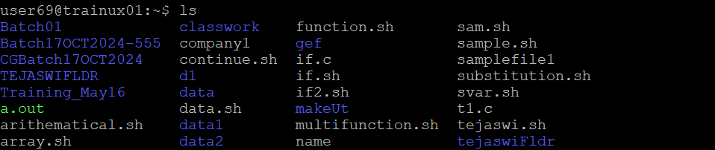

1. **Write the command to list all files in descending order of their size.**

Ans : ls -lS

1. **Suppose there are files temp1, temp2, temp3. Write command to remove the files without listing them explicitly**

**Ans :** rm temp*

1. **Which command is used to list top few lines in the file?**

**Ans** : head fruits

1. **Create a directory “testdir”**

**Ans** : mkdir testdir



1. **Use cp command to do the following** 
   1. **Copy the file tb1.1 (created above) in the same directory.**
   2. **Write a command to copy all the files i.e tb1.1,tb2.1,tb3.1,…..tb10.1 in a new directory –“new”**
   3. **Create a subdirectory in new in named“new1”.**
   4. **Write a command to copy selectively only tb2.1, tb6.1, tb7.1 and tb10.1 in the directory new1.**
   5. **Write a command to copy the entire directory “new” to a directory “newprogs”. [Note : use the –R option of “cp” command ]**

**Ans** : cp tb1.1 tb1.1_copy

cp -rf tb*.1 new/

mkdir new/new1

cp tb2.1 tb6.1 tb7.1 tb10.1 new1/

cp -r new newprogs/



1. **Find out the difference between** 
   1. **“mv” & “cp”** 
      * mv : move -This command is used to move files or directories from one location to another.
      * cp : copy - This command is used to create a copy of files or directories.
   2. **“rm”, “rmdir”** 
      * rm : remove -This command is used to delete files and directories. It can remove individual files or multiple files at once.
      * rmdir : remove directory - This command is to delete empty directories .If you use this on a directory that contains files or subdirectories, it will return an error
   3. **“mkdir” and “mkdir -p”**
      * mkdir : make directory - This command is used to create a new directory. If you create a directory that already exists, it will return an error
      * mkdir -p : This command allows you to create a directory and its parent directories if they do not already exist. If the directory already exists, it will not return an error.
2. **Use a single command rmdir once to remove “testdir” and all its sub directories and files created above.**

**Ans** : rm -rf testdir



1. **Which command is used to get the manual information of a command?**

**Ans :** man is used to get the manual information of a command

1. **If you are not able to change to a directory what could be the likely cause?**

**Ans** : The directory you are trying to change may not exist.

Permission denied to access the directory.

Incorrect Path

1. **Explain the differences among the following commands**

**Ans :**  a. cd / : This command changes the current directory to the root directory of the filesystem.

b. cd .. : This command moves you up one level in the directory hierarchy.

c. cd : This command takes to your home directory

d. cd ../..   : This command moves you up two levels in the directory hierarchy.