**Linux**

* The Linux Operating System is a type of operating system that is similar to Unix, and it is built upon the Linux Kernel.
* The Linux Kernel is like the brain of the operating system because it manages how the computer interacts with its hardware and resources.
* The system’s source code is accessible to everyone for anyone to look at and change, making it cool that anyone can see how the system works.
* Developed by Linus Torvalds in 1991, the Linux operating system is a powerful and flexible open-source software.
* Kernel

Shell

Terminal

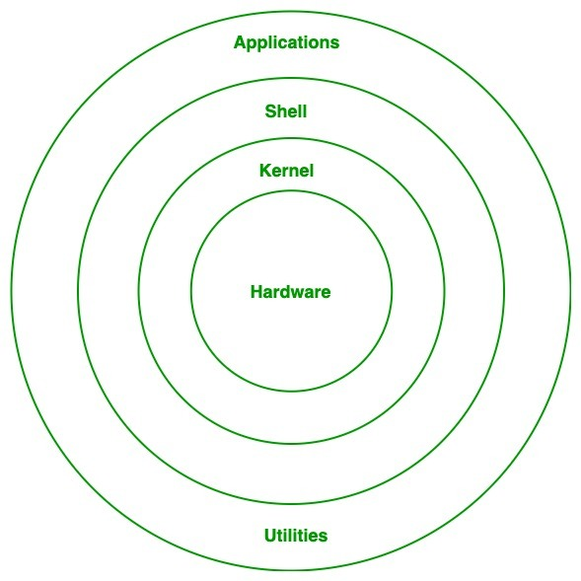

1. **Kernel:**[Kernel](https://www.geeksforgeeks.org/kernel-in-operating-system/) is the core of the Linux based operating system. It virtualizes the common hardware resources of the computer to provide each process with its virtual resources.
2. **System Library:**Linux uses system libraries, also known as shared libraries, to implement various functionalities of the operating system.
3. **Shell:**The shell is the user interface of the Linux Operating System. It allows users to interact with the system by entering commands, which the shell interprets and executes.
4. **Hardware Layer:**The hardware layer encompasses all the physical components of the computer, such as RAM,HDD,CPU (Central Processing Unit), and input/output devices.
5. **System Utility:**System utilities are essential tools and programs provided by the Linux Operating System to manage and configure various aspects of the system.

**Linux Commands**

Commonly used commands include

* ls to list contents of directories,
* cd to modify directories, and
* pwd to show the path of the current directory.
* Cp(copy) , mv(move) , rm(remove) someone can manage file activities.

A shell script comprises the following elements –

* Shell Keywords – if, else, break etc.
* Shell commands – cd, ls, echo, pwd, touch etc.
* Functions
* Control flow – if..then..else, case and shell loops etc.

**Displaying the file contents on the terminal:**

Cat

More

Less

Head

Tail

**File and Directory Manipulation Commands:**

Mkdir

Cp

Mv

Rm

Touch

**Extract, sort, and filter data Commands:**

Grep

Sort

Wc

Cut

**Basic Terminal Navigation Commands:**

Ls

Ls -l

Ls -a

Cd

Pwd

Man

Rmdir

Echo