Resume Keyword Extraction using NLP
Mini Project Report

Abstract
This mini project builds an explainable NLP pipeline that extracts useful terms and skills from resumes and compares a resume with a job description. The notebook processes the supplied 962-row resume dataset, removes 796 exact duplicate rows to retain 166 unique resume texts, normalizes words, identifies noun-phrase candidates, applies spaCy named entity recognition, and ranks one-, two-, and three-word terms with TF-IDF. A small editable skills list supplements those signals. The notebook also calculates cosine similarity, reports matched and missing listed skills, and creates category charts and word clouds. The output is intended to support human review; it is not an automated hiring decision.

Introduction
A resume contains skills and experience in free-form text, so comparing many documents with a job description can take time. Natural language processing (NLP) can turn that text into candidate keywords and phrases that are easier to review. This project reuses techniques practiced in the lab and keeps each stage visible in a single Jupyter notebook so that the processing steps can be explained during a viva.

Problem Statement
Recruiters spend substantial time screening resumes, and manual review becomes difficult when many applications arrive. Important skills and qualifications can be missed during that review. The project creates an NLP system that extracts useful resume keywords and presents them in a structured way to help recruiters review candidates faster.

Dataset
The input is data/UpdatedResumeDataSet.csv with the columns Category and Resume. It contains 962 rows, 25 categories, and no missing values in those columns. Exact text deduplication leaves 166 unique resume texts, so 796 duplicate rows are removed before the analysis. Category plots use all original rows to describe the source distribution; corpus-level keyword and word-cloud analysis uses the unique resumes to limit the influence of repeated text.
Dataset measure | Notebook result | Meaning
Source rows | 962 | Original CSV records
Categories | 25 | Resume category labels
Exact duplicate rows removed | 796 | One copy retained per exact resume text
Unique resumes | 166 | Texts used for corpus-level analysis
Missing Category / Resume | 0 / 0 | No missing values in the two source columns
Likely encoding-artifact rows | 725 | Simple scan for Ã, â, or replacement glyphs
The encoding-artifact count is a screening heuristic, not a verified count of corrupted records. The notebook normalizes a few recognizable sequences and otherwise preserves the original resume text for inspection.

Most frequent source categories
Category | Rows
Java Developer | 84
Testing | 70
DevOps Engineer | 55
Python Developer | 48
Web Designing | 45

Methodology
The notebook follows a sequence of small, inspectable stages. Each stage is linked to the corresponding lab experiment so the project can be explained using techniques already practiced.
Notebook stage | Lab experiment | How it is used
Inspect the data | Experiments 1 and 10 | Pandas reports the dataset dimensions, categories, missing values, duplicate count, and a sample.
Deduplicate and clean | Experiment 2 | Keep the first exact resume copy, normalize spacing and selected encoding artifacts, tokenize, and preserve useful technical forms.
Remove stopwords and lemmatize | Experiment 3 | Remove English stopwords and reduce tokens to lemma forms for later ranking.
POS, morphology, and phrase chunks | Experiments 4, 6, and 7 | NLTK tags words, demonstrates POS-aware lemmatization, and extracts simple noun-phrase candidates.
Named entities and skills | Experiment 8 | spaCy NER supplies entity candidates; a transparent common-skills list supplements technical vocabulary.
Rank and compare text | Experiments 5 and 9 | TF-IDF ranks unigrams, bigrams, and trigrams; cosine similarity compares a resume with job text and skill overlap is listed.
Explore the corpus | Experiment 10 | Matplotlib charts category counts and resume lengths; WordCloud summarizes the overall and selected-category text.

Results
The notebook fit a TF-IDF matrix with 166 unique resumes and up to 50,000 features. The top ten original categories were Java Developer (84), Testing (70), DevOps Engineer (55), Python Developer (48), Web Designing (45), HR (44), Hadoop (42), Data Science (40), Mechanical Engineer (40), and Sales (40). The sample demo produced a 29.5% cosine similarity; six of the seven skills found in the sample job description appeared in the sample resume, while communication was missing. This percentage describes a two-document TF-IDF comparison and should not be treated as a hiring score.
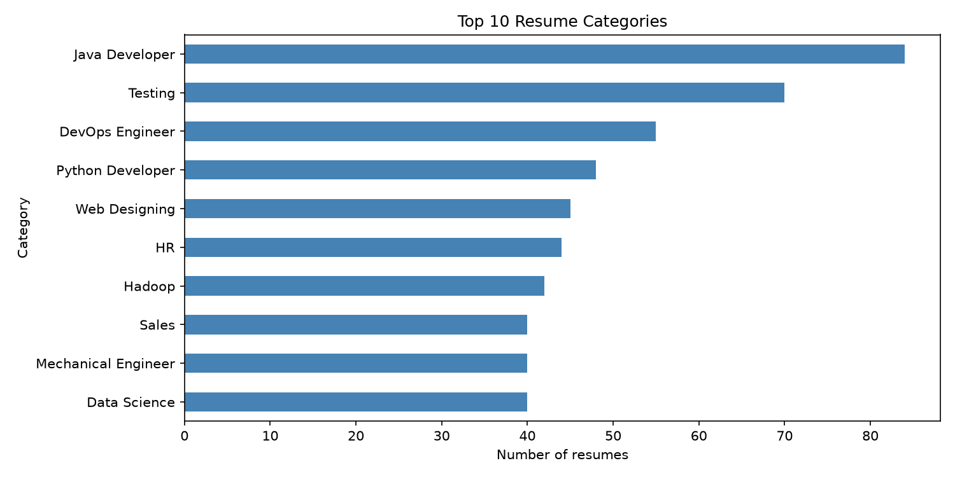
Figure 1. Top 10 categories in the original dataset.
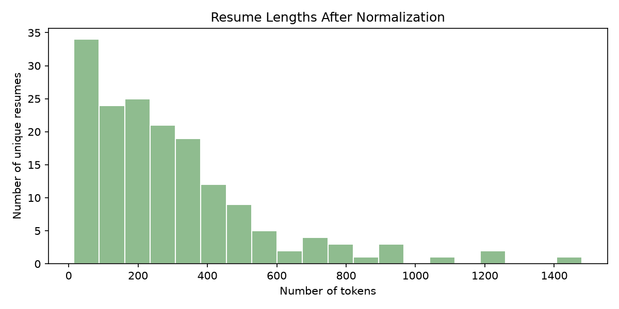
Figure 2. Token counts for unique resumes after normalization.

Results from word clouds
The word clouds show frequent terms after the notebook removes stopwords and repeated resumes. They are visual summaries that help explore the corpus; they do not measure keyword quality or candidate suitability.
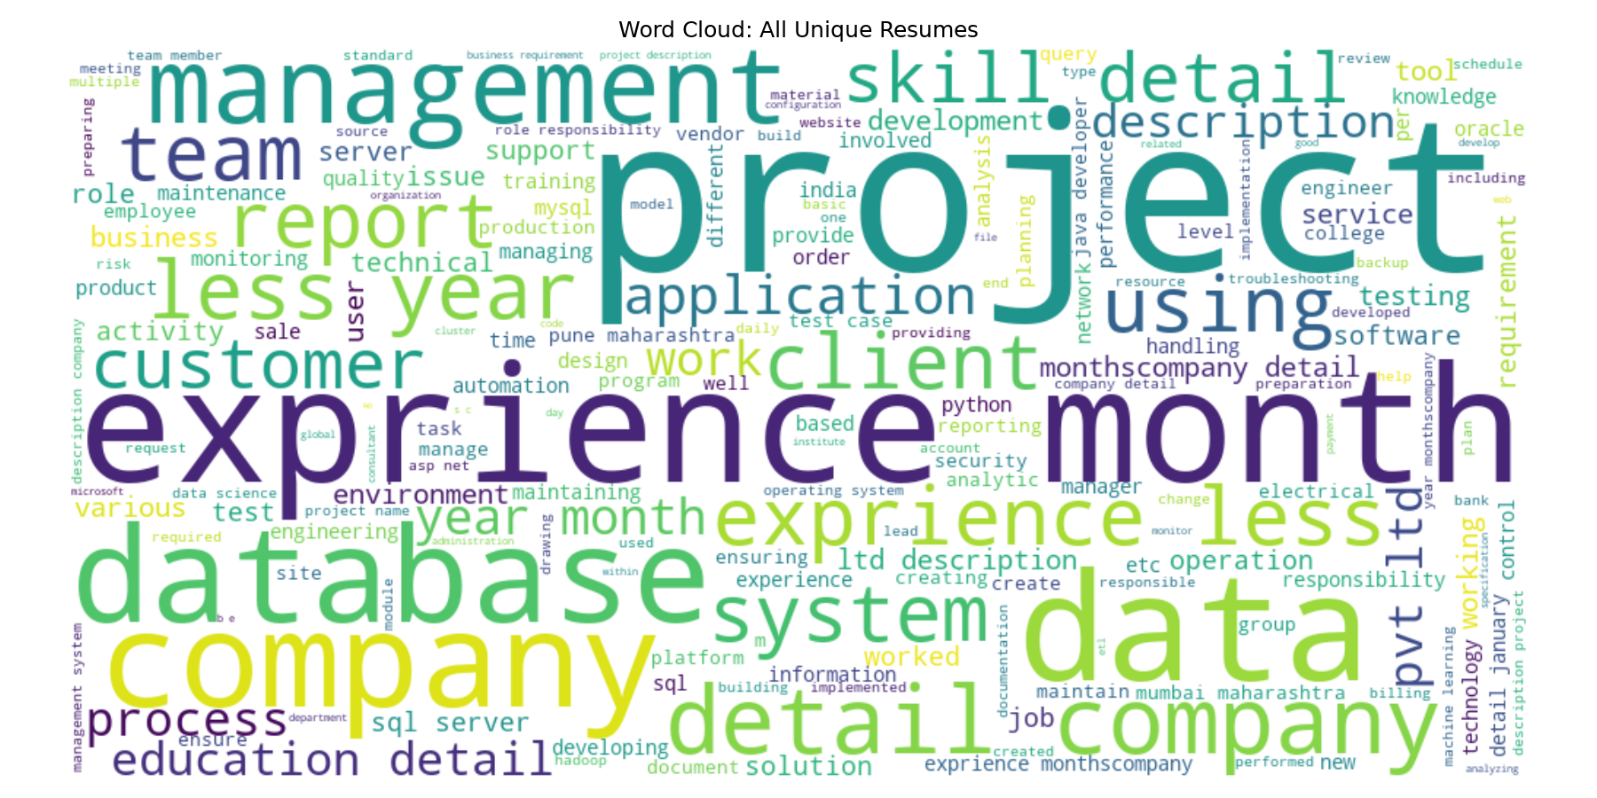
Figure 3. Word cloud for all unique resumes.
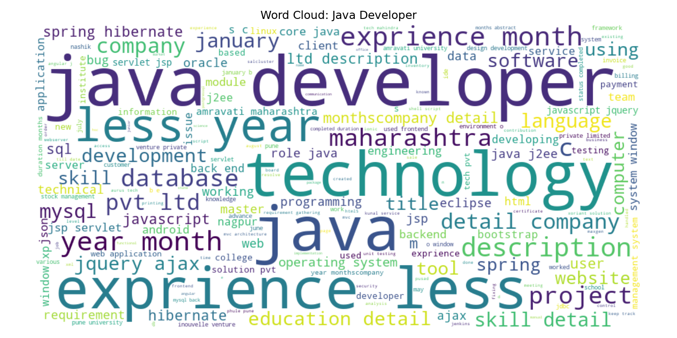  Java Developer | 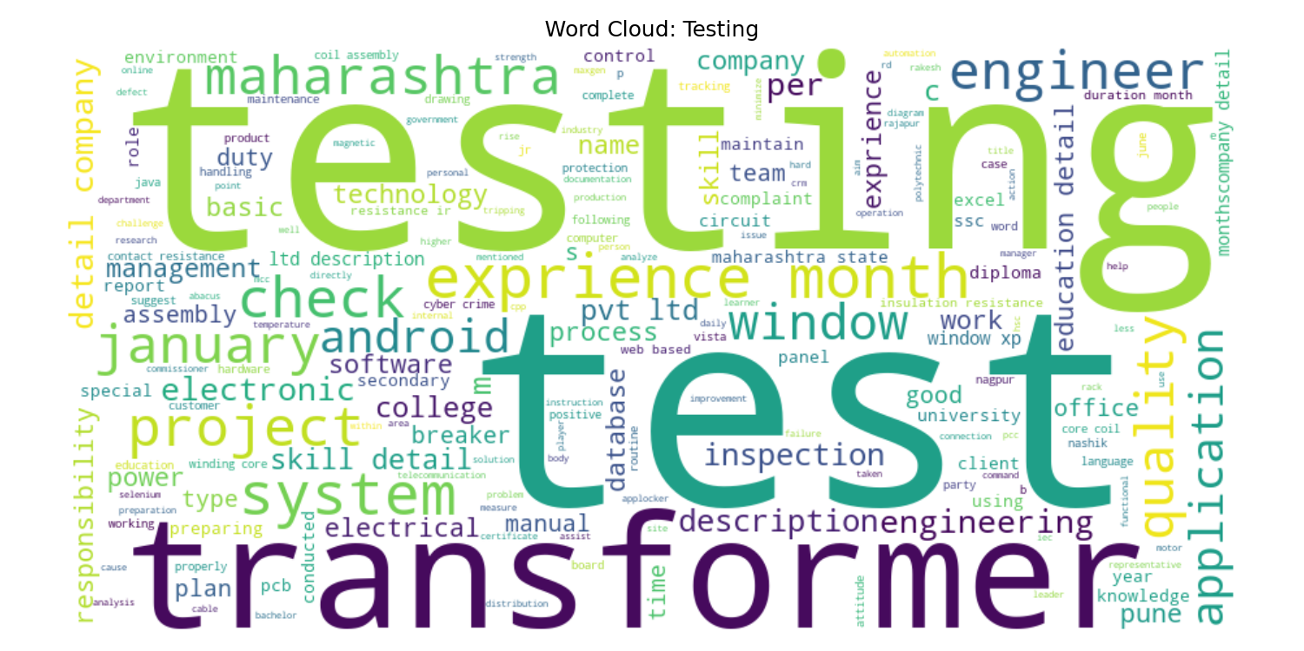  Testing | 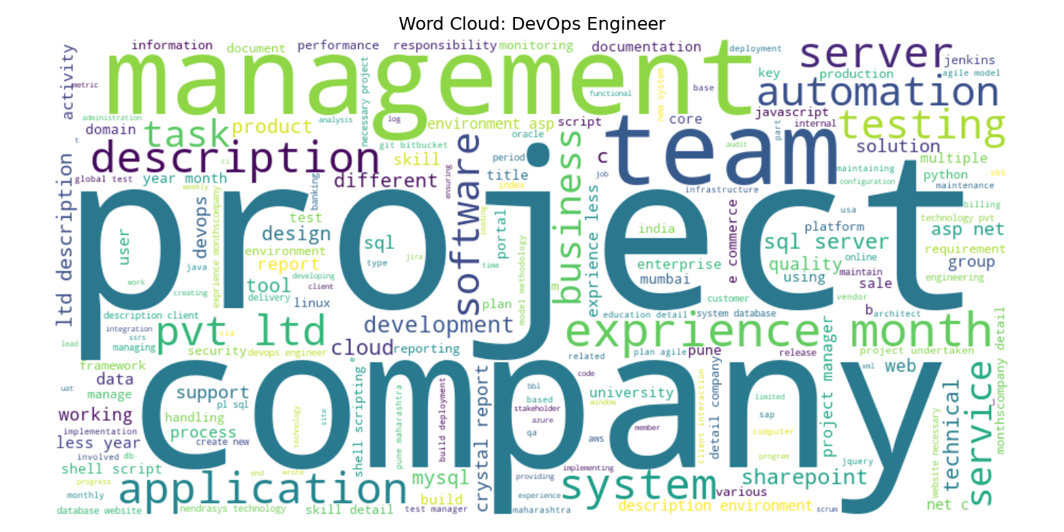  DevOps Engineer

Limitations
- The common-skills list is manually curated and incomplete; a skill absent from the list cannot appear in the matched or missing skill lists.
- spaCy uses a general English model, not a resume-specific model. The sample output labels technical terms such as Matplotlib or SQL as entities inconsistently.
- The noun-phrase grammar is intentionally small. POS tagging can be unreliable on resume fragments and lists, so some extracted phrases are awkward.
- The match percentage is cosine similarity from TF-IDF features fitted only to the resume/job pair. It can vary with wording and does not assess experience quality or context.
- Exact duplicate removal keeps the first record for each identical resume and therefore can under-represent repeated applicants or category assignments in corpus-level analysis.
- The encoding-artifact scan is heuristic; some matched character sequences may be legitimate text, and not every encoding problem is corrected automatically.
- The notebook demonstrates analysis on a fixed dataset and sample text. Results require human review and should not be used as the sole basis for hiring decisions.

Conclusion
This project demonstrates a simple resume keyword pipeline built from the lab methods: preprocessing, stopword removal and lemmatization, POS tagging and chunking, NER, n-gram TF-IDF, cosine similarity, and exploratory charts. Deduplicating first reduces the dataset from 962 rows to 166 distinct resume texts for corpus-level analysis. The combined keyword and skill outputs can make resume review more structured, while the reported limitations show why the results should remain explainable and subject to human judgment.

