Resume Keyword Extraction Using NLP
NLP Lab Mini Project Report
Project overview An explainable pipeline that removes duplicate resumes, cleans text, ranks keywords, and compares a resume with an optional job description.

Abstract
This mini project develops a small NLP system for extracting useful terms from resumes. It uses the supplied resume dataset, removes exact duplicate resume texts, applies tokenization, stopword removal and lemmatization, and ranks terms with TF-IDF. POS based noun phrases and a short common-skills list add readable skill candidates. The Streamlit interface accepts a pasted resume and an optional job description. With the sample resume and job text, it identified Python, SQL, machine learning, AWS and Tableau as shared listed skills and returned a 57.6% cosine-similarity score. The score is a text similarity measure, not a prediction of candidate suitability.

Introduction
A resume contains useful evidence about a candidate, but the information is written as unstructured text. Reviewing many resumes manually can take time, and readers may overlook relevant skills. Natural Language Processing (NLP) converts text into a form that can be cleaned, compared and summarized. This project applies techniques practiced in the lab to rank terms and phrases from a resume, then optionally compare its language with a job description.
The project is designed as a simple, inspectable lab application. Its stages reuse NLTK for cleaning and linguistic analysis, scikit-learn for TF-IDF and cosine similarity, pandas for dataset handling, spaCy for named entities, matplotlib and WordCloud for exploration, and Streamlit for the input page.

Problem Statement
Recruiters spend substantial time screening resumes, and manual review becomes difficult when many applications arrive. Important skills and qualifications can be missed during that review. The project therefore aims to extract useful resume keywords and present them in a structured way to help recruiters review candidates faster.

Dataset
The source file is data/UpdatedResumeDataSet.csv, with Category and Resume columns. It contains 962 rows across 25 categories and no missing values in those two columns. Exact resume text was used to identify duplicates; the first copy was retained. The resulting data/resumes_clean.csv contains 166 distinct resumes, so 796 additional duplicate rows were removed. The source file was left unchanged.
Category | Rows | Category | Rows
Advocate | 20 | Hadoop | 42
Arts | 36 | Health and fitness | 30
Automation Testing | 26 | Java Developer | 84
Blockchain | 40 | Mechanical Engineer | 40
Business Analyst | 28 | Network Security Engineer | 25
Civil Engineer | 24 | Operations Manager | 40
Data Science | 40 | PMO | 30
Database | 33 | Python Developer | 48
DevOps Engineer | 55 | SAP Developer | 24
DotNet Developer | 28 | Sales | 40
ETL Developer | 40 | Testing | 70
Electrical Engineering | 30 | Web Designing | 45
HR | 44
Data quality note. Some text contains likely encoding artifacts, including “NaÃ¯ve Bayes” and malformed bullet symbols. The preprocessing stage corrects a small number of known forms; it does not guarantee repair of every artifact.

Methodology
- 1. Inspect and deduplicate - experiments 1 and 10. pandas reads the source CSV and removes exact duplicate Resume values before corpus-level analysis. It keeps the first row for each resume and writes Category, Resume and Cleaned_Resume to a separate file.
- 2. Clean and normalize - experiments 2 and 3. A regular-expression tokenizer preserves useful technical spellings such as C++, C#, .NET and scikit-learn. The text is lowercased, whitespace is normalized, known encoding patterns are adjusted, English stopwords are removed, and WordNetLemmatizer reduces tokens to their noun lemma.
- 3. Find linguistic phrases - experiments 4, 6 and 7. NLTK assigns POS tags to cleaned tokens. A regular-expression chunk grammar groups adjective and noun-like sequences. Two and three word candidates from those chunks are considered alongside TF-IDF terms.
- 4. Add entity labels - experiment 8. spaCy’s en_core_web_sm model identifies entity spans such as people, organizations, dates and places. This general-purpose model is supporting evidence because it may miss skills or label a technology as another entity type.
- 5. Rank terms and skills - experiments 5 and 9. TfidfVectorizer is fitted on the 166 unique cleaned resumes with unigram, bigram and trigram features. The app transforms a pasted resume and displays its highest scoring terms. A built-in list of common technologies and skills provides a second, easy-to-explain extraction method.
- 6. Compare with a job description - experiment 9. When job text is supplied, the app transforms the cleaned resume and job description into the same corpus-derived TF-IDF feature space and calculates cosine similarity. It reports that value as a percentage and lists common skills found in both texts or only in the job description.
- 7. Explore the corpus - experiment 10. matplotlib charts show the ten largest categories and resume lengths. WordCloud summarizes all unique resumes and the three largest categories. Category counts use the original rows; word clouds use deduplicated resumes.

Results
The preprocessing step reduced the working corpus from 962 rows to 166 unique resume texts. The original category counts are uneven: Java Developer has the most rows (84), while Advocate has the fewest (20). The charts below show the category distribution and the vocabulary found in the unique resumes.
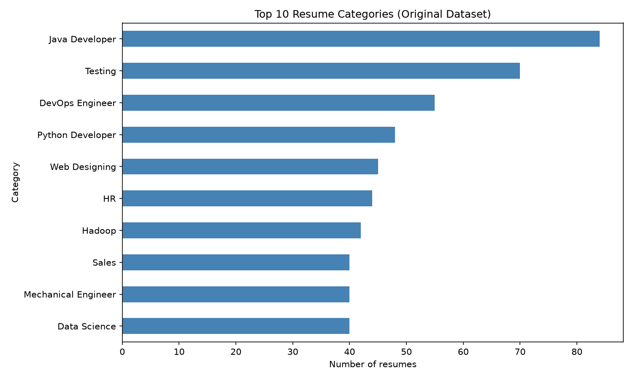
Figure 1. Ten categories with the most rows in the original dataset.
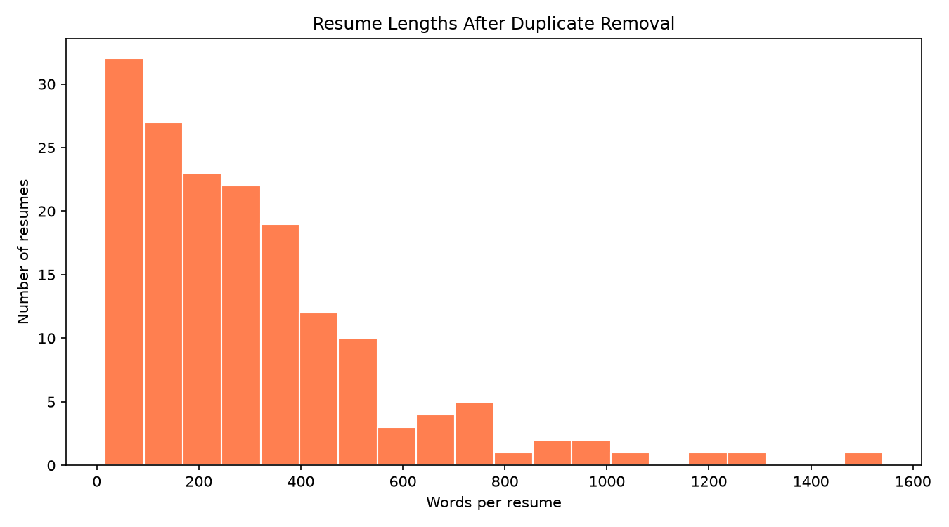
Figure 2. Word-count distribution after duplicate removal.
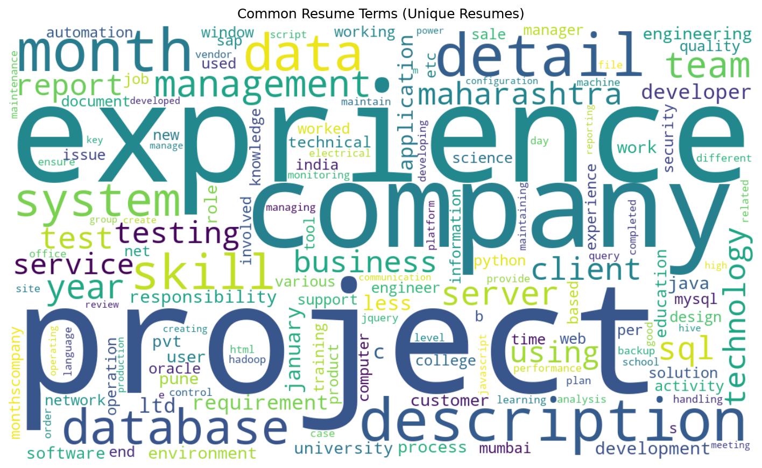
Figure 3. Frequent terms across unique cleaned resumes.
Sample app result. For the sample data analyst resume and job description, the app reported a 57.6% cosine-similarity score. It matched Python, SQL, machine learning, AWS and Tableau; the job description had no unmatched skills from the app’s built-in list. The top TF-IDF terms included “python sql” (0.253), “data analyst” (0.253) and “scikit-learn” (0.234).

Limitations
- The common-skills dictionary covers only selected technologies and phrases. New or less common skills may not appear in the extracted skill list.
- TF-IDF measures term importance relative to this dataset. It does not understand synonyms, context or whether a candidate is qualified.
- Cosine similarity measures overlap in weighted terms. The displayed percentage is not a hiring probability or a validated fit score.
- spaCy NER is trained for general entities, not resume skills, and may label technologies incorrectly or miss them.
- The source contains encoding artifacts and repeated resumes. Only exact duplicate resume strings are removed, and only a few known text patterns are corrected.
- The project demonstrates the pipeline on supplied data and sample text; it does not include a labeled accuracy evaluation or recruiter study.

Conclusion
This project combines lab techniques into an explainable resume-keyword workflow. It removes repeated resume texts, cleans and lemmatizes the remaining text, ranks terms with TF-IDF, adds phrase and skill candidates, and optionally compares a resume with a job description. Charts provide a view of category balance and common vocabulary. The app can support an initial review, but its results should be checked by a person because its skill list, training corpus and general-purpose NLP models have clear limits.

