**SQL ASSESSMENT**

1. Display the name of movies, movie type is starts with Drama.

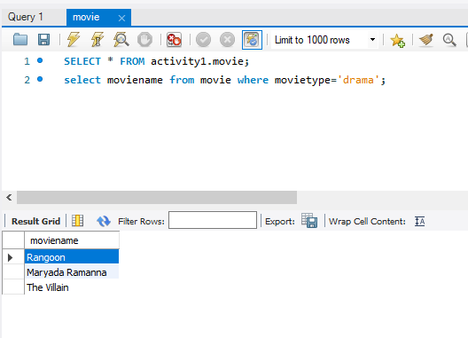

1. Display the movies acted by actor Ayushmann.

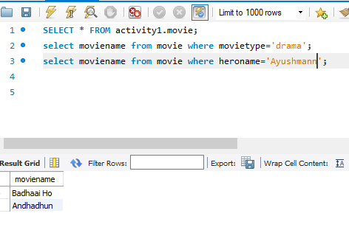

1. Display the count of movies, having length above 18.

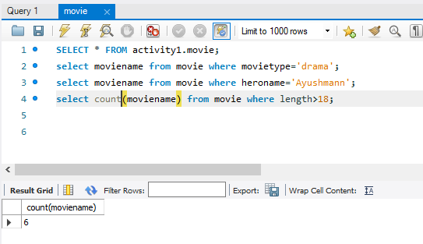

1. Display the movie having minimum length.

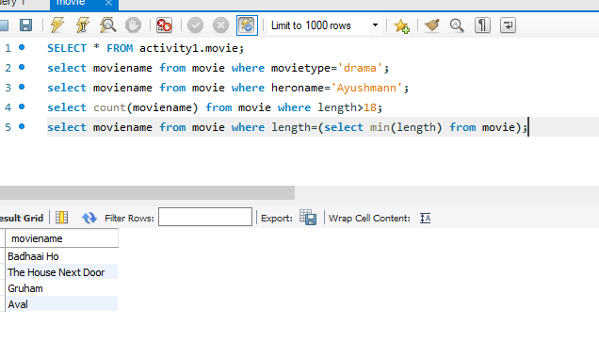

1. Display all the details of movie, the language that first name starts with ‘T’

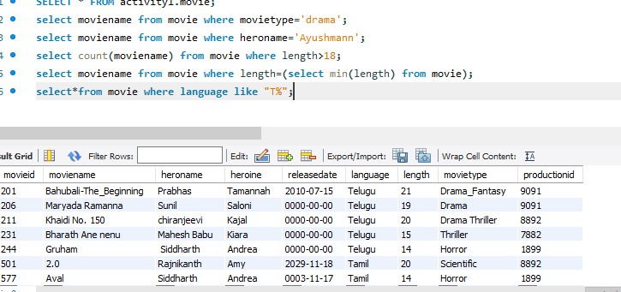

1. Display the movie name, hero name, heroine name whose having maximum length.

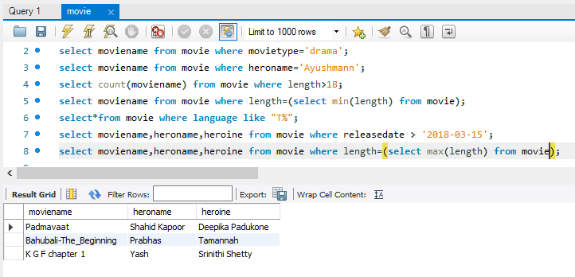

1. Display the movie name, hero name, heroine name the movie released after 15 march 2018

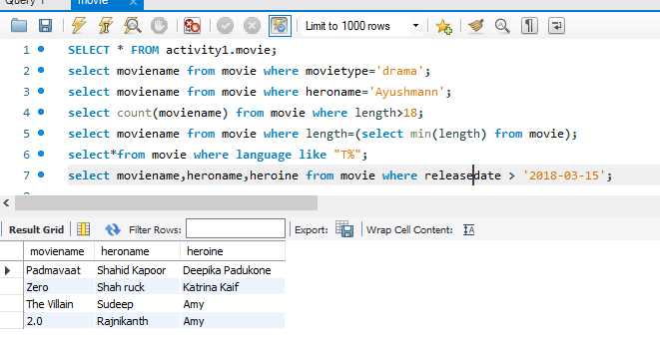

1. Display the count of thriller movies.

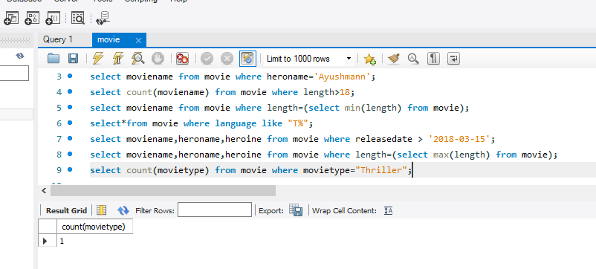

1. Display the count of movies whose released before 15 march 2018.

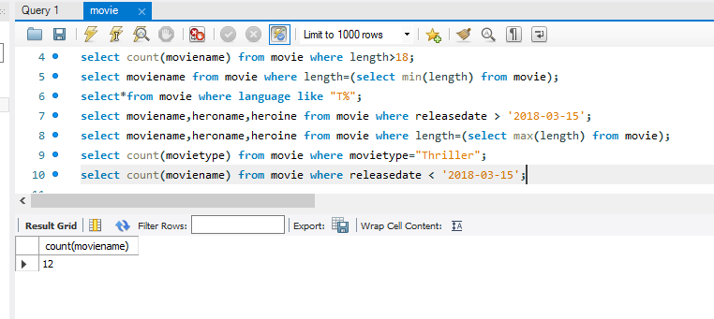

1. Display the release date of the movie name ‘Zero’.

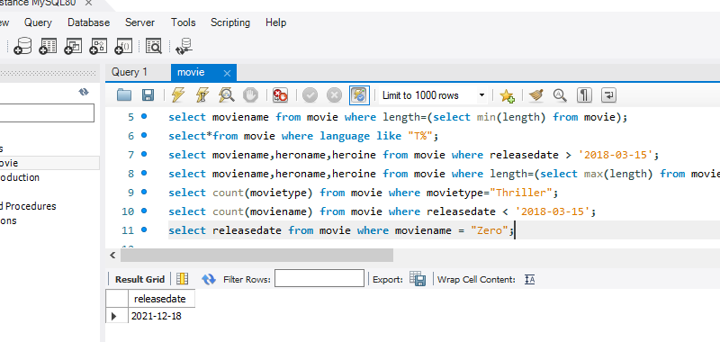

11.Display the actor name that acted with ‘Amy’.

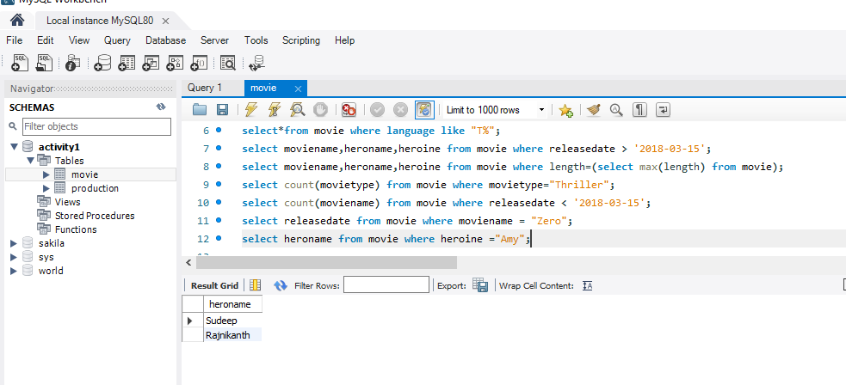

12.Display the Count of maximum movies released in a month of October.

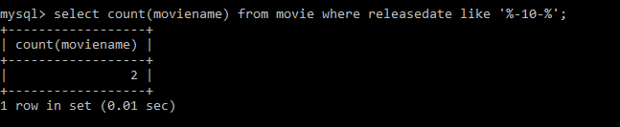

13.Display the movienames whose production id for different languages.

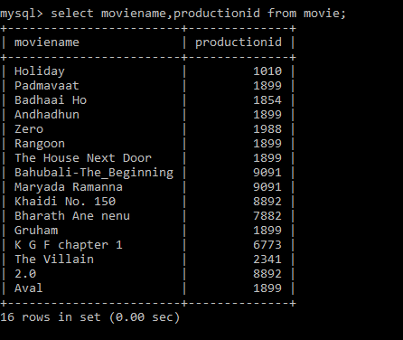

**ADVANCED.**

1)Write the query to display productionid, production name with total number movies produced by each.

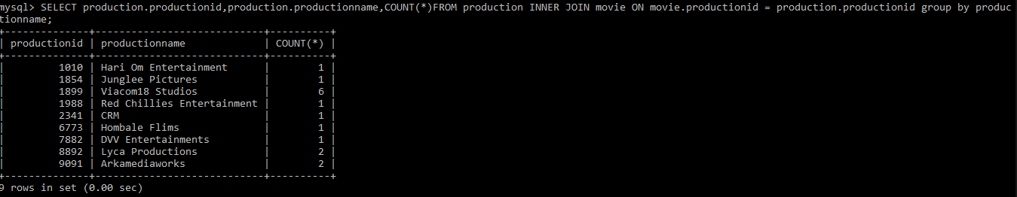

2. Write the query to display production name, owner name have produced more than 2 movies.

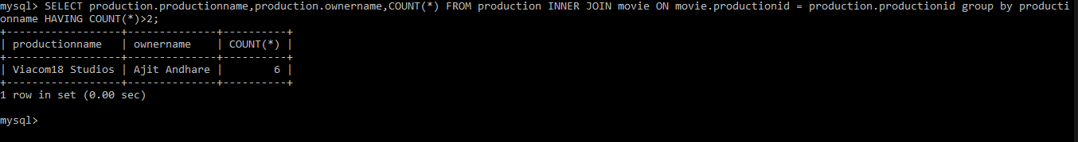

3. Write the query to display production name, owner name have produced maximum movies.

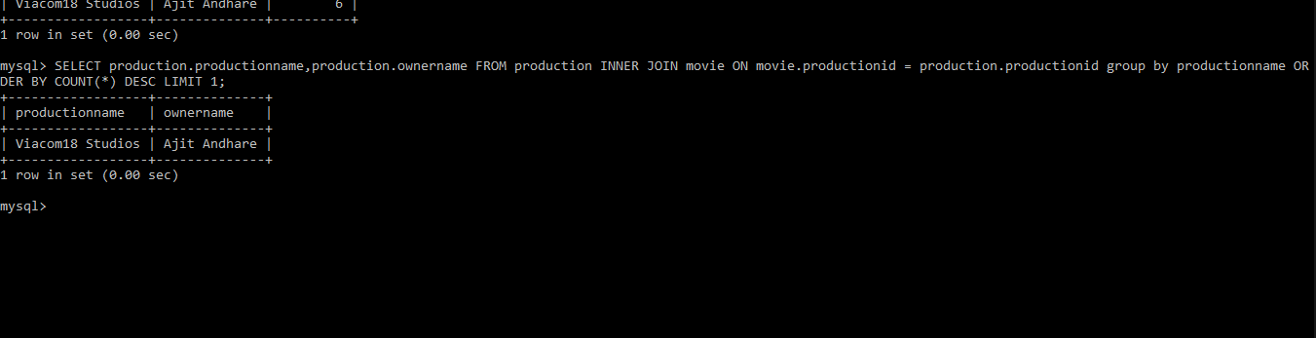

4. Write the query to display the moviename, heroname and productionname acted in the producer name= ’Subaskaran’