OSSP WEEK 2 PRACTICAL REPORT
Name: Tejaswin Amara
Roll No: 2520090104
Department: CS&IT
Course: OSSP
Week: 2

Task 1: Process Creation using fork(), exec(), and wait()
Objective: Develop a C program that accepts a Linux command, creates a child process using fork(), executes the command using exec(), waits for the child process using wait(), and displays the Parent and Child Process IDs.
Figure 1: Writing the C program in Nano Editor
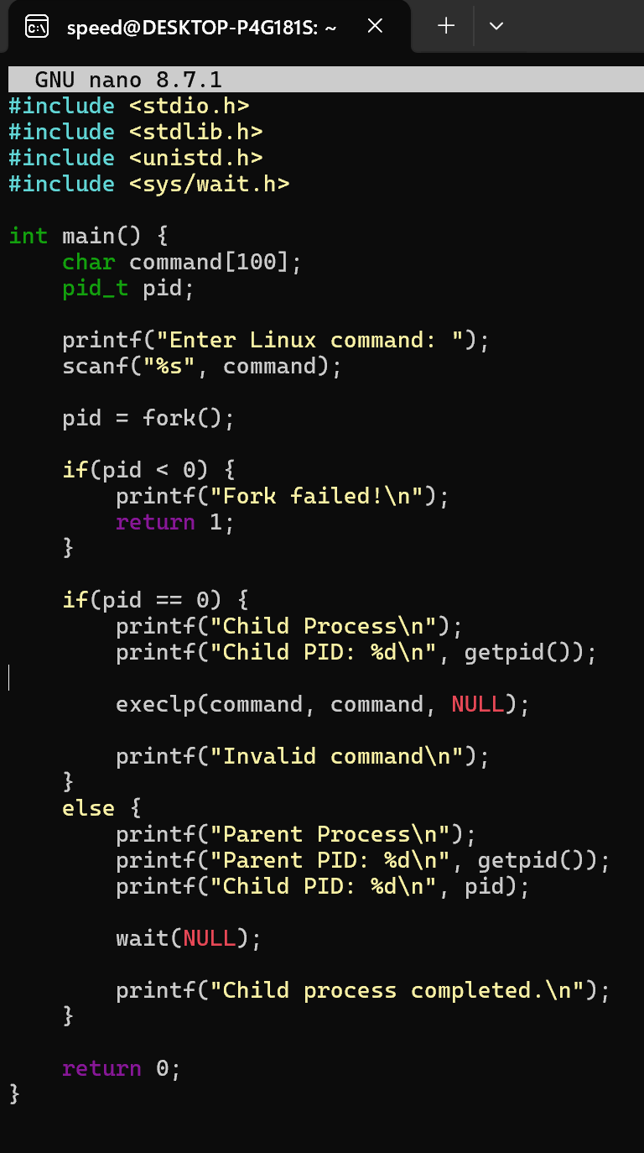
Figure 2: Compiling the program and executing the 'ls' command
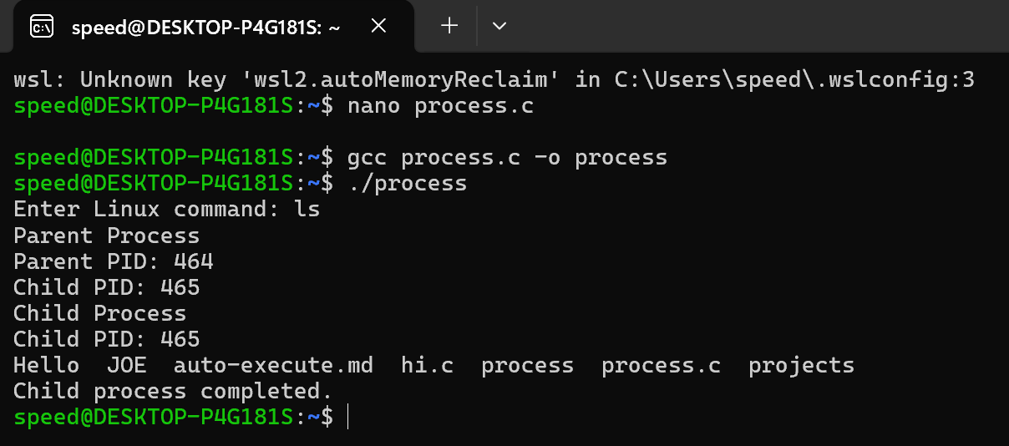
Figure 3: Executing the 'pwd' command
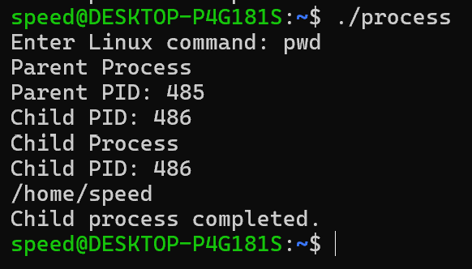

Task 2: Hardware Resources and Operating System Services
The following Linux commands were executed to study operating system services and hardware abstraction:
• uname -a
• lscpu
• ps
• top
Figure 4: Output of lscpu, ps and top
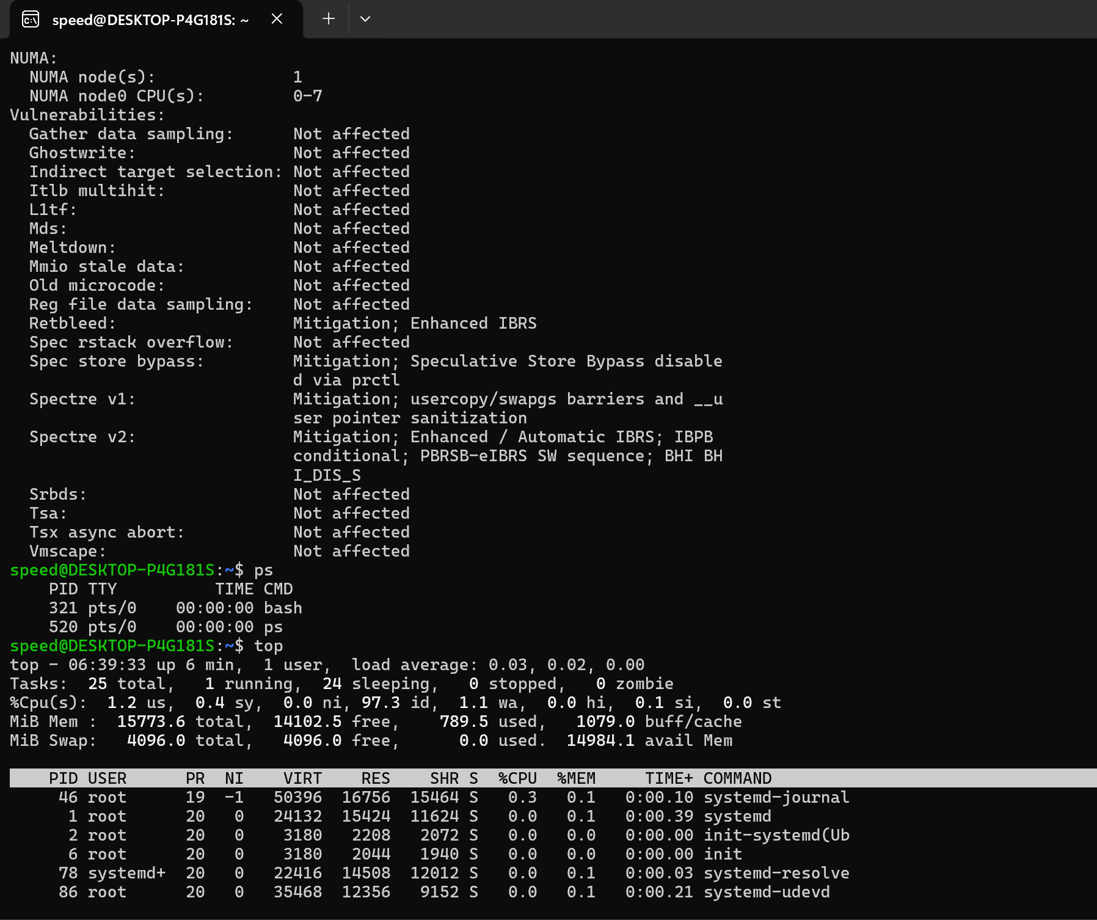

Observation
CPU: The operating system schedules processor time among processes.
Memory: The OS allocates and manages memory for each process.
Storage: The OS manages files and directories through the file system.
I/O Devices: Device drivers allow applications to communicate with hardware.

Conclusion
The practical successfully demonstrated Linux process creation using fork(), command execution using exec(), synchronization using wait(), and the abstraction of hardware resources through operating system services.

