NAME: Shivam Tiwari ID NO: 2520080026
Couse: OSSP
WEEK 2
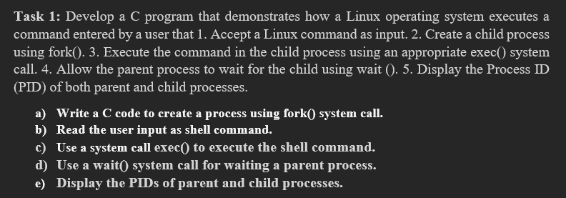
- Create a file
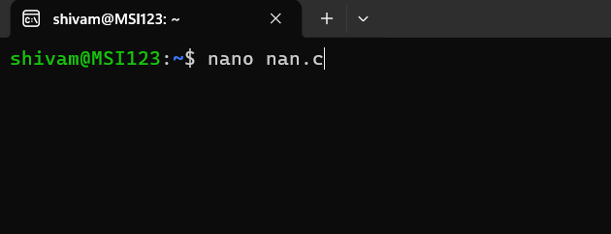
Then press enter to open command
2)write a code
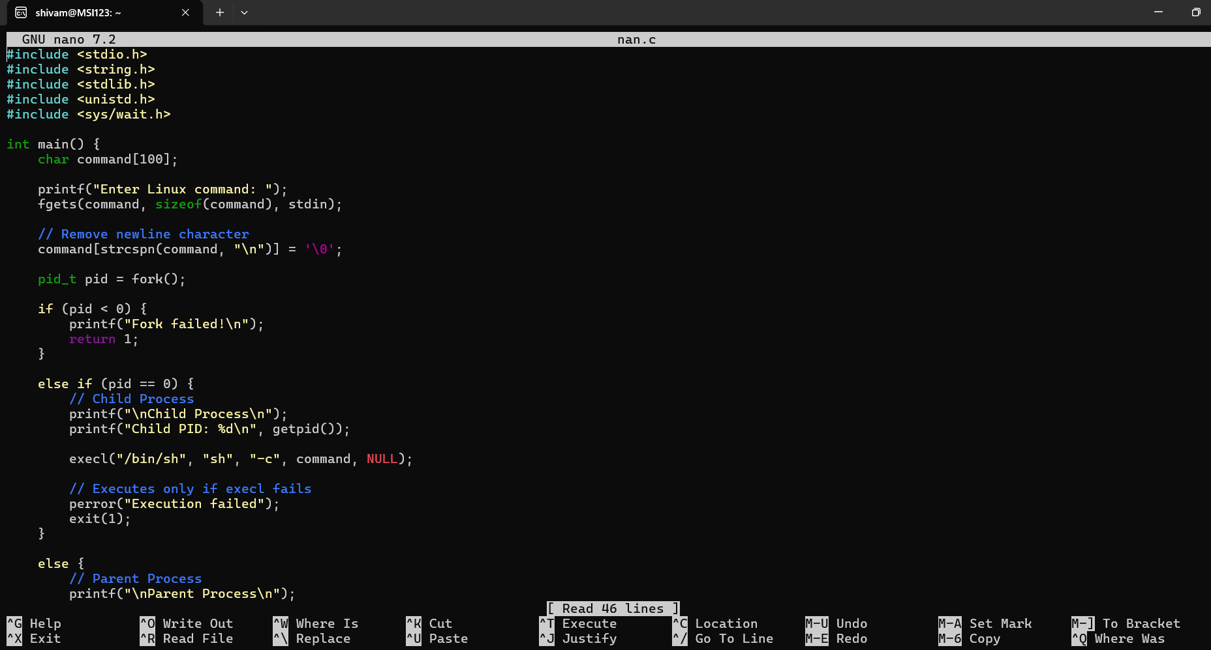
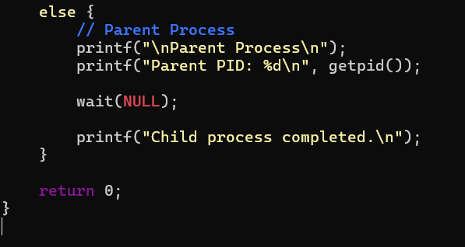
- To save press control O
- To come back to shell press control X
- Then for compilation write a command
gcc filename.c -o filename
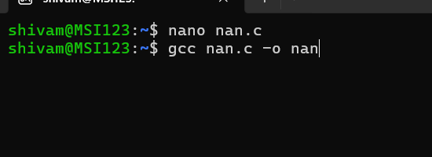
Then press enter then to view a output write a command
./filename
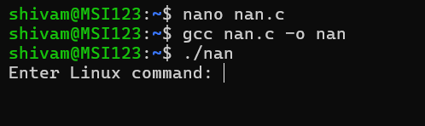
Then you will be asking to enter linux command to view the output
In ENTER LINUX COMMAND: enter either "pwd” command (or) “ls” command to see the output of your code
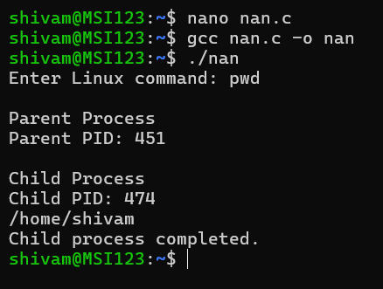
OUTPUT :
Enter Linux command : pwd

Parent Process
Parent PID: 474

Child Process
Child PID: 474
/home/shivam
Child process completed.
Task-2: Using Linux terminal commands (uname, lscpu, ps, top), investigate the relationship between hardware resources and operating system services. Prepare a report explaining how the OS abstracts CPU, memory, storage, and I/O devices.
