Host a Ubuntu Virtual Machine using Oracle VM Virtual Box. (5 marks)

1. **Download and Install Oracle VM VirtualBox**:
2. **Download Ubuntu ISO Image**:
3. **Create a New Virtual Machine in VirtualBox**:
4. **Allocate Memory (RAM)**:
5. **Create a Virtual Hard Disk**:

Set up Visual Studio code on Ubuntu VM. (5 marks)

* Open a web browser in your Ubuntu VM.
* Visit the Visual Studio Code download page.
* Click on the .deb (Debian, Ubuntu) download link to download the .deb package of Visual Studio Code.

Set up Python. (5 marks)

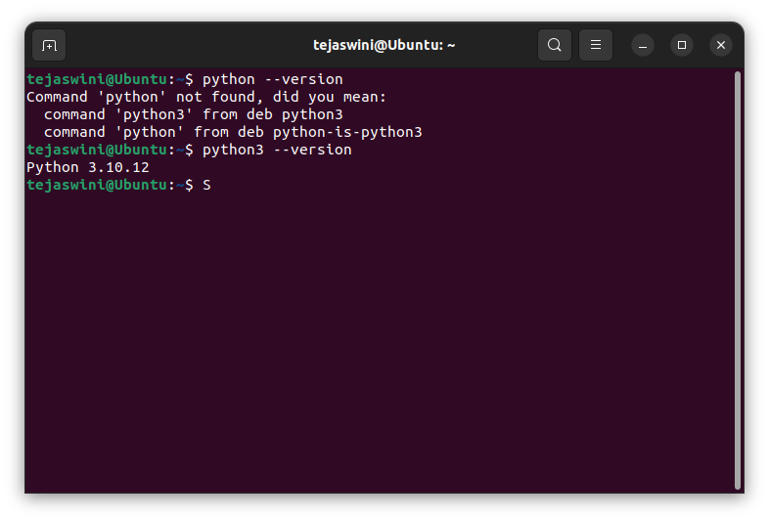

Clone this Github repository https://github.com/Vikas098766/Microservices.git (1 mark)

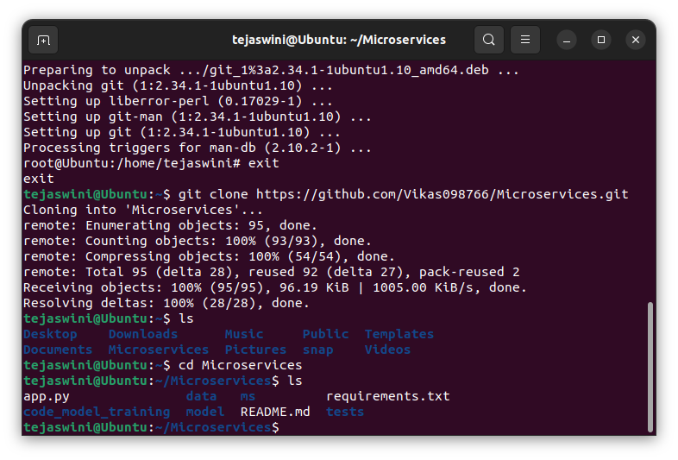

Create a Virtual Environment. (1 mark)

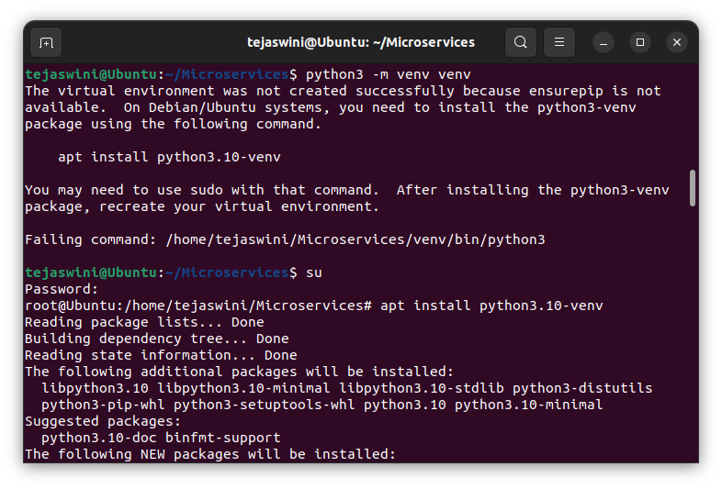

Install the dependencies from requirements.txt file. ( 1 mark)



Train and save the model. (2 marks)

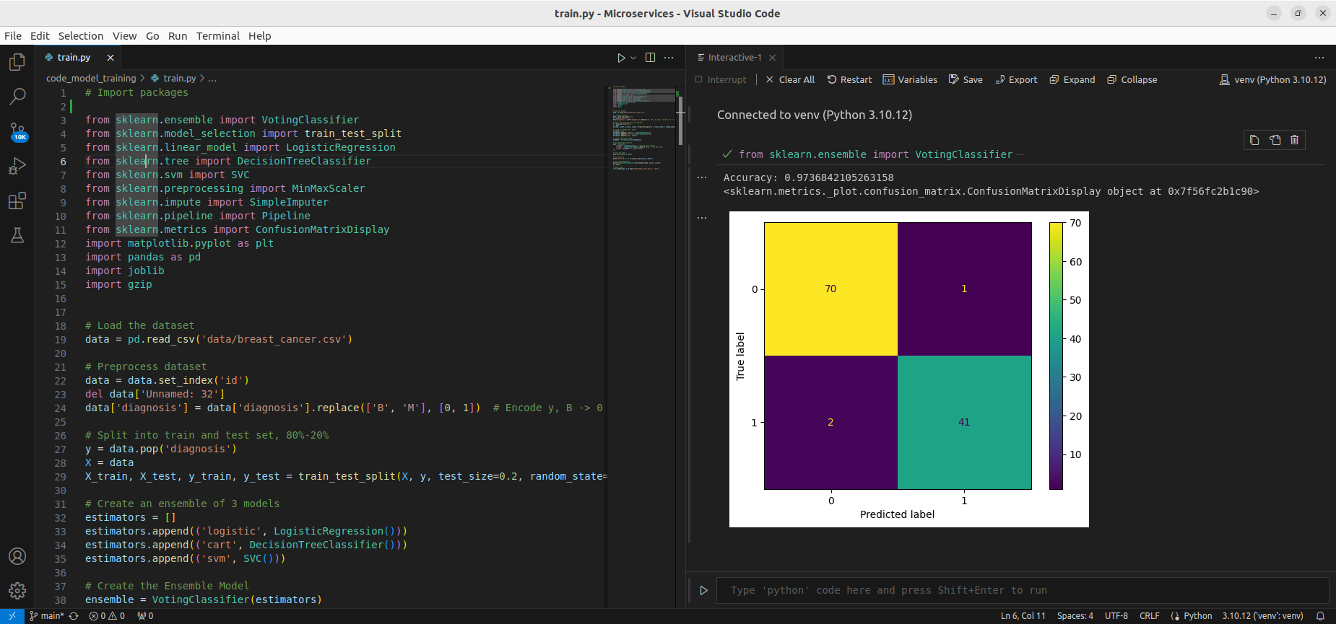

Test the Flask web application. (5 marks)

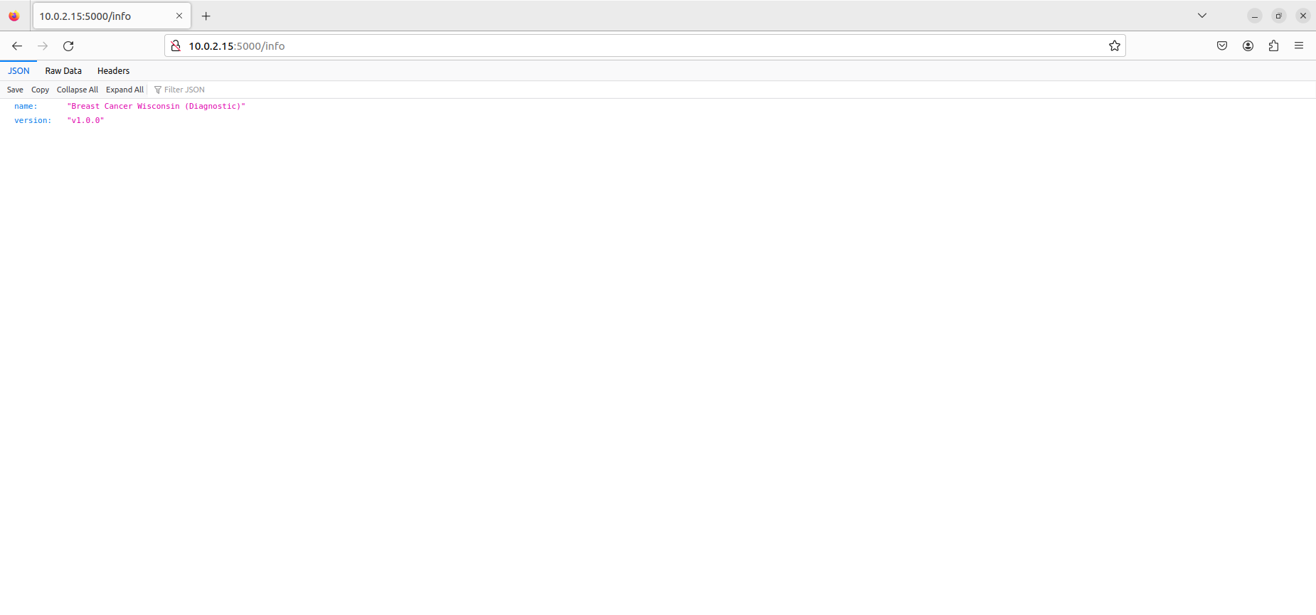

Test the application and make predictions using the example calls available in the folder /tests. (5 marks)

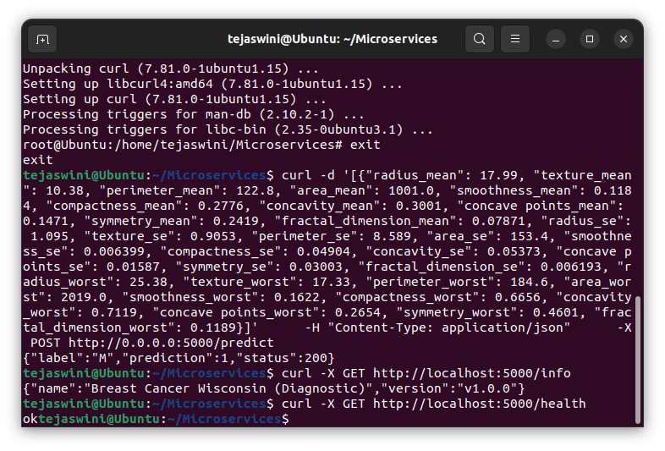

.Create a docker image containing everything needed to run the application.(10 marks)

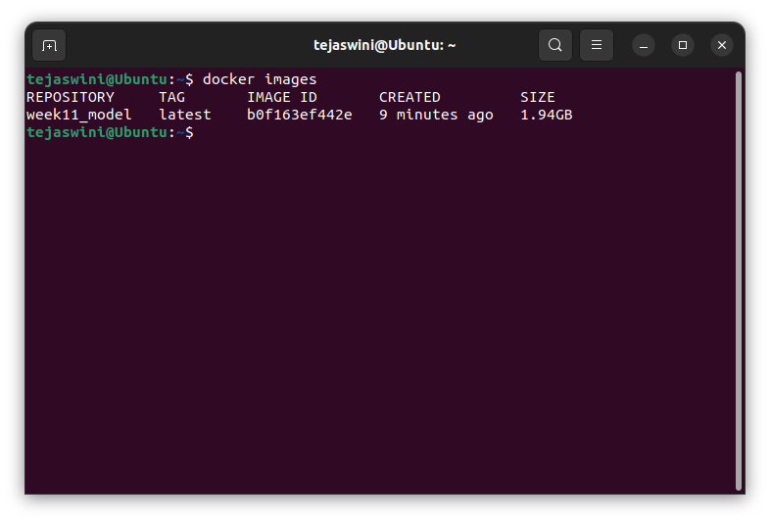

Run the containerized application as a prediction service and test it locally by passing some example calls and get the prediction. (10 marks)

