SCREEN SHOTS
To run project double click on ‘run.bat’ file from ‘Title3_SVM_CNN’ folder to get below screen
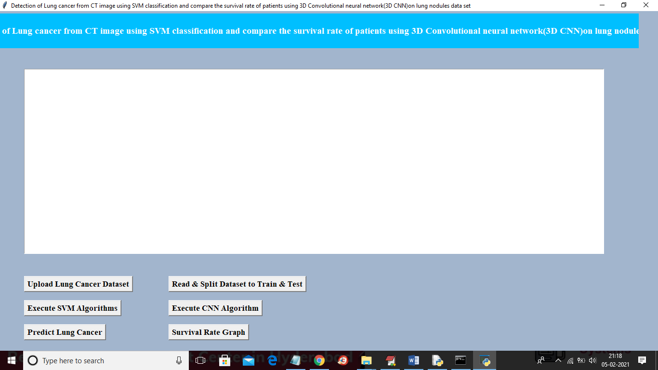
Similar to first two projects here also you upload ‘Dataset’ folder and then click on “read & split” button and then execute SVM and CNN and then predict cancer and go for survival rate graph. For CNN results you can refer to black console below
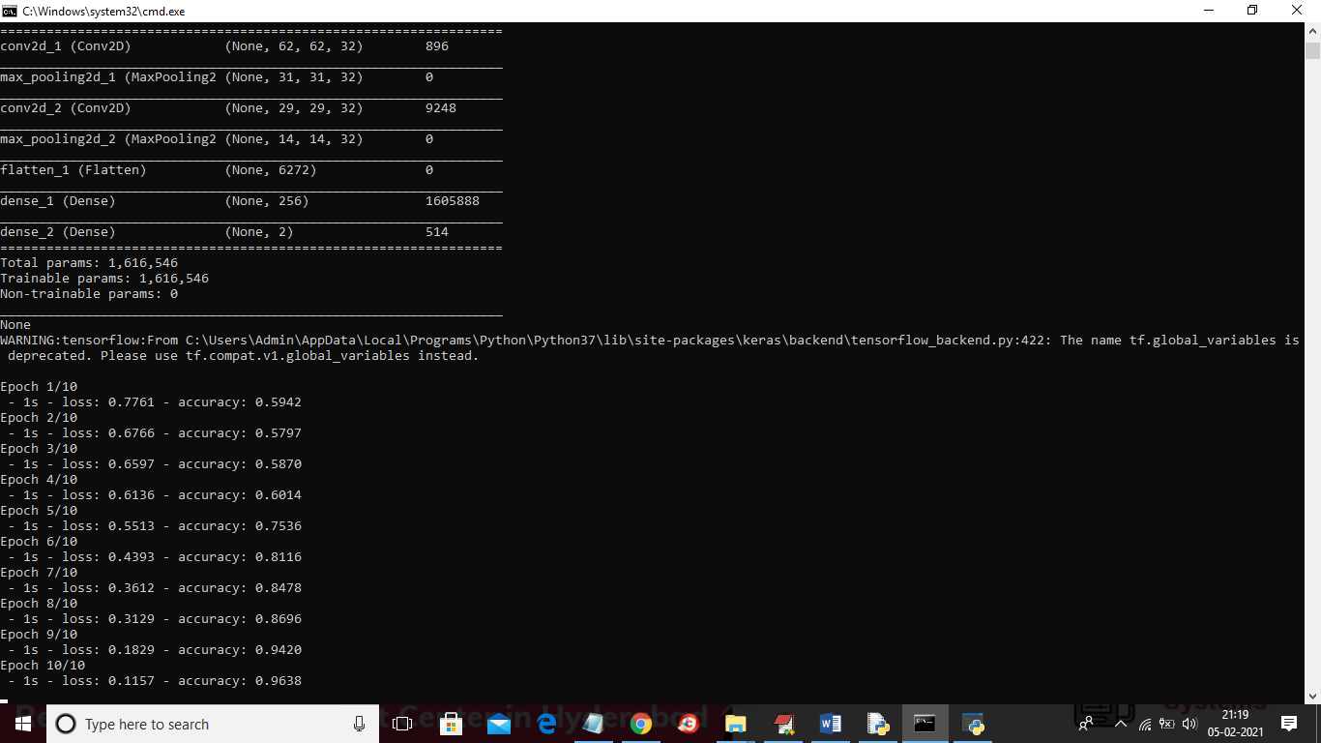
In above screen you can see for CNN we use multiple filters to filter dataset for better prediction result and in above screen in first layer CNN use 62 X 62 image size with 32 filters and in second layer for 31 X 31 image size also it uses 32 filters and for each filter we will have best image features and prediction accuracy will be better. In above screen to run CNN I used 10 epoch/iteration and for each increase iteration accuracy get better and better and for last epoch we got 0.96% accuracy and below is the final accuracy result for both SVM and CNN
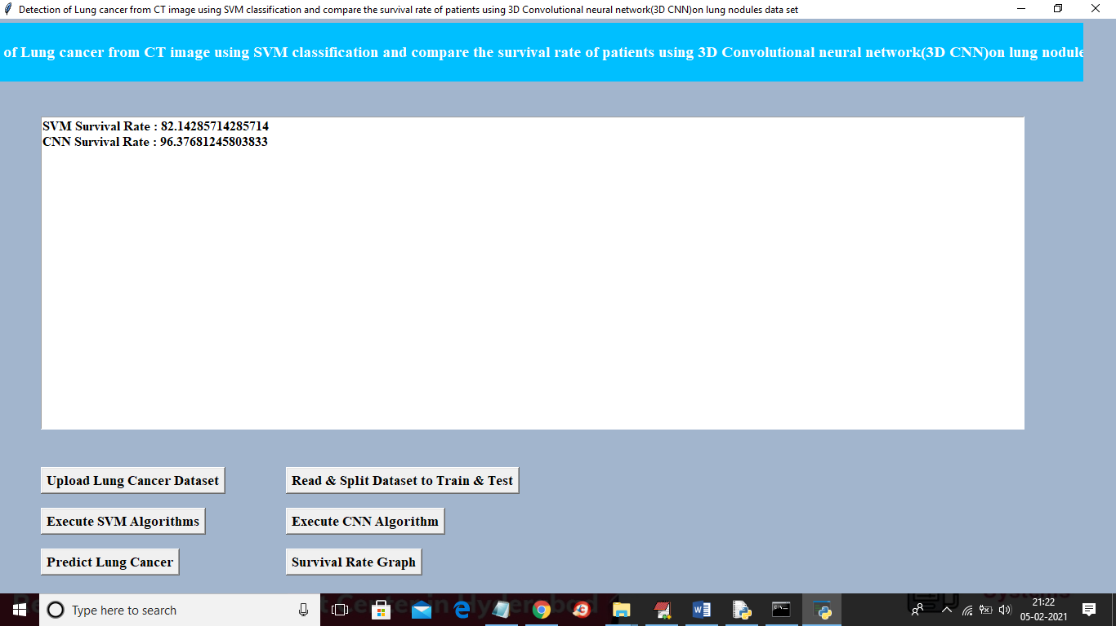
In above screen SVM survival rate is 82% and CNN survival rate is 96% and similarly you can go for predict button and graph button.

Title 4
Prediction of time-to-event outcomes in diagnosing lung cancer based on SVM and compare the accuracy of predicted outcome with Deep CNN algorithm
In this project we are training SVM and CNN with same LUNG dataset and then calculating and comparing accuracy of both algorithms
SCREEN SHOT
To run this project double click on ‘run.bat’ file from ‘Title4_SVM_CNN_Accuracy’ folder to get below screen
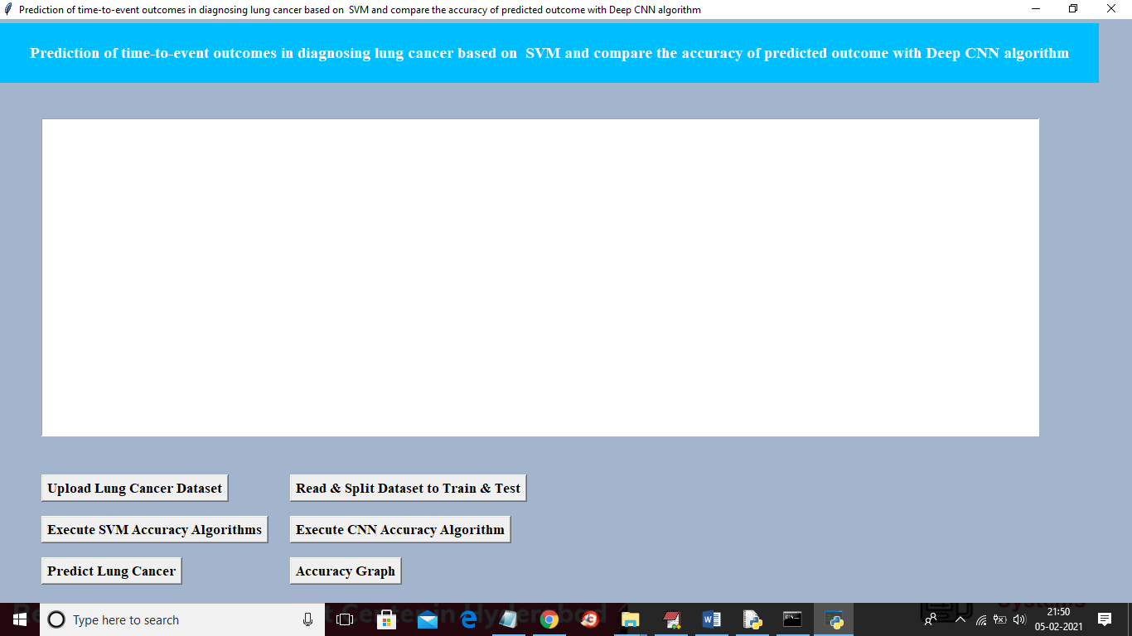
In above screen similar to first two projects upload dataset and then click on ‘read and split dataset’ button and then execute SVM with accuracy and CNN with accuracy and then you can go for predict lung cancer and accuracy graph
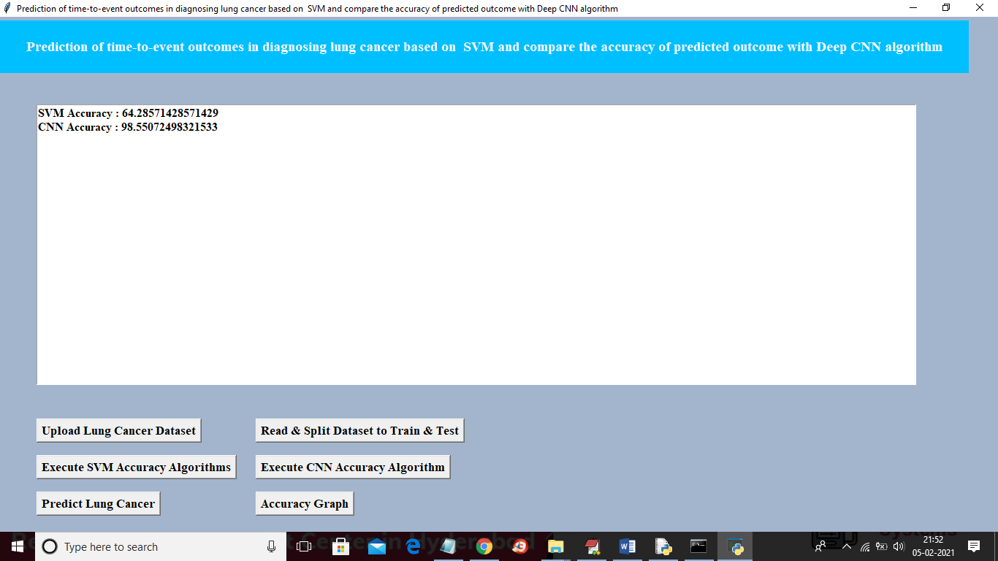
In above screen SVM accuracy is 64% and CNN accuracy is 98% and below is the comparison graph for title 4
