WEEK 3 REPORT
Unsupervised Learning and Clustering Analysis
Customer Segmentation using K-Means Clustering
Yuva Intern – Virtual Data Science with Python Trainee
Prepared by: Tejaswini Narkhede

1. Objective
The objective of this task was to apply unsupervised learning to a public dataset and divide customers into meaningful groups using clustering. The Online Retail II dataset was used for customer segmentation. RFM (Recency, Frequency and Monetary) features were created for each identified customer and K-Means clustering was applied to these features.

2. Dataset Used
The Online Retail II dataset was used for this analysis. It contains retail transaction records including invoice information, product details, quantities, prices, dates, customer identifiers and countries. The preprocessed dataset used for Week 3 contained 1,003,758 transaction records and 14 columns.
Source: UCI Machine Learning Repository – Online Retail II.
https://archive.ics.uci.edu/dataset/502/online+retail

3. Methodology
- Load the preprocessed Online Retail II dataset.
- Keep records with an identified Customer ID for customer-level analysis.
- Calculate Recency, Frequency and Monetary values for each customer.
- Standardize the three RFM features using StandardScaler.
- Use the Elbow Method to select the number of clusters.
- Apply K-Means clustering with the selected number of clusters.
- Analyze cluster size and average RFM characteristics.
- Visualize and interpret the resulting customer segments.

4. RFM Feature Creation
Feature | Meaning | Calculation
Recency | How recently the customer purchased. | Days since the customer's last purchase.
Frequency | How often the customer purchased. | Number of unique invoices/orders.
Monetary | How much the customer spent. | Total transaction amount.
A reference date one day after the latest transaction date was used for Recency. The resulting RFM dataset contained 5,853 identified customers.
reference_date = df["InvoiceDate"].max() + pd.Timedelta(days=1)
customer_df = df[df["Customer ID"] != "Unknown"].copy()
rfm = customer_df.groupby("Customer ID").agg({
"InvoiceDate": lambda x: (reference_date - x.max()).days,
"Invoice": "nunique",
"TotalAmount": "sum"
})
rfm.columns = ["Recency", "Frequency", "Monetary"]

5. Feature Scaling
Because the three RFM features have different numerical ranges, StandardScaler was used before K-Means clustering so that the features could be compared on a common scale.
scaler = StandardScaler()
rfm_scaled = scaler.fit_transform(rfm)

6. Selecting the Number of Clusters
The Elbow Method was used with K values from 2 to 6. The decrease in inertia becomes smaller after approximately four clusters, so K = 4 was selected for the final model.
inertia = []
for k in range(2, 7):
model = KMeans(n_clusters=k, random_state=42, n_init=10)
model.fit(rfm_scaled)
inertia.append(model.inertia_)
plt.plot(range(2, 7), inertia, marker="o")
plt.title("Elbow Method")
plt.xlabel("Number of Clusters")
plt.ylabel("Inertia")
plt.show()
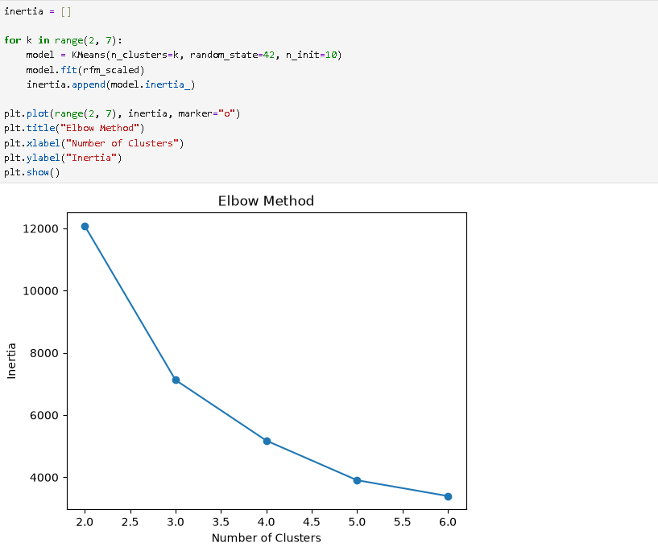
Figure 1. Elbow Method for selecting the number of clusters.

7. K-Means Clustering
K-Means was applied with four clusters. random_state=42 was used for reproducibility and n_init=10 was used for multiple centroid initializations.
kmeans = KMeans(n_clusters=4, random_state=42, n_init=10)
rfm["Cluster"] = kmeans.fit_predict(rfm_scaled)

8. Clustering Results
The final model produced four customer segments:
Cluster | Customers | Avg. Recency | Avg. Frequency | Avg. Monetary
0 | 3833 | 67.11 | 7.22 | 2878.34
1 | 4 | 3.5 | 202.75 | 422987.81
2 | 1978 | 461.68 | 2.22 | 723.88
3 | 38 | 24.26 | 99.24 | 76993.61
cluster_summary = rfm.groupby("Cluster")[["Recency", "Frequency", "Monetary"]].mean().round(2)
cluster_size = rfm["Cluster"].value_counts().sort_index()

9. Cluster Visualization
A simple scatter plot of Frequency against Monetary Value was used to visualize the customer segments. Each point is colored according to its assigned cluster.
plt.figure(figsize=(8, 5))
plt.scatter(rfm["Frequency"], rfm["Monetary"],
c=rfm["Cluster"], cmap="viridis", alpha=0.6)
plt.title("Customer Clusters")
plt.xlabel("Frequency")
plt.ylabel("Monetary Value")
plt.show()
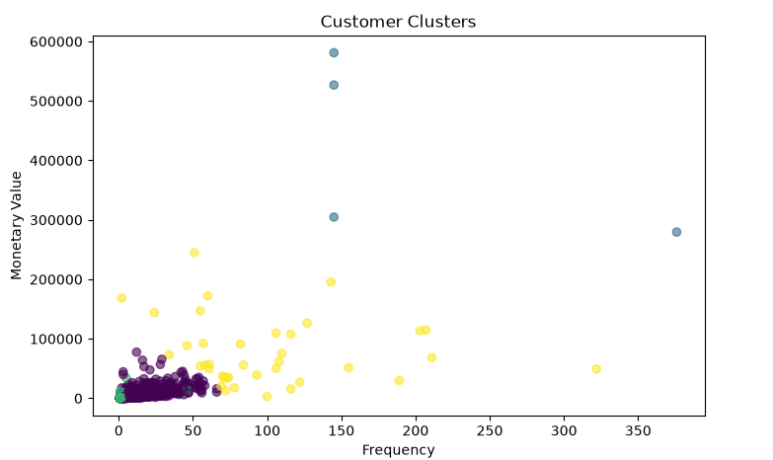
Figure 2. Customer clusters based on purchase frequency and monetary value.

10. Cluster Interpretation
Cluster 0 – Regular/Medium-Value Customers
The largest segment, with 3,833 customers. Average Recency is 67.11 days, Frequency is 7.22 and Monetary value is 2,878.34. These customers show moderate purchasing activity and spending.
Cluster 1 – Very High-Value and Highly Active Customers
This cluster contains 4 customers. Average Recency is 3.50 days, Frequency is 202.75 and Monetary value is 422,987.81, showing exceptionally high activity and spending.
Cluster 2 – Inactive/Low-Value Customers
This segment contains 1,978 customers. Average Recency is 461.68 days, Frequency is 2.22 and Monetary value is 723.88. The high Recency and low Frequency indicate relatively inactive customers.
Cluster 3 – High-Value, Frequent Customers
This cluster contains 38 customers. Average Recency is 24.26 days, Frequency is 99.24 and Monetary value is 76,993.61, indicating frequent purchases and substantially higher spending.

11. Discussion and Implications
The results show clear differences in customer purchasing behavior. Most customers belong to the regular/medium-value or inactive/low-value groups, while a small number of customers have exceptionally high frequency and monetary value. These segments can be used as a simple basis for customer-focused analysis. For example, inactive customers could be considered for re-engagement, while high-value groups could be considered for retention activities.

12. Conclusion
This task demonstrated the use of unsupervised learning for customer segmentation using the Online Retail II dataset. RFM features were created and standardized before applying K-Means. The Elbow Method supported the selection of four clusters. The resulting segments showed different levels of recency, purchase frequency and monetary value, providing a simple view of historical customer purchasing behavior.

13. Tools and Libraries Used
Python, Pandas, NumPy, Matplotlib and Scikit-learn.

14. Reference
Chen, D. (2012). Online Retail II. UCI Machine Learning Repository. https://archive.ics.uci.edu/dataset/502/online+retail

