Artificial Intelligence Project Based Learning (PBL) Report on
AI-BASED ADAPTIVE INTERVIEW PREPARATION SYSTEM
Submitted in partial fulfilment of the
Requirements for the award of the degree of
BACHELOR OF TECHNOLOGY
IN
COMPUTER SCIENCE AND ENGINEERING
(ARTIFICIAL INTELLIGENCE & MACHINE LEARNING)
Submitted by
M. Tejaswini (24R11A6668)
N. Shreya (24R11A6676)
Under the esteemed guidance of
Mr. Shaik Akbar
Associate Professor, CSE (AI & ML) Department, GCET

GEETHANJALI COLLEGE OF ENGINEERING AND TECHNOLOGY
Department of Computer Science and Engineering (AI & ML)
(UGC Autonomous)
(Accredited by NAAC with A+ Grade, Approved by AICTE and
Affiliated to JNTUH Cheeryal (V), Keesara (M), Medchal (Dist), Telangana – 501 301.
October – 2026

GEETHANJALI COLLEGE OF ENGINEERING AND TECHNOLOGY
Department of Computer Science and Engineering (AI & ML)
(UGC Autonomous)
(Accredited by NAAC with A+ Grade, Approved by AICTE and Affiliated to JNTUH
Cheeryal (V), Keesara (M), Medchal (Dist), Telangana – 501 301.
October – 2026
CERTIFICATE
This is to certify that the Artificial Intelligence Project Based Learning (PBL) Report entitled “AI-Based Adaptive Interview Preparation System” is a bonafide work done and submitted by M. Tejaswini (24R11A6668) and N. Shreya (24R11A6676) during the academic year 2026–2027, in partial fulfilment of the requirements for the award of the Bachelor of Technology degree in Computer Science and Engineering (Artificial Intelligence & Machine Learning) from Geethanjali College of Engineering and Technology.
The project work demonstrates the application of Artificial Intelligence concepts to adaptive interview preparation using Search Algorithms, Constraint Satisfaction, Propositional Logic and First-Order Logic. The work was carried out under the guidance and supervision of the faculty guide.
Certified further that, to the best of our knowledge, the work in this project has not been submitted to any other institution for the award of any degree or diploma.

FACULTY GUIDE  Mr. Shaik Akbar  Associate Professor  CSE (AI&ML) Department | HOD – CSE (AI&ML)  Dr. A. Nageswara Rao  Head of the Department  CSE (AI&ML) Department
DECLARATION
We hereby declare that the project report entitled “AI-Based Adaptive Interview Preparation System” is an original work carried out and submitted by us to the Department of Computer Science and Engineering (Artificial Intelligence & Machine Learning), Geethanjali College of Engineering and Technology, in partial fulfilment of the requirements for the award of the Bachelor of Technology degree.
The project was developed as an Artificial Intelligence Project Based Learning activity under the guidance of Mr. Shaik Akbar, Associate Professor, Department of CSE (AI & ML). The report describes the implementation and behaviour of the submitted project files to the best of our knowledge.
We further declare that this work has not been submitted to any other institution for the award of any degree or diploma.

Signature of the Students
M. Tejaswini
(24R11A6668)
N. Shreya
(24R11A6676)
ACKNOWLEDGEMENT
The successful completion of this project would not have been possible without the guidance and support of several people. We express our sincere gratitude to the management, Principal and Vice Principal for providing the academic environment and infrastructure required for the completion of this project.
We convey our deepest appreciation to our faculty guide, Mr. Shaik Akbar, Associate Professor in the Department of Computer Science and Engineering (Artificial Intelligence & Machine Learning) at Geethanjali College of Engineering and Technology. His guidance, suggestions and encouragement have been valuable throughout the project work.
We are grateful to the Head of the Department, Dr. A. Nageswara Rao, for the support extended by the department. We also thank the project coordinators and faculty members for their assistance and feedback during the development of the project.
Finally, we thank our friends and classmates for their suggestions and encouragement, which helped us complete this project successfully.
ABSTRACT
The AI-Based Adaptive Interview Preparation System is an interactive application that helps students prepare for technical interviews on any subject of their choice. For the topic entered by the candidate, a customised question bank is generated dynamically through the Google Gemini REST API, and a built-in offline generator keeps the application working without an internet connection. The system is developed in Python using only the standard library, with Tkinter providing the graphical interface.
The system applies core Artificial Intelligence concepts to select and evaluate questions: classical search (BFS, DFS, Uniform Cost Search, Iterative Deepening and Bidirectional Search), informed and local search (Greedy Best-First Search, A*, Hill Climbing and Simulated Annealing), Constraint Satisfaction Problems with domain filtering, constraint relaxation and backtracking, propositional logic (forward chaining, backward chaining and resolution) and First-Order Logic unification with forward chaining.
Each answer is scored by keyword matching, a weakness profile of the candidate is updated, and the next question is chosen adaptively. At the end of the session a detailed report shows the overall mastery, subtopic performance, recommended revision areas and a trace of the AI algorithms that were executed. The present scope is limited to text-based technical questions; semantic answer evaluation, voice input and persistent student profiles are not implemented.
Keywords: Artificial Intelligence, Adaptive Interview Preparation, Search Algorithms, A* Search, Constraint Satisfaction Problem, Propositional Logic, First-Order Logic, Google Gemini API, Python, Tkinter.
LIST OF FIGURES
Figure No. | Description | Page No.
Fig. 5.1 | Home Screen – Candidate Profile & Interview Topic | 17
Fig. 5.2 | Adaptive Interview Settings | 17
Fig. 5.3 | Question Screen with AI Selection Strategy | 18
Fig. 5.4 | Answer Entry and Submission | 18
Fig. 5.5 | Evaluation & Propositional Logic Inference Trace | 19
Fig. 5.6 | Final Technical Assessment Report | 19
Fig. 5.7 | Targeted Revision & Weak Areas | 20
Fig. 5.8 | AI Algorithms Execution Showcase | 20
TABLE OF CONTENTS
S. No. | Contents | Page No.
 | Certificate | ii
 | Declaration | iii
 | Acknowledgement | iv
 | Abstract | v
 | List of Figures | vi
 | Table of Contents | vii
1 | INTRODUCTION | 1
2 | AIM AND OBJECTIVES | 2
2.1 | Aim of Proposed System | 2
2.2 | Objectives of Proposed Project | 2
3 | IMPLEMENTATION | 4
4 | SAMPLE CODE | 7
5 | OUTPUT SCREENS | 17
6 | CONCLUSION | 21
6.1 | Future Enhancements | 21
7 | REFERENCES | 22

1. INTRODUCTION
Interview preparation is usually done with static question lists that ignore the strengths and weaknesses of the learner and give no feedback about missed concepts. A candidate preparing for a technical interview needs questions that match the current level of understanding, and feedback that shows which concepts were covered and which were missed.
The AI-Based Adaptive Interview Preparation System is a smart practice platform that helps students get ready for technical interviews in a personalised way. It combines a Tkinter interface with classical Artificial Intelligence techniques, so that the questions a candidate faces are chosen intelligently, one at a time, according to how well the candidate has performed so far.
The candidate enters any interview topic, such as Operating Systems, Python or DBMS, selects a base difficulty and the number of questions, and the system generates a question bank for that topic using the Google Gemini REST API. If the internet connection or the API is unavailable, a built-in offline generator supplies the questions.
Problem Statement
To develop an Artificial Intelligence application that generates technical interview questions for any topic, selects each next question adaptively according to the candidate’s performance and weak skills, evaluates the answers automatically, and presents a final report with revision areas.
Proposed System
The proposed system uses a two-stage selection process. Questions are first filtered as a Constraint Satisfaction Problem, and then a search algorithm chooses the best candidate. Early questions use A*, BFS, Uniform Cost Search, Bidirectional Search and Iterative Deepening Search over a prerequisite graph of questions, while later questions rotate between Greedy Best-First Search, A*, Hill Climbing and Simulated Annealing. After each answer, propositional forward chaining infers facts such as Mastered_Skill, and the final report demonstrates First-Order Logic unification and resolution.
Scope of the Project
- Generate a topic-specific question bank using the Google Gemini REST API with an offline fallback.
- Select the next question adaptively using CSP filtering, graph search, heuristic search and local search.
- Evaluate each answer by keyword matching and show the concepts mentioned and omitted.
- Maintain a weakness profile and raise or lower the target difficulty automatically.
- Infer the knowledge state of the candidate using propositional and first-order logic.
- Present setup, question, feedback and final report screens through a desktop interface.
The current implementation evaluates answers by keyword matching only; it does not perform semantic analysis of the answers, support voice input or store candidate profiles between sessions.
2. AIM AND OBJECTIVES
2.1. Aim of Proposed System
The main aim of the project is to develop an intelligent interview preparation system that adapts to every candidate. Users can enter any technical topic, answer questions in their own words and receive instant feedback, while the system uses AI search, constraint satisfaction and logical reasoning to decide which question should be asked next, so that practice is focused on the weak areas of the candidate at a suitable level of difficulty.
The purpose of the project is also to demonstrate how the core topics of the Artificial Intelligence syllabus (search strategies, heuristic and local search, constraint satisfaction, propositional logic and first-order logic) can be applied together in a single practical application, built only with the Python standard library.
2.2. Objectives of Proposed Project
- Dynamic Question Generation: Generate customised technical interview questions for any topic using the Google Gemini REST API, with difficulty levels and expected keywords for every question.
- Adaptive Question Selection: Choose each next question according to the recent performance and weak skills of the candidate.
- Uninformed Search: Use BFS, DFS, Uniform Cost Search, Iterative Deepening Search and Bidirectional Search over a prerequisite graph of questions.
- Informed and Local Search: Use Greedy Best-First Search, A* Search, Hill Climbing and Simulated Annealing to target the most useful questions.
- Constraint Satisfaction: Apply domain filtering, constraint relaxation and backtracking so that only valid, unasked questions of a suitable difficulty are considered.
- Logical Reasoning: Use propositional forward chaining, backward chaining and resolution, and first-order logic unification with forward chaining, to infer the knowledge state of the candidate.
- Automatic Answer Evaluation: Score each answer through keyword matching with an elaboration bonus.
- Offline Reliability: Provide a built-in offline fallback so that the system works without an internet connection or a valid API key.
- Interactive User Interface: Build an easy-to-use Tkinter interface with setup, question, feedback and final report screens.
- Educational Value: Provide a learning platform that shows how AI algorithms work in practice.
Hard Constraints
Hard constraints determine whether a question is eligible to be asked:
- A question must not have been asked already in the current session.
- The difficulty of a question must not exceed the allowed difficulty level.
- If no question satisfies the difficulty constraint, the constraint is relaxed so that the interview can continue.
Soft Constraints
Soft constraints guide the search towards a better choice of question, but they do not decide eligibility:
- Prefer questions on skills in which the candidate is weak.
- Prefer questions close to the current target difficulty.
- Rotate between search strategies so that different AI techniques are demonstrated.
3. IMPLEMENTATION
The implementation integrates classical Artificial Intelligence algorithms into a desktop application. The key emphasis is on adaptive question selection, transparent reasoning and real-time feedback, so that every candidate receives a personalised and meaningful practice session.
System Architecture
Candidate / Tkinter Interface
Topic, difficulty, number of questions, answers
⇓
Question Generator
Google Gemini REST API → Offline fallback generator
⇓
Search and Reasoning Engine
CSP filtering → BFS / DFS / UCS / IDS / Bidirectional → Greedy / A* / Hill Climbing / Simulated Annealing
⇓
Evaluation Module
Keyword scoring → weakness profile → propositional inference
⇓
Feedback and Final Report
Score, mastery, revision areas, algorithm trace
Figure 3.1: System architecture
System Environment and User Interface
The application is written in pure Python using only the standard library (Tkinter, json, urllib.request, math, random, threading and collections). The interface has four screens: the home screen for entering the candidate name, topic, difficulty and number of questions; the question screen where the candidate types an answer; the feedback screen showing the score, keyword analysis and logic inference trace; and the final report screen. Question generation runs in a background thread so that the window never freezes.
Data Representation
Each question is stored as a dictionary containing an id, subtopic, skill, difficulty (1–3), the question text and a list of expected keywords. Questions are the nodes of a prerequisite graph in which easier questions of a subtopic point to harder ones. A weakness profile maps every skill to a score between 0 and 100 that is updated after each answer.
Table 3: Constraint Satisfaction elements used in the project
Variables | The next question to be asked from the question pool.
Domains | The set of unasked questions generated for the topic.
Constraints | Question not already asked, difficulty not above the allowed level, with relaxation if the domain becomes empty.
Solution | A single valid question selected by a search strategy.
Question Generation
The topic is sent to the Google Gemini REST API with a prompt that asks for a JSON array of questions with subtopic, skill, difficulty and expected keywords. The client tries several Gemini models in turn. If every model fails or no valid API key is available, the built-in offline generator supplies a question bank so that the application continues to work.
Search and Reasoning Integration
- Prerequisite Graph: Easier questions of a subtopic point to harder ones, forming the graph used by BFS, DFS, UCS, IDS and Bidirectional Search.
- Heuristic Selection: A* uses f(n) = g(n) + h(n), where h(n) measures the weakness of the skill and the gap from the target difficulty.
- Local Search: Hill Climbing and Simulated Annealing explore the neighbourhood of candidate questions and avoid local optima.
- Constraint Handling: CSP filtering removes asked and too-difficult questions, relaxes the difficulty constraint if the domain becomes empty and falls back to backtracking.
System Logic and Dynamic Environment
- Strategy Rotation: The first five questions use A*, BFS, UCS, Bidirectional Search and IDS; later questions rotate between Greedy Best-First, A*, Hill Climbing and Simulated Annealing.
- Adaptive Difficulty: If the average of the last three scores is 80 or more the target difficulty is increased; if it is below 45 the target difficulty is decreased.
- Weakness Profile: The score of every skill is updated as a moving average, so that weak skills are given a higher priority later in the interview.
- Logical Inference: Propositional forward chaining derives facts such as Mastered_Skill or Schedule_Remediation_Skill from rules like “IF Weak_Skill AND Knowledge_Base_Updated → Schedule_Remediation”.
Evaluation and Feedback
The performance of the candidate is determined by how many of the expected concept keywords appear in the answer. The score is out of 100: 90 marks are given for keyword coverage, with an elaboration bonus of 5 or 10 marks for answers of at least 15 or 30 words. The feedback screen lists the concepts that were mentioned and those that were omitted.
Technologies Used
Table 4: Software and techniques used
Python | Implements the search, CSP and logic algorithms, answer evaluation and the Gemini REST client.
Tkinter | Provides the dark-themed graphical interface with cards, badges and a scrollable report.
Gemini REST API | Generates the topic-specific question bank through urllib.request.
Search Algorithms | BFS, DFS, UCS, IDS, Bidirectional, Greedy Best-First, A*, Hill Climbing and Simulated Annealing.
CSP | Domain filtering, constraint relaxation and backtracking for valid question selection.
Logic | Propositional and first-order inference, unification and resolution.
Advantages
- Adapts the difficulty and subtopic of every question to the candidate’s answers instead of using a fixed list.
- Supports any topic because the question bank is generated on demand.
- Shows which algorithm selected each question and the inference trace, making the AI reasoning transparent.
- Works offline through the built-in fallback generator.
- Applies syllabus-related AI methods to a practical learning problem.
Limitations and Future Enhancements
The present version evaluates answers by keyword matching, so a correct answer written with different words may receive a lower score. Candidate profiles are not saved between sessions. Future versions could add semantic answer evaluation using language models, persistent student profiles with progress charts, voice-based answers, mock HR rounds and a timer for a realistic interview simulation.
4. SAMPLE CODE
The following listings are taken from the submitted source file InterviewPrepSystem.py. They highlight the main components of the implementation rather than reproducing every line of interface code.
Imports and Configuration
The module uses only the Python standard library and defines the Gemini model list and the colour theme.
1 from collections import deque
2 import urllib.request
3 import urllib.error
4
5 import tkinter as tk
6 from tkinter import ttk, messagebox, scrolledtext
7
8 # ---------------------------------------------------------------------------
9 # CONFIGURATION & CONSTANTS
10 # ---------------------------------------------------------------------------
11 DEFAULT_API_KEY = "YOUR_GEMINI_API_KEY"
12 GEMINI_MODELS = [
13 "gemini-flash-lite-latest",
14 "gemini-3.1-flash-lite-preview",
15 "gemini-3-flash-preview",
16 "gemini-flash-latest"
17 ]
18
19 FALLBACK_FILE = "questions.json"
20
21 # UI Theme Color Palette (Modern Dark / Slate Indigo)
22 THEME = {
23 "bg_main": "#0f172a", # Slate 900
24 "bg_card": "#1e293b", # Slate 800
25 "bg_card_hover": "#273549", # Slate 750
26 "bg_input": "#0b132b", # Deep navy input box
27 "border": "#334155", # Slate 700
28 "border_light": "#475569", # Slate 600
29 "text_main": "#f8fafc", # Slate 50
30 "text_muted": "#94a3b8", # Slate 400
31 "text_dim": "#64748b", # Slate 500
32 "primary": "#6366f1", # Indigo 500
33 "primary_hover": "#4f46e5", # Indigo 600
34 "secondary": "#06b6d4", # Cyan 500
35 "accent": "#8b5cf6", # Violet 500
36 "success": "#10b981", # Emerald 500
37 "warning": "#f59e0b", # Amber 500
38 "danger": "#ef4444", # Rose 500
39 }
Listing 1: Imports and configuration
Gemini Question Generation
The client sends a prompt to the Gemini REST API, tries each model in turn and parses the returned JSON array.
1 class GeminiClient:
2 """Client for Google Gemini REST API using urllib.request."""
3
4 @staticmethod
5 def test_key(api_key):
6 """Test if the given API key can connect to the Gemini API."""
7 key = api_key.strip()
8 if not key:
9 return False, "API key is empty."
10 url = f"https://generativelanguage.googleapis.com/v1beta/models?key={key}"
11 try:
12 req = urllib.request.Request(url)
13 with urllib.request.urlopen(req, timeout=10) as resp:
14 data = json.loads(resp.read().decode("utf-8"))
15 models = data.get("models", [])
16 return True, f"Connected successfully! ({len(models)} models available)"
17 except urllib.error.HTTPError as e:
18 return False, f"HTTP Error {e.code}: {e.reason}"
19 except Exception as e:
20 return False, f"Connection error: {str(e)}"
21
22 @staticmethod
23 def generate_questions(topic, num_questions=10, api_key=DEFAULT_API_KEY):
24 """
25 Dynamically generate interview questions for any topic using Gemini.
26 Returns a list of dicts with id, topic, skill, difficulty, question, keywords.
27 """
28 key = api_key.strip() or DEFAULT_API_KEY
29 prompt = f"""Generate exactly {num_questions} high-quality technical interview questions for the topic: '{topic}'.
30 Ensure questions vary across difficulty levels (1=Easy, 2=Medium, 3=Hard) and cover diverse subtopics/skills.
31 Return strictly a valid JSON array of objects with this schema:
32 [
33 {{
34 "id": 1,
35 "topic": "Specific Subtopic Name",
36 "skill": "Specific Concept or Skill Name",
37 "difficulty": 1,
38 "question": "Clear, precise technical interview question.",
39 "keywords": ["keyword1", "keyword2", "keyword3", "keyword4"]
40 }}
41 ]
42 Do not include markdown code fences or explanatory text. Return only the JSON array."""
43
44 payload = {
45 "contents": [{"parts": [{"text": prompt}]}],
46 "generationConfig": {
47 "temperature": 0.35,
48 "responseMimeType": "application/json"
49 }
50 }
51 data_bytes = json.dumps(payload).encode("utf-8")
52
53 last_error = None
54 for model in GEMINI_MODELS:
55 url = f"https://generativelanguage.googleapis.com/v1beta/models/{model}:generateContent?key={key}"
56 req = urllib.request.Request(url, data=data_bytes, headers={"Content-Type": "application/json"})
57 try:
58 with urllib.request.urlopen(req, timeout=25) as resp:
59 result = json.loads(resp.read().decode("utf-8"))
60 raw = result["candidates"][0]["content"]["parts"][0]["text"].strip()
61 if raw.startswith("```json"):
62 raw = raw[7:]
63 if raw.startswith("```"):
64 raw = raw[3:]
65 if raw.endswith("```"):
66 raw = raw[:-3]
67 questions = json.loads(raw.strip())
68 if isinstance(questions, list) and len(questions) > 0:
69 # Normalize question IDs
70 for idx, q in enumerate(questions, start=1):
71 q["id"] = idx
72 if "difficulty" not in q or q["difficulty"] not in (1, 2, 3):
73 q["difficulty"] = 2
74 if "keywords" not in q or not isinstance(q["keywords"], list):
75 q["keywords"] = [q.get("skill", "concept").lower()]
76 return questions, f"Generated dynamically via Gemini ({model})"
77 except Exception as e:
78 last_error = str(e)
79 continue
80
81 # If all models fail, raise error
82 raise RuntimeError(f"Gemini API request failed: {last_error}")
Listing 2: Gemini API client
Offline Fallback Generator
When the API is unavailable, a built-in generator supplies questions for the topic.
1 def get_offline_questions(topic, num_questions=10):
2 """
3 Provides rich fallback questions when offline or if no API key is provided.
4 Includes built-in banks for popular domains or adapts existing questions.json.
5 """
6 # 1. Try reading from questions.json if available
7 if os.path.exists(FALLBACK_FILE):
8 try:
9 with open(FALLBACK_FILE, "r", encoding="utf-8") as f:
10 qs = json.load(f)
11 if qs:
12 # Filter by topic if possible or return subset
13 matching = [q for q in qs if topic.lower() in q.get("topic", "").lower()]
14 pool = matching if len(matching) >= 5 else qs
15 selected = random.sample(pool, min(num_questions, len(pool)))
16 for i, q in enumerate(selected, 1):
17 q["id"] = i
18 return selected
19 except Exception:
20 pass
21
22 # 2. Hardcoded fallback bank for general CS & AI topics
23 templates = [
24 {"skill": "Core Fundamentals", "diff": 1, "kw": ["definition", "purpose", "concept", "advantage"]},
25 {"skill": "Architecture & Flow", "diff": 2, "kw": ["process", "components", "execution", "lifecycle"]},
26 {"skill": "Performance & Efficiency", "diff": 2, "kw": ["complexity", "optimization", "time", "memory"]},
27 {"skill": "Edge Cases & Conflict Handling", "diff": 3, "kw": ["deadlock", "race condition", "handling", "prevention"]},
28 {"skill": "System Scaling & Best Practices", "diff": 3, "kw": ["scalability", "robustness", "patterns", "latency"]},
29 ]
30 generated = []
31 for i in range(1, num_questions + 1):
32 tpl = templates[(i - 1) % len(templates)]
33 generated.append({
34 "id": i,
35 "topic": topic,
36 "skill": f"{topic} {tpl['skill']}",
37 "difficulty": tpl["diff"],
38 "question": f"Explain the principles of {tpl['skill']} in {topic}. Discuss its practical significance and trade-offs.",
39 "keywords": tpl["kw"] + [topic.lower().split()[0]]
40 })
41 return generated
Listing 3: Offline fallback generator
Prerequisite Graph and Breadth-First Search
Questions become graph nodes; BFS finds a path from the easiest to the target question.
1 def graph_from_questions(questions):
2 """
3 Builds a directed prerequisite dependency graph between questions.
4 Questions of lower difficulty within matching or related subtopics point
5 to questions of higher difficulty.
6 """
7 nodes = [q["id"] for q in questions]
8 graph = {n: [] for n in nodes}
9 by_topic = {}
10 for q in questions:
11 by_topic.setdefault(q["topic"], []).append(q)
12
13 # Within topic prerequisite edges
14 for q in questions:
15 same = by_topic.get(q["topic"], [])
16 lower = [x for x in same if x["difficulty"] < q["difficulty"]]
17 if lower:
18 nearest = max(lower, key=lambda x: x["difficulty"])
19 graph[nearest["id"]].append(q["id"])
20
21 # If graph is too sparse, connect sequential levels across topics
22 for i in range(len(questions) - 1):
23 curr_id = questions[i]["id"]
24 next_id = questions[i + 1]["id"]
25 if next_id not in graph[curr_id]:
26 graph[curr_id].append(next_id)
27
28 return graph
29
30
31 def bfs(graph, start, goal):
32 """Unit I: Breadth-First Search (queue-based, explores shortest path in steps)."""
33 queue = deque([[start]])
34 visited = {start}
35 while queue:
36 path = queue.popleft()
37 node = path[-1]
38 if node == goal:
39 return path
40 for nxt in graph.get(node, []):
41 if nxt not in visited:
42 visited.add(nxt)
43 queue.append(path + [nxt])
44 return [start]
Listing 4: Graph construction and BFS
Heuristic and Local Search
Greedy Best-First, A*, Hill Climbing and Simulated Annealing choose among the candidate questions.
1 def greedy_best_first(candidates, weakness_scores):
2 """Unit I: Greedy Best-First Search (picks candidate maximizing weakness priority)."""
3 if not candidates:
4 return None
5 return max(candidates, key=lambda q: weakness_scores.get(q["skill"], 50) / max(1, q["difficulty"]))
6
7
8 def heuristic(q, weakness_scores, target_difficulty):
9 """A* Heuristic function h(n) measuring skill mismatch and target difficulty gap."""
10 weakness = weakness_scores.get(q["skill"], 50)
11 difficulty_gap = abs(q["difficulty"] - target_difficulty)
12 # Lower heuristic is closer to optimal interview targeting
13 return (100 - weakness) + (difficulty_gap * 15)
14
15
16 def a_star_select(candidates, weakness_scores, target_difficulty):
17 """Unit I: A* Search (evaluates candidates with f(n) = g(n) + h(n))."""
18 if not candidates:
19 return None
20 return min(candidates, key=lambda q: q["difficulty"] * 10 + heuristic(q, weakness_scores, target_difficulty))
21
22
23 def hill_climbing(candidates, weakness_scores, target_difficulty):
24 """Unit I: Hill Climbing Local Search (greedily steps to neighbor with best score)."""
25 if not candidates:
26 return None
27
28 def score(q):
29 return 100 - heuristic(q, weakness_scores, target_difficulty)
30
31 current = random.choice(candidates)
32 improved = True
33 iterations = 0
34 while improved and iterations < 10:
35 iterations += 1
36 improved = False
37 neighbors = random.sample(candidates, min(3, len(candidates)))
38 for n in neighbors:
39 if score(n) > score(current):
40 current = n
41 improved = True
42 break
43 return current
44
45
46 def simulated_annealing(candidates, weakness_scores, target_difficulty):
47 """Unit I: Simulated Annealing (probabilistic acceptance using cooling schedule)."""
48 if not candidates:
49 return None
50
51 def score(q):
52 return 100 - heuristic(q, weakness_scores, target_difficulty)
53
54 current = random.choice(candidates)
55 temperature = 12.0
56 for _ in range(20):
57 candidate = random.choice(candidates)
58 delta = score(candidate) - score(current)
59 if delta > 0 or random.random() < math.exp(delta / max(temperature, 0.05)):
60 current = candidate
61 temperature *= 0.85
62 return current
Listing 5: Informed and local search
Constraint Satisfaction
Domain filtering removes invalid questions; backtracking picks a question when other methods fail.
1 def csp_filter(questions, max_difficulty, asked_ids, weaknesses):
2 """
3 Unit II: CSP Filtering.
4 Applies unary and relational constraints:
5 - Variable: Next question
6 - Domain constraints: Unasked (id not in asked_ids), difficulty <= max_difficulty.
7 - Constraint relaxation applied if domain becomes empty.
8 """
9 result = []
10 for q in questions:
11 if q["id"] in asked_ids:
12 continue
13 if q["difficulty"] > max_difficulty:
14 continue
15 result.append(q)
16
17 # Constraint Relaxation: If difficulty constraint prunes everything, relax it
18 if not result:
19 for q in questions:
20 if q["id"] not in asked_ids:
21 result.append(q)
22 return result
23
24
25 def backtracking_pick(candidates, asked_ids):
26 """Unit II: CSP Backtracking search to assign consistent next question."""
27 assignment = []
28
29 def backtrack(index):
30 if len(assignment) == 1:
31 return assignment[0]
32 if index >= len(candidates):
33 return None
34 q = candidates[index]
35 if q["id"] in asked_ids:
36 return backtrack(index + 1)
37 assignment.append(q)
38 res = backtrack(index + 1)
39 if res:
40 return res
41 assignment.pop()
42 return backtrack(index + 1)
43
44 return backtrack(0)
Listing 6: CSP filtering and backtracking
Propositional Logic
Forward chaining, backward chaining and resolution infer the knowledge state of the candidate.
1 def propositional_forward_chaining(facts, rules):
2 """
3 Unit II: Propositional Logic Forward Chaining.
4 Iteratively infers new facts from satisfied rule premises until a fixed point.
5 """
6 inferred = set(facts)
7 changed = True
8 trace = []
9 while changed:
10 changed = False
11 for premises, conclusion in rules:
12 if set(premises).issubset(inferred) and conclusion not in inferred:
13 inferred.add(conclusion)
14 trace.append(f"Fired rule {premises} -> '{conclusion}'")
15 changed = True
16 return inferred, trace
17
18
19 def propositional_backward_chaining(goal, facts, rules, visited=None):
20 """Unit II: Propositional Logic Backward Chaining (goal-directed deduction)."""
21 visited = visited or set()
22 if goal in facts:
23 return True
24 if goal in visited:
25 return False
26 visited.add(goal)
27 for premises, conclusion in rules:
28 if conclusion == goal:
29 if all(propositional_backward_chaining(p, facts, rules, visited.copy()) for p in premises):
30 return True
31 return False
32
33
34 def resolution_demo():
35 """Unit II: Resolution refutation theorem proving demonstration: (P v Q) and (~Q) => P."""
36 clauses = [
37 {"P", "Q"},
38 {"~Q"},
39 ]
40 resolvents = []
41 for c1 in clauses:
42 for c2 in clauses:
43 for lit in list(c1):
44 opposite = "~" + lit if not lit.startswith("~") else lit[1:]
45 if opposite in c2:
46 resolvent = (c1 - {lit}) | (c2 - {opposite})
47 if resolvent and resolvent not in resolvents:
48 resolvents.append(resolvent)
49 return resolvents
Listing 7: Propositional logic
First-Order Logic
Unification matches patterns with facts, and forward chaining derives new facts.
1 def unify(pattern, fact):
2 """
3 Unit III: First-Order Logic Unification.
4 Matches variables (starting with '?') against ground constants/terms.
5 e.g. unify('Mastered(?student, ?skill)', 'Mastered(Student, Deadlock)')
6 """
7 p = pattern.strip()
8 f = fact.strip()
9 if p == f:
10 return {}
11 if p.startswith("?"):
12 return {p: f}
13 if f.startswith("?"):
14 return {f: p}
15
16 if "(" in p and ")" in p and "(" in f and ")" in f:
17 p_pred = p.split("(")[0].strip()
18 f_pred = f.split("(")[0].strip()
19 if p_pred != f_pred:
20 return None
21 p_args = [x.strip() for x in p[p.find("(") + 1:-1].split(",")]
22 f_args = [x.strip() for x in f[f.find("(") + 1:-1].split(",")]
23 if len(p_args) != len(f_args):
24 return None
25 subst = {}
26 for pa, fa in zip(p_args, f_args):
27 if pa.startswith("?"):
28 subst[pa] = fa
29 elif fa.startswith("?"):
30 subst[fa] = pa
31 elif pa != fa:
32 return None
33 return subst
34 return None
35
36
37 def fol_forward_chaining(facts, rules):
38 """
39 Unit III: FOL Forward Chaining.
40 Applies substitution lifting to derive ground conclusions from generalized rules.
41 """
42 inferred = set(facts)
43 changed = True
44 while changed:
45 changed = False
46 for premise, conclusion in rules:
47 for fact in list(inferred):
48 subst = unify(premise, fact)
49 if subst is not None:
50 derived = conclusion
51 for var, val in subst.items():
52 derived = derived.replace(var, val)
53 if derived not in inferred:
54 inferred.add(derived)
55 changed = True
56 return inferred
Listing 8: FOL unification and forward chaining
Answer Evaluation
The score is computed from keyword coverage with an elaboration bonus.
1 def evaluate_answer(answer, keywords):
2 """
3 Evaluates candidate answer against expected concept keywords.
4 Returns: score (0-100), matched_keywords (list), missed_keywords (list).
5 """
6 text = answer.lower().strip()
7 if not text:
8 return 0, [], keywords
9
10 words = text.split()
11 matched = []
12 missed = []
13 for k in keywords:
14 k_clean = k.lower().strip()
15 if k_clean in text:
16 matched.append(k)
17 else:
18 missed.append(k)
19
20 hits = len(matched)
21 total_kw = max(1, len(keywords))
22 score = int((hits / total_kw) * 90)
23
24 # Elaboration bonus for substantive technical response
25 if len(words) >= 30:
26 score = min(100, score + 10)
27 elif len(words) >= 15:
28 score = min(100, score + 5)
29
30 return score, matched, missed
Listing 9: Keyword-based answer evaluation
Adaptive Question Selection
The method combines CSP filtering, difficulty adaptation and the rotation of search strategies.
1 def select_next_question(self):
2 """
3 Selects the next question by combining:
4 1. CSP filtering (domain reduction)
5 2. Graph-based classical search (BFS, DFS, UCS, IDS, Bidirectional)
6 3. Heuristic & Local search (A*, Greedy, Hill Climbing, Simulated Annealing)
7 4. CSP Backtracking fallback
8 """
9 candidates = csp_filter(
10 self.questions, self.difficulty, self.asked_ids, self.weakness
11 )
12 if not candidates:
13 return None, "No remaining questions in pool"
14
15 step = len(self.history)
16 recent = self.history[-3:]
17 avg_score = sum(x["score"] for x in recent) / len(recent) if recent else 60
18 target_diff = self.difficulty
19 if avg_score >= 80:
20 target_diff = min(3, self.difficulty + 1)
21 elif avg_score < 45:
22 target_diff = max(1, self.difficulty - 1)
23
24 # Graph formulation for search algorithms
25 q_graph = graph_from_questions(candidates)
26 start_node = candidates[0]["id"]
27 goal_node = candidates[-1]["id"]
28 by_id = {q["id"]: q for q in candidates}
29
30 selected = None
31 algo_name = ""
32 algo_reason = ""
33
34 # Early interview questions demonstrate Classical Uninformed Searches
35 if step == 0:
36 algo_name = "A* Search [Unit I]"
37 selected = a_star_select(candidates, self.weakness, target_diff)
38 algo_reason = f"Evaluated f(n)=g(n)+h(n) targeting difficulty {target_diff}."
39 elif step == 1:
40 algo_name = "Breadth-First Search (BFS) [Unit I]"
41 path = bfs(q_graph, start_node, goal_node)
42 target_id = path[1] if len(path) > 1 else path[0]
43 selected = by_id.get(target_id, candidates[0])
44 algo_reason = f"Level-order queue traversal along path: {path}."
45 elif step == 2:
46 algo_name = "Uniform Cost Search (UCS) [Unit I]"
47 path = ucs(q_graph, start_node, goal_node, by_id)
48 target_id = path[1] if len(path) > 1 else path[0]
49 selected = by_id.get(target_id, candidates[0])
50 algo_reason = f"Priority queue picked lowest difficulty step cost along path: {path}."
51 elif step == 3:
52 algo_name = "Bidirectional Search [Unit I]"
53 path = bidirectional_search(q_graph, start_node, goal_node)
54 target_id = path[len(path) // 2] if path else candidates[0]["id"]
55 selected = by_id.get(target_id, candidates[0])
56 algo_reason = f"Forward & backward frontiers met at node {target_id}."
57 elif step == 4:
58 algo_name = "Iterative Deepening Search (IDS) [Unit I]"
59 path = ids(q_graph, start_node, goal_node)
60 target_id = path[-1] if path else candidates[0]["id"]
61 selected = by_id.get(target_id, candidates[0])
62 algo_reason = f"Bounded DFS explored up to depth {len(path)}."
63 else:
64 # Subsequent adaptive questions rotate Informed & Local Search
65 mode = step % 4
66 if mode == 0:
67 algo_name = "Greedy Best-First Search [Unit I]"
68 selected = greedy_best_first(candidates, self.weakness)
69 algo_reason = "Maximizes weakness prioritization score."
70 elif mode == 1:
71 algo_name = "A* Search [Unit I]"
72 selected = a_star_select(candidates, self.weakness, target_diff)
73 algo_reason = f"Optimal balance of difficulty cost g(n) and target gap h(n)."
74 elif mode == 2:
75 algo_name = "Hill Climbing Local Search [Unit I]"
76 selected = hill_climbing(candidates, self.weakness, target_diff)
77 algo_reason = "Greedy local search explored neighborhood."
78 else:
79 algo_name = "Simulated Annealing [Unit I]"
80 selected = simulated_annealing(candidates, self.weakness, target_diff)
81 algo_reason = "Probabilistic temperature exploration escaped local optima."
82
83 # Fallback to CSP Backtracking if needed
84 if not selected or selected["id"] in self.asked_ids:
85 algo_name = "CSP Backtracking Assignment [Unit II]"
86 selected = backtracking_pick(candidates, self.asked_ids)
87 algo_reason = "Backtracking resolved variable assignment with unasked constraint."
88
89 self.selection_method = algo_name
90 self.selection_reason = algo_reason
91 return selected, algo_reason
92
93 # -----------------------------------------------------------------------
94 # SCREEN 2: ACTIVE TECHNICAL INTERVIEW QUESTION
95 # -----------------------------------------------------------------------
Listing 10: Adaptive question selection
Application Entry Point
The main function creates the Tkinter window and starts the application.
1 #8. Application Entry Point
2 def main():
3 root = tk.Tk()
4 ModernInterviewApp(root)
5 root.mainloop()
6
7
8 if __name__ == "__main__":
9 main()
Listing 11: Application entry point
5. OUTPUT SCREENS
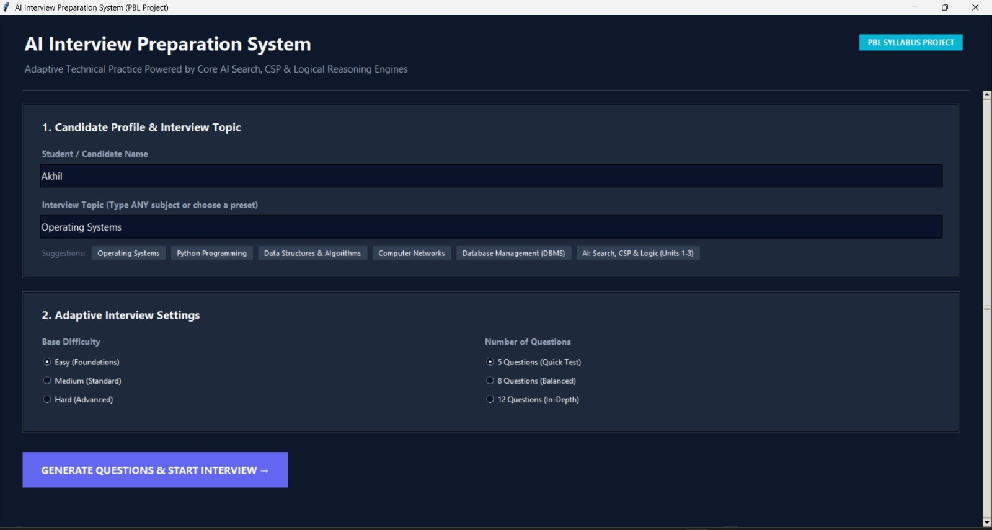
Figure 5.1: Home Screen – Candidate Profile & Interview Topic
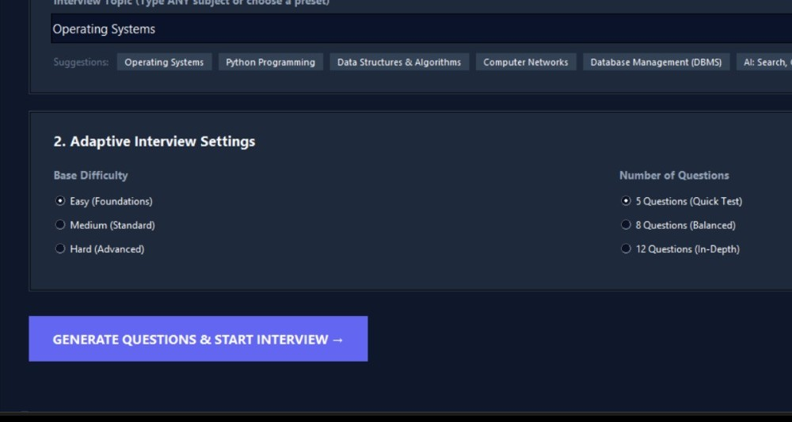
Figure 5.2: Adaptive Interview Settings

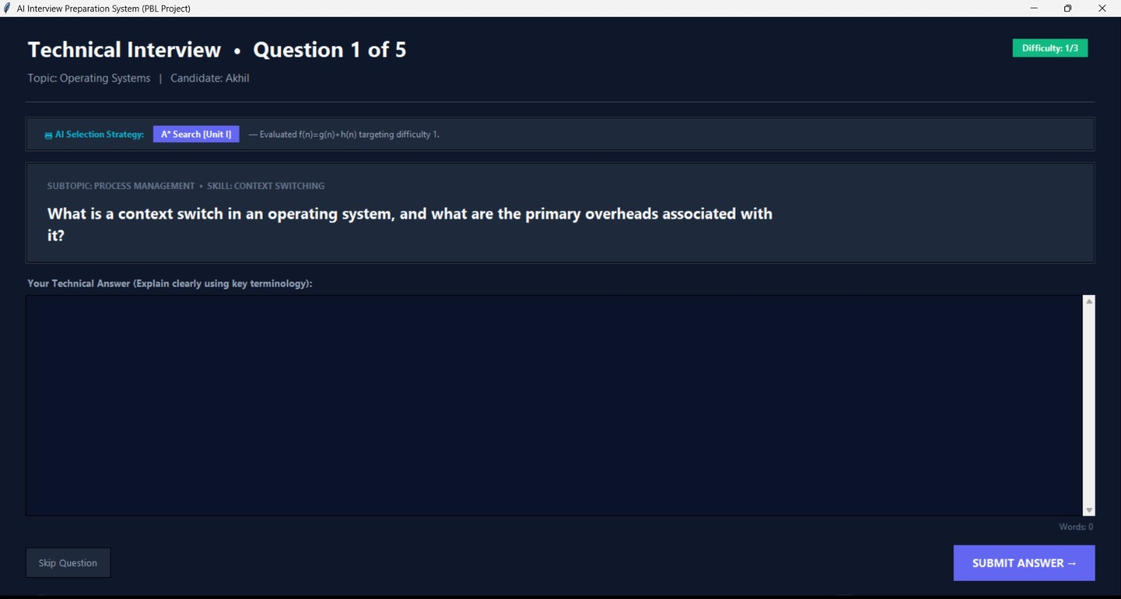
Figure 5.3: Question Screen with AI Selection Strategy
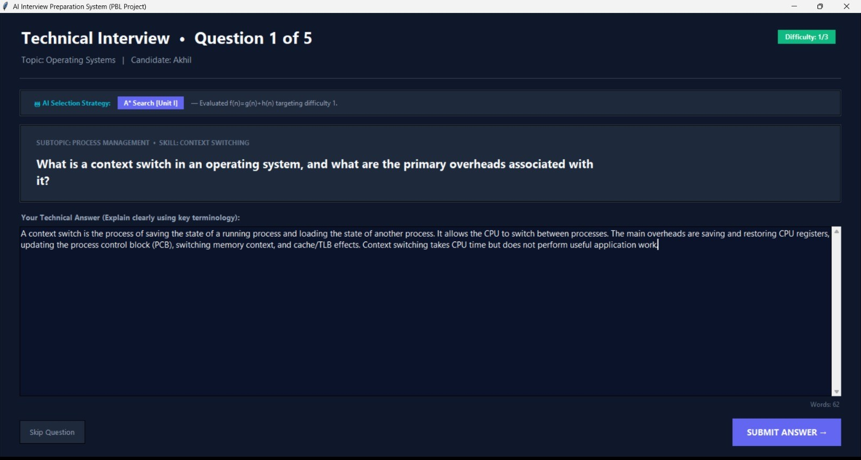
Figure 5.4: Answer Entry and Submission

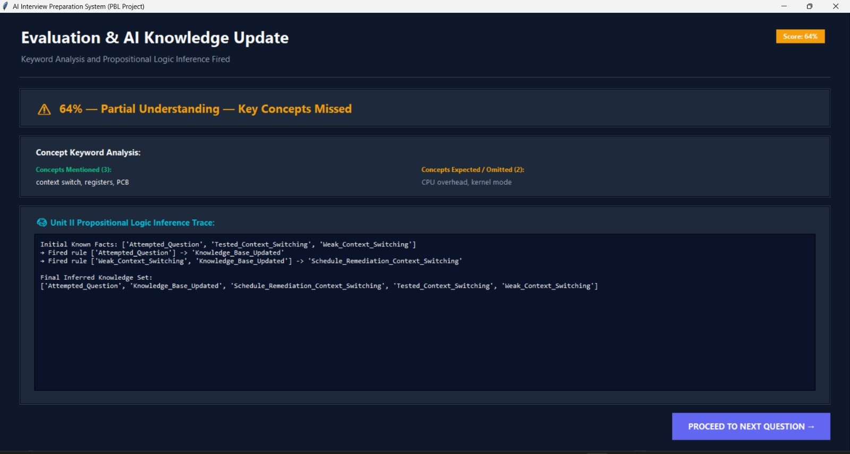
Figure 5.5: Evaluation & Propositional Logic Inference Trace
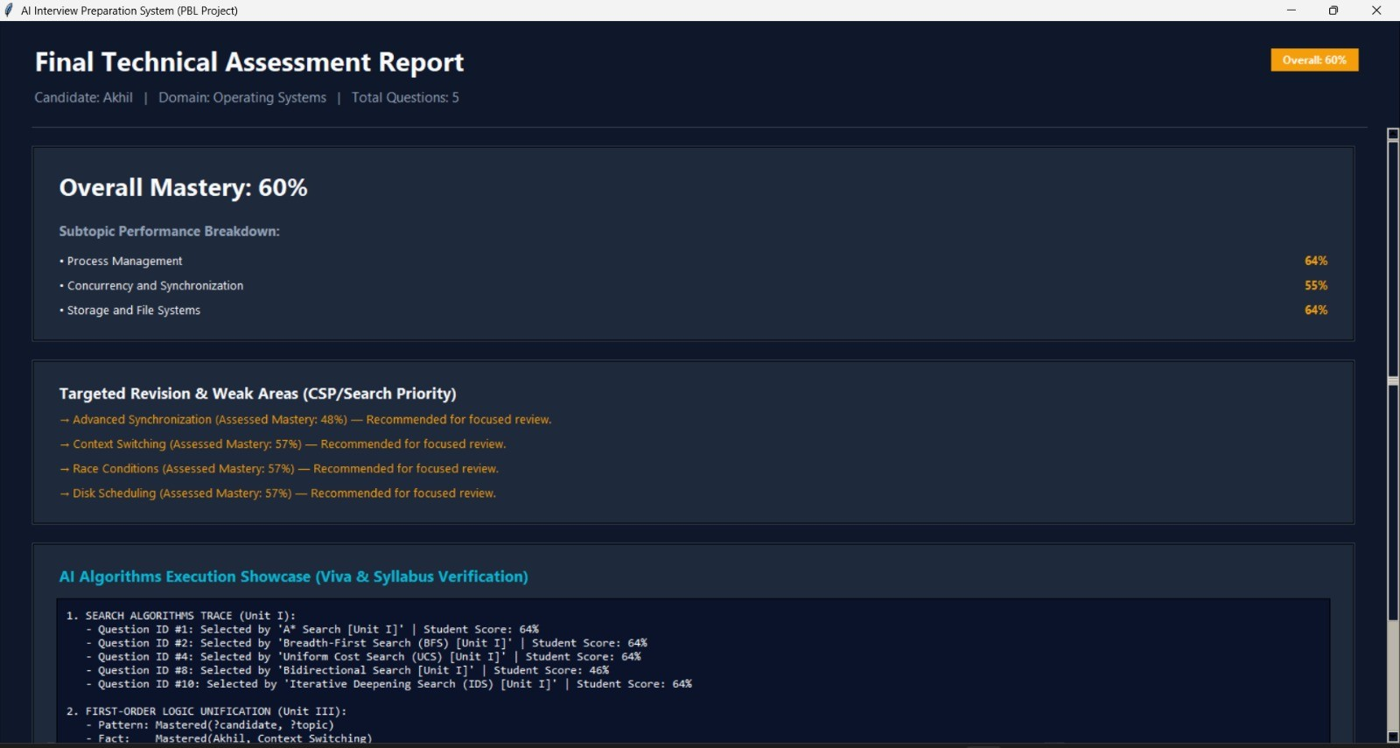
Figure 5.6: Final Technical Assessment Report

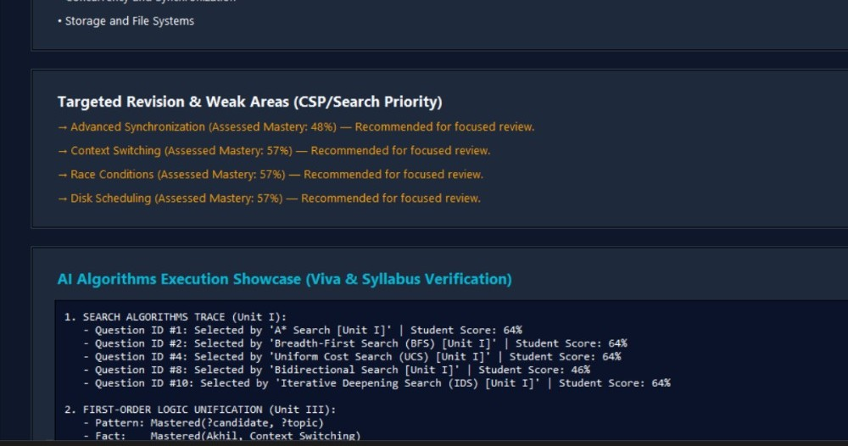
Figure 5.7: Targeted Revision & Weak Areas
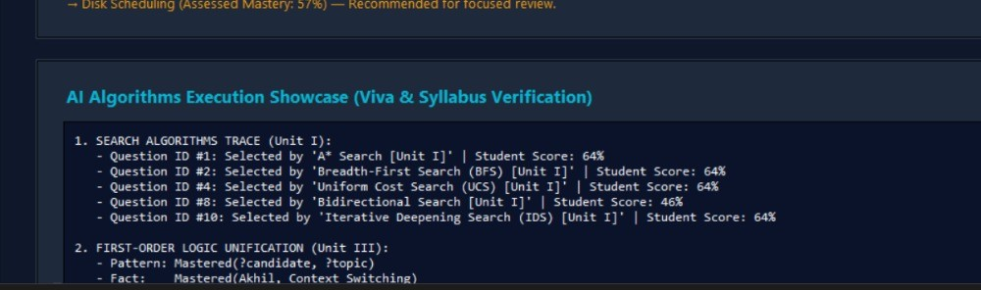
Figure 5.8: AI Algorithms Execution Showcase
6. CONCLUSION
The AI-Based Adaptive Interview Preparation System successfully demonstrates how core Artificial Intelligence techniques can be applied to a practical learning problem. By combining dynamic question generation using the Google Gemini API with CSP filtering, graph search, and heuristic and local search, the system selects every question adaptively according to the performance and the weak skills of the candidate.
Through a simple but effective keyword-based evaluation and a logical knowledge base, the project shows how propositional logic and first-order logic can be used to represent and reason about what a candidate has learnt. The interface presents each step clearly, including the search strategy that was used and the inference trace, while the offline fallback ensures that the application works reliably even without an internet connection.
In conclusion, the project provides a useful tool for interview preparation and a transparent demonstration of the AI syllabus units on search, constraint satisfaction and logic.
6.1. Future Enhancements
The project can be extended in the following ways:
- Replace keyword matching with semantic answer evaluation using language models.
- Add persistent student profiles and progress charts across multiple sessions.
- Add voice-based answers and mock HR rounds for a realistic interview simulation.
- Add a timer for each question and an overall interview time limit.
- Allow the final report to be exported to PDF and enable users to review past sessions.
- Provide a web-based version so that the system can be used from any browser.
7. REFERENCES
- Russell, S. J., and Norvig, P. Artificial Intelligence: A Modern Approach, 4th Edition. Pearson, 2021.
- Python Software Foundation. “Python Programming Language.” Available at: https://www.python.org/
- Hart, P. E., Nilsson, N. J., and Raphael, B. “A Formal Basis for the Heuristic Determination of Minimum Cost Paths.” IEEE Transactions on Systems Science and Cybernetics, 4(2), 1968, pp. 100–107.
- Kirkpatrick, S., Gelatt, C. D., and Vecchi, M. P. “Optimization by Simulated Annealing.” Science, 220(4598), 1983, pp. 671–680.
- Google AI for Developers. “Gemini API Documentation.” Available at: https://ai.google.dev/gemini-api/docs
- Python Documentation. “tkinter — Python interface to Tcl/Tk.” Available at: https://docs.python.org/3/library/tkinter.html
- Python Documentation. “urllib.request — Extensible library for opening URLs.” Available at: https://docs.python.org/3/library/urllib.request.html
- Artificial Intelligence course notes and prescribed syllabus material covering Search, Constraint Satisfaction Problems and Logic.

