Operating System Project Based Learning (PBL) Report on
Simulate File Locking Mechanism in Database Management Systems

Submitted in partial fulfilment of the

Requirements for the award of the degree of
BACHELOR OF TECHNOLOGY
IN
Computer Science and Engineering (AI & ML)
Submitted by
M. Tejaswini [24R11A6668]
N. Shreya [24R11A6676]
Tanvi patil [24R11A6696]
V. Vaishnavi [24R11A6699]
Ms. M. Gayatri

Assistant Professor, CSE (AI&ML) Department

Geethanjali College of Engineering and Technology


Geethanjali College of Engineering and Technology
Department of Computer Science and Engineering (AI & ML)
(UGC AUTONOMOUS INSTITUTION)
Accredited by NAAC with ‘A+’ Grade & NBA, Approved by AICTE and Affiliated to J.N.T.U.H

Cheeryal (V), Keesara (M), Medchal(D), Telangana-501 301.

APRIL-2026

CONTENTS
S.No. | Contents | Page No
1. | Abstract | 1
2. | Introduction | 2
3. | Example with Solution | 3
4. | System Configuration | 5
5. | Implementation | 6
6. | Output | 9
7. | Conclusion | 10
8. | References | 11


Geethanjali College of Engineering and Technology
Department of Computer Science and Engineering (AI & ML)
(UGC AUTONOMOUS INSTITUTION)
Accredited by NAAC with ‘A+’ Grade & NBA, Approved by AICTE and Affiliated to J.N.T.U.H

Cheeryal (V), Keesara (M), Medchal(D), Telangana-501 301.

APRIL-2026
DEPARTMENT OF COMPUTER SCIENCE AND ENGINEERING (AI & ML)

CERTIFICATE

This is to certify that the Operating System (PBL) Report entitled “Simulate File Locking Mechanism in Database Management Systems” is a bonafide work done and submitted by M. Tejaswini [24R11A6668], N. Shreya [24R11A6676], Tanvi Patil [24R11A6696], V. Vaishnavi [24R11A6699] during the academic year 2025–2026, in partial fulfilment of the requirement for the award of the degree of Bachelor of Technology in “Computer Science and Engineering (AI & ML)” from Geethanjali College of Engineering and Technology (Accredited by NAAC with “A+” Grade & NBA, Approved by AICTE and Affiliated to JNTUH),is a bonafide record of work carried out under the guidance and supervision.
Certified further that to the best of my knowledge, the work presented in this project has not been submitted to any other institution for the award of any degree or diploma.

FACULTY GUIDE HEAD OF THE DEPARTMENT
Ms. M. Gayatri Dr. A. Nageswara Rao
Assistant Professor Professor & HOD
CSE (AI & ML) Department CSE (AI & ML) Department
DECLARATION
We hereby declare that the project report entitled “Simulate File Locking Mechanism in Database Management Systems” is an original work done and submitted to the Department of Computer Science and Engineering (AI & ML), Geethanjali College of Engineering and Technology (Accredited by NAAC with ‘A+’ Grade & NBA, Approved by AICTE and Affiliated to JNTUH), in partial fulfilment of the requirement for the award of the degree of Bachelor of Technology in Computer Science and Engineering (AI & ML).This report is a record of bonafide project work carried out by us under the guidance of Ms. M. Gayatri, Senior Assistant Professor, Department of CSE (AI & ML).
We further declare that the work presented in this project has not been submitted, either in part or in full, for the award of any other degree or diploma in this institute or any other institute or university.

Signature of the Student
N. Tejaswini
(24R11A6668)

Signature of the Student
N. Shreya
(24R11A6676)

Signature of the Student
Tanvi patil
(24R11A6696)

Signature of the Student
V. Vaishnavi
(24R11A6699)
ABSTRACT
This project simulates a file locking mechanism in a Database Management Systems using the C programming language. In systems where multiple users or processes attempt to access the same file simultaneously, maintaining data consistency becomes a critical challenge. To address this, the project implements file locking using system calls, ensuring that only one process can modify the file at a time while others wait.
The simulation uses multiple processes to represent different users and applies file locks to control concurrent access. The output is both displayed on the terminal and written to a file, demonstrating how proper synchronization prevents data corruption. This project provides a practical understanding of operating system concepts such as process synchronization, mutual exclusion, and safe file handling.

INTRODUCTION
In modern multi-user operating systems, multiple processes often need to access shared resources such as files simultaneously. When several processes attempt to read from or write to the same file at the same time, it can lead to serious issues like race conditions, data inconsistency, and file corruption. Without proper coordination, these conflicts can disrupt system reliability and affect overall performance. Therefore, an efficient mechanism is required to control concurrent access and maintain data integrity.
To address this problem, this project presents a File Locking Mechanism Simulation in a Database Management Systems using the C programming language and system-level calls. In this implementation, multiple processes are created using the fork() system call, where each process represents a different user trying to access a shared file. To regulate access, the fcntl() system call is used to apply file locks, ensuring controlled and synchronized operations.
Whenever a process attempts to write to the file, it first requests a lock. If the file is already locked by another process, it is forced to wait until the lock becomes available. Once the lock is acquired, the process safely writes data to the file and then releases the lock, allowing other waiting processes to proceed. This mechanism ensures that only one process can modify the file at any given time, thereby preventing data conflicts and maintaining consistency.
This project demonstrates how operating systems manage concurrent file access in a structured and efficient manner. By analyzing both the terminal output and the contents of the generated file, the effectiveness of the locking mechanism can be clearly observed. The implementation highlights key operating system concepts such as mutual exclusion, process synchronization, deadlock avoidance, and safe resource sharing, making it a practical demonstration of real-world system behavior.

EXAMPLE WITH SOLUTION
File locking is a synchronization technique used in operating systems to control access to shared files. When multiple processes attempt to access the same file simultaneously, locks ensure that only one process can modify the file at a time, preventing data inconsistency and corruption.
In this project, multiple users are represented as processes, and a shared file acts as the common resource. The system uses file locking (fcntl) to maintain safe and controlled access among processes.
Basic Terms
- Shared File
It is the common resource accessed by multiple processes.
Example: shared_file.txt
- Process (User)
Each process represents a user trying to access the file.
Example: User1, User2, User3
- Lock
A mechanism used to restrict access to the file.
- Write Lock (Exclusive Lock) → Only one process can write
- Other processes must wait until the lock is released
- Critical Section
The part of the program where the file is accessed or modified.
Only one process can execute this section at a time.
Conditions for Safe Execution
The system is in a safe state if:
- Only one process holds the lock at a time
- Other processes wait until the lock is released
- All processes eventually complete execution

Steps of File Locking Mechanism
- Process requests access to the file
- System checks if the file is locked
- If not locked → grant lock
- Process enters critical section and writes to file
- Process releases the lock
- Waiting processes are allowed to proceed one by one
Algorithm Conditions
- Only one process can hold the write lock at a time
- If file is locked → other processes must wait
- After execution → process releases the lock
- All processes execute sequentially without conflict
Example
Number of Processes (Users): 3
Shared Resource: 1 File
Step-by-Step Execution
Step 1: User1 requests lock
Step 2: Lock is granted to User1, starts writing
Step 3: User2 requests lock → waits
Step 4: User3 requests lock → waits
Step 5: User1 finishes and releases lock
Step 6: User2 gets lock and writes
Step 7: User2 releases lock
Step 8: User3 gets lock and writes
Output (File Content)
User1 wrote to file
User2 wrote to file
User3 wrote to file
Safe Execution Sequence
User1 → User2 → User3
This sequence ensures that only one process writes at a time, preventing data corruption and maintaining consistency.
Without File Locking
If locking is not used:
- Multiple processes write simultaneously
- Output becomes inconsistent
- Data may overlap or get corrupted
Final Understanding
This example demonstrates how file locking ensures:
- Mutual Exclusion
- Process Synchronization
- Safe Resource Sharing
Thus, the system avoids conflicts and maintains data integrity in a multi-user environment

SYSTEM CONFIGURATION

Hardware Requirements
- Processor: Intel i3 or above
- RAM: 4 GB minimum
- Hard Disk: 500 GB (optional)
- Input Devices: Keyboard and Mouse
- Monitor: Standard Display

Software Requirements
- Operating System: Windows 10 / 11
- Programming Language: C
- Compiler: GCC (GNU Compiler Collection)
- Development Tool: code::Blocks/Vs Code/ Turbo C

CODE IMPLEMENTATION
#include <stdio.h>
#include <stdlib.h>
#include <unistd.h>
#include <fcntl.h>
#include <sys/wait.h>
#include <string.h>

void write_file(int fd, int user) {
struct flock lock;

// Configure lock
lock.l_type = F_WRLCK; // Write lock
lock.l_whence = SEEK_SET;
lock.l_start = 0;
lock.l_len = 0; // Lock entire file

printf("User%d is trying to acquire lock...\n", user);

// Acquire lock
if (fcntl(fd, F_SETLKW, &lock) == -1) {
perror("Lock failed");
exit(1);
}

printf("User%d acquired lock and is writing...\n", user);

// Prepare data
char buffer[100];
snprintf(buffer, sizeof(buffer), "User%d wrote to file\n", user);

// Write to file
write(fd, buffer, strlen(buffer));

sleep(2); // Simulate delay

printf("User%d releasing lock...\n", user);

// Release lock
lock.l_type = F_UNLCK;
fcntl(fd, F_SETLK, &lock);
}

int main() {
int fd = open("shared_file.txt", O_CREAT | O_WRONLY | O_APPEND, 0666);

if (fd < 0) {
perror("File open error");
return 1;
}

// Create 3 user processes
for (int i = 1; i <= 3; i++) {
pid_t pid = fork();

if (pid == 0) { // Child process
write_file(fd, i);
close(fd);
exit(0);
}
}

// Wait for all child processes
for (int i = 0; i < 3; i++) {
wait(NULL);
}

close(fd);
return 0;
}
OUTPUT

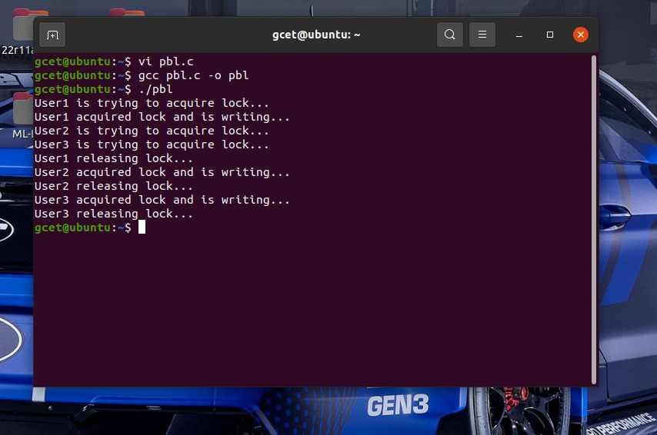

CONCLUSION
This project successfully demonstrates the implementation of a File Locking Mechanism in a Database Management Systems using the C programming language. The main objective was to simulate how operating systems manage concurrent access to shared files and ensure data integrity.
By using system calls such as fork() and fcntl(), multiple processes were created to represent different users attempting to access a common file. The file locking mechanism ensured that only one process could write to the file at a time, while other processes waited until the lock was released. This effectively prevented race conditions, data inconsistency, and file corruption.
The program clearly illustrates key operating system concepts such as mutual exclusion, process synchronization, and safe resource sharing. The output observed both in the terminal and in the generated file confirms that the locking mechanism works correctly, maintaining a proper sequence of execution among processes.
Overall, this project provides a practical understanding of how file locking is used in real systems to handle concurrent access efficiently. It highlights the importance of synchronization techniques in maintaining system stability and reliability in multi-user environments.

REFERENCES
- GeeksforGeeks – File Locking in Operating System
File Locking in OS
https://www.geeksforgeeks.org/file-locking-in-operating-system/
File locking is used to restrict access to a file by multiple processes to avoid data inconsistency
- TutorialsPoint – File Locking using fcntl()
File Locking in C using fcntl
https://www.tutorialspoint.com/unix_system_calls/fcntl.htm
The fcntl() system call is used for file control operations, including applying locks on files.
- Wikipedia – File Locking
File Locking Overview
https://en.wikipedia.org/wiki/File_locking
File locking is a mechanism that restricts access to a file to prevent conflicts between processes
- GeeksforGeeks – fork() System Call
fork() in Operating System
https://www.geeksforgeeks.org/fork-system-call/
The fork() system call is used to create new processes in Unix-based systems
- TutorialsPoint – Process Synchronization
Process Synchronization in OS
https://www.tutorialspoint.com/operating_system/os_process_synchronization.htm
Process synchronization ensures that multiple processes execute safely without interfering with each other

