Assembly Language Programming Project Based Learning (PBL) Report on

Security Lock System

Submitted in partial fulfilment of the

Requirements for the award of the degree of
BACHELOR OF TECHNOLOGY
IN
Computer Science and Engineering (AI & ML)
Submitted by
M. Tejaswini [24R11A6668]
N. Shreya [24R11A6676]
Tanvi Patil[24R11A6696]
V. Vaishnavi[24R11A6699]
Ms. B Sreelatha

Associate Professor, ECE Department

Geethanjali College of Engineering and Technology


Geethanjali College of Engineering and Technology
Department of Computer Science and Engineering (AI & ML)
(UGC AUTONOMOUS INSTITUTION)
Accredited by NAAC with ‘A+’ Grade & NBA, Approved by AICTE and Affiliated to J.N.T.U.H

Cheeryal (V), Keesara (M), Medchal(D), Telangana-501 301.

APRIL-2026

CONTENTS

S.No. | Contents | Page No
1. | Abstract | 1
2. | Introduction | 2
3. | Block Diagram | 3
4. | System Configuration | 4
5. | Implementation | 5
6. | Output | 7
7. | Conclusion | 11
8. | References | 12


Geethanjali College of Engineering and Technology
Department of Computer Science and Engineering (AI & ML)
(UGC AUTONOMOUS INSTITUTION)
Accredited by NAAC with ‘A+’ Grade & NBA, Approved by AICTE and Affiliated to J.N.T.U.H

Cheeryal (V), Keesara (M), Medchal(D), Telangana-501 301.

APRIL-2026
DEPARTMENT OF COMPUTER SCIENCE AND ENGINEERING (AI & ML)

CERTIFICATE

This is to certify that the Assembly Language Programming (PBL) Report entitled “Security Lock System”is a bonafide work done and submitted by M.Tejaswini [24R11A6668], N.Shreya [24R11A6676], Tanvi Patil [24R11A6696], V.Vaishnavi [24R11A6699] during the academic year 2025–2026, in partial fulfilment of the requirement for the award of the degree of Bachelor of Technology in Computer Science and Engineering (AI & ML) from Geethanjali College of Engineering and Technology (Accredited by NAAC with “A+” Grade & NBA, Approved by AICTE and Affiliated to JNTUH),is a bonafide record of work carried out under the guidance and supervision.
Certified further that to the best of my knowledge, the work presented in this project has not been submitted to any other institution for the award of any degree or diploma.

FACULTY GUIDE HEAD OF THE DEPARTMENT
Ms. B. Sreelatha Dr. A. Nageswara Rao
Associate Professor Professor & HOD
ECE Department CSE (AI & ML) Department
DECLARATION
We hereby declare that the project report entitled ﻿“Security Lock System”is an original work done and submitted to the Department of Computer Science and Engineering (AI & ML), Geethanjali College of Engineering and Technology (Accredited by NAAC with ‘A+’ Grade & NBA, Approved by AICTE and Affiliated to JNTUH), in partial fulfilment of the requirement for the award of the degree of Bachelor of Technology in Computer Science and Engineering (AI & ML).This report is a record of bonafide project work carried out by us under the guidance of Ms. B. Sreelatha, Associate Professor, Department of ECE.
We further declare that the work presented in this project has not been submitted, either in part or in full, for the award of any other degree or diploma in this institute or any other institute or university.

Signature of the Student
M. Tejaswini
(24R11A6668)

Signature of the Student
N.Shreya
(24R11A6676)

Signature of the Student
Tanvi Patil
(24R11A6696)

Signature of the Student
V.Vaishnavi
(24R11A6699)
ABSTRACT
The Security Lock System implemented using Assembly Level Language is designed to provide controlled access to systems or restricted areas through precise and efficient password verification. The system operates by accepting user input in the form of a password and comparing it with a predefined value stored in memory. Based on this comparison, the system either grants or denies access, ensuring security and preventing unauthorized usage. By directly interfacing with hardware ports, the program achieves high execution speed and efficient utilization of system resources.

This project emphasizes low-level programming techniques such as register manipulation, instruction-level control, looping mechanisms, and conditional branching for password validation. It provides a clear understanding of how software interacts closely with hardware in embedded systems. The use of Assembly Language allows fine-grained control over operations, which is crucial for real-time applications like security and authentication systems.

Additionally, the system demonstrates the principles of real-time systems, where the correctness of operations depends not only on logical accuracy but also on timely execution. The design can be further enhanced by integrating features such as multiple authentication attempts, alarm systems, or biometric verification to improve security and reliability. Overall, the project serves as a practical implementation of access control using low-level programming.

INTRODUCTION
The Security Lock System is a fundamental application used to manage and control access to systems or restricted areas by allowing only authorized users. With the increasing need for data protection and system security, efficient access control mechanisms have become essential to prevent unauthorized usage, protect sensitive information, and ensure system reliability. This project focuses on designing and implementing a security lock system using Assembly Level Language, which provides direct interaction with hardware and precise control over system operations.

In this system, access is controlled through password verification, where the user is required to enter a predefined password. The entered password is compared with the stored value, and based on the result, access is either granted or denied. The use of Assembly Language enables efficient execution, as it operates at a low level, allowing direct manipulation of registers, memory, and input/output ports. This makes the system faster and more suitable for real-time applications where quick and accurate response is critical.

The project demonstrates key concepts such as looping, conditional branching, input/output operations, and hardware interfacing. It also reflects the principles of real-time systems, where the correctness of operations depends not only on logical output but also on timely execution. Furthermore, the system can be extended by integrating advanced features such as multiple authentication attempts, alarm systems, or biometric verification for enhanced security. Overall, this project provides a strong foundation in low-level programming and real-time security system design.
BLOCK DIAGRAM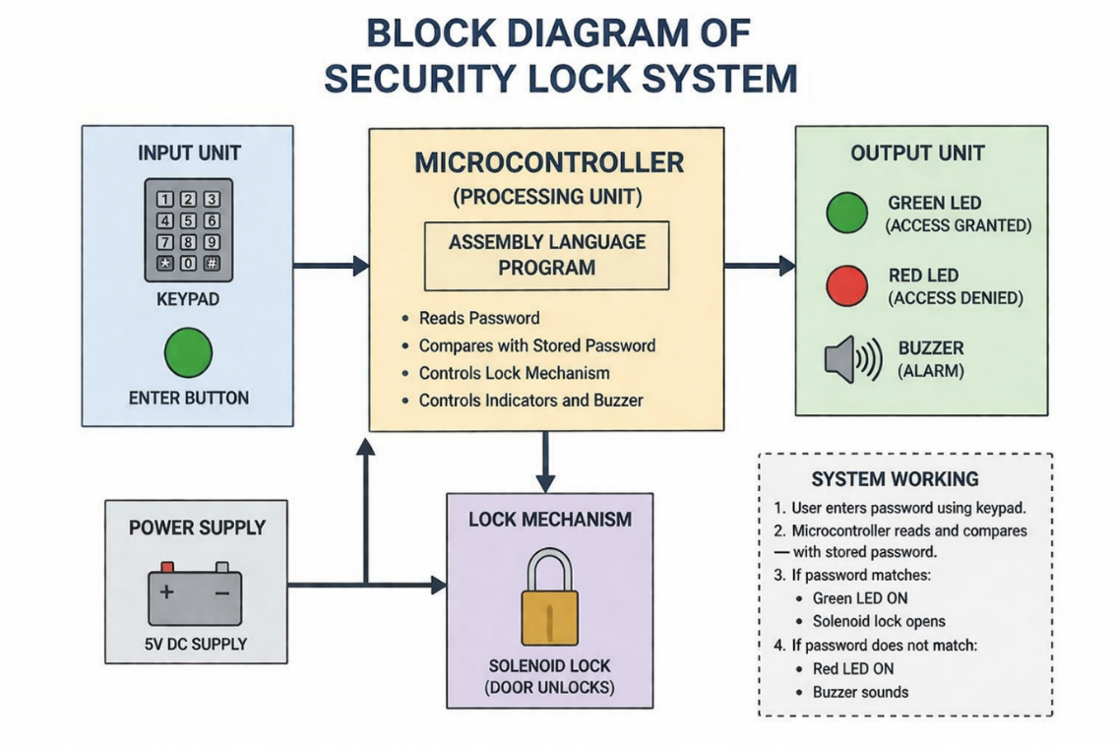
FLOWCHART
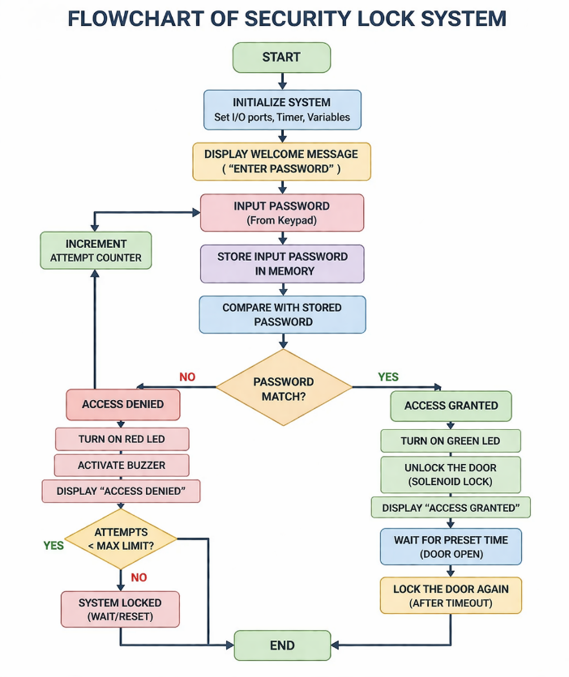

SYSTEM CONFIGURATION
Hardware Requirements
- Processor: Intel 8086 / 8086 compatible processor
- RAM: Minimum 256 MB (or higher recommended)
- Hard Disk: Minimum 100 MB free space
- Keyboard: Standard keyboard
- Monitor: VGA / SVGA Monitor
Software Requirements
- Operating System: Windows 7 / 8 / 10 / 11 or DOS
- Assembler: MASM (Microsoft Macro Assembler)
- Linker: TLINK
- Emulator (Optional): DOSBox / EMU8086
- Text Editor: Notepad++ / Visual Studio Code / Notepad
Programming Language
- 8086 Assembly Language Programming (ALP)
Platform
- DOS Environment / DOS Emulator

CODE IMPLEMENTATION
.MODEL SMALL
.STACK 100H
.DATA
PASSWORD DB '1234' ; STORED PASSWORD
INPUT DB 5 DUP(?) ; USER INPUT BUFFER
MSG1 DB 10,13,'ENTER PASSWORD: $'
MSG2 DB 10,13,'ACCESS GRANTED!$'
MSG3 DB 10,13,'ACCESS DENIED!$'
MSG4 DB 10,13,'TOO MANY ATTEMPTS!$'
STAR DB '*$'
ATTEMPTS DB 3
.CODE
MAIN:
MOV AX, @DATA
MOV DS, AX
START:
CMP ATTEMPTS, 0
JE EXIT_PROGRAM
; DISPLAY PROMPT
MOV AH, 09H
LEA DX, MSG1

INT 21H
; TAKE INPUT
MOV SI, 0
INPUT_LOOP:
MOV AH, 01H
INT 21H
CMP AL, 13 ; ENTER KEY
JE CHECK_PASSWORD
MOV INPUT[SI], AL ; STORE INPUT
INC SI
; PRINT '*'
MOV AH, 09H
LEA DX, STAR
INT 21H
JMP INPUT_LOOP
CHECK_PASSWORD:
MOV SI, 0
MOV DI, 0
MOV CX, 4
COMPARE_LOOP:
MOV AL, INPUT[SI]

MOV BL, PASSWORD[DI]
CMP AL, BL
JNE WRONG
INC SI
INC DI
LOOP COMPARE_LOOP
; CORRECT PASSWORD
MOV AH, 09H
LEA DX, MSG2
INT 21H
JMP END_PROGRAM
WRONG:
DEC ATTEMPTS
MOV AH, 09H
LEA DX, MSG3
INT 21H
JMP START
EXIT_PROGRAM:
MOV AH, 09H
LEA DX, MSG4
INT 21H

END_PROGRAM:
MOV AH, 4CH
INT 21H
END MAIN

OUTPUT:
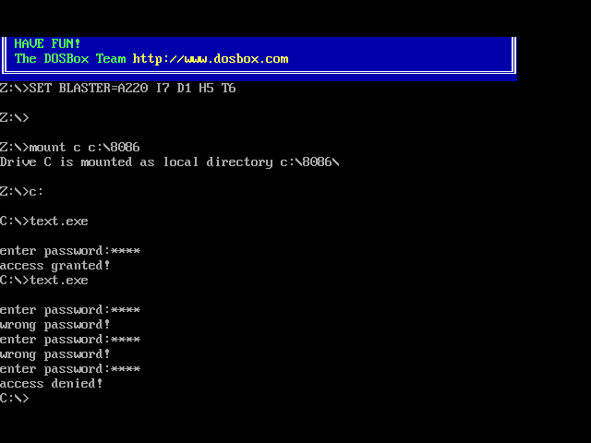

LISTFILE:

1 0000 .model small
2 0000 .stack 100h

3 0000 .data
4 0000 31 32 33 34 password db '1234'
5 0004 ?? ?? ?? ?? ?? input db 5 dup(?)

6 0009 0A 0D 45 6E 74 65 72 20 70 61 73 73 77 6F 72 64 3A 20 24
msg1 db 10,13,'Enter password: $'

7 001C 0A 0D 41 63 63 65 73 73 20 67 72 61 6E 74 65 64 21 24
msg2 db 10,13,'Access granted!$'

8 0030 0A 0D 41 63 63 65 73 73 20 64 65 6E 69 65 64 21 24
msg3 db 10,13,'Access denied!$'

9 0043 0A 0D 54 6F 6F 20 6D 61 6E 79 20 61 74 74 65 6D 70 74 73 21 24
msg4 db 10,13,'Too many attempts!$'

10 005B 2A 24 star db '*$'

11 005D 03 attempts db 3

12 005E .code
13 005E main:
14 005E B8 ---- mov ax,@data
15 0061 8E D8 mov ds,ax

16 0063 start:
17 0063 80 3E ---- 00 cmp attempts,0

18 0068 74 ?? je exit_program

19 006A B4 09 mov ah,09h
20 006C BA ---- lea dx,msg1
21 006F CD 21 int 21h

22 0071 BE 0000 mov si,0

23 0074 input_loop:
24 0074 B4 01 mov ah,01h
25 0076 CD 21 int 21h

26 0078 3C 0D cmp al,13
27 007A 74 ?? je check_password

28 007C 88 84 ---- mov input[si],al
29 0080 46 inc si

30 0081 B4 09 mov ah,09h
31 0083 BA ---- lea dx,star
32 0086 CD 21 int 21h

33 0088 EB EA jmp input_loop

34 008A check_password:
35 008A BE 0000 mov si,0
36 008D BF 0000 mov di,0
37 0090 B9 0004 mov cx,4

38 0093 compare_loop:
39 0093 8A 84 ---- mov al,input[si]

40 0097 8A 9D ---- mov bl,password[di]

41 009B 38 D8 cmp al,bl
42 009D 75 ?? jne wrong

43 009F 46 inc si
44 00A0 47 inc di
45 00A1 E2 F0 loop compare_loop

46 00A3 B4 09 mov ah,09h
47 00A5 BA ---- lea dx,msg2
48 00A8 CD 21 int 21h
49 00AA EB ?? jmp end_program

50 00AC wrong:
51 00AC FE 0E ---- dec attempts

52 00B0 B4 09 mov ah,09h
53 00B2 BA ---- lea dx,msg3
54 00B5 CD 21 int 21h
55 00B7 EB AA jmp start

56 00B9 exit_program:
57 00B9 B4 09 mov ah,09h
58 00BB BA ---- lea dx,msg4
59 00BE CD 21 int 21h

60 00C0 end_program:
61 00C0 B4 4C mov ah,4Ch
62 00C2 CD 21 int 21h

63 00C4 end main

CONCLUSION
The Security Lock System implemented using 8086 Assembly Language demonstrates an effective application of low-level programming in real-time security and access control systems. The project successfully simulates a password-based authentication mechanism by verifying user input and controlling access accordingly. Through this implementation, the importance of accuracy, reliability, and time-bound execution in real-time systems is clearly understood.

One of the major advantages of using Assembly Language in this project is the direct interaction with hardware. By using input/output port instructions, the program efficiently controls indicators such as LEDs or alarms with minimal overhead. This low-level control allows for faster execution and better performance compared to high-level languages, especially in systems where quick response and security are critical. The use of comparison logic and delay loops ensures proper validation and response timing within the system.

Furthermore, this system reflects the principles of real-time operating systems, where the correctness of the system depends not only on logical output but also on timely execution. Any delay or incorrect validation could lead to unauthorized access or system vulnerability, emphasizing the need for precise control and efficient processing.

Although the current implementation uses a fixed password and basic validation, the system can be further enhanced by incorporating advanced features such as multiple authentication attempts, alarm systems, biometric verification, and microcontroller integration. These improvements would make the system more secure, robust, and suitable for real-world applications.

In conclusion, the Security Lock System serves as a practical and educational example of how Assembly Language can be used to design real-time security applications. It not only strengthens programming skills but also provides valuable insights into embedded systems and hardware-level operations, making it a significant learning experience in the field of computer engineering.

REFERENCES

- Security lock systems are used to control access to systems or restricted areas through authentication methods such as passwords, ensuring safety and data protection.
https://en.wikipedia.org/wiki/Access_control
- The 8086 microprocessor supports assembly language programming and is widely used for learning low-level hardware interaction.
https://en.wikipedia.org/wiki/Intel_8086
- Assembly language allows direct control of hardware using registers, memory addressing, and I/O port instructions.
https://en.wikipedia.org/wiki/Assembly_language
- Input/Output operations in 8086 are performed using IN and OUT instructions to communicate with external devices.
https://en.wikipedia.org/wiki/Input/output
- Real-time systems require tasks to be completed within strict timing constraints to ensure correct system behavior.
https://en.wikipedia.org/wiki/Real-time_computing

