functions

1. Define a function called greet that logs “Hello!” to the console. Call the function after defining it.
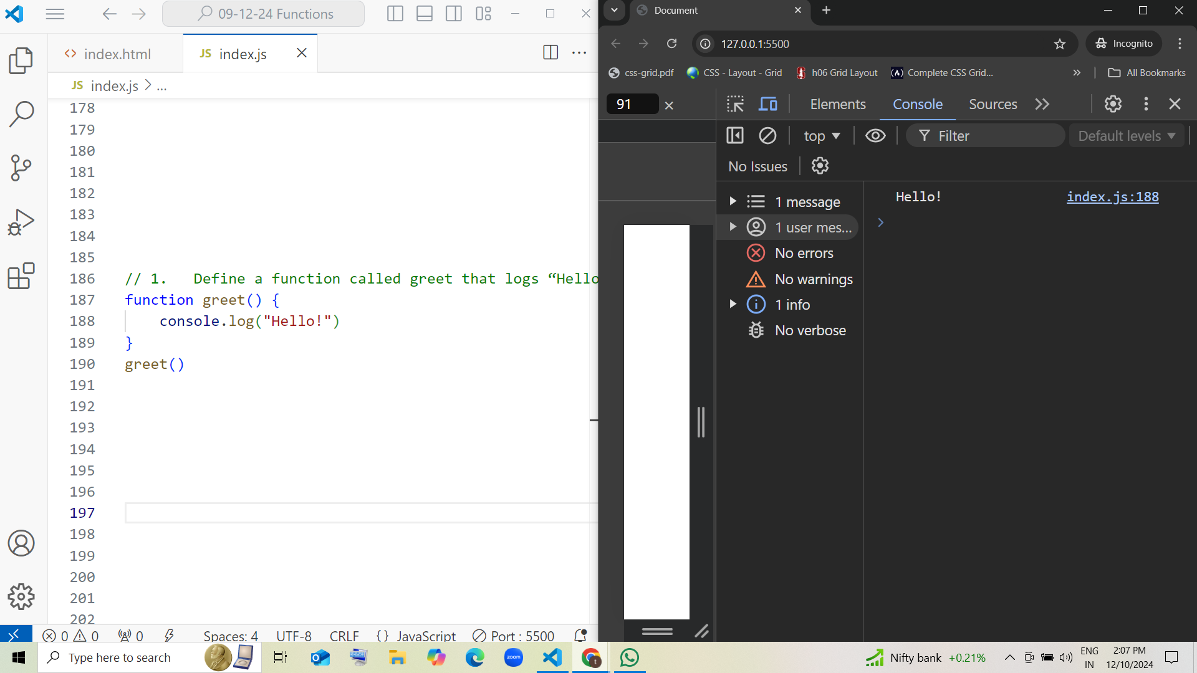

2. Write a function named showMessage that logs “This is a message!” to the console. Call the function once after defining it.

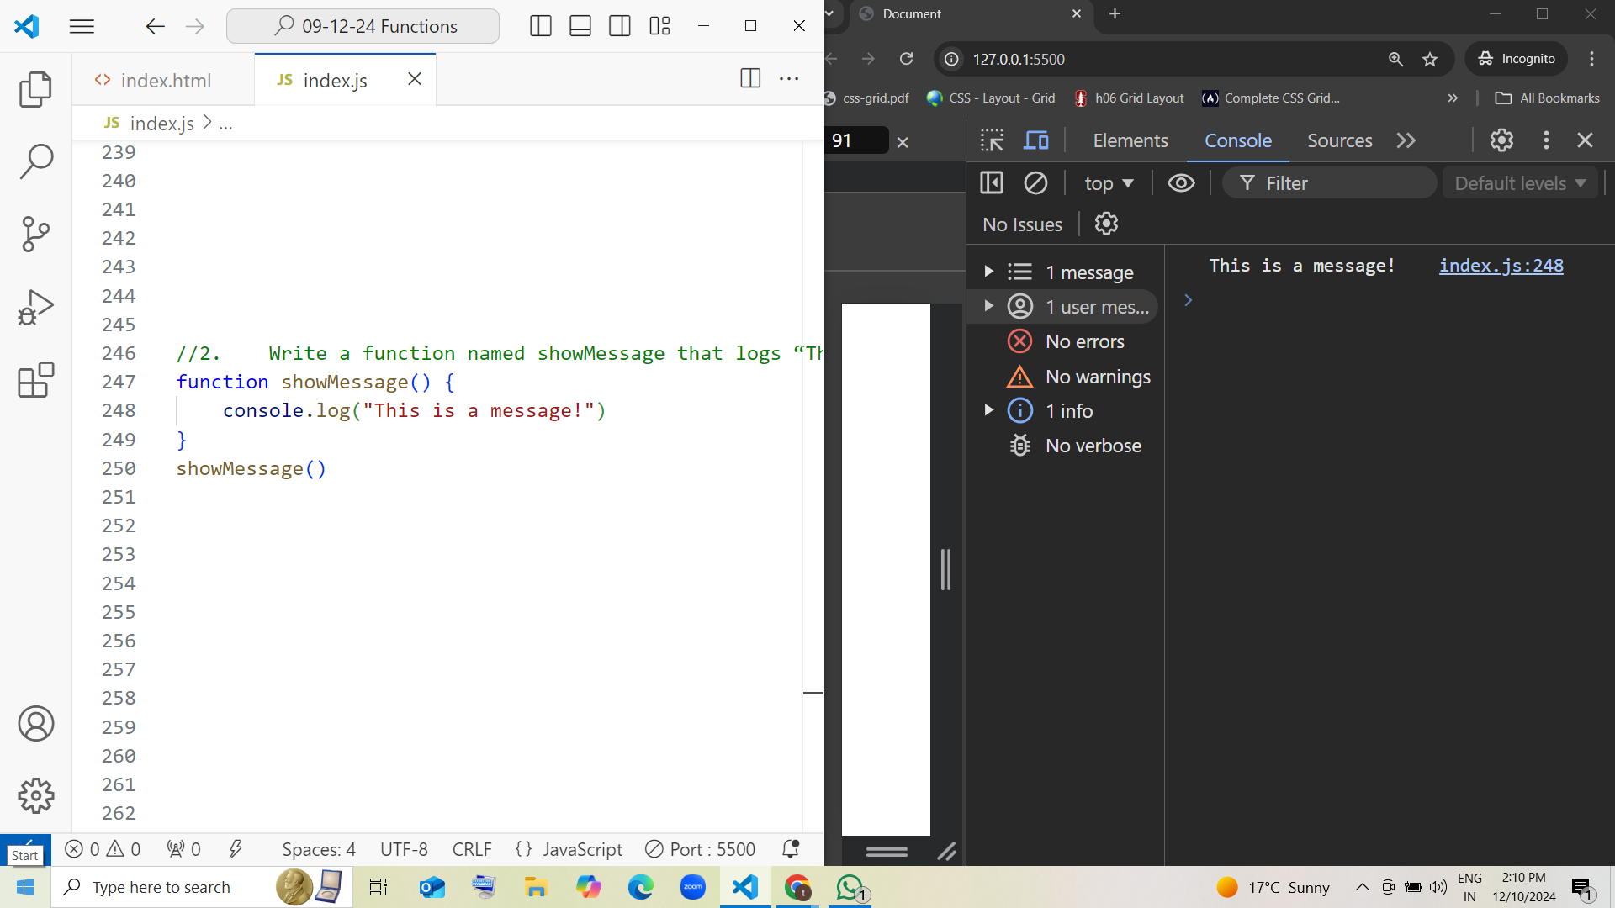

3. Create a function called logInfo that prints “Logging Information…” to the console. Call the function after defining it.

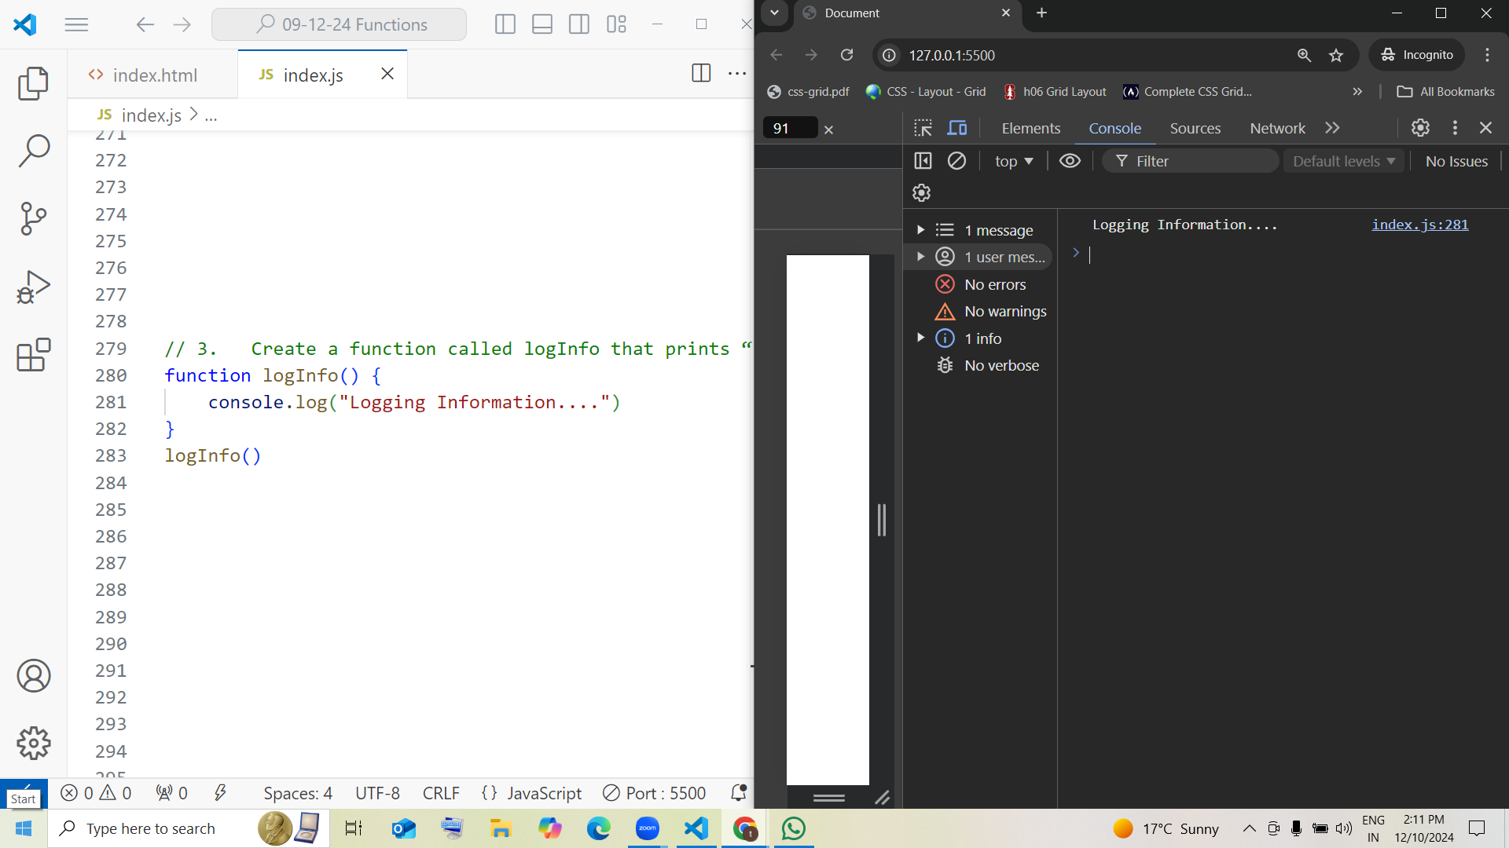

4. Define two functions:
– startGame that logs “Game Started!”
– endGame that logs “Game Over!”
Inside the startGame function, call the endGame function.

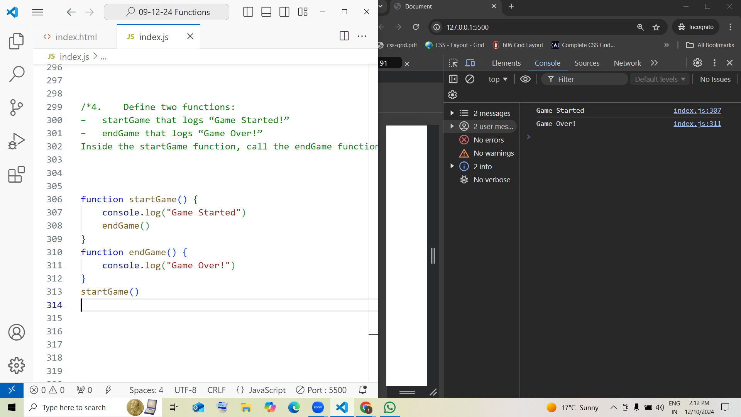

5. Create two functions:
– beginTask that logs “Task Started”.
– finishTask that logs “Task Finished”.
Inside the beginTask function, call the finishTask function.
