7. Demonstrate the use/features of online Bug Tracking/Issue Tracking "mantis".
Take source code of any open source you like and find minimum three bugs (mention their type on answer sheet ) in terms removing error/bug or adding feature to it.
Bug tracking on any suitable open source (code) from internet.
Compare all FOSS bug tracking tools.

1. Create account on mantis hub (https://mantishub.com/)
2. Go to Manage>Projects and Create New Project – myProject and scroll down to add new category which can be used while reporting the issue.

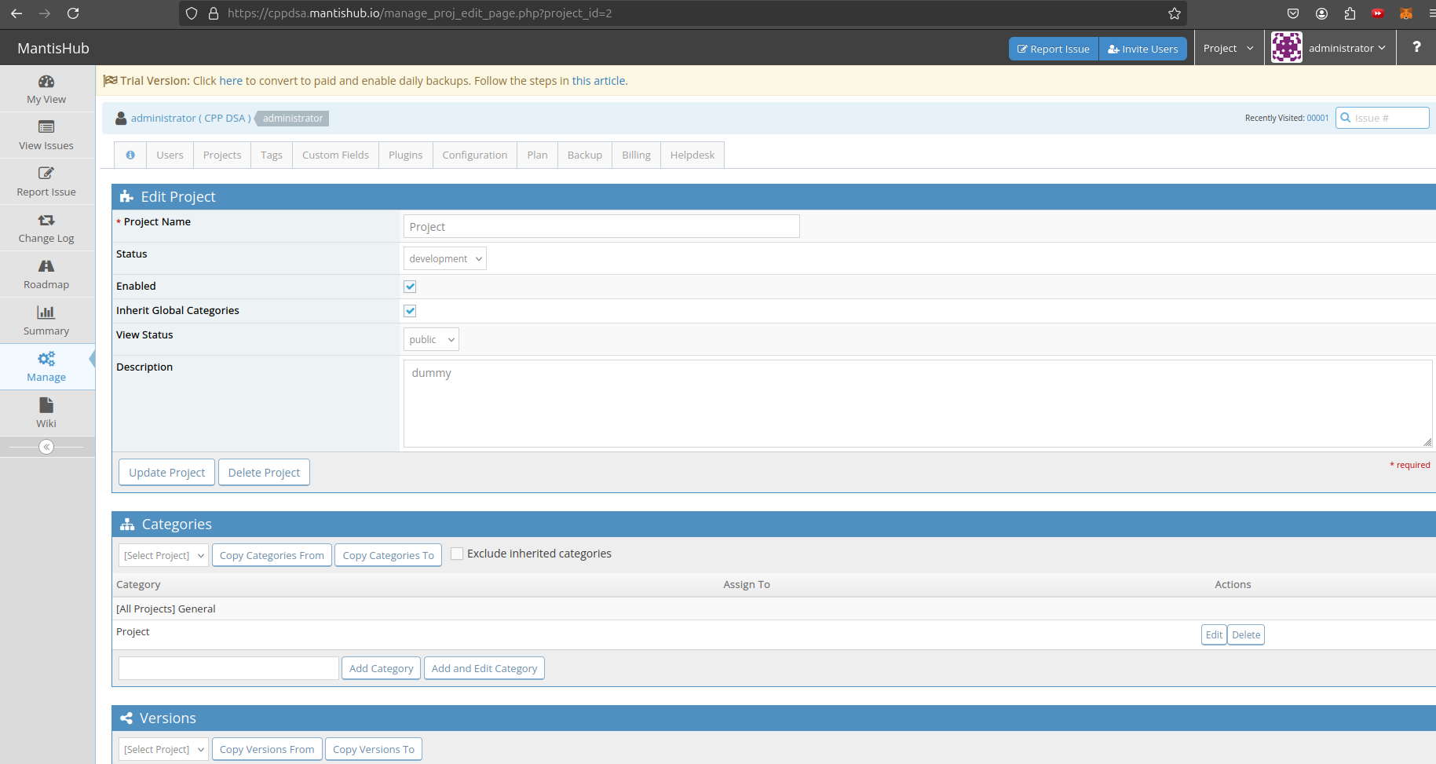

3. Go to Manage>Users and Create New Account. After clicking on ‘Create User’ scroll down and Add user to project and Add User to myProject.

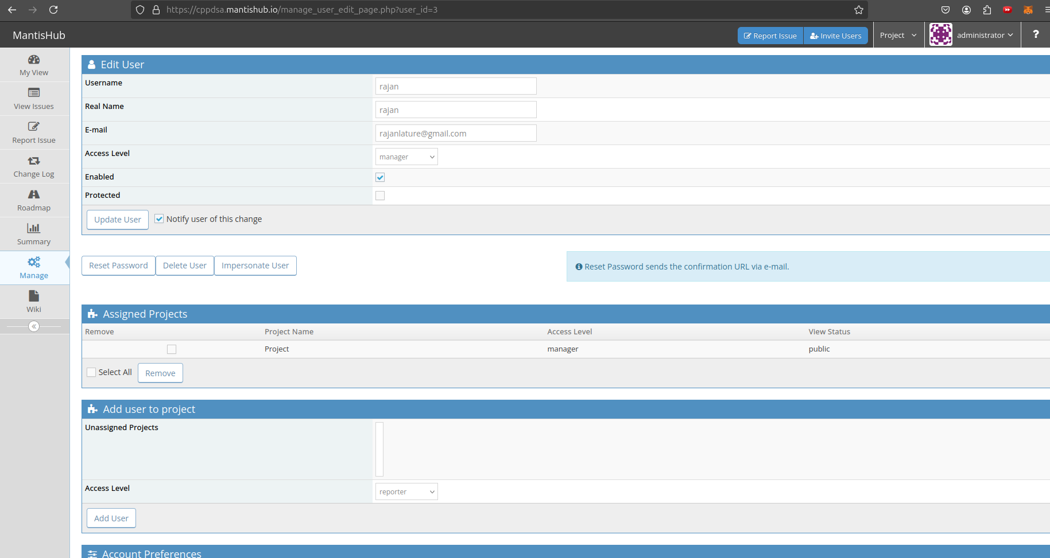
4. To report the issue go to ‘Report Issue’ and add issue

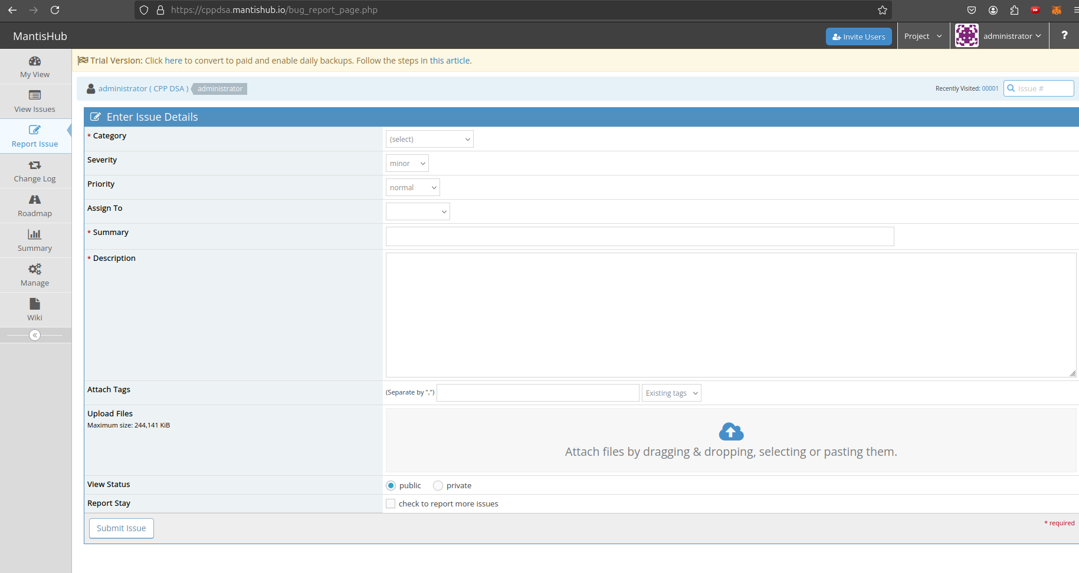

Theory:

1. Bugzilla
- Developed by: Mozilla Foundation
- Main Features:
  - Advanced search and filtering capabilities.
  - Email notifications and reports.
  - Customizable workflows and access controls.
  - Time tracking and detailed reports.
  - Support for attachments and dependency tracking.
- Pros:
  - Highly customizable and powerful.
  - Extensive community support and documentation.
  - Great for handling complex workflows and large projects.
- Cons:
  - Outdated UI.
  - Requires some expertise to set up and configure.
- Best For: Larger projects requiring robust, feature-rich tracking.

2. Redmine
- Developed by: Jean-Philippe Lang
- Main Features:
  - Supports multiple projects with issue tracking, Gantt charts, and calendars.
  - Wiki and forum integrations.
  - Customizable issue fields and workflows.
  - Role-based access control.
  - Time-tracking and project planning.
- Pros:
  - User-friendly interface.
  - Extensible with plugins.
  - Strong project management capabilities.
- Cons:
  - Less focused on bug tracking alone; more of a project management tool.
  - Limited built-in reporting features.
- Best For: Teams looking for combined project management and issue tracking.

3. MantisBT
- Developed by: MantisBT Team
- Main Features:
  - Simple interface with powerful bug tracking.
  - Email notifications and RSS feeds.
  - Role-based permissions and project hierarchies.
  - Customizable workflows and fields.
  - Support for plugins and integrations with source control systems.
- Pros:
  - Lightweight and easy to set up.
  - Active community and support for extensions.
  - Great for small to medium-sized projects.
- Cons:
  - Limited project management functionality.
  - UI is somewhat basic and dated.
- Best For: Teams needing a straightforward, easy-to-implement bug tracker.

4. Trac
- Developed by: Edgewall Software
- Main Features:
  - Wiki-based issue tracking with a timeline of project events.
  - Milestones, custom fields, and roadmaps.
  - Simple user interface, strong Git/SVN integration.
  - Customizable workflows and ticket types.
- Pros:
  - Minimalistic and integrated with SCM systems.
  - Strong documentation system with Wiki features.
- Cons:
  - Limited reporting and customization features.
  - Not suited for large, complex projects with high volume.
- Best For: Small to medium-sized projects with simple requirements.

5. Fossil
- Developed by: D. Richard Hipp
- Main Features:
  - Integrated issue tracking, wiki, and distributed SCM.
  - Timeline and branching for version control.
  - Simple and quick setup with minimal dependencies.
- Pros:
  - All-in-one system with low system requirements.
  - Ideal for distributed development.
- Cons:
  - Limited feature set in terms of dedicated bug tracking.
  - Less customizable and limited third-party integrations.
- Best For: Small, distributed teams looking for a lightweight, all-in-one solution.

