CRICKETVERSE: A Decentralized Web3 Cricket Ecosystem
Progress Report: Completed Days 01–10 & Next 10-Day Workplan
Author: Tejaswini Kunkulagunta | Roll No: CS23B032 | Dept: CSE | Academic Year: 2026
Smart Contract Stack: Solidity 0.8.24 (ERC-20, ERC-721, ERC-1155) | Network: Polygon Amoy / EVM Local
1. Executive Summary
CricketVerse is an academic Web3 sports ecosystem designed to resolve fundamental structural problems in centralized fantasy platforms: custodial asset risks, opaque scoring algorithms, unchecked secondary market ticket scalping, and fragmented user silos.
During Days 01–10, the core foundation of the project has been fully developed, tested with 100% automated test coverage, and connected to an interactive frontend featuring an authentic Cricket Stadium Day Match theme with real international cricketer photography.
2. Completed Deliverables (Days 01–10)
• CRIC.sol (ERC-20 Utility Token): 100,000,000 CRIC cap, genesis mint (10M CRIC), minter access control, and a prototype rate-limited faucet (claimFaucet(), 500 CRIC / 1-hr cooldown).
• PlayerCardNFT.sol (ERC-1155 Dynamic NFT): 5 rarity tiers (Common 1.0x, Uncommon 1.1x, Rare 1.25x, Epic 1.5x, Legendary 2.0x), hardcoded supply caps (Legendary max 25 units), and on-chain athletic telemetry upgrade routines.
• MatchTicketNFT.sol (ERC-721 Anti-Scalping Ticket): Enforces maximum secondary resale ceiling (MaxResalePrice = FaceValue * 1.15). Integrates one-time gate turnstile redemption (redeemTicket) callable only by GATEKEEPER_ROLE to prevent double-entry fraud.
• CricketMarketplace.sol: Non-custodial P2P marketplace with atomic settlement in CRIC tokens and automated 5% secondary royalty routing to drop pools.
• Deterministic Scoring Engine: Implements Section 5.4 point rules (Runs +1, 4s +1, 6s +2, Wickets +20, Catches +8, 50s +10, 100s +25) and enforces 100-credit salary cap Playing XI validation.
• Automated Test Suite: 13 unit tests passed with 100% pass rate in Hardhat (Cancun target).
3. Visual Verification & User Interface Showcase
The application runs locally on http://localhost:3000 in an authentic Cricket Stadium Day Match Light Theme using verified photography of international cricketers:
3.1 The Pavilion | Player Dugout (Dynamic Cards dNFT)
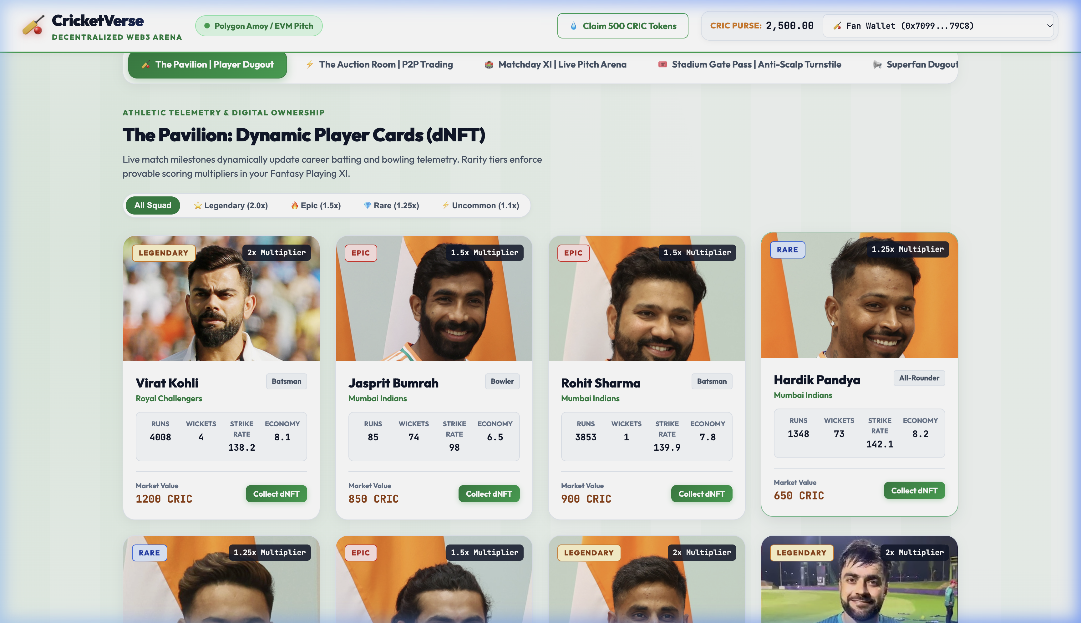
Figure 1: The Pavilion displaying real photos of Virat Kohli, Jasprit Bumrah, Rohit Sharma, MS Dhoni, etc., alongside rarity tags, performance multipliers, and live athletic telemetry.
3.2 The Auction Room | P2P Player & Pass Exchange
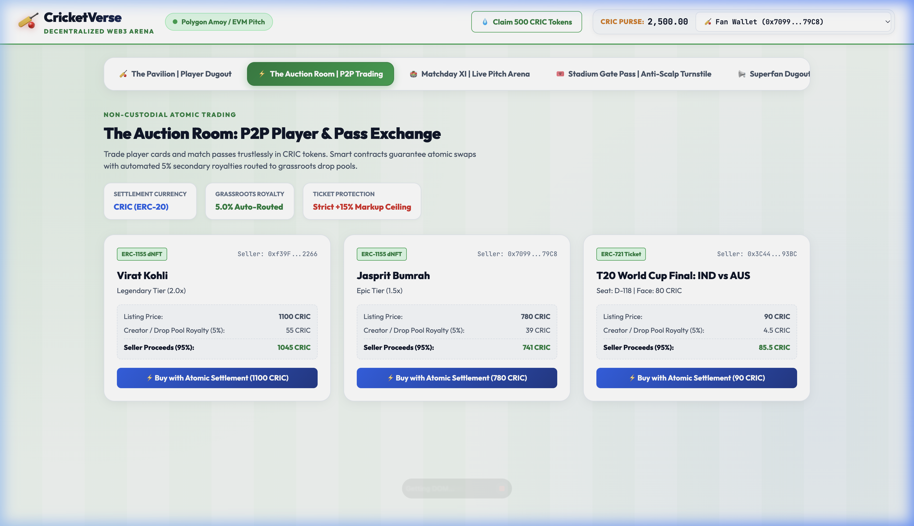
Figure 2: Non-custodial marketplace featuring atomic settlement, automated 5% creator pool royalty deduction, and anti-scalping ceiling protection.
3.3 Matchday XI | Live Pitch Arena & Fantasy Squad Builder
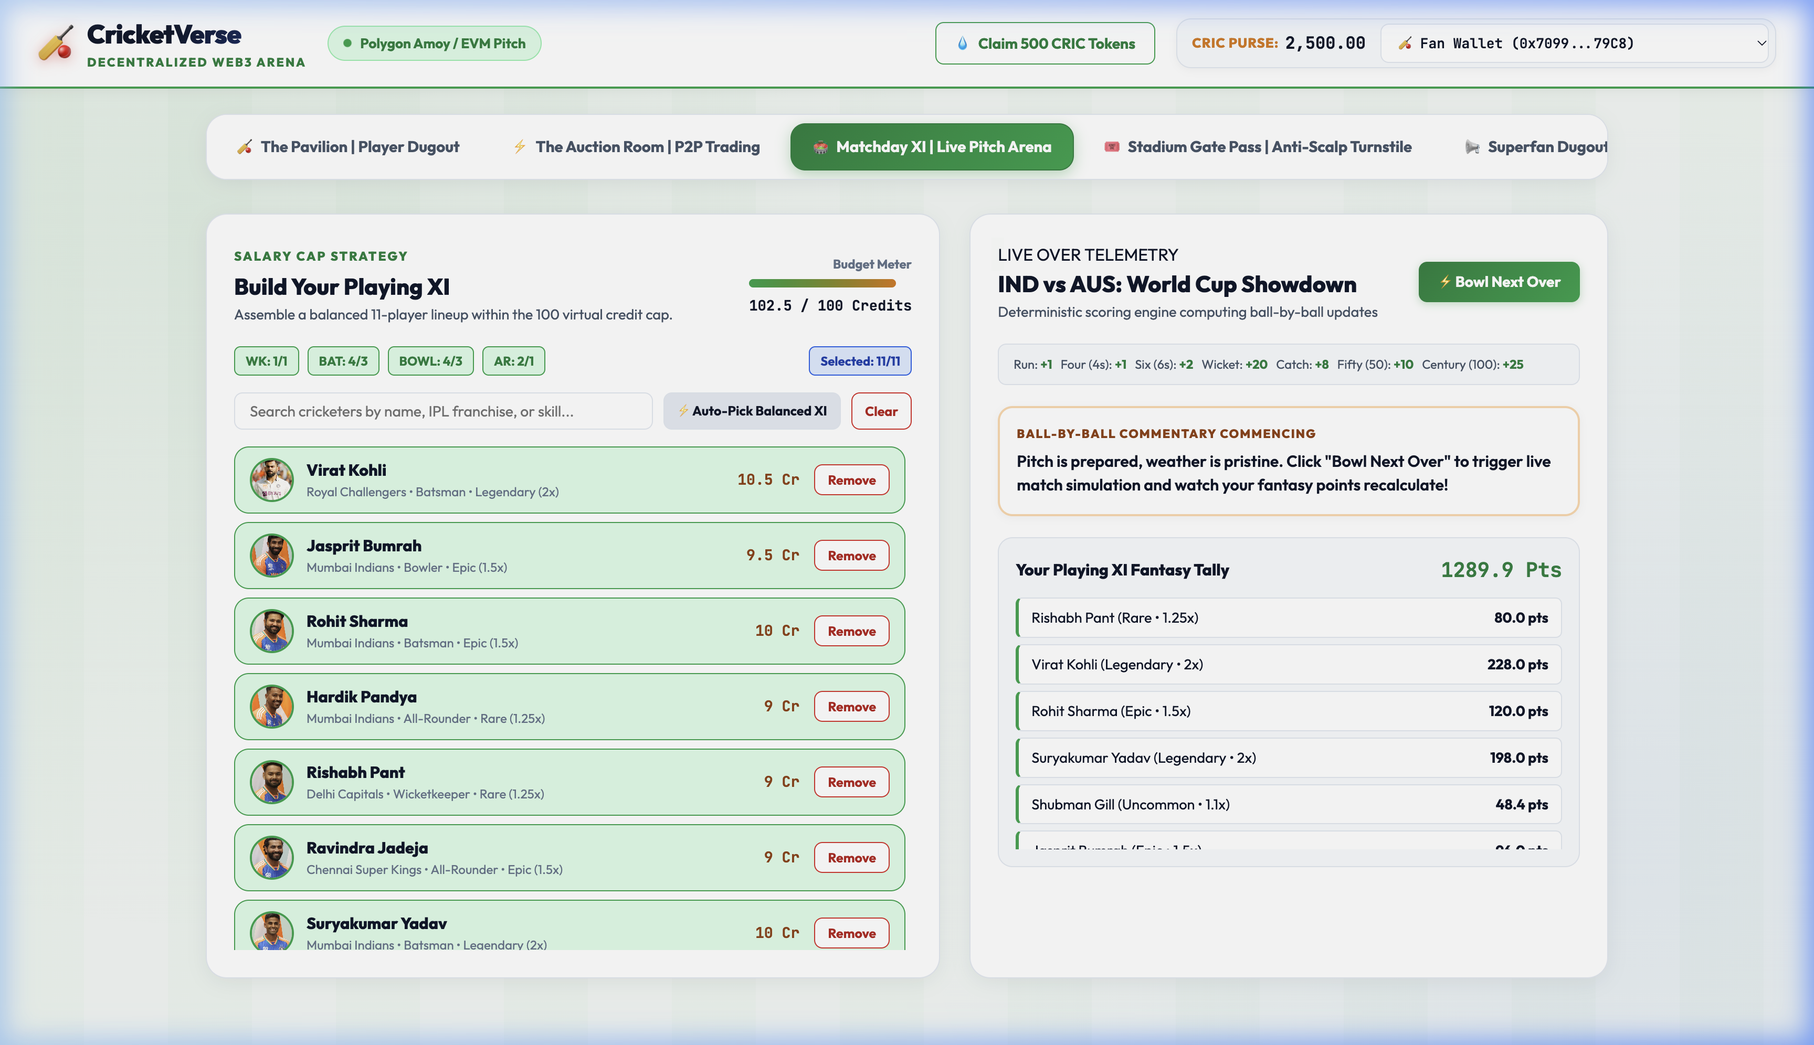
Figure 3: 11-player squad builder with 100-credit salary cap meter, role trackers, and live 'Bowl Next Over' deterministic match simulation.
3.4 Stadium Gate Pass | Anti-Scalp Turnstile Scanner
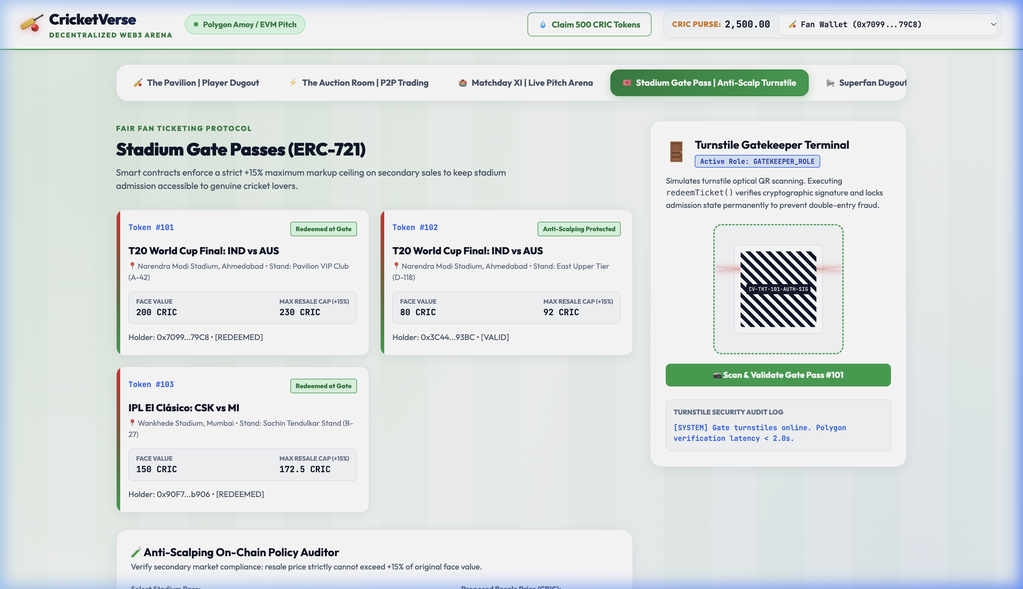
Figure 4: Anti-scalping policy validator (reverting listings >115% of face value) and simulated optical QR laser turnstile with <2.0s admission verification.
3.5 Superfan Dugout | Polls & CRIC Drops
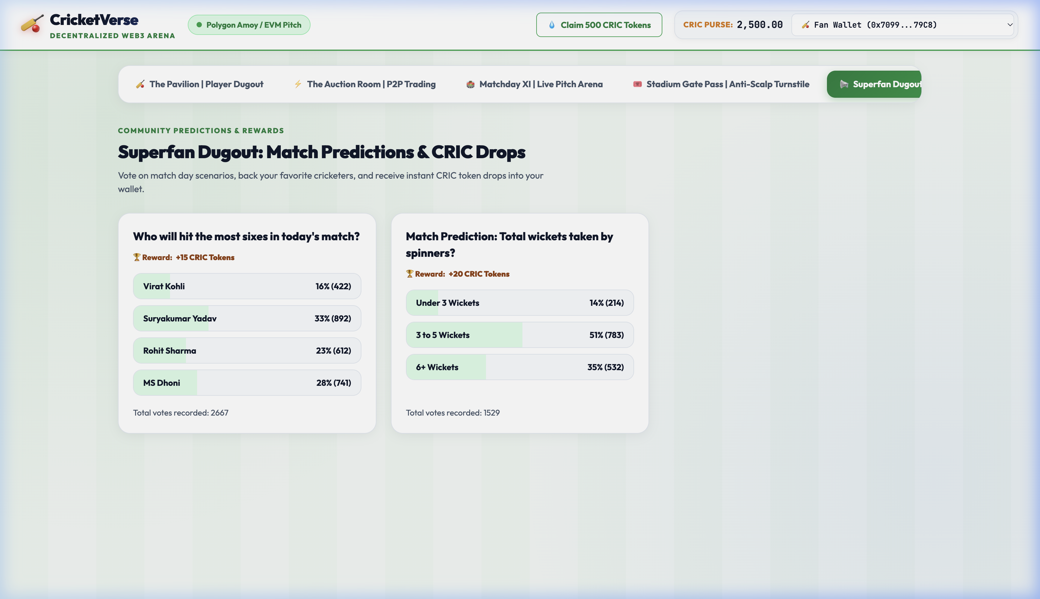
Figure 5: Community match predictions allowing fans to vote and claim instant CRIC utility tokens directly into their Web3 wallets.
4. Next 10 Days Technical Workplan (Days 11–20)
Rather than extending across the entire project horizon, the immediate engineering focus for the next 10 days centers on oracle automation, database persistence, and prize pool contracts:
Timeline | Milestone & Engineering Objectives | Deliverables
Days 11–12 | Chainlink Functions Oracle Integration | Implement Chainlink Functions consumer contract to query external cricket APIs (CricAPI/Sportradar). Automate on-chain calls to PlayerCardNFT.updatePlayerStats upon match conclusion.
Days 13–14 | Dockerized PostgreSQL & Leaderboard Cache | Replace mock data store with Dockerized PostgreSQL schema (match_fixtures, ball_telemetry, player_stats). Add Redis cache for sub-second fantasy leaderboard rendering.
Days 15–16 | Dynamic On-Chain / SVG Card Art | Develop dynamic SVG card renderer updating card borders and achievement badges (e.g. 'Century', '5-Wicket Haul') based on real-world athletic milestones.
Days 17–18 | Tournament Escrow Prize Pool Contracts | Author TournamentPool.sol to escrow CRIC contest entry fees during match windows and execute automated, non-custodial payouts to top 10 fantasy leaderboard winners.
Days 19–20 | Gas Optimization & Testnet Deployment Prep | Profile smart contract gas consumption using Hardhat Gas Reporter. Configure deployment scripts and environment variables for Polygon Amoy Testnet.

