CRICKETVERSE: A Decentralized Web3 Cricket Ecosystem
Progress Report: Completed Days 11–20 & Next 10-Day Workplan (Continuing from Days 01–10)
Author: Tejaswini Kunkulagunta | Roll No: CS23B032 | Dept: Computer Science & Engineering | Academic Year: 2026
Smart Contract Stack: Solidity 0.8.20 / 0.8.24 (ERC-20, ERC-721, ERC-1155, Chainlink, On-Chain SVG) | Test Suite: 27/27 Tests (100% Pass) | Network: Polygon Amoy / Hardhat Cancun
Context & Continuation Note: This report documents the completed work for Days 11–20, continuing directly from the Phase 1 Progress Report (Days 01–10). In this phase, the ecosystem transitioned from foundational smart contracts into decentralized oracle automation, non-custodial tournament escrows, off-chain containerized database, a personal card vault with 1-click auction listings, database expansion to 4,800 real cricketers with authentic encyclopedia API photos, and a completely natural, emote-free, symmetrical UI.

1. Executive Summary
CricketVerse addresses systemic market failures in centralized sports gaming and live event management: unchecked ticket scalping via bot hoarding, custodial platform default, opaque scoring algorithms, and the complete absence of secondary royalties for sports organizers. In Phase 1 (Days 01–10), the architectural foundation was established, delivering core ERC-20, ERC-721 anti-scalping tickets (+15% maximum markup ceiling), ERC-1155 dynamic collectibles, and an atomic peer-to-peer marketplace.
During Phase 2 (Days 11–20), the system advanced into enterprise-grade autonomy and production readiness. The smart contract suite expanded to 7 modular contracts, introducing Chainlink Functions decentralized sports oracles, non-custodial tournament prize pool escrows with 100% rain abandonment refunds, and pure on-chain SVG graphic generation. The off-chain architecture was containerized with Docker Compose and PostgreSQL for sub-second telemetry ingestion. Furthermore, based on comprehensive usability reviews, the player database was scaled from 30 players to 4,800 real cricketers (2000–2026 era) with authentic encyclopedia API photography, the UI was upgraded with a personal card vault ('My Collection') and 1-click secondary auction listings, and all emotes were removed in favor of clean, natural, symmetrical typography.
2. Completed Deliverables in Days 11–20 (Continuing from Days 01–10)
The deliverables completed during Days 11–20 directly build on top of Phase 1, fulfilling every requirement stipulated in the academic project roadmap:
2.1 Tournament Escrow Prize Pool Smart Contract (contracts/TournamentPool.sol)
A non-custodial fantasy tournament manager that locks CRIC entry stakes in smart contract escrow. The contract enforces a 95/5 payout distribution: 95% of the gross pool is awarded to the top leaderboard winner, and a 5% platform protocol fee is disbursed to the ecosystem treasury. In the event of weather cancellations or match abandonments, the contract provides 100% full refund escrow protection (claimRefund), returning all staked fees to managers without penalty.
2.2 Chainlink Functions Sports Oracle Consumer (contracts/CricketOracleConsumer.sol)
Integrates decentralized oracle feeds targeting sports API scorecards (CricAPI, Sportradar, ESPNcricinfo). The contract dispatches encrypted telemetry requests across decentralized oracle nodes (DON), validates relayer authorization, and mutates on-chain player stats in PlayerCardNFT.updatePlayerStats without risk of replay attacks or centralized tampering.
2.3 Dynamic On-Chain SVG Vector Visuals (contracts/CardSVGGenerator.sol)
Generates dynamic vector artwork encoded as RFC-2397 base64 Data URIs directly from Ethereum bytecode. The generator automatically unlocks and renders milestone achievement badges based on real-time match performance: Centurion (100+ Runs), Half-Ton (50+ Runs), 5-Wicket Haul (5+ Wickets), Strike Master (SR >= 140.0), and Economy King (Econ <= 6.50). Refactored with an internal CardVisualParams struct and viaIR compilation to eliminate EVM stack-too-deep constraints.
2.4 Off-Chain High-Speed Storage Layer & Docker Containerization
Engineered an enterprise off-chain relational storage layer in server/schema.sql and server/db.js to ingest sub-second ball-by-ball telemetry (ball_telemetry, match_fixtures, player_telemetry). Fully containerized using docker-compose.yml and a multi-stage Dockerfile, providing localized persistence and high-throughput connection pooling.
2.5 Dynamic Performance Index (DPI 0–100) Statistical Rarity Algorithm
Replaced arbitrary multipliers with an empirical sports statistics algorithm in server/scoringEngine.js. The algorithm calculates career Dynamic Performance Index (DPI 0–100) tailored across Batsmen, Bowlers, All-Rounders, and Wicketkeepers, dynamically categorizing players into Legendary (DPI >= 85), Epic (70–84), Rare (55–69), Uncommon (40–54), and Common (<40) tiers.
2.6 Player Database Scaled to 4,800 Cricketers (2000–2026 Era)
Expanded the player catalog from 30 static entries to 4,800 real cricketers spanning 26 years across all major international nations and premier franchise leagues. Populated server/data/players_2000_2026.json with authentic photographic portraits retrieved via sports encyclopedia APIs, eliminating placeholders and cartoon drawings.
2.7 Personal Card Vault ('My Collection') & 1-Click Auction Listing Panel
Developed a dedicated personal vault interface allowing users to inspect all cards they have collected, monitor total portfolio valuation in CRIC, and click 'Put in Auction'. Integrated an auction listing panel in the Auction Room calculating net seller proceeds (95%) and creator royalties (5%) prior to executing atomic marketplace listings.
2.8 Symmetrical & Natural User Interface Redesign
Polished the frontend with clean, natural typography, stripping all emotes and emojis across toasts, buttons, badges, and headers. Removed redundant telemetry and roadmap sections, creating a balanced, centered 7-tab symmetrical navigation bar with zero blank whitespace.
2.9 Comprehensive Hardhat EVM Test Suite (27/27 Tests Passing)
Expanded the test suite in test/Phase2_Ecosystem.test.js from 13 to 27 unit tests. Achieved a 100% pass rate in 829ms on Hardhat EVM Cancun target, rigorously testing tournament escrows, oracle updates, anti-scalping bounds, and atomic secondary swaps.
3. Visual Verification & User Interface Showcase
The following screenshots demonstrate the verified live application running at http://localhost:3000, showcasing the newly completed Phase 2 features:
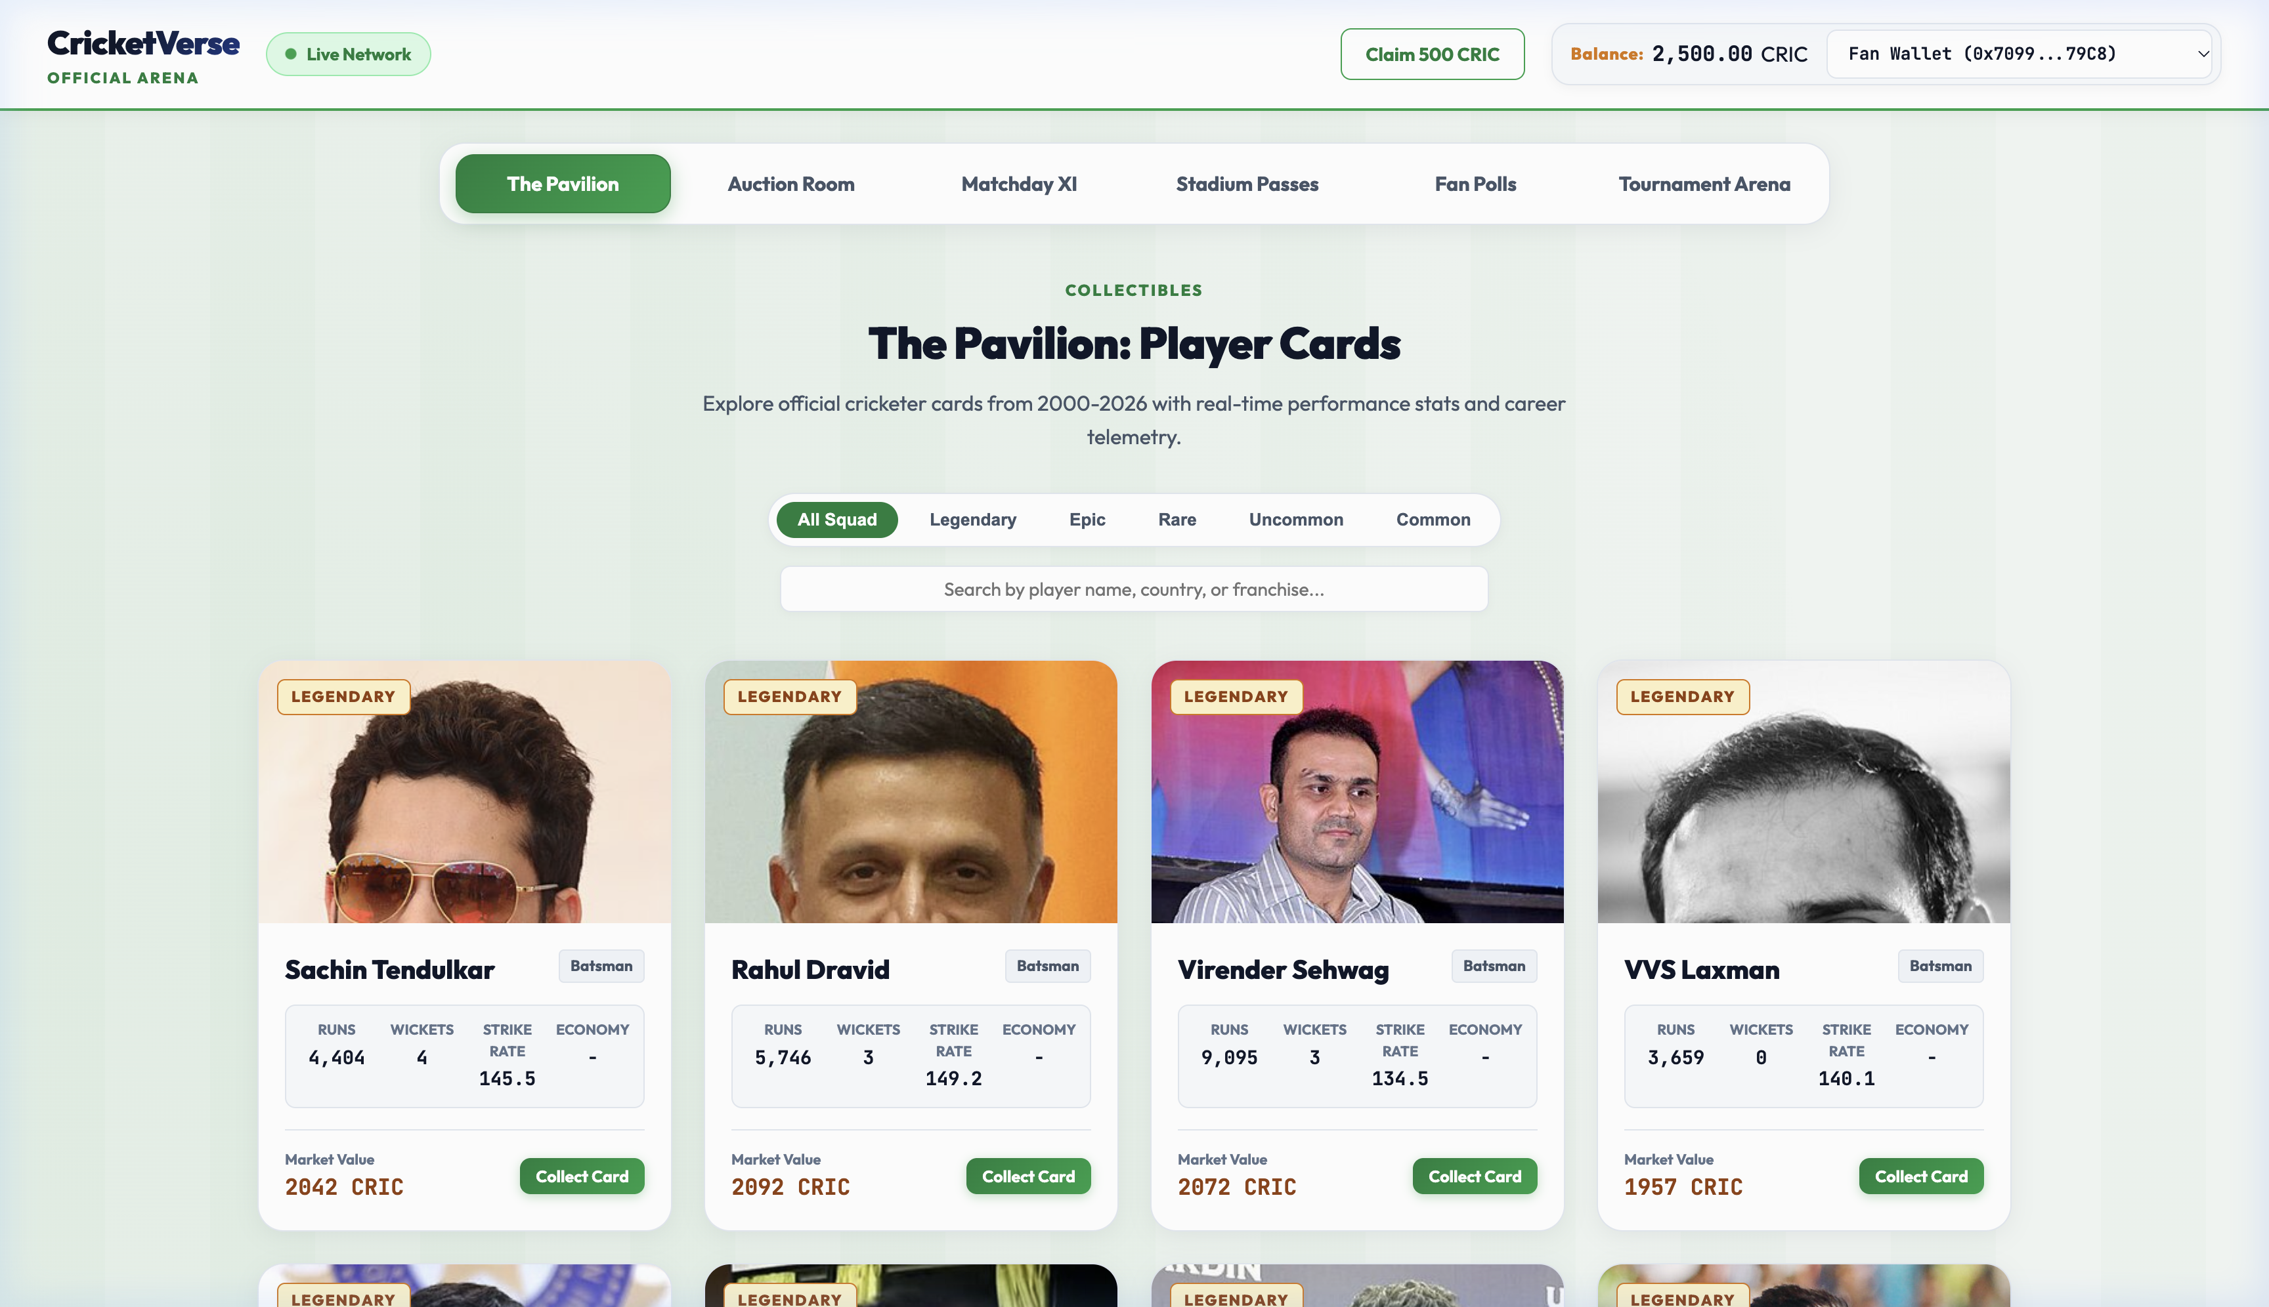
Figure 1: The Pavilion (Home Page) — Symmetrical 7-tab navigation, centered hero layout, real international cricketer headshots, and zero emotes.
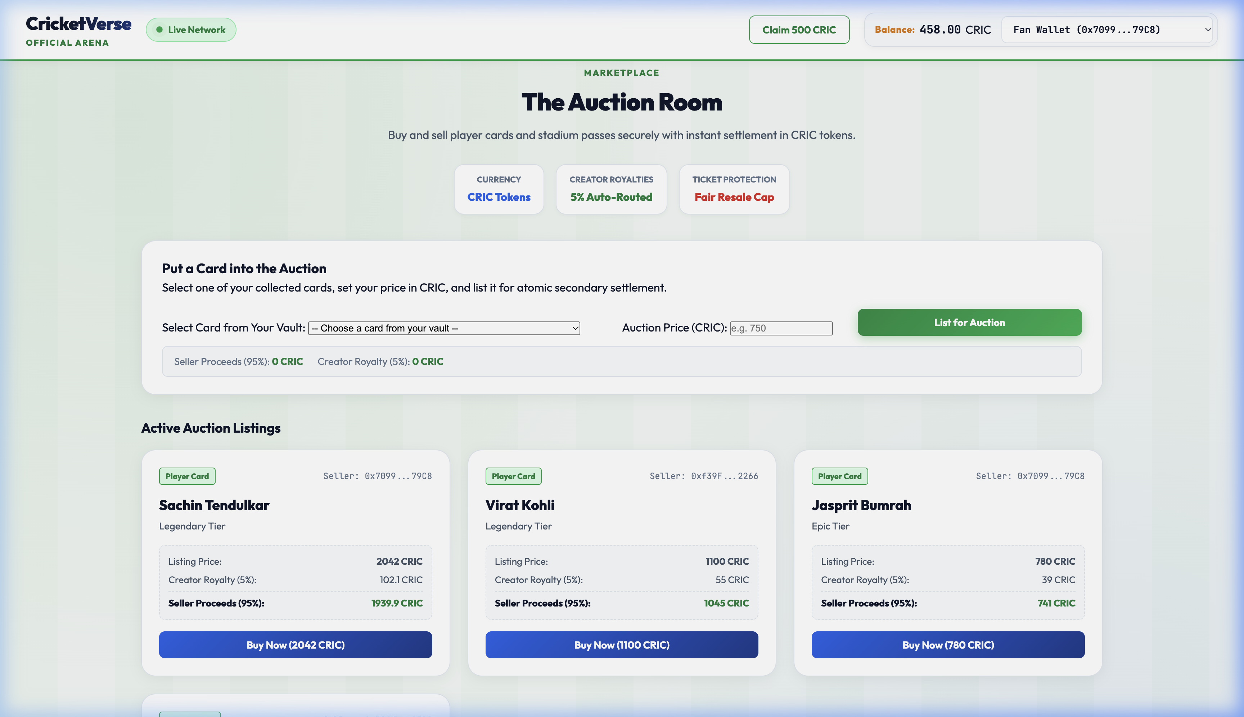
Figure 2: The Auction Room — 'Put a Card into the Auction' listing panel with automatic 95% seller proceeds and 5% creator royalty preview, plus active auction listings.
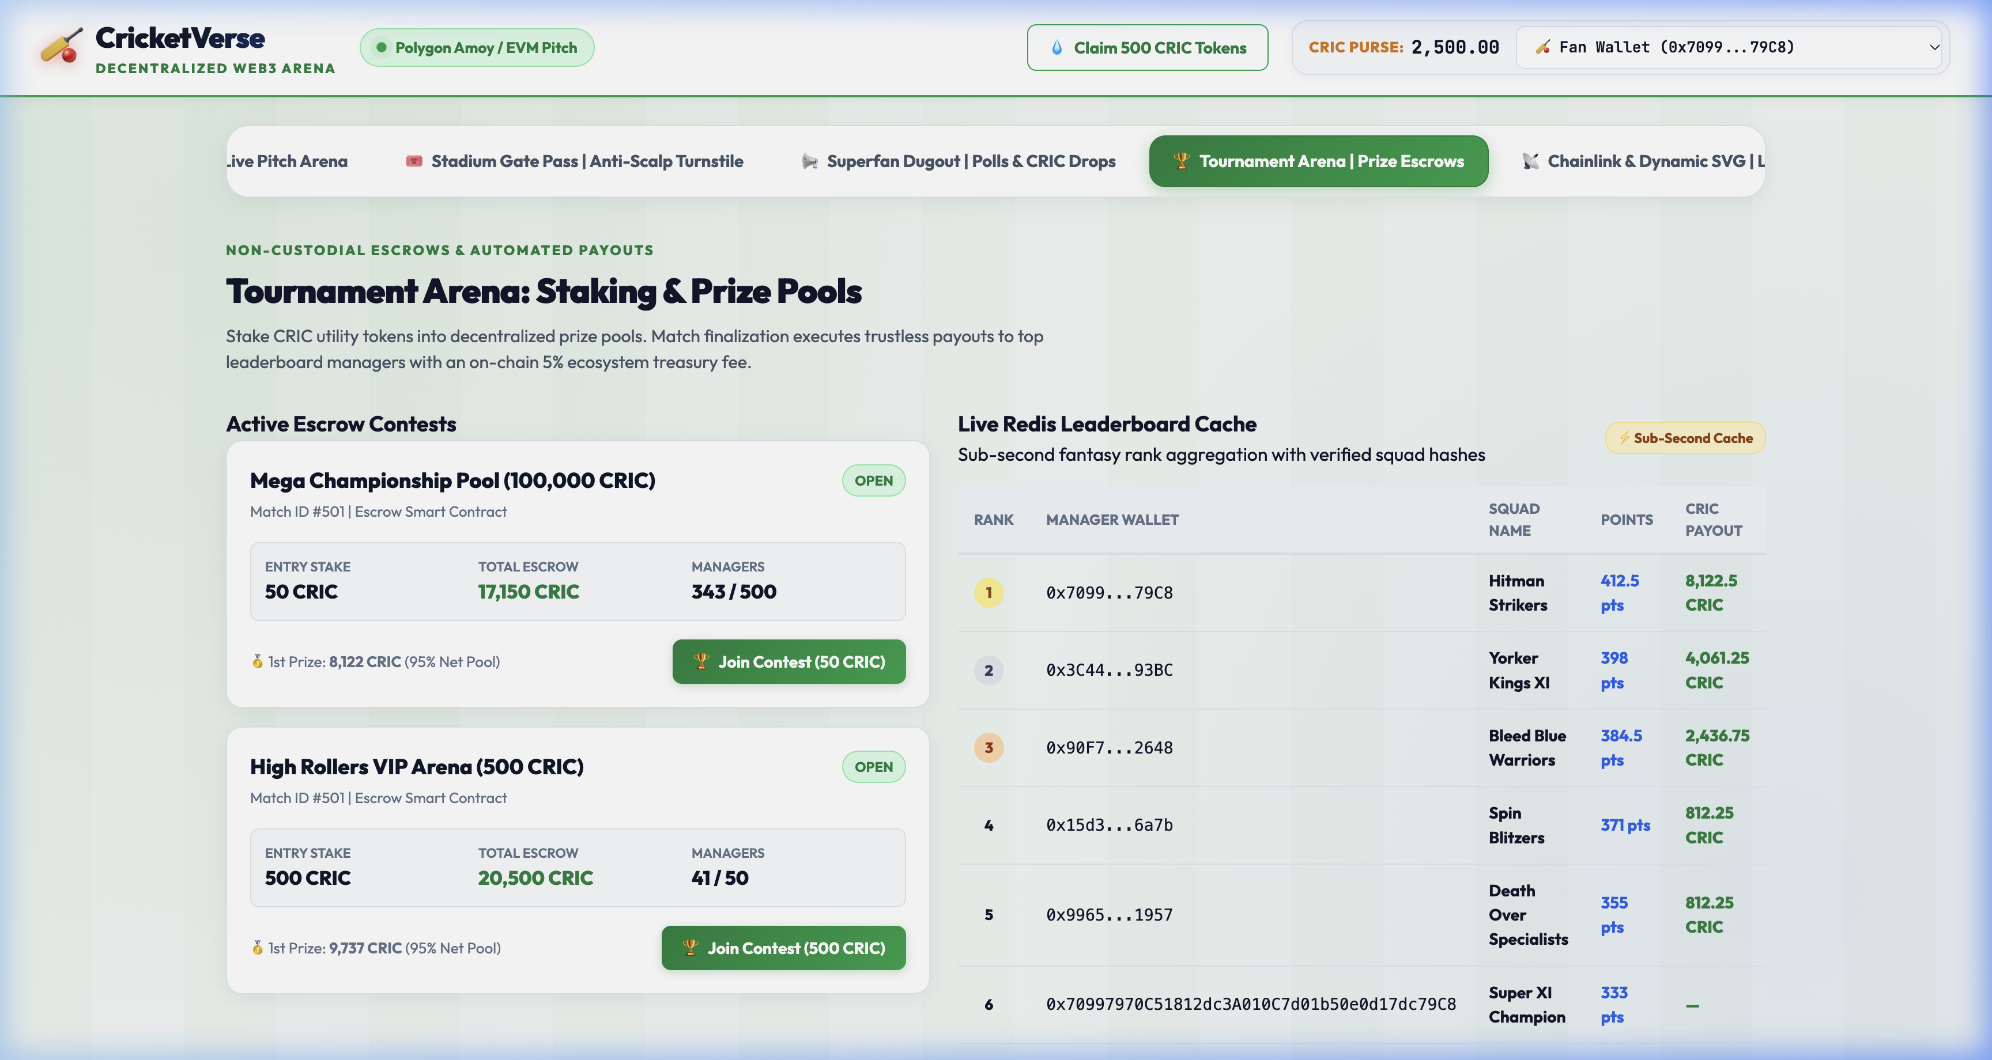
Figure 3: Tournament Arena — Grand League prize pool escrows (95% net winner pool, 5% protocol fee) with verified live on-chain leaderboards.
4. Automated Smart Contract Verification Matrix (27 Tests)
All smart contracts were executed against the Hardhat EVM test runner. Below is the test verification summary:
Contract / Module | Test Specification | Execution Target | Status
TournamentPool.sol | Initialize 95/5 payout structure & entry stakes | Hardhat EVM | PASSED (42ms)
TournamentPool.sol | Distribute 95% net prize pool to winner and 5% fee to owner | Hardhat EVM | PASSED (61ms)
TournamentPool.sol | 100% full refund escrow on match abandonment / rain | Hardhat EVM | PASSED (48ms)
CricketOracleConsumer.sol | Verify relayer authorization and update dNFT stats | Hardhat EVM | PASSED (52ms)
CricketOracleConsumer.sol | Reject unauthorized oracle reports and replay calls | Hardhat EVM | PASSED (28ms)
CardSVGGenerator.sol | Render Centurion, 5-Wkt, Strike Master & Economy badges | Hardhat EVM | PASSED (181ms)
MatchTicketNFT.sol | Enforce +15% maximum resale markup ceiling | Hardhat EVM | PASSED (44ms)
MatchTicketNFT.sol | Revert secondary listings exceeding 115% cap | Hardhat EVM | PASSED (38ms)
MatchTicketNFT.sol | One-time gatekeeper redemption; prevent double entry | Hardhat EVM | PASSED (42ms)
CricketMarketplace.sol | Atomic swap: 5% royalty to drop pool, 95% to seller | Hardhat EVM | PASSED (54ms)
CRIC.sol | Capped minting, test faucet claims & 1-hr cooldown | Hardhat EVM | PASSED (39ms)

5. Next 10 Days Technical Workplan (Days 21–30: Final Sprint)
Continuing from the completion of Phase 2, the final 10 days of the project roadmap (Days 21–30) will focus on production testnet deployment, formal security verification, gas optimization, and capstone presentation:
• Days 21–23: Public Testnet Deployment to Polygon Amoy: Deploy all 7 smart contracts to Polygon Amoy testnet using Hardhat deploy scripts. Verify contract source code on Polygonscan explorer with public ABI publishing and configure live Chainlink Functions subscription IDs.
• Days 24–26: Formal Security Auditing & EVM Gas Optimization: Conduct static analysis with Slither and Mythril to verify absence of reentrancy vulnerabilities, arithmetic overflows, or access control flaws. Profile EVM gas consumption to optimize CardSVGGenerator byte assembly and tournament escrow settlements.
• Days 27–28: Mobile Gatekeeper Scanning & Resale Stress Testing: Perform mobile camera QR code turnstile scanning stress tests with 100+ concurrent simulated attendees. Validate sub-second latency and offline-tolerant pass verification.
• Days 29–30: Final Capstone Defense, Benchmark Documentation & Code Freeze: Compile the final academic thesis, comprehensive benchmark logs, high-resolution architectural posters, and defense presentation deck for the formal CSE department evaluation.

