Use Random Function ***(( RANDOM ))*** to get Single Digit

echo "The single digit numbers are:"

echo $(( $RANDOM % 10))

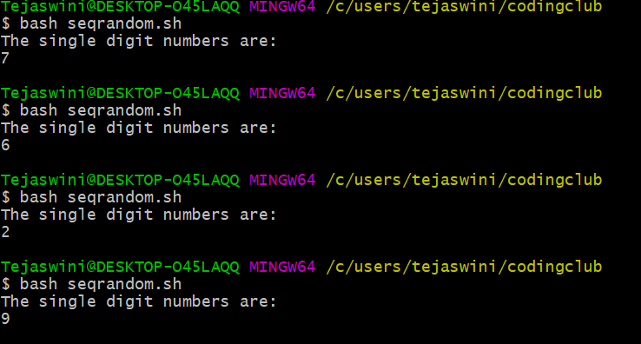

Add two Random Dice Number and Print the Result

echo "program 2,3"

echo "sum of 2 random number in a dice is:"

d1=$((RANDOM%6))

d2=$((RANDOM%6))

echo "$d1,$d2"

sum=$((d1+d2))

echo "$sum";

