Write a function to check if the two numbers are Palindromes

#!/bin/bash -x

function palindrome() {

s=0

rev=""

temp=$num

while [ $num -gt 0 ]

do

s=$(( $num % 10 ))

num=$(( $num / 10 ))

#to store previous number and current digit in reverse

rev=$( echo ${rev}${s} )

done

if [ $temp -eq $rev ];

then

echo "Number is palindrome"

else

echo "Number is NOT palindrome"

fi

}

for (( i=1; i<=2; i++ ))

do

read -p "Enter a number to check: " num

palindrome $num

done

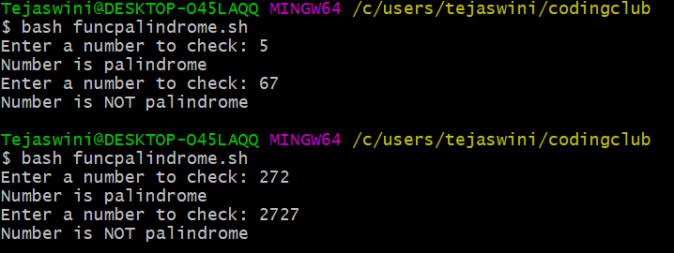

Take a number from user and check if the number is a Prime then show

that its palindrome is also prime

a. Write function check if number is Prime

b. Write function to get the Palindrome.

c. Check if the Palindrome number is also prime

#!/bin/bash

function prime() {

if [ $num -eq 1 ]

then

echo $num "is neither a prime number nor a composite"

exit

else

for(( i=2; i<=$num/2; i++ ))

do

if [ $(( $num%i )) -eq 0 ]

then

echo "$num is not a prime number."

break

fi

done

palindrome $num

fi

}

function palindrome() {

s=0

rev=""

temp=$num

while [ $num -gt 0 ]

do

s=$(( $num % 10 ))

num=$(( $num / 10 ))

#to store previous number and current digit in reverse

rev=$( echo ${rev}${s} )

done

if [ $temp -eq $rev ];

then

echo "Number is a palindrome"

else

echo "Number is NOT a palindrome"

fi

for(( i=2; i<=$rev/2; i++ ))

do

if [ $(( $rev%i )) -eq 0 ]

then

echo "$rev is not a prime number."

exit

fi

done

echo "$rev is a prime number"

}

read -p "Enter the number to check: " num

prime $num

