Write a program that reads 5 Random 3 Digit values and then outputs the minimum

and the maximum value

echo "Write a program that reads 5 Random 3 Digit values and

then outputs the minimum

and the maximum value"

m=$(((RANDOM%99)+100))

n=$(((RANDOM%9)+100))

o=$(((RANDOM%99)+100))

p=$(((RANDOM%99)+100))

q=$(((RANDOM%99)+100))

echo $m; echo $n; echo $o; echo $p; echo $q

if (( ($m>$n) && ($m>$o) && ($m>$p) && ($m>$q) )); then

echo "maximum number is $m"

elif (( ($n>$m) && ($n>$o) && ($n>$p) && ($n>$q) )); then

echo "maximum number is $n"

elif (( ($o>$m) && ($o>$n) && ($o>$p) && ($o>$q) )); then

echo "maximum number is $o"

elif (( ($p>$m) && ($p>$o) && ($p>$n) && ($p>$q) )); then

echo "maximum number is $p"

else

echo "maximum number is $q"

fi

#minimun value

if (( ($m<$n) && ($m<$o) && ($m<$p) && ($m<$q) )); then

echo "minimum number is $m"

elif (( ($n<$m) && ($n<$o) && ($n<$p) && ($n<$q) )); then

echo "minimum number is $n"

elif (( ($o<$m) && ($o<$n) && ($o<$p) && ($o<$q) )); then

echo "minimum number is $o"

elif (( ($p<$m) && ($p<$o) && ($p<$n) && ($p<$q) )); then

echo "minimum number is $p"

else

echo "minimum number is $q"

fi

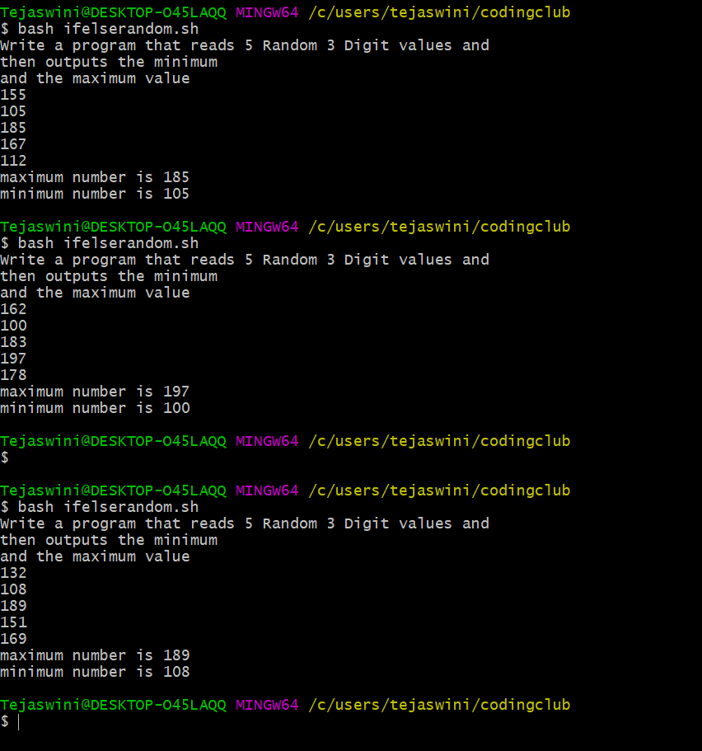

Write a program that takes day and month from the command line and prints true if

day of month is between March 20 and June 20, false otherwise.

echo "Write a program that takes day and month from the

command line and prints true if

day of month is between March 20 and June 20, false otherwise?"

echo ""

echo ""

read -p "Enter Date: " date

read -p "Enter Month: " Month

# should validate input: non-blank, numeric

combo=0

res="false"

st=1

if [ $Month -ge 3 -a $Month -le 6 ]; then

# 30 for Apr, Jun

# 31 for Mar, May

dlimit=$((30 + (Month % 2)))

if [ $date -ge 1 -a $date -le $dlimit ]; then

combo=$(((Month * 100) + date))

# true Mar 20 to Jun 20

if [ $combo -ge 320 -a $combo -le 620 ]; then

res="true"

st=0

fi

fi

fi

echo "$Month/$date $res"

exit $st

echo "===================================================="

echo " 3.Write a program that takes a year as input and outputs the Year is a Leap Year or not

a Leap Year. A Leap Year checks for 4 Digit Number, Divisible by 4 and not 100 unless

divisible by 400."

echo -n "Enter year (YYYY): "

read y

a = 'expr $y%4'

b = 'expr $y%100'

c = 'expr $y%400'

if[$a -eq 0 -a $b -ne - -o $c -eq 0]

then

echo "$y is leap year"

else

echo "$y is not a leap year"

fi

