Table of Contents

1. INTRODUCTION: 5

1.1 Project Objective 5

1.2 Dataset Overview 5

1.3 Data Cleaning and Preparation Process 5

2. DATA VISUALIZATION 9

2.1 Data Exploration 10

2.2 Comparative Visualizations 14

2.3 Axis Labelling and Scaling 15

2.4 Use of Color, Size, and Shape 17

2.5 Interactive Features for Data Exploration 17

3. HYPOTHESIS AND ANALYSIS DIRECTIONS 18

3.1 Dashboard 1: Overview 18

3.1.1 Clearly Stated Hypotheses: 19

3.1.2 Methodology: 19

3.1.3 Insights and Patterns: 19

3.2 Dashboard 2: Economic Indicators 20

3.2.1 Clearly Stated Hypotheses: 20

3.2.2 Methodology: 20

3.2.3 Insights and Patterns: 21

3.3 Dashboard 3: D3-Sector Contributions 22

3.3.1 Clearly Stated Hypotheses: 22

3.3.2 Methodology: 22

3.3.3 Insights and Patterns: 23

3.4 Dashboard 4: D4-Climate&Agriculture 24

3.4.1 Clearly Stated Hypotheses: 24

3.4.2 Methodology: 24

3.4.3 Insights and Patterns: 25

3.5 Dashboard 5: D5-Mobile Impacts 26

3.5.1 Clearly Stated Hypotheses: 26

3.5.2 Methodology: 26

3.5.3 Insights and Patterns: 27

3.6 Dashboard 6: D6-Health Indicators 28

3.6.1 Clearly Stated Hypotheses: 28

3.6.2 Methodology: 28

3.6.3 Insights and Patterns: 29

4. ETHICAL CONSIDERATIONS 30

5. USER EXPERIENCE AND ENGAGEMENT 31

5.1 User-Friendly Design 31

5.2 Interactivity and Accessibility 32

5.3 Real-World Application of Colin Ware’s Engagement Principle 32

5.4 Publishing and Sharing 33

6. CONCLUSION 33

6.1 Summary of Findings 33

6.2 Implications 33

6.3 Next Steps 34

6.4 Overall Value 34

**Global Development Analysis**

# **1. INTRODUCTION**

In today’s globally connected world, visualizing national development trends can provide deep insights into the economic, social, and health conditions of countries. This project, titled **“Global Development Analysis,”** is designed to transform raw global indicators into meaningful stories using interactive Tableau dashboards. The central focus is not just on data analysis—but on preparing, cleaning, and organizing the dataset in a way that supports compelling, insightful, and professional-grade visualizations.

## **1.1 Project Objective**

The main objective of this project is to build an impressive and interactive Tableau dashboard that presents development indicators across countries and regions in a clear and visually engaging manner. To achieve this, the project involves:

* Cleaning and refining the *Countries of the World* dataset to ensure analytical readiness.
* Designing powerful Tableau visualizations that highlight patterns, trends, and relationships in global development.
* Offering users the ability to interactively explore how different countries perform across dimensions such as GDP, literacy, health, and economic structure.

The dashboard's goal is to provide a refined, exploratory experience that enables stakeholders to quickly uncover regional strengths, global discrepancies, and important development factors.

## **1.2 Dataset Overview**

The dataset includes **227 countries** and captures a wide range of indicators, such as:

* Economic: GDP per capita, sectoral contributions (agriculture, industry, service), phone usage per 1000 people.
* Health: Infant mortality, birth rate, and death rate.
* Social and Demographic: Literacy rate, population, net migration.
* Environmental and Geographic: Climate, arable land, area, and coastline ratio.

The dataset’s breadth makes it ideal for regional comparisons and identifying high- and low-performing nations across multiple development dimensions.

## **1.2.1 Meta Data Description**

* **Country**: The name of the country being described.
* **Region**: The broader geographical area the country belongs to.
* **Population**: The total number of people living in the country.
* **Area (sq. mi)**: The country's total land area, in square miles.
* **Population Density (per sq. mi)**: The number of people living per square mile of land.
* **Coastline to Coast Area Ratio**: This ratio indicates how much of the country’s land is along the coastline.
* **Net Migration**: The difference between the number of people moving into and out of the country.
* **Infant Mortality (per 1,000 births)**: The number of infant deaths per 1,000 live births. .
* **GDP per Capita**: The Gross Domestic Product (GDP) divided by the population of the country.
* **Literacy**: The percentage of the population that can read and write.
* **Phones per 1,000**: The number of telephones (landlines and mobile phones) for every 1,000 people.
* **Arable Land**: The percentage of land that is suitable for farming.
* **Crops**: The percentage of the land used for growing crops.
* **Non-Agricultural Land**: The portion of land that is not used for agricultural purposes, either urban areas or undeveloped land.
* **Climate**: Describes the general climate type of the country.
* **Birthrate**: The number of live births per 1,000 people per year.
* **Deathrate**: The number of deaths per 1,000 people per year.
* **Agriculture**: The percentage of GDP that comes from the agricultural sector.
* **Industry**: The percentage of GDP that comes from the industrial sector.
* **Service**: The percentage of GDP that comes from the service sector.

## **1.3 Data Cleaning and Preparation Process**

Before building the Tableau dashboard, the dataset was thoroughly cleaned and formatted to enhance accuracy and usability:

**Format Standardization**

* Converted non-European numeric formats (e.g., 1,234 used for decimals) into standard decimal points.
* Transformed all numeric columns from strings to appropriate numerical types.

**Column Name Normalization**

* Renamed all headers to lowercase with underscores, removing spaces and special characters for consistency (e.g., "GDP ($ per capita)" → gdp_($_per_capita)).

**Climate Decoding (Label Encoding)**

* Replaced numeric codes in the climate column with descriptive labels:

1 → Hot/Dry

2 → Tropical

3 → Temperate

4 → Cold

**Handling Missing Values**

* Skewness was computed for all numerical columns.

Highly skewed: Imputed missing values with Median.

Normally distributed: Imputed with Mean.

* All imputed values were rounded to two decimal places.
* Validation ensured zero missing values remain.

**Region and Categorical Cleanup**

* Standardized region labels for consistency (title case, removed spacing).
* Created calculated fields in Tableau to categorize:

GDP per capita → *Low, Medium, High*

Literacy rate → *Low, Medium, High*

**Calculated Fields Created in Tableau**

|  |  |
| --- | --- |
| Calculated fields | Description |
| GDP Category | If GDP<5000, then they are low-GDP countries;  If 5000<GDP<20000, then they are medium GDP countries;  If GDP>20000, then they are high-GDP countries |
| Literacy Category | If literacy<70, then they are low-literacy countries;  If 70< literacy <90, then they are medium literacy countries;  If literacy >90, then they are high-literacy countries |
| Dominant Sector | It shows the dominant sector of that country by comparing the values of agriculture, industry and services |
| Climate Category | Categories are divided into:   1. Hot/ Dry 2. Tropical 3. Temperate 4. Cold |
| Country KPI | Gives an overview of the country's details |

**Key Discoveries from the Cleaned Dataset**

With the dataset now fully cleaned and structured, it opens the door to a range of valuable insights that can be uncovered through Tableau visualizations:

* **Economic and Educational Alignment**  
  Countries with higher GDP per capita tend to report elevated literacy rates, particularly in more developed regions, highlighting a potential link between education and economic prosperity.
* **Health Outcomes and Migration Patterns**  
  Nations experiencing higher net migration often demonstrate stronger healthcare systems, as evidenced by lower infant mortality rates. This suggests that healthcare access may act as a migration pull factor.
* **Development and Economic Composition**  
  Economically advanced countries are largely service-driven, while lower-income nations rely more heavily on agriculture, indicating a structural shift in economic focus with development.
* **Climate and Agricultural Viability**  
  Tropical and temperate regions generally possess greater proportions of arable land, pointing to stronger agricultural potential that can influence both domestic sustainability and global food supply chains.
* **Technology as a Development Indicator**  
  Countries with higher phone usage per 1,000 people often exhibit better infrastructure and economic strength, suggesting that digital connectivity can serve as a marker of modernization and growth.

**2. DATA VISUALIZATION**

Effective data visualization is essential for uncovering trends, identifying patterns, and deriving insights from complex datasets. Before delving into detailed analysis, a series of foundational visualizations was created to provide a high-level overview of the data’s structure, distribution, and quality. These visuals helped identify outliers, assess missing values, and confirm the readiness of the data for deeper exploration.

The visualization approach was grounded in Edward Tufte’s principles of graphical integrity and Colin Ware’s theories of visual perception. Charts were designed with accurate scaling, minimal non-data ink, and intuitive color schemes to enhance clarity without overwhelming the viewer. This ensured that each visual was both truthful and accessible, laying a strong foundation for informed, data-driven decisions in the subsequent stages of analysis.

**Design Principles Applied**

**Edward Tufte – Graphical Integrity Concepts**

* **Accurate Representation of Data:** All charts were developed with properly scaled and labelled axes to ensure no distortion in the interpretation of economic or health metrics.
* **Outlier Inclusion:** Outliers in variables like GDP or infant mortality were retained and visualized using adjusted axis ranges or annotations to highlight their significance rather than exclude them to preserve data integrity.
* **High Data-to-Ink Ratio:** Visualizations avoided unnecessary embellishments. Gridlines and borders were minimized to focus on the core data.

**Colin Ware – Visual Perception and Message Clarity**

* **Use of Color and Contrast:** Colors were used effectively to distinguish between regions, GDP & literacy without overwhelming the viewer.
* **Size and Shape Cues:** In scatter and bubble plots, marker size was mapped to variables like GDP or sectoral share, while consistent shape encoding ensured intuitive interpretation.
* **Readable Fonts and Layouts:** All visuals were created using legible fonts, balanced spacing, and logical layouts to enhance interpretability.

**Accessibility and Transparency**

* All charts maintained high resolution, optimal aspect ratios, and font sizes suitable for readability.
* Interactive elements such as tooltips and annotations (in Tableau) were added to provide contextual explanations of notable patterns or anomalies (e.g., countries with high GDP but low literacy rates).

## **2.1 Data Exploration**

In line with Edward Tufte’s principles of data integrity, the data exploration phase prioritized transparency, precision, and faithful representation of global development indicators. Initial visual analyses were designed to highlight patterns across countries while avoiding any misleading impressions due to scale manipulation or data exclusion.

* **Faithful Scaling and Axes**: Visuals were constructed with properly scaled axes to ensure accurate interpretation of key metrics such as GDP, literacy rate, and infant mortality across different regions and countries.
* **Handling Outliers and Missing Values**: Outliers — such as countries with extreme GDP or mortality figures — were retained and visualized using expanded axis ranges or distinct markers. Missing data was acknowledged through visual filters or annotated notes, ensuring no hidden gaps in interpretation.

**Visual Techniques Used in Exploration**

**Bar Chart**

Bar charts are ideal for comparing quantitative data across multiple categories, making them especially useful for identifying top performers and understanding the distribution of values within groups. They support effective visual ranking, side-by-side comparisons, and trend spotting over discrete categories.

* A side-by-side bar chart titled “Sector Contribution Breakdown by Country” was created using a dynamic SELECT N parameter to show the top N countries by GDP in each region.
* The chart displays the percentage contribution of agriculture, industry, and service sector for each of these top countries.
* Filters for region, country, and sector allow users to customize the view and select multiple values as desired.
* In the example, the Asia (Ex. Near East) region is selected, showing all its countries and sectors.
* Hong Kong has the highest GDP per capita in this region, followed by Japan.
* In both Hong Kong and Japan, the services sector dominates, while the agriculture sector has the smallest share.

**Choropleth Maps (Categorical):**

Categorical choropleth maps are effective for displaying grouped data across geographic regions using color-coded categories. They simplify complex data by classifying values (e.g., GDP or literacy) into ranges like High, Medium, and Low, enabling quick visual comparisons and highlighting regional patterns at a glance.

* A **choropleth map** was created to visualize countries based on **GDP** and **literacy rate** categories.
* Countries were colored according to their values, categorized into **High**, **Medium**, or **Low** ranges.
* A **toggle option** allows users to switch the map view between **GDP** and **literacy rate**.
* A **region filter** lets users focus on specific parts of the world for more targeted insights.
* The map provides a clear overview of global disparities in GDP and literacy, helping users identify patterns across regions and categories.

**Pie Chart**

Pie charts provide a clear visual representation of proportions within a whole, making it easy to compare the relative sizes of different categories. They help users quickly identify the largest or smallest segments and assess the distribution of data across various categories.

* A pie chart was created to show sector-wise GDP contribution (Agriculture, Industry, and Services) by region.
* Each sector is represented by a distinct color to make interpretation easier.
* A region filter allows users to focus on specific areas and view how each sector contributes to the regional GDP, summing to 100%.
* A country filter enables users to see how much a selected country contributes to each sector in the region, but the percentages are based on the overall total and may not sum to 100%.
* This chart helps users compare sector dominance within a region and evaluate how individual countries contribute to global sectoral GDP.

**Key Performance Indicators (KPIs)**

Key Performance Indicators (KPIs) provide a quick overview of critical metrics, highlighting top performers and global averages. They help users monitor trends and compare individual data points against benchmarks at a glance.

* Comparison of KPIs (Global Average GDP and Regional Average GDP) helps identify economic positioning of a region relative to the global benchmark.
* If the Regional Average GDP is higher than the Global Average GDP, the region may be economically advanced or more developed.
* If the Regional Average GDP is lower than the Global Average GDP, it may suggest economic challenges or a developing status.
* The difference between the two KPIs highlights disparities and helps prioritize focus areas for analysis or policy.
* Dynamic filtering by region updates the KPI, enabling real-time comparisons and targeted insights.

**Bubble Plot**

Bubble plots provide a visual summary of multivariate data, using position and size to compare multiple metrics at once. They help users quickly identify patterns, outliers, and relationships between variables, making them ideal for highlighting the impact or scale of a specific factor across categories.

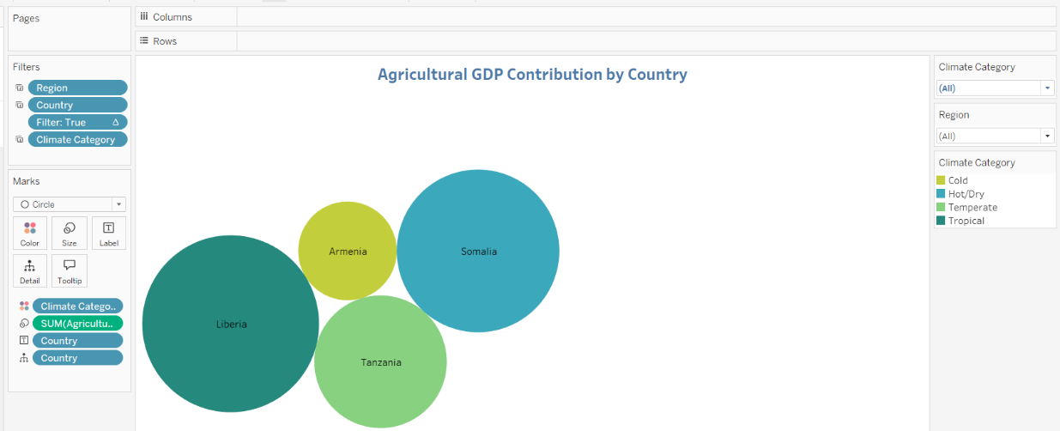

* A bubble plot was created to show agricultural sector contribution to GDP across countries.
* The size of each bubble represents how much agriculture contributes to that country's GDP.
* Countries are grouped by their dominant climate type (e.g., tropical, temperate, hot) for environmental comparison.
* The plot dynamically updates based on the selected region, highlighting the top contributing country.
* Top countries in each climate category are labeled inside the bubble for easy identification.
* This visualization helps identify which climates support stronger agricultural economies.

**Scatter plot**

Scatter plots are effective for exploring relationships between two numerical variables. They help users identify trends, clusters, and correlations, making them ideal for visualizing patterns, comparing groups, and spotting outliers in the data.

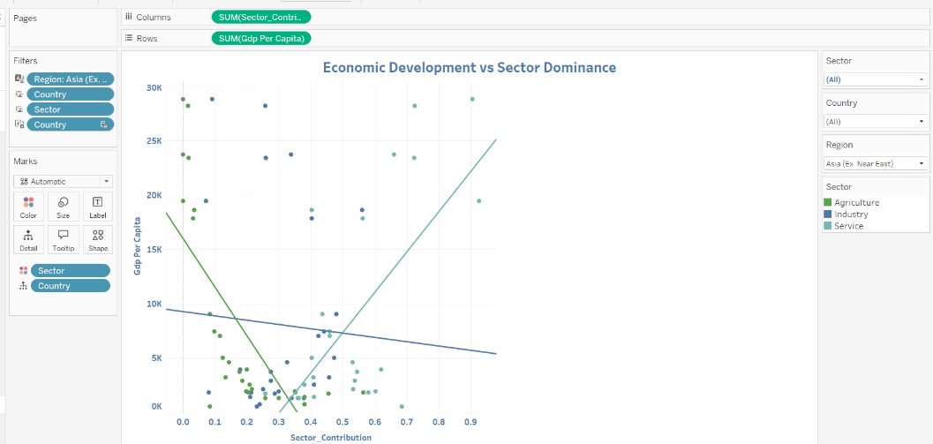

* Scatter plots were created to explore the relationship between GDP and sectoral contributions (agriculture, industry, and services).
* Each dot represents a country, allowing for a country-level comparison.
* Different colors were used to distinguish between the three sectors.
* Trend lines were added for each sector to visualize how GDP varies with its contribution.
* The plots help reveal patterns, regional differences, and correlations between sector performance and GDP.

## **2.2 Comparative Visualizations**

To explore trends, patterns, and contrasts across movies, the following visual comparisons were created:

* **Title**: *Sector Contribution Breakdown by Country*
* **Purpose**: Compares the percentage contribution of agriculture, industry, and services sectors for the top N countries by GDP in each selected region.
* **Visualization Type**: **Side-by-side bar chart** — ideal for comparing multiple categories across countries.
* **Dynamic Parameter**: Utilizes a SELECT N parameter to show the top N GDP countries in a region, making the chart adaptable and insightful.
* **Interactivity**: Includes multi-select filters for region, country, and sector, allowing users to tailor the view based on specific analysis needs.

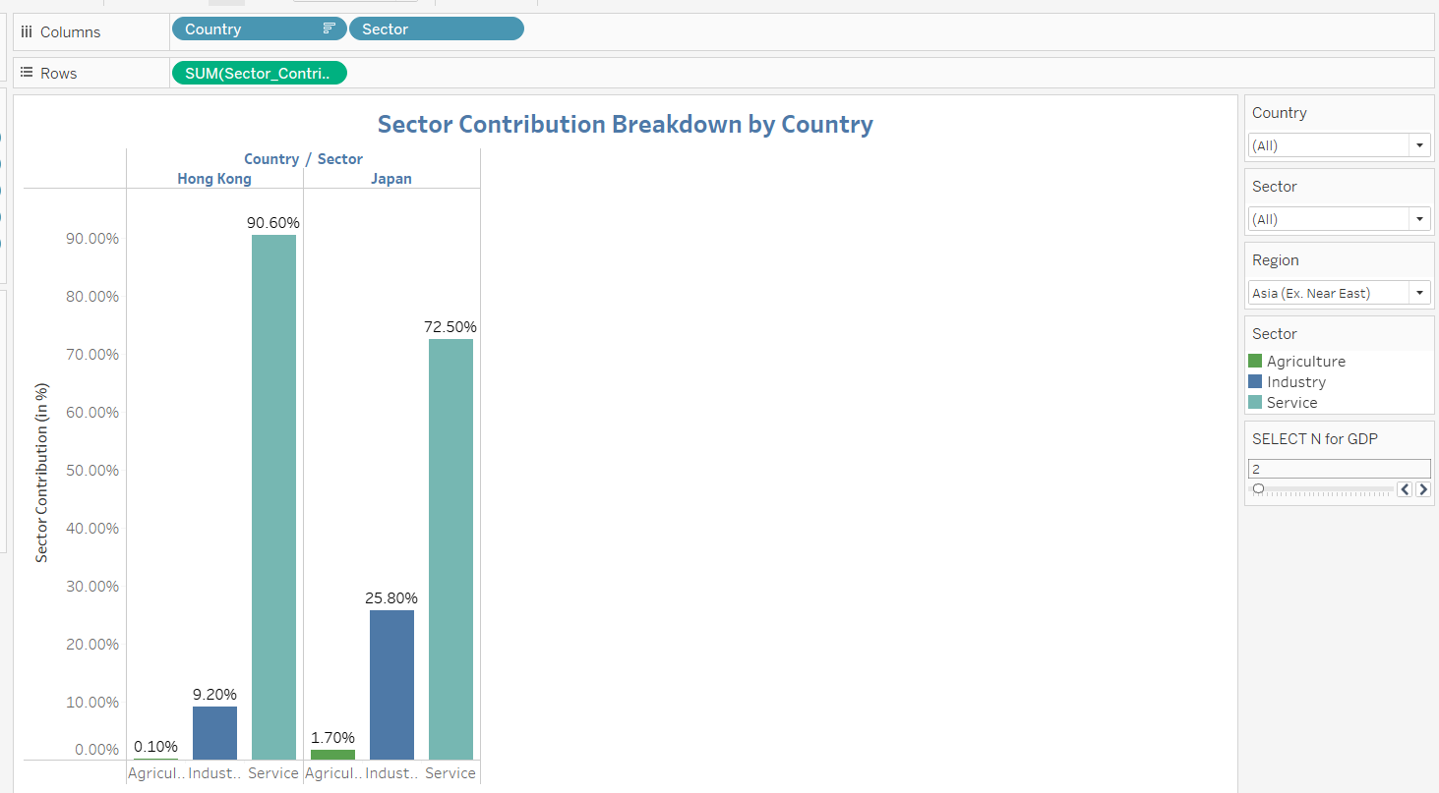

* **Example View:**
  + **Region:** *Asia (Ex. Near East)*
  + **Insight:** Hong Kong and Japan have the highest GDP per capita in this region.
  + **Pattern:** Both countries are service-driven economies, with the services sector dominating and agriculture contributing the least.

## **2.3 Axis Labelling and Scaling**

* To evaluate and showcase how axis labeling and scale integrity are applied to ensure accurate, readable, and meaningful data visualizations, referencing Edward Tufte’s principles of Graphical Integrity.

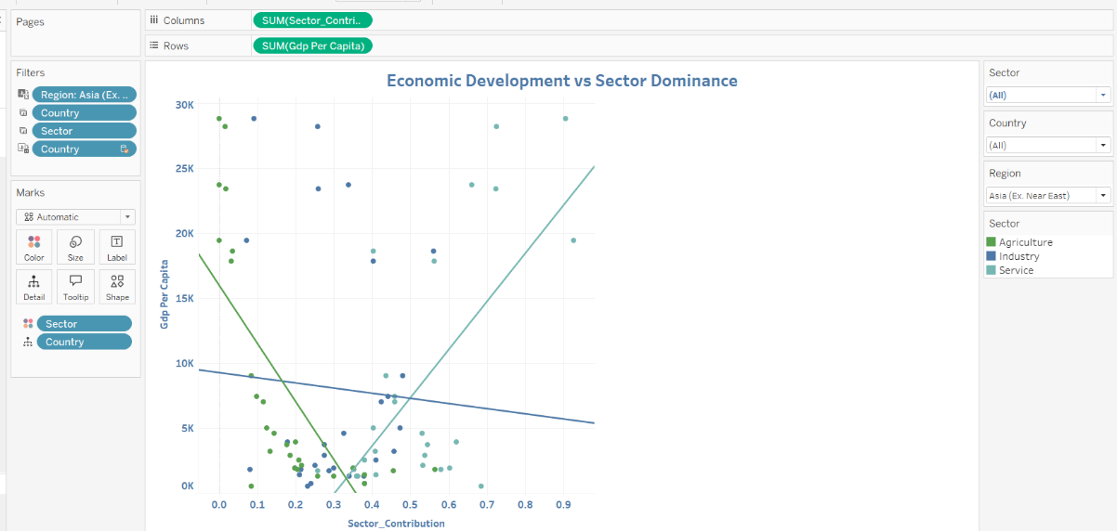

**Chart Design Principles for Clear Interpretation:**

**Chart Type and Axis Scaling:**

* The scatter plot is utilized to explore the relationship between GDP and sector contributions (Agriculture, Industry, Services) across countries.
* X -Axis (Sector Contribution): Represents the percentage contribution of each sector (Agriculture, Industry, Services) to the GDP, with clear, consistent intervals.
* Y-Axis (GDP): Displays GDP values, ranging from lower to higher GDP countries. The scale is proportional, ensuring accurate representation of economic differences.
* Proportional Scaling: Both axes are scaled in a way that prevents visual distortion, allowing users to interpret how GDP correlates with sector contributions effectively.
* **Example:** The scatter plot ensures the relationship between GDP and sector contribution is clearly understood, without exaggeration of trends or data points.

**Legibility and Clear Labeling:**

* **X-Axis (Sector Contribution):** Labeled with percentage values for sector contributions, ranging from 0% to 100%.
* **Y-Axis (GDP):** Properly labeled with GDP values in clear, regular intervals (e.g., from 0 to 5 trillion USD), ensuring easy identification of economic size.
* **Tick Marks:** Positioned at regular intervals, providing clear markers to help users track data across both axes.
* **Units:** GDP is marked in trillions of USD, and sector contributions are in percentages, making it straightforward to interpret the chart.

**High-Resolution and Visual Clarity:**

* The scatter plot is presented in high resolution, ensuring clear visibility of data points and labels.
* Minimal Visual Clutter: Gridlines are kept to a minimum, and the background is simple, allowing users to focus on the data points and trends.
* The design follows Tufte’s principle of data-ink ratio, ensuring that only necessary elements (data points, labels, and trend lines) are included for analysis.

**Accurate and Non-Misleading Representation:**

* **No Manipulation of Scales:** The axes and intervals used in the scatter plot reflect the true values of GDP and sector contributions, avoiding any exaggeration or minimization of trends.
* **No 3D Effects or Unnecessary Decorations:** The chart uses a clean, 2D design without visual distractions, which allows for a more straightforward interpretation of the data.
* **Clear and Honest Data Representation:** The scatter plot adheres to best practices, ensuring that the information is presented transparently, with no misleading visual techniques.

## **2.4 Use of Color, Size, and Shape**

**Color**

* The scatter plot uses **distinct colors** to represent different sectors (Agriculture, Industry, Services), making it easy to differentiate between the contributions of each sector.
* **Color Coding:** Each sector is assigned a unique color, ensuring clear visual distinction and enabling users to quickly identify sector-specific trends or outliers.
* **Tufte’s Principle of Data-Ink Ratio:** Color is used sparingly and meaningfully, focusing on differentiating data points rather than adding unnecessary visual elements. This supports clarity without overcomplicating the design.

**Size**

* **Bubble Size:** In case of a bubble plot or similar charts, the size of the bubble can represent the magnitude of sector contributions to GDP. Larger bubbles indicate a greater contribution, while smaller bubbles show lesser contributions.
* **Perceptual Principle:** By varying bubble sizes, the user can intuitively grasp the relative weight of different sectors in each country’s GDP. This allows for quick comparison and highlights the most significant contributions visually.

**Shape**

* **Dots:** In scatter plots or bubble charts, dots are used to represent individual countries. The position of each dot indicates the relationship between two variables (e.g., GDP and sector contribution), and the size of the dot indicates the magnitude of that variable.
* **Bars:** In bar charts, the length of the bar represents the relative magnitude of a category, such as sectoral contribution in each country. Bars provide an effective way to compare categories across regions, highlighting top performers visually.

## **2.5 Interactive Features for Data Exploration**

* **Tooltips:** Hover-over tooltips provide users with detailed information when they hover over data points (e.g., country names, sector contributions, GDP values). This interaction enables users to gain deeper insights without cluttering the visualization, aligning with Colin Ware’s principle of exploratory interaction.
* Tooltips are designed to show additional context, such as exact numerical values, rankings, and sector breakdowns, helping users understand the data in more detail.
* **Filters:** Dynamic filters allow users to narrow down data based on specific criteria, such as region, sector, and top N countries by GDP. This interactivity supports users in focusing on subsets of data that align with their interests, facilitating exploratory analysis.
* Filters help users view and compare data across different categories, providing a personalized experience and enhancing the interpretability of the chart based on user-defined parameters.
* **User-Centric Interaction:** Interactive charts enable users to zoom, hover, and select specific regions or countries to see more granular data. This enhances the exploration of global data by allowing users to drill down and identify specific trends or patterns.
* The exploratory interaction helps users actively engage with the data, making the analysis process intuitive and responsive to their needs.
* **Responsive adjustments:** Interactive elements, such as dropdowns, sliders, and checkboxes, enable users to dynamically adjust the chart's view, making the data visualization responsive to changes and providing a more immersive and engaging experience.

# **3. HYPOTHESIS AND ANALYSIS DIRECTIONS**

## **3.1 Dashboard 1: Overview**

### **3.1.1 Clearly Stated Hypotheses**

**Hypothesis:** A high-level overview of development indicators such as GDP, literacy, birth, and death rates will reveal general development patterns and outliers among countries.

**Data Used:** Aggregated country-level data on GDP per capita, literacy rate and other important factors.  
**Visualization:** This dashboard integrates KPI summary tiles and a geographic overview to provide a macro-level snapshot of development trends across countries.

### **3.1.2 Methodology**

**Purpose:** Provide a high-level snapshot of country-level development indicators.  
**Steps Taken:**

**Data Preparation:** Aggregated key variables (GDP per capita, literacy rate, population, climate, birth and death rate) at the country level.

**KPI Tiles:** Created calculated fields for country overview, then used visualization for readability.

**Map Visualization:** Plotted an overview map using country geographic roles to display an overview.

**Interactivity:** Tooltips and map filters allow users to explore summary metrics country by country.

**Color Encoding:** Color gradient used to differentiate region-wise visually on the map and KPIs.

### **3.1.3 Insights and Patterns**

* Countries with higher GDP per capita often also report higher literacy rates and lower net migration, suggesting better socio-economic stability.
* The interactive map revealed distinct clusters: For example, [Western Europe](https://en.wikipedia.org/wiki/Western_Europe), [North America](https://en.wikipedia.org/wiki/North_America), and [East Asia](https://en.wikipedia.org/wiki/East_Asia) grouped in the high GDP/high literacy quadrant.
* Countries like the USA, China, and Germany are among the top in GDP distribution globally.
* Countries in Sub-Saharan Africa and parts of South Asia consistently showed lower KPIs, flagging them as development-priority regions.
* Net migration tended to be positive in high-income countries (e.g., [Canada](https://en.wikipedia.org/wiki/Canada), [Germany](https://en.wikipedia.org/wiki/Germany)) and negative in developing nations, reflecting migration due to economic disparity.
* Countries like Chile and Argentina show relatively higher literacy but moderate GDP.
* Countries like India and Nigeria contribute less GDP per capita despite large populations.
* Countries such as Bangladesh and Ethiopia show signs of improvement in literacy, indicating successful educational initiatives.
* KPI card comparisons showed noticeable global inequality: top countries had over 10x higher GDP than the global average.
* Outliers: Some countries (e.g., oil-rich Gulf nations) show very high GDP but moderate literacy, indicating education lags behind economic wealth
* Clicking on any country in the interactive map opens its corresponding Wikipedia page, allowing users to quickly access comprehensive information about the country's demographics, economy, history, and more.

## **3.2 Dashboard 2: Economic Indicators**

### **3.2.1 Clearly Stated Hypotheses**

**Hypothesis:** Countries with higher literacy rates tend to have higher GDP per capita, indicating that human capital is a key driver of economic growth.

**Data Used:** Country-level GDP and literacy rate statistics.

**Visualization:** A parameter-driven indicator toggles, and thematic maps (GDP & literacy map) are used to explore the relationship between literacy and economic output.

### **3.2.2 Methodology**

**Purpose**: Explore the relationship between education (literacy) and economic strength (GDP).  
**Steps Taken:**

**Parameter Control:** Built a parameter to switch between GDP per capita and Literacy rate in visualizations.

**Side by side Bar chart Analysis:** Visualized average GDP Vs average literacy using side by side bars to identify trends.

**Map View:** GDP & Literacy map used filled maps with diverging color schemes to emphasize variable contrast.

**Lollipop chart:** It shows the region’s literacy dominance and is sorted in descending order.

**Insights Tracking:** Tooltip annotations and reference lines helped detect correlation strength.

### **3.2.3 Insights and Patterns**

* A strong positive correlation was evident between GDP per capita and literacy rate, validating the human capital hypothesis.
* Nations like Luxembourg, United States, Japan, Switzerland and Norway top the GDP per capita list.
* Nordic countries, South Korea, and Japan lead with >99% literacy.
* Europe dominates the upper end of literacy rankings, while African and South Asian countries are scattered toward the bottom.
* Some outliers exist — countries with high literacy but low GDP (e.g., some Eastern European or Latin American nations), possibly due to limited industrial infrastructure or political instability.
* Countries like Poland and Malaysia show a balance between increasing GDP and literacy.
* The dashboard highlights three distinct economic-literate groupings based on GDP per capita and literacy rates:
  1. High GDP, high literacy (e.g., [USA](https://en.wikipedia.org/wiki/United_States), [Germany](https://en.wikipedia.org/wiki/Germany), [Japan](https://en.wikipedia.org/wiki/Japan))
  2. Moderate GDP, high literacy (e.g., [Brazil](https://en.wikipedia.org/wiki/Brazil), [Ukraine](https://en.wikipedia.org/wiki/Ukraine))
  3. Low GDP, low literacy (e.g., [Chad](https://en.wikipedia.org/wiki/Chad), [Afghanistan](https://en.wikipedia.org/wiki/Afghanistan)).

## **3.3 Dashboard 3: D3-Sector Contributions**

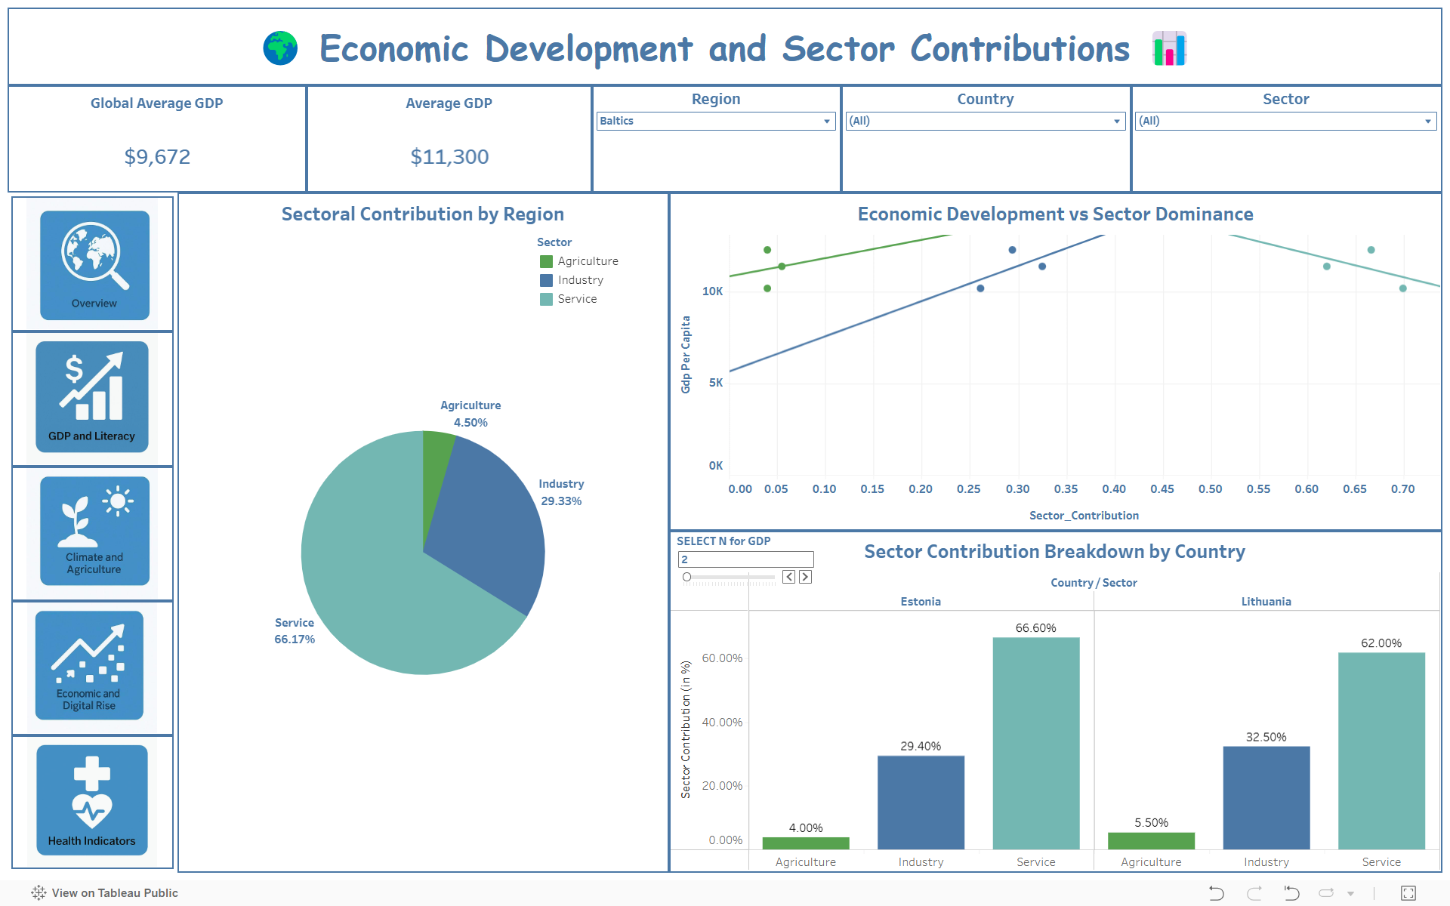

### **3.3.1 Clearly Stated Hypotheses**

**Hypothesis:** The structure of a country’s economy (i.e., the contributions of agriculture, industry, and services) varies depending on its stage of economic development.

**Data Used:** Sectoral GDP contributions for each country.

**Visualization:** Bar charts or pie charts compare how different countries depend on various sectors, highlighting patterns among developing vs developed nations.

### **3.3.2 Methodology**

**Purpose:** Analyze sector-wise contributions to GDP across countries.  
**Steps Taken:**

**Data Aggregation:** GDP values for Agriculture, Industry, and Services were normalized to percentage contribution.

**Visualization Style**: Bar charts used to compare sectors side-by-side for top N countries that has high GDP per capita.

**Sorting and Highlighting:** Bars were sorted based on dominant sector; color-coded for visual differentiation.

**Calculated Fields:** Total GDP and percentage share by sector were calculated to enable relative comparisons.

**Tooltip Details**: Interactive tooltips display both absolute and relative sector values.

### **3.3.3 Insights and Patterns**

* Developing economies rely heavily on agriculture, while advanced economies show dominant contributions from services and industry.
* The visualization revealed that countries like India and Kenya have more than 25% GDP from agriculture, whereas countries like the US, UK, and Japan derive over 70% from services - especially finance, IT, and healthcare.
* Nations like Thailand and Morocco derive a large portion of services GDP from tourism, causing seasonal volatility.
* Industrial dominance was strongest in fast-growing economies (e.g., China, Vietnam), highlighting transitional phases of development.
* Vietnam and Bangladesh show increasing industry shares, especially textiles and electronics.
* Some countries remain stuck with moderate industry but no services growth — e.g., Indonesia and parts of Latin America.
* Nations like Brazil and Turkey show more evenly distributed GDP across the three sectors, aiding resilience.
* Pie & bar charts helped to compare the economic DNA of countries, illustrating a clear developmental path from agrarian to industrial to service-oriented economies.
* Most countries show a decadal trend of rising service sector dominance, reducing reliance on agriculture/industry.

## **3.4 Dashboard 4: D4-Climate&Agriculture**

### **3.4.1 Clearly Stated Hypotheses**

**Hypothesis:** Climatic conditions (e.g., temperature, rainfall) impact the degree to which countries rely on agriculture, influencing their economic structure.

**Data Used:** Agricultural sector contribution to GDP and climate-related metrics.

**Visualization:** Dual-axis or comparative bar charts are likely used to examine climate variables alongside agriculture dependency. The dashboard highlights regional differences and vulnerability.

### **3.4.2 Methodology**

**Purpose:** Investigate how climate influences agricultural reliance.  
**Steps Taken:**

**Climate Metrics Integration:** Combined agricultural GDP with external climate datasets (temperature, rainfall).

**Sankey Chart:** Used to show climate and agriculture metrics on the same chart with separate y-axes, with the width of the flow as a number of countries.

**Color Coding:** Different colors for temperature, rainfall, and agriculture to distinguish them clearly

**Filters & Grouping:** Enabled region-based filtering to compare climate-agriculture patterns across continents.

**Derived Insights**: Charts revealed patterns in how climate factors like temperature and rainfall influence a country's reliance on agriculture.

### **3.4.3 Insights and Patterns**

* Countries in tropical regions (e.g., Sub-Saharan Africa, parts of Southeast Asia) show higher agricultural dependence but lower GDP — suggesting low productivity or climate vulnerability.
* Climate charts suggested that extreme rainfall and temperature regions underperform in agriculture GDP, indicating climate stress on economic output.
* Countries with average temps between 15°C–25°C show higher agricultural productivity (e.g., parts of Europe, China).
* A negative relationship emerged between average temperature and agricultural output beyond certain thresholds (~30°C), suggesting the adverse effect of heat on productivity.
* Nations near the equator (e.g., Chad, Sudan) face declining crop yields due to rising temperatures and erratic rainfall.
* Countries with moderate climates (e.g., parts of Europe and South America) had both higher agricultural efficiency and economic balance.
* Northern countries (e.g., Russia, Canada) have low agriculture output despite vast land, due to shorter growing seasons.
* Countries like India and Brazil show agriculture highly dependent on monsoons or seasonal rainfall.
* Nations like Ethiopia, Myanmar, and Nepal have >30% of GDP from agriculture, showing rural reliance.
* Declining farm productivity in dry zones (e.g., parts of Pakistan, Kenya) has led to increased rural-urban migration.
* Countries with low output but good conditions (e.g., Democratic Republic of Congo) indicate underinvestment rather than poor climate.

## **3.5 Dashboard 5: D5-Mobile Impacts**

### **3.5.1 Clearly Stated Hypotheses**

**Hypothesis:** Digital connectivity measured through mobile phone usage positively correlates with GDP and literacy rates, suggesting a digital divide between developing and developed regions.

**Data Used:** Mobile phones per 1,000 people, GDP per capita, literacy rate.

**Visualization:** Scatterplots like phones vs GDP/literacy, visualize digital access and its link to economic indicators. The dashboard shows how digital infrastructure influences development outcomes.

### **3.5.2 Methodology**

**Purpose**: Visualize how mobile penetration relates to economic and educational outcomes.  
**Steps Taken:**

**Key Metrics Used:** Mobile phones per 1,000 people, GDP per capita, and literacy rate.

**Scatterplot View:** Created phones vs GDP/literacy view using mobile usage on the x-axis and GDP/literacy on the y-axis.

**Parameter Toggle**: Allowed users to switch between GDP and literacy as dependent variables.

**Interactivity**: Tooltips, highlight actions, and filters provide exploratory interaction by country or region.

**Correlation Analysis:** Trend lines (linear) are optionally added to help assess the strength of the relationship.

### **3.5.3 Insights and Patterns**

* There was a clear trend: countries with higher mobile phone penetration generally had better literacy and GDP, validating digital infrastructure as a growth driver.
* Outliers like India and Indonesia had relatively high mobile access but lagged in GDP per capita, indicating that digital access alone doesn’t guarantee wealth.
* African nations had low mobile density and poor economic outcomes, while Western and East Asian nations topped both indicators.
* Some countries (e.g., Saudi Arabia) show high phone usage but moderate literacy, possibly due to imported labor demographics.
* Countries with higher mobile penetration also tend to have higher literacy rates — seen in Southeast Asia, Latin America.
* Nations like Vietnam and Peru punch above their GDP weight in mobile access — showing good infrastructure growth.
* In some cases (e.g., Zimbabwe), phone access is relatively high despite low GDP — often driven by informal economies.
* Mobile phones are now critical for health, education, and banking, especially in rural or unbanked areas.
* High phone penetration in some low-literacy countries may be due to voice-based services and app simplicity, showing accessibility potential.
* The visualizations reinforced the digital divide — a developmental gap defined not just by economic power, but by technological access.

## 

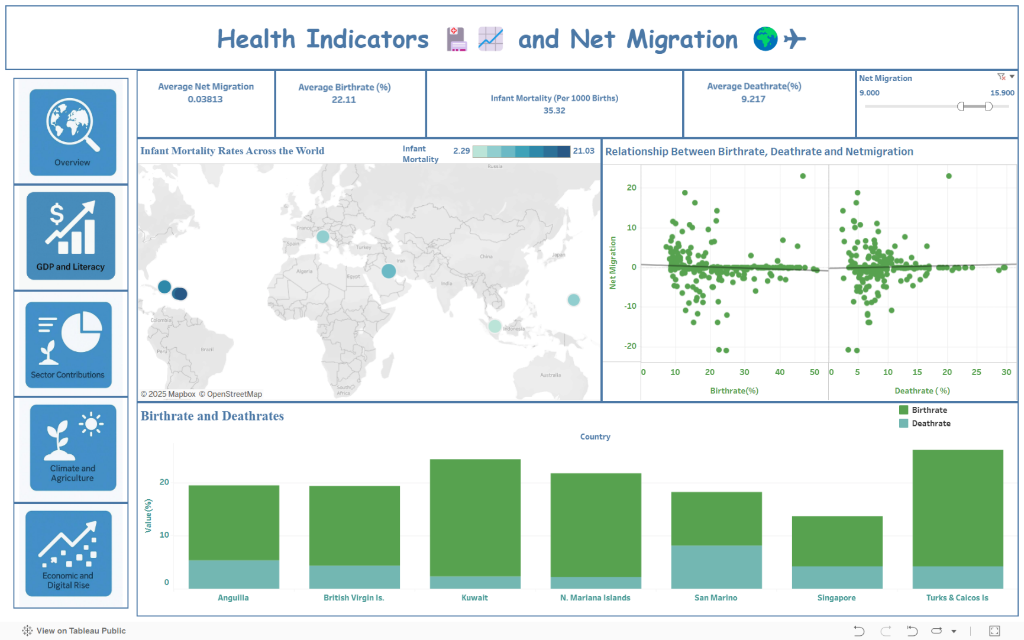**3.6 Dashboard 6: D6-Health Indicators**

### **3.6.1 Clearly Stated Hypotheses**

**Hypothesis:** Health outcomes (birth rate, death rate, infant mortality) differ significantly across countries and are associated with migration patterns and economic development.

**Data Used:** Birth and death rates, net migration statistics.

**Visualization:** Bar charts and maps from sheets like Deathrate and Birthrate, Net Migration by Country, and Net Migration vs Health Indicator present regional comparisons of health indicators and their socioeconomic implications.

### **3.6.2 Methodology**

**Purpose:** Compare health outcomes (birth rate, death rate, infant mortality) and their effect on migration.  
**Steps Taken:**

**Data Integration:** Joined health indicators with net migration data for each country.

**Bar Charts & Maps:** Deathrate and Birthrate bar charts show differences by country, while maps visualize the infant mortality rate.

**Calculated Ratios:** Health index metrics were computed to standardize and compare across countries.

**Combined View**: Net Migration vs Health Indicator sheet used a scatterplot to analyze how health affects mobility.

**Filtering & Highlighting:** Users can interactively explore individual countries or regions to see detailed breakdowns.

### **3.6.3 Insights and Patterns**

* High birth and death rates correlated with low economic development, especially in parts of Africa and South Asia.
* Countries with negative net migration often faced poor health outcomes, suggesting public health as a push factor for emigration.
* Developed nations (e.g., Japan, Germany) showed low birth and death rates but positive net migration, possibly due to aging populations and skilled migration policies.
* Developing Nations such as Nigeria, Pakistan, and DR Congo show high birth rates, but also moderately high death rates.
* Countries like India and Brazil are seeing falling birth rates, while death rates stabilize — signs of demographic transition.
* Some European countries (e.g., Bulgaria, Ukraine) have higher death than birth rates, leading to population shrinkage.
* High infant mortality is clearly linked to low GDP and weak health infrastructure, especially in Chad, Somalia, and Afghanistan.
* Some countries with mid-range GDP show major differences in outcomes between urban and rural populations.
* Countries like Sri Lanka and Cuba perform well in health despite low GDP, due to strong public health systems.
* In developed countries, health systems must prepare for rising elderly care needs as birth rates drop and life expectancy rises.
* Health indicators acted as indirect predictors of stability, with sharp contrasts seen between health index values and net migration in vulnerable regions.

**Cross-Dashboard Patterns & Holistic Insights**

* Cluster Analysis: High-GDP, high-literacy, low-mortality, high-digital-access countries formed one consistent group.
* Regional Trends: Sub-Saharan Africa and parts of South Asia repeatedly scored low across all indicators, while Western Europe and East Asia led most KPIs.
* Interdependency of Indicators: Literacy, mobile penetration, and health outcomes appear as drivers, while GDP and migration serve as consequences or outcomes.
* Outlier Recognition: Some nations defy trends — for example, high-literacy but low-GDP countries highlight the role of governance, geopolitical conflict, or corruption.

**4. ETHICAL CONSIDERATIONS**

**1.Economic Indicators**

The economic levels (high, medium, low) are consistently color-coded, allowing for quick visual differentiation of regional disparities. In the "Avg. Literacy vs Avg. GDP" dual bar chart, each region displays two adjacent bars representing average literacy rate and average GDP per capita. This design makes it easy to compare both indicators side by side within each region, highlighting where education and economic development align — or diverge.

Both bars are plotted on clearly labeled, appropriately scaled axes, ensuring that the comparison is visually accurate and not misleading. The uniform structure supports intuitive interpretation, while interactive filters above the chart allow users to isolate specific regions or economic tiers, enabling targeted analysis without losing the broader global context.

**2. Economic Development and Sector Contributions**

In this dashboard, consistent sector color-coding (green for agriculture, blue for industry, and teal for service) ensures easy comparison across regions and countries. Visual elements like pie charts and bar plots are proportionally scaled to avoid exaggerating any sector’s contribution. The scatter plot for sector dominance vs. GDP is clearly labeled and avoids overlapping points, ensuring honest interpretation. Filters for country, region, and sector improve transparency, allowing users to explore specific subsets of data without misrepresentation. The updated version reduces visual clutter and improves layout clarity compared to the older design.

**3. Impact of climate change on Arable land and agriculture**

The dashboard for this uses clearly defined color schemes to distinguish climate categories, ensuring users can accurately interpret the impact on arable land. The Sankey diagram presents data flow transparently, with proportional widths that avoid visual distortion. All chart axes and legends are labelled to prevent misinterpretation of values. Interactive filters by climate category, region, and country allow tailored exploration without presenting biased summaries. Compared to the earlier version, the updated layout enhances readability and legend clarity, reducing confusion in categorical representation.

**4. How Mobile penetration reflects education and wealth**

This ensures clarity by using a consistent green color gradient to represent mobile phone penetration levels without exaggerating regional differences. Axis scales and bubble sizes are proportionally set to prevent visual bias in GDP and literacy comparisons. The correlation and impact graphs include trend lines to support objective interpretation rather than forcing conclusions. Filters allow transparent data slicing by GDP, literacy, and region. The updated version refines map shading and bubble placement to improve interpretability while avoiding clutter or overemphasis.

**5. Health Indicators and Net migration**

The dashboard uses consistent and appropriately scaled color gradients to represent infant mortality rates, helping viewers distinguish values without distortion. In the updated version, bubble sizes and color intensity on the world map have been refined for better balance and readability. Scatter plots show clear axes and a neutral trend line to avoid implying causation where it doesn't exist. The bar chart in the revised version presents more countries with uniform formatting, reducing sampling bias. Overall, the layout improvements help prevent visual exaggeration and support ethical data communication.

# **5. USER EXPERIENCE AND ENGAGEMENT**

In this project, significant attention was given to the **user interface (UI)** and **user experience (UX)** design principles derived from **Colin Ware’s Engagement Framework**, ensuring the dashboard not only delivers insights but also maintains intuitive, meaningful interaction.

## **5.1 User-Friendly Design**

Aligned with Colin Ware’s principle that "visualizations should encourage sustained attention," this dashboard employs several layout and design strategies to enhance usability:

* **Thematic Navigation Bar**: A vertically stacked icon-based sidebar categorizes the dashboard into logical modules such as "GDP and Literacy", "Health Indicators", and "Climate and Agriculture." Each icon is not only symbolic but color-matched, allowing users to quickly associate the section's theme.
* **Visual Hierarchy and Fonts**: Headings such as *Global Development Analysis Dashboard* and *Economic Indicators* are presented in large, bold, and themed fonts with emojis to enhance user recognition and emotional engagement. Font sizes and styles are applied consistently to differentiate between titles, subtitles, and axis labels.
* **Whitespace and Alignment**: Elements are evenly spaced, and consistent padding and alignment rules are applied across views. This promotes visual clarity, reduces fatigue, and makes it easier for users to scan and interpret charts.
* **Color Theory Application**: Colors are chosen using psychological relevance and perceptual discrimination:
  + **Greens and blues** dominate maps and bar charts, reflecting sectors like agriculture and health.
  + **Warm shades** are used selectively to indicate lower performance or critical values (e.g., in mortality rates or low mobile penetration).
  + **Gradient scales** on choropleth maps help users intuitively compare country-level metrics.

## **5.2 Interactivity and Accessibility**

To support **engagement and exploration**, interactive elements are embedded throughout the dashboards:

* **Filter Controls**: Dropdown filters at the top of each dashboard allow users to slice the data by region, country, literacy level, GDP category, and more. This customization helps users explore trends at different levels of granularity.
* **Dynamic Charts and Maps**:
  + Visuals such as scatter plots and bubble charts update automatically based on selected parameters, reinforcing data relationships (e.g., phones per 1000 vs GDP per capita).
  + The “Impact of Mobile Penetration” view dynamically shows the correlation of phone access with GDP and literacy, encouraging analytical thinking.
* **Tooltip Customization**: Every map and chart includes tooltips that display relevant country-level metrics (e.g., GDP, birthrate, literacy) upon hover, delivering detailed context without crowding the layout.
* **Linked Visuals and Highlight Actions**: Users can click on a country, region, or sector in one chart and see corresponding updates in all related charts. For example, selecting the Baltics in the sector view filters the entire dashboard to show GDP and contribution breakdown for Estonia, Latvia and Lithuania.
* **Accessible Design Considerations**:
  + Maps include legend scales and color ramps for interpretability.
  + Color-blind–friendly palettes were considered.
  + Labels and legends maintain high contrast ratios for readability.

## **5.3 Real-World Application of Colin Ware’s Engagement Principle**

Colin Ware emphasizes the need for layered information, guiding users from overview to detail-on-demand. The dashboard applies this through:

* A macro-level overview tab that provides a regional map for orientation.
* Themed sections (like “Economic Indicators” and “Health Indicators”) that progressively reveal detailed charts.
* “Select View” and “Choose Indicator” options that allow users to dive deeper without overwhelming the initial layout.

This layered information strategy respects varying cognitive loads among users, whether they are scanning for high-level patterns or analyzing granular metrics.

## **5.4 Publishing and Sharing**

To promote transparency, accessibility, and collaborative review:

* The full dashboard has been published on **Tableau Public**, enabling sharing with faculty, peers, and the broader public.

📍 **Public Access Link**:

<https://public.tableau.com/views/InfoVizualisation-Group-5/D2-EconomicIndicators?:language=en-US&publish=yes&:sid=&:redirect=auth&:display_count=n&:origin=viz_share_link>

# **6. CONCLUSION**

## **6.1 Summary of Findings**

* **Economic and Educational Link**: Countries with higher GDP per capita generally showed higher literacy levels, indicating that investment in education plays a vital role in economic growth.
* **Health and Migration Trends**: Nations with better healthcare outcomes, such as lower infant mortality, tended to have positive net migration, suggesting that health facilities attract migration.
* **Economic Structure by Development Stage**: Less developed countries were found to depend more on agriculture, whereas developed nations had economies driven by services and industry.
* **Climate and Agriculture**: Countries with tropical or temperate climates had more arable land and better agricultural output, but extreme heat negatively impacted productivity.
* **Mobile Connectivity and Development**: Higher mobile phone usage was associated with better GDP and literacy, showing that digital access is a strong indicator of development.

## **6.2 Implications**

* **Policy Making**: Governments can use these insights to focus on improving education, health systems, and digital infrastructure to boost development.
* **Development Planning**: NGOs and international bodies can prioritize low-performing regions for targeted interventions.
* **Sustainable Growth**: These findings highlight the need to integrate climate resilience and technology access into national development strategies.

## **6.3 Next Steps**

* **Advanced Analysis**: Using regression models and clustering to find deeper connections among the indicators.
* **Time-Based Study**: Including data over the years to study changes and trends in development.
* **Predictive Insights**: Build forecasting models to predict future development based on existing patterns.

## **6.4 Overall Value**

This project goes beyond basic data visualization, it offers a well-structured, interactive platform for exploring global development through an analytical and user-centric lens. By applying key principles of data design and user experience, the dashboard makes it easy to explore how countries differ across various indicators such as GDP, literacy, health, technology, and climate.

The major strength of this work lies in its ability to **convert complex datasets into clear, meaningful insights**. Through filters, color coding, and dynamic visuals, users can effortlessly analyze relationships, spot outliers, and understand how different development factors are interconnected. The dashboard has been designed to be both informative and easy to navigate, ensuring accessibility for a wide range of users.

Overall, this project demonstrates how **data visualization can be a powerful tool** for understanding global inequalities and supporting informed decisions. It adds significant academic and practical value by turning raw data into insights that are both engaging and actionable.