Home Work #1

Written Assignment

W1) 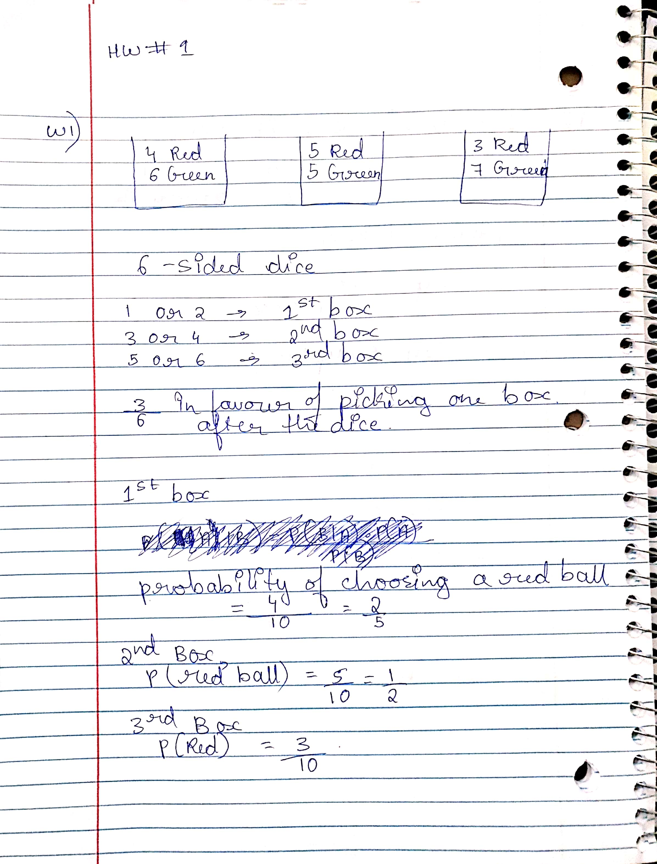

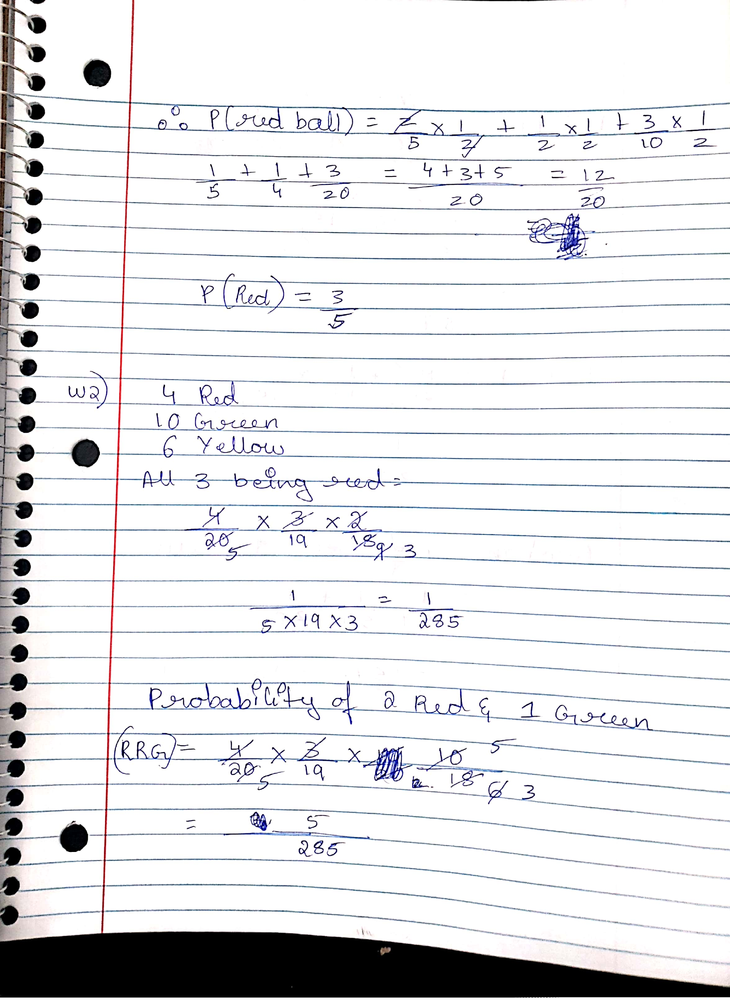

W2)



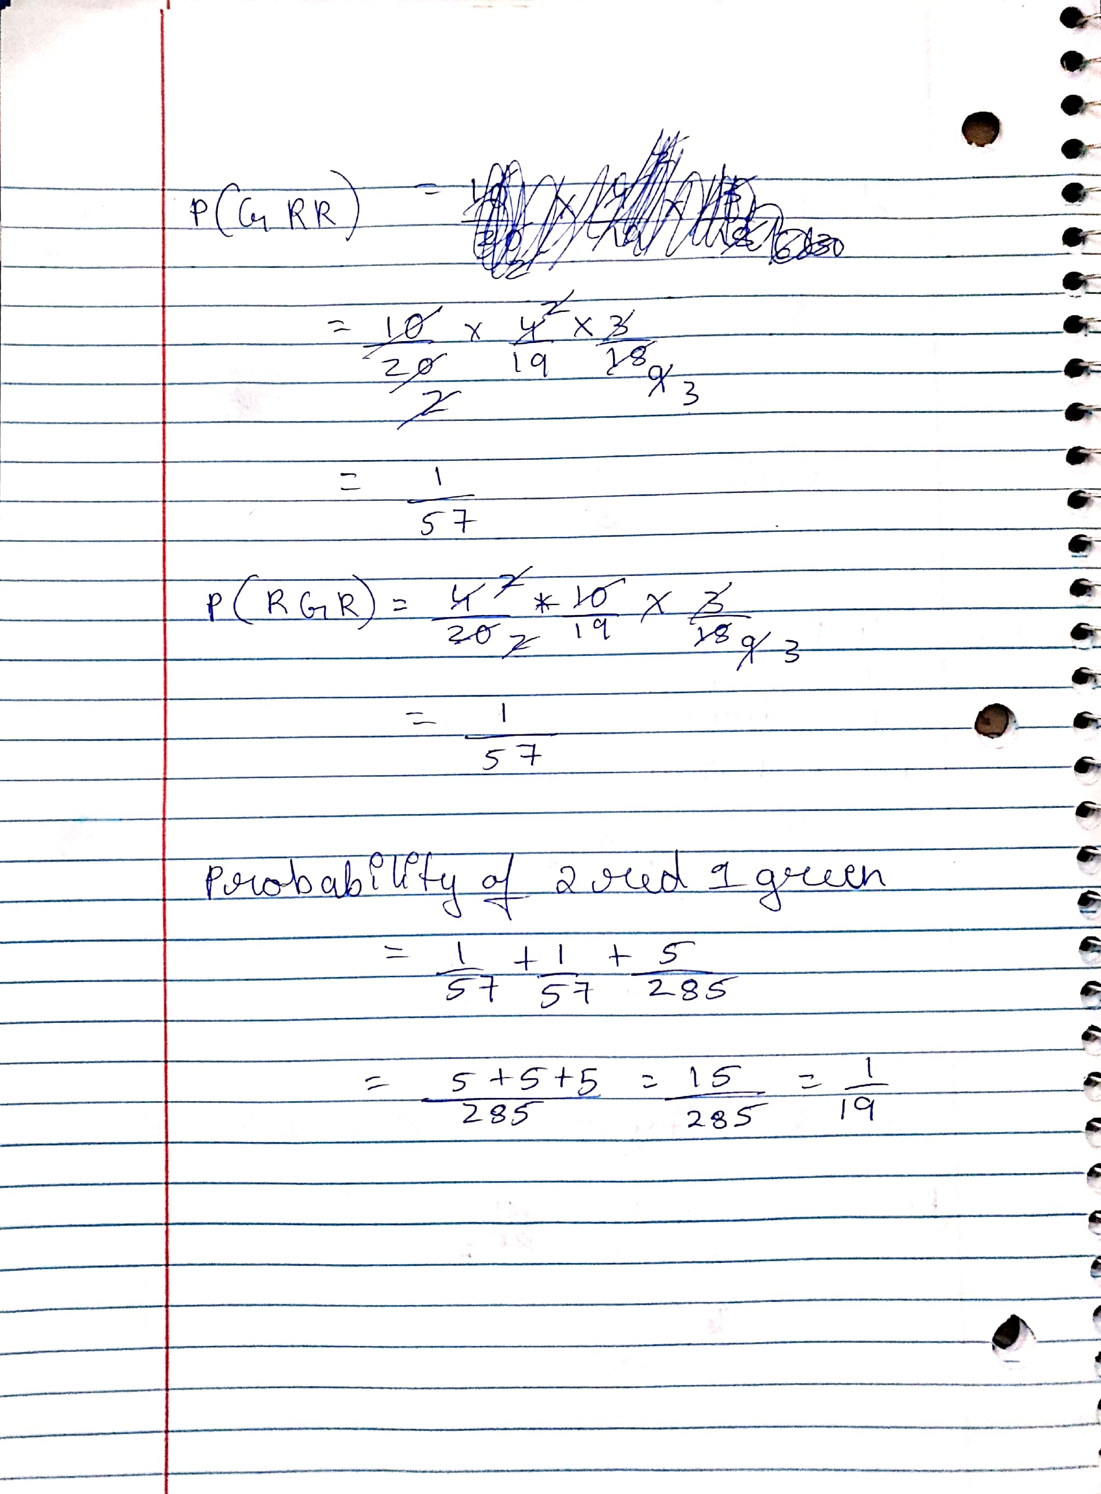

W3)

Programming Assignment

P1)

Output: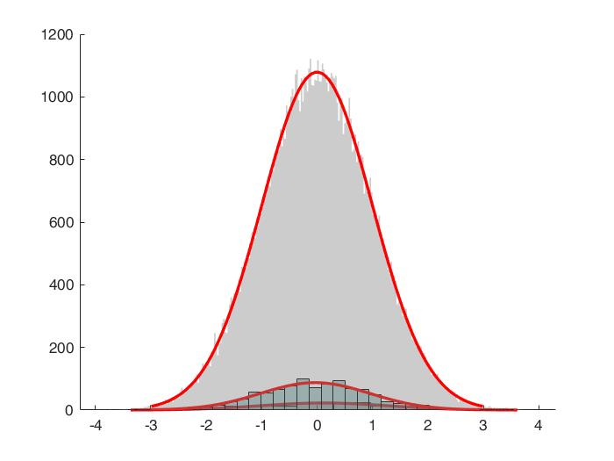

Code:

rng(0,'twister');

stddev = 1;

mean = 0;

set1 = stddev.*randn(100,1) + mean;

set2 = stddev.*randn(1000,1) + mean;

set3 = stddev.*randn(100000,1) + mean;

hold on;

h1=histfit(set1);

set(h1(1),'facecolor',[0.5,0.2,0.2]);

set(h1(1),'FaceAlpha',0.3);

%set(h1(2),'LegendInformation','IconDisplayStyle','off');

%legend('Sample set');

%hold on

h2=histfit(set2);

set(h2(1),'facecolor',[0.2,0.5,0.5]);

set(h2(1),'FaceAlpha',0.4);

%hold off

%hold on

h3=histfit(set3);

set(h3(1),'facecolor',[0.5,0.5,0.5]);

set(h3(1),'FaceAlpha',0.4);

hold off

P2)

Output:

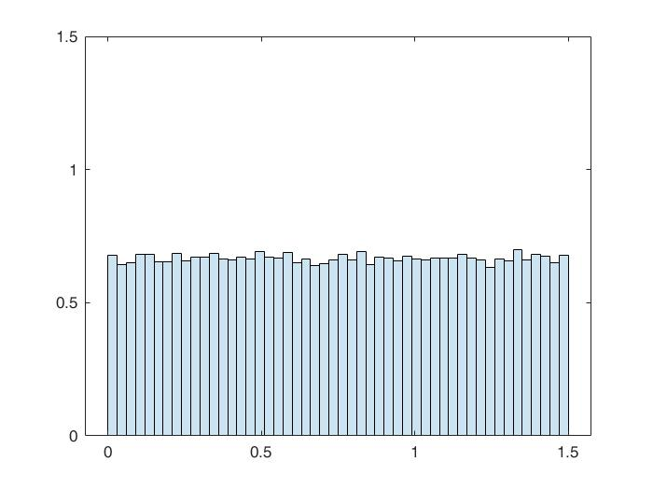

Code:

rng('default')

stddev = 1.5;

mean = 0;

%set1 = stddev.*unifrnd(100,1) + mean;

%set2 = stddev.*unifrnd(1000,1) + mean;

%set3 = stddev.*unifrnd(100000,1) + mean;

set1 = stddev.*rand(100,1) + mean;

set2 = stddev.*rand(1000,1) + mean;

set3 = stddev.*rand(100000,1) + mean;

%set4=unifrnd(0,1000);

%hold on;

h1=histfit(set1);

set(h1(1),'facecolor',[0.5,0.2,0.2]);

set(h1(1),'FaceAlpha',0.3);

%set(h1(2),'LegendInformation','IconDisplayStyle','off');

%legend('Sample set');

hold on

h2=histfit(set2);

set(h2(1),'facecolor',[0.2,0.5,0.5]);

set(h2(1),'FaceAlpha',0.4);

%hold off

%hold on

h3=histfit(set3);

set(h3(1),'facecolor',[0.5,0.5,0.5]);

set(h3(1),'FaceAlpha',0.4);

hold off

h = histogram(set3,'Normalization','pdf');

set(h(1),'FaceAlpha',0.2);

grid = linspace(min(set3),max(set3));

line(0.67,grid,'color','r')

P3)

Output: Please zoom in histfit is used

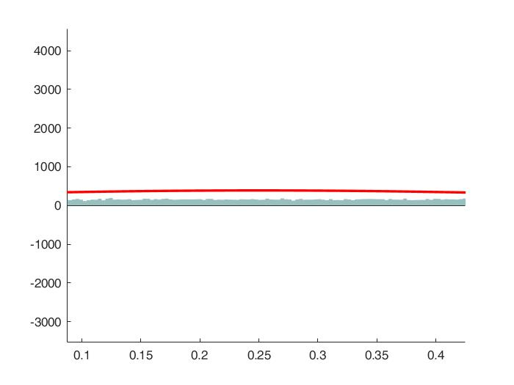

Code:

rng(0,'twister');

a = -2;

b = 2;

r = (b-a).*rand(100000,1) + a;

p = (b-a).*rand(100000,1) + a;

%r_range = [min(-2) max(2)];

hold on;

for i = 1:length(r)

    if (r(i) >= -1) && (r(i) <= 1)

        r(i)=abs(r(i));

        fprintf('Inside if ');

    else

        fprintf('0?');

        r(i)=0;

    end

end

%java.lang.Thread.sleep(duration*10000);

h2=histfit(r(2:length(r)));

set(h2(1),'facecolor',[0.2,0.5,0.5]);

set(h2(1),'FaceAlpha',0.5);

%%h = histogram(r);

%hs=histogram(r);

%set(hs(1),'FaceAlpha',0.5);

hold off;

P4)

Output:

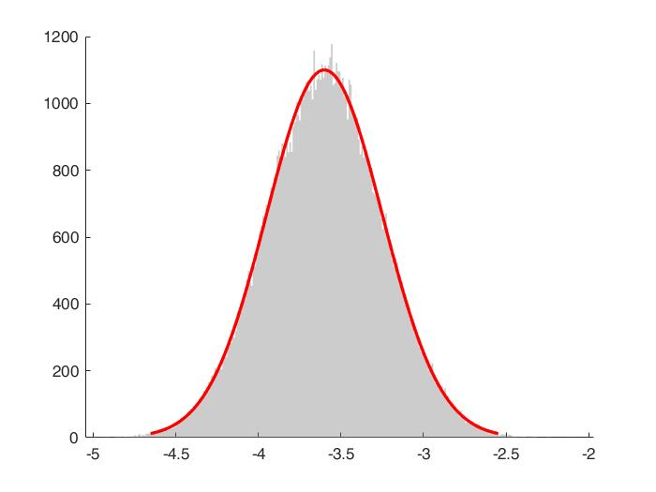

Code:

rng(0,'twister');

stddev = 1;

mean = 0;

set1 = stddev.*randn(100000,1) + mean;

stddev = 0.5;

mean = 2;

set2 = stddev.*randn(100000,1) + mean;

set3=rand(100000,1);

p=[0.3 0.7];

%for i = 1:2

    for j = 1:length(set1)

        set1(j)=min(-5,max(5,set1(j)));

        set1(j)=set1(j)*p(1);

    end

    for j = 1:length(set2)

        set1(j)=min(-5,max(5,set1(j)));

        set2(j)=set2(j)*p(2);

    end

%end

for j = 1:length(set2)

        set3(j)=set2(j)+set1(j);

end

hold on;

%h1=histfit(set1);

%set(h1(1),'facecolor',[0.5,0.2,0.2]);

%set(h1(1),'FaceAlpha',0.3);

%h2=histfit(set2);

%set(h2(1),'facecolor',[0.2,0.5,0.5]);

%set(h2(1),'FaceAlpha',0.4);

h3=histfit(set3);

set(h3(1),'facecolor',[0.5,0.5,0.5]);

set(h3(1),'FaceAlpha',0.4);

hold off

P5)

Output: The below histogram has both the sample sizes of X and Y plotted

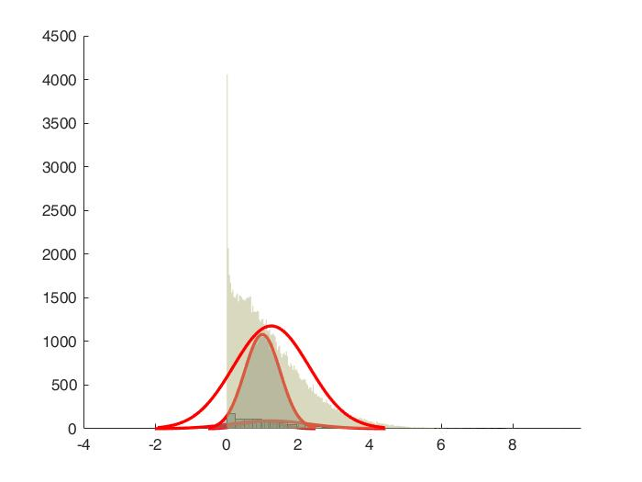

Output for sample size 1000 for both X and Y

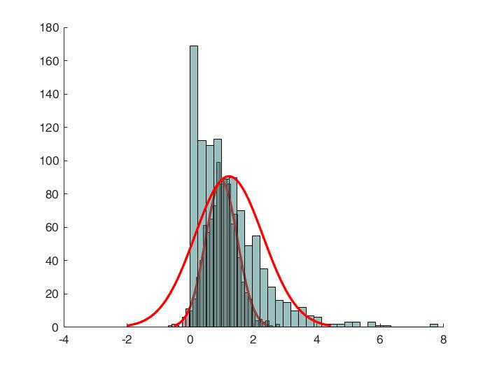

Output for sample size 100,000 for both X and Y

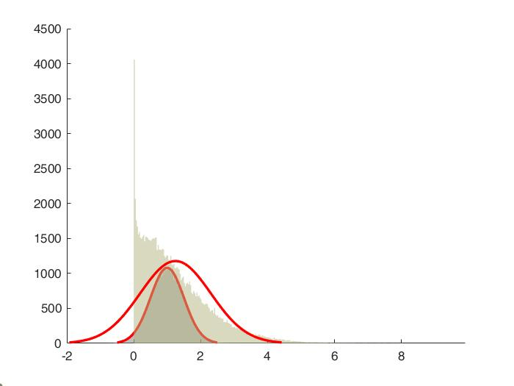

Code:

rng(0,'twister');

stddev = 0.5;

mean = 1;

set1 = stddev.*randn(1000,1) + mean;

set2 = stddev.*randn(100000,1) + mean;

yset1 = stddev.*randn(1000,1) + mean;

yset2 = stddev.*randn(100000,1) + mean;

   for j = 1:length(set1)

        %set1(j)=min(-3,max(3,set1(j)));

   end

   for j = 1:length(set2)

        %set2(j)=min(-3,max(3,set2(j)));

   end

    yset1 = set1.^2;

    yset2 = set2.^2;

   %yset1 = yset1.*randn(1000,1) + mean;

   %for j = 1:length(set1)

   %     yset1(j)=set1(j)*set1(j);

   %end

   %for j = 1:length(set2)

    %    set2(j)=min(-3,max(3,set2(j)));

   %end

hold on;

h1=histfit(set1);

set(h1(1),'facecolor',[0.5,0.2,0.2]);

set(h1(1),'FaceAlpha',0.5);

h2=histfit(yset1);

set(h2(1),'facecolor',[0.2,0.5,0.5]);

set(h2(1),'FaceAlpha',0.5);

h3=histfit(set2);

set(h3(1),'facecolor',[0.5,0.5,0.5]);

set(h3(1),'FaceAlpha',0.5);

h4=histfit(yset2);

set(h4(1),'facecolor',[0.7,0.7,0.5]);

set(h4(1),'FaceAlpha',0.5);

hold off