12_1



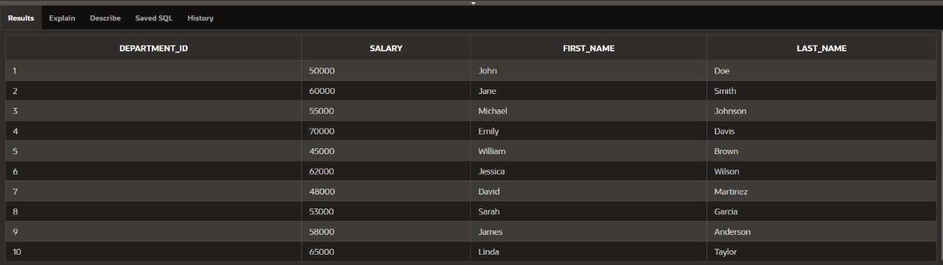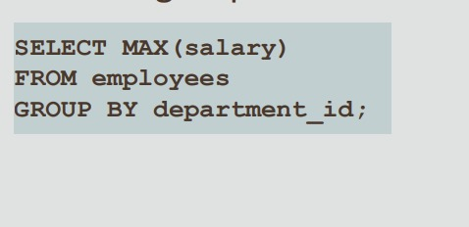

Dp 12_2

UPDATE copy_employees

SET phone_number = '123456'

WHERE employee_id = 3;

SELECT *FROM COPY_EMPLOYEZ

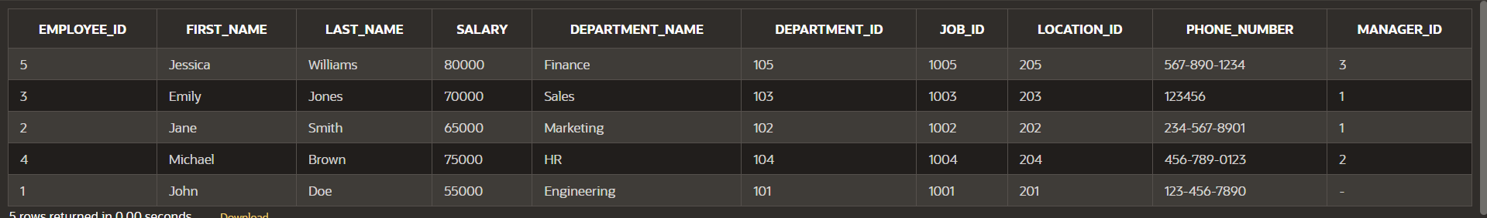

UPDATE copy_employeZ

SET phone_number = '654321',

WHERE last_name = 'Jones'

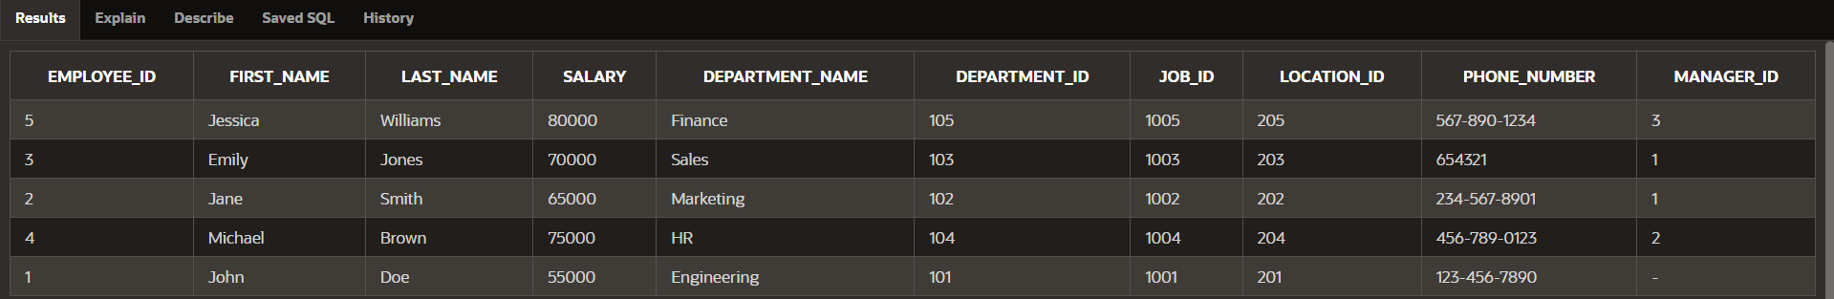

UPDATE copy_employeZ

SET salary = (SELECT salary

FROM copy_employeZ

WHERE employee_id = 1)

WHERE employee_id = 2;

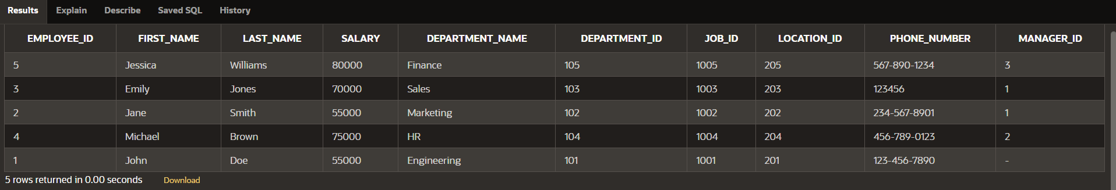

UPDATE copy_employeZ

SET salary = (SELECT salary

FROM copy_employeZ

WHERE employee_id = 4),

job_id = (SELECT job_id

FROM copy_employeZ

WHERE employee_id = 2)

WHERE employee_id = 3;

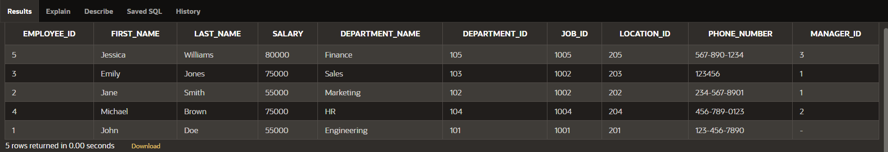

DELETE from copy_employeZ

WHERE employee_id = 3;

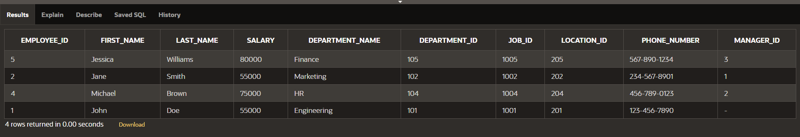

MERGE INTO copy_emp c USING employees e

ON (c.employee_id = e.employee_id)

WHEN MATCHED THEN UPDATE

SET

c.last_name = e.last_name,

c.department_id = e.department_id

WHEN NOT MATCHED THEN INSERT

VALUES (e.employee_id, e.last_name, e.department_id);

12_3

INSERT INTO my_employees

(hire_date, first_name, last_name)

VALUES

(DEFAULT, 'Angelina', 'Wright');

INSERT INTO my_employees

(first_name, last_name)

VALUES

('Angelina', 'Wright');

UPDATE my_employees

SET hire_date = DEFAULT

WHERE last_name = 'Wright';

