TEST-7

JAVA PROGRAMMING-CSA0961

SET-B

07-08-2024

3)Design a class Product with properties productId, name, and price. Extend this class with

subclasses Electronics and Clothing. Implement methods to calculate discounts based on

membership status for electronics and seasonal sales for clothing.

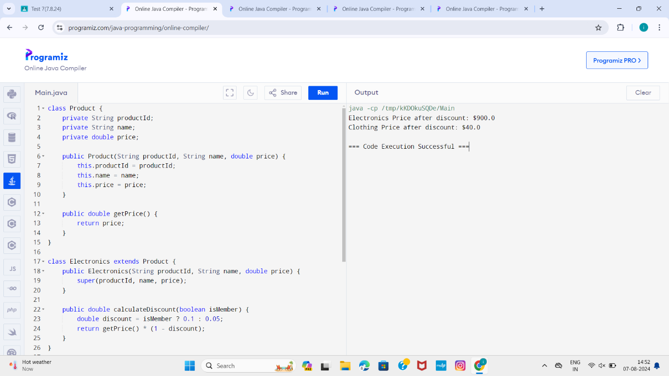

2)Create a base class GameCharacter with properties name, health, and level. Extend this

class with subclasses Warrior, Mage, and Archer. Implement methods such as attack()

and defend() differently for each subclass, showcasing polymorphism through

inheritance.

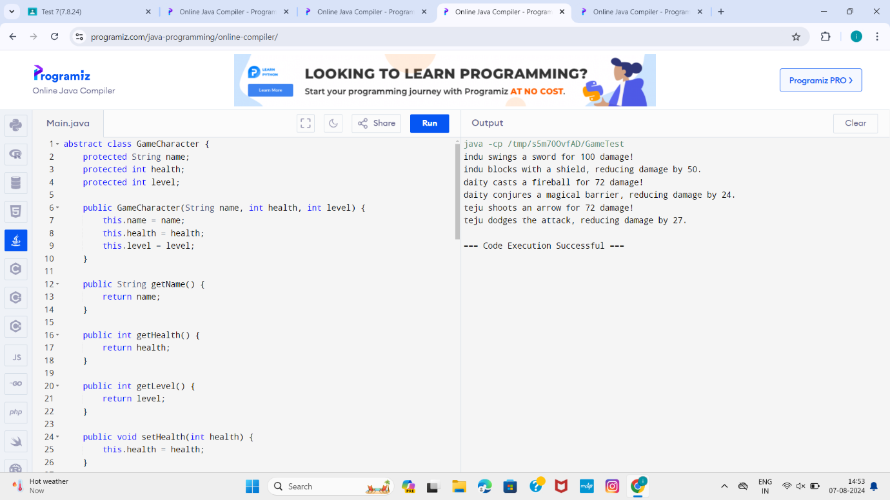

1)Design a class BankAccount with properties accountNumber and balance, and methods

deposit() and withdraw(). Extend this class with subclasses SavingsAccount and

CheckingAccount. Implement specific rules such as minimum balance requirements and

interest calculation for savings accounts.

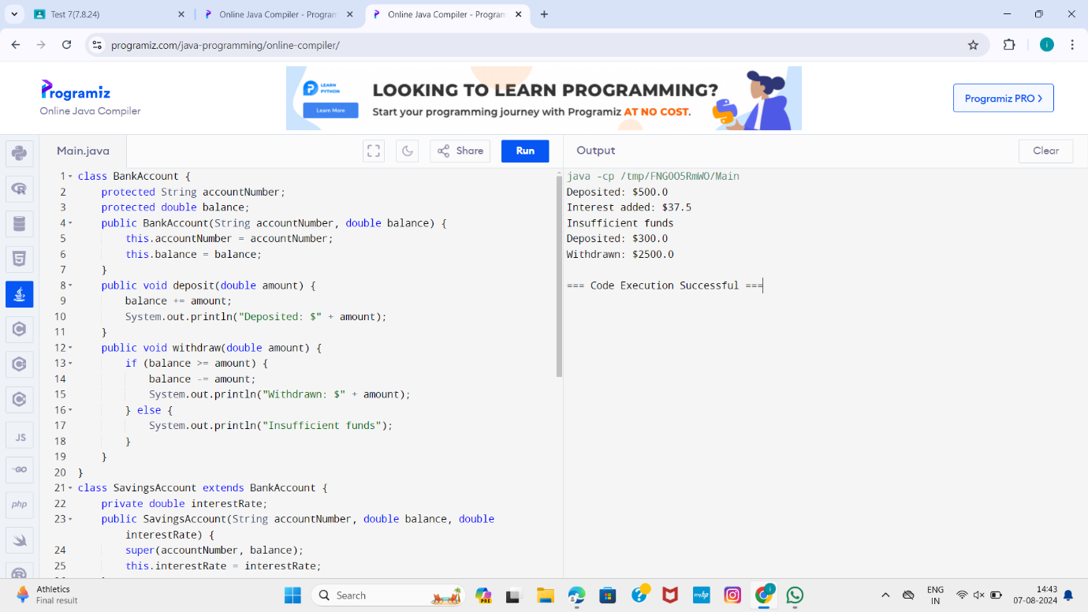

4)Design a class LibraryItem with properties title, author, and year. Extend this class with

subclasses Book and DVD. Implement methods for checking in and out items, and

display detailed information for each item type.

