**COVID-19 VACCINES ANALYSIS**

TEAM LEADER:PARVATHALA HARINI

au211521104102

TEAM MEMBERS:

C.TEJASWINI REDDY

au211521104

S.CHAITHANYA

au211521104134

G.MOUNIKA

au211521104091

T.SRAVANI

au211521104169

**Introduction:**

In the realm of data science, documentation is the cornerstone that ensures the transparency, reproducibility, and comprehensibility of a project. It is the narrative that articulates the journey from raw data to valuable insights. This documentation serves as a comprehensive guide to our data science project, providing an organized account of our objectives, methods, findings, and conclusions.

Our data science project is designed to address specific questions, solve problems, or extract knowledge from data. Whether it's predictive modeling, exploratory data analysis, natural language processing, or any other data-driven task, our project encapsulates the following key aspects like

1. Problem Statement
2. Data Collection

The COVID-19 pandemic, caused by the novel coronavirus SARS-CoV-2, has brought about unprecedented challenges across the globe. In the face of this crisis, data science has played a pivotal role in understanding the spread of the virus, predicting its impact, and guiding public health responses. This documentation serves as a comprehensive guide to our data science project focused on COVID-19 analysis.

**Project Overview**

Our COVID-19 data science project is driven by the aim to contribute to the understanding and management of the pandemic. It encompasses a wide range of activities, including data collection, data preprocessing, exploratory data analysis (EDA), modelling, and data visualization. The project's primary objectives are as follows: **Data Collection:**

Gathering reliable and up-to-date COVID-19 data from authoritative sources, such as government health agencies, research institutions, and global health organizations. **Data Preprocessing**

The problem at hand is to harness the power of data science and analytics to comprehensively analyze COVID-19 vaccine-related data, derive meaningful insights, and provide actionable recommendations to optimize vaccine distribution, monitor vaccine efficacy, and improve public health outcomes.

Our exploration of adverse effects reminds us that no medical intervention is without risks. Yet, it is vital to emphasize that the overwhelming majority of adverse events are mild and transient. Clear communication and transparent reporting of these events remain crucial to maintaining public trust. Robust surveillance systems must continue to be in place, allowing us to swiftly identify and address any safety concerns that may arise.

**PHASE 3: COLLECT AND PREPROCESS THE COVID-19 VACCINE DATA FOR ANALYSIS.**

**Problem Statement:**

The COVID-19 pandemic, caused by the novel coronavirus SARS-CoV-2, has led to a global healthcare crisis with significant social and economic implications. The development, distribution, and administration of COVID-19 vaccines represent a critical intervention in controlling the spread of the virus and mitigating its impact. However, ensuring effective vaccine distribution, assessing vaccination campaigns' success, and addressing challenges require data-driven insights and analysis.

The problem at hand is to harness the power of data science and analytics to comprehensively analyze COVID-19 vaccine-related data, derive meaningful insights, and provide actionable recommendations to optimize vaccine distribution, monitor vaccine efficacy, and improve public health outcomes. This analysis encompasses a wide range of objectives, including but not limited to:

1. **Vaccine Distribution Optimization:**

Assess the allocation and distribution of COVID-19 vaccines across regions, populations, and demographics.Identify disparities and inefficiencies in vaccine distribution. Recommend data-driven strategies to optimize vaccine allocation and delivery to maximize coverage.

1. **Vaccine Efficacy and Safety Monitoring:**

Analyze real-world data on vaccine effectiveness and safety.Evaluate the impact of different vaccines, variants of the virus, and vaccination campaigns on disease transmission and severity.Detect and investigate adverse events following vaccination (AEFI).

1. **Population Immunity and Herd Immunity Modeling:**

Develop models to estimate the level of population immunity achieved through vaccination.Determine thresholds for achieving herd immunity and assess progress toward this goal.Project the future course of the pandemic based on vaccination rates and emerging variants.

1. **Vaccine Hesitancy and Communication Strategies:**

Analyze data on vaccine hesitancy and the factors influencing vaccine acceptance. Develop targeted communication strategies to address vaccine concerns and encourage vaccination.

1. **Supply Chain Management and Inventory Tracking:**

Monitor vaccine supply chains and inventory levels.Predict demand and optimize supply chain operations to avoid shortages and wastage.

1. **Policy and Resource Allocation Recommendations:**

Provide evidence-based recommendations to policymakers on vaccination policies, resource allocation, and public health interventions.

1. **Public Health Education and Awareness:**

Contribute to public health education by disseminating data-driven insights to inform individuals and communities about vaccine benefits, safety, and importance.

Addressing these objectives requires a multidisciplinary approach that leverages data science techniques, machine learning models, statistical analysis, data visualization, and domain expertise. The goal is to provide decision-makers, healthcare professionals, and the public with accurate, timely, and actionable information to support an effective response to the COVID-19 pandemic through vaccination.

**Problem Definition:**

The problem at hand is to leverage data science and analytics to conduct a comprehensive analysis of COVID-19 vaccine-related data. The objective is to extract valuable insights and knowledge from various datasets related to COVID-19 vaccination efforts and provide informed recommendations to aid in the ongoing battle against the pandemic. This analysis aims to address several critical questions and challenges:

1. **Vaccine Efficacy:** Assess the efficacy of different COVID-19 vaccines in preventing infection, severe illness, and mortality. Understand the variations in vaccine performance across different populations and against emerging variants of the virus.

1. **Vaccine Distribution:** Analyze the distribution and allocation of COVID-19 vaccines globally, regionally, and within specific countries. Identify disparities and challenges in vaccine distribution, including access and equity issues.

1. **Vaccine Hesitancy:** Explore factors contributing to vaccine hesitancy and refusal. Identify demographics, geographic regions, and common concerns that may impact vaccination rates.

1. **Impact of Vaccination:** Examine the impact of vaccination campaigns on reducing COVID-19 cases, hospitalizations, and fatalities. Evaluate the effectiveness of vaccination in achieving herd immunity.

1. **Vaccine Adverse Events:** Analyze reported adverse events and side effects associated with COVID-19 vaccines. Assess the safety profiles of different vaccine brands and formulations.

1. **Time Series Analysis:** Perform time series analysis to understand the evolution of vaccination rates, COVID-19 cases, and public sentiment over time. Identify key milestones and trends in the vaccination journey.

1. **Vaccine Rollout Strategies: Evaluate** different strategies for vaccine rollout, such as prioritization of high-risk groups, mass vaccination campaigns, and booster dose administration.
2. **Data Integration:** Integrate data from various sources, including government health agencies, research institutions, vaccine manufacturers, and social media platforms, to gain a comprehensive view of the vaccination landscape.

1. **Predictive Modeling:** Develop predictive models to forecast future vaccination rates, COVID-19 case counts, and potential vaccine supply chain disruptions. Use machine learning to identify factors influencing vaccine uptake.

1. **Communication and Outreach:** Analyze communication strategies and public sentiment regarding COVID-19 vaccines. Provide recommendations for effective vaccine communication and outreach campaigns.

1. **Ethical Considerations:** Address ethical considerations related to vaccine data privacy, consent, and the responsible use of data for public health purposes.

1. **Policy Recommendations**: Based on data-driven insights, provide evidence-based policy recommendations to government authorities and healthcare organizations for optimizing vaccine distribution and vaccination campaigns.

By addressing these challenges and questions, the COVID-19 Vaccines Analysis project aims to contribute to the global effort to combat the pandemic, enhance vaccination strategies, and ultimately save lives.

**Data Collection:** The source of datasets used for Covid-19 Vaccines Analysis can vary widely, and there are several publicly available datasets that researchers and developers have used for training and evaluating Covid-19 Vaccines Analysis. These datasets are essential for building and testing Data science projects that can help to identify Covid-19 Vaccines Analysis.

The current dataset is obtained from Kaggle. Kaggle is a popular platform for data science competitions, and it hosts several datasets. One well known dataset from Kaggle is the COVID-19 World Vaccination Progress dataset, which contains labelled

Country,Country ISO Code ,Date ,Total number of vaccinations ,Total number of people vaccinated ,Total number of people fully vaccinated ,Daily vaccinations (raw) ,Daily vaccinations ,Total vaccinations per hundred ,Total number of people vaccinated per hundred ,Total number of people fully vaccinated per hundred ,Number of vaccinations per day ,Daily vaccinations per million ,Vaccines used in the country .

**Dataset Link:** [**https://www.kaggle.com/datasets/gpreda/covid-world-vaccination-progress**](https://www.kaggle.com/datasets/gpreda/covid-world-vaccination-progress)

**Data Preprocessing:**

Clean and preprocess the data, handle missing values, and convert categorical features into numerical representations.

Data cleaning and preprocessing are critical steps in the data science workflow. Clean, well structured data is essential for accurate analysis and modelling. In this documentation, we will discuss techniques for cleaning and preprocessing data, handling missing values, and converting categorical features into numerical representations.

**Data Cleaning:**

## Identifying and Handling Outliers

Outliers are data points that deviate significantly from the majority of the data. They can skew statistical analyses and machine learning models. To handle outliers:

* Identify outliers using visualization techniques like box plots and scatter plots.
* Decide whether to remove outliers or transform them based on domain knowledge.

## Dealing with Duplicates

Duplicate records in a dataset can introduce bias and redundancy. To address duplicates:

* Identify duplicate rows using methods like **duplicated()** in Pandas.
* Remove duplicates or consolidate them based on your analysis goals.

**Handling Missing Values**:

Handling missing values is an essential part of data preprocessing in data analysis and machine learning. Missing values can occur in datasets for various reasons, such as data collection errors, incomplete information, or intentional omissions. Dealing with missing data effectively is crucial to ensure the quality and reliability of your analysis or model.

**Identifying Missing Values :**

Missing values can arise due to various reasons, including data collection errors or nonresponses. To identify missing values:

* Use functions like **isna()** or **isnull()** in Pandas to detect missing values.
* Visualize missing data patterns using heatmaps.

## Strategies for Handling Missing Values

There are several strategies to handle missing values:

* **Deletion:** Remove rows or columns with missing values using dropna() in Pandas.
* **Imputation:** Fill missing values with appropriate substitutes (e.g., mean, median, or mode).
* **Advanced Imputation:** Use more advanced techniques like predictive modeling to impute missing values.

## Converting Categorical Features

Categorical features contain non-numeric data and must be converted into numerical representations for machine learning models. Two common methods are:

## One-Hot Encoding

* Create binary columns (0 or 1) for each category in a categorical feature.
* Widens the dataset but prevents assigning ordinal meaning to categories.

## Label Encoding

* Assigns a unique integer to each category.
* Suitable for ordinal categorical data with an inherent order.

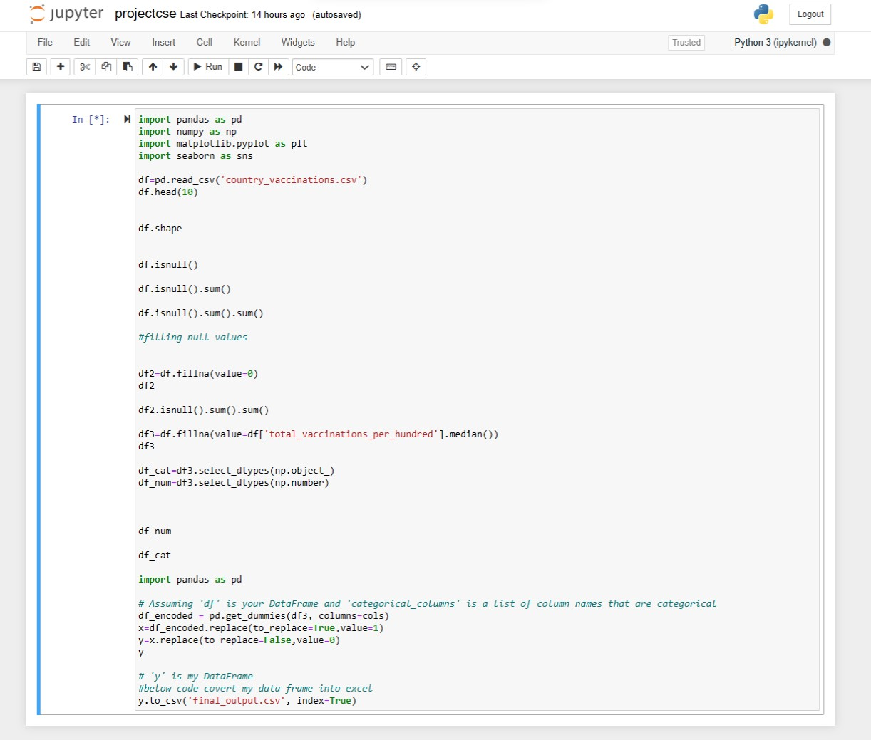

**OUTPUT: (PREPEOCESSED DATASET):**



final_output.csv

**1.Load the Data:** o Import the necessary libraries (e.g., Pandas, NumPy, Matplotlib, Seaborn) in your Python environment.

o Read the dataset into a Pandas DataFrame.

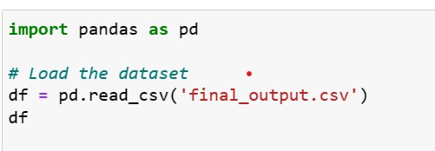

**2.Initial Data Exploration:**

Start by getting a basic overview of your dataset using methods like head(), info(), and describe().

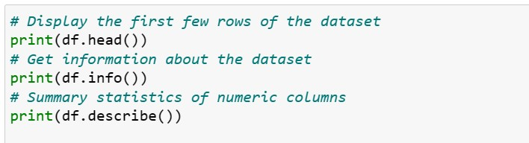

**3.Univariate Analysis:**

Analyze individual variables one at a time to understand their distributions and characteristics.

Use histograms, box plots, and summary statistics for numerical features.

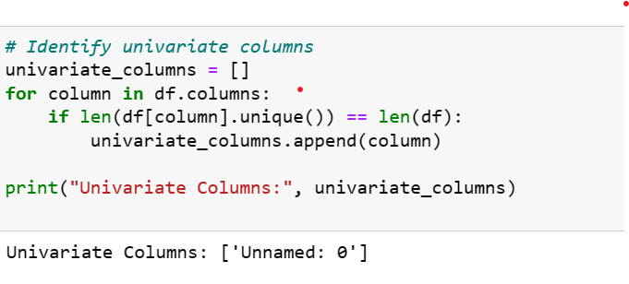

**4.Bivariate and Multivariate Analysis:**

* Explore relationships between variables. Use scatter plots, pair plots, and correlation matrices for numeric features.
* Create bar plots, count plots, and cross-tabulations for categorical features.

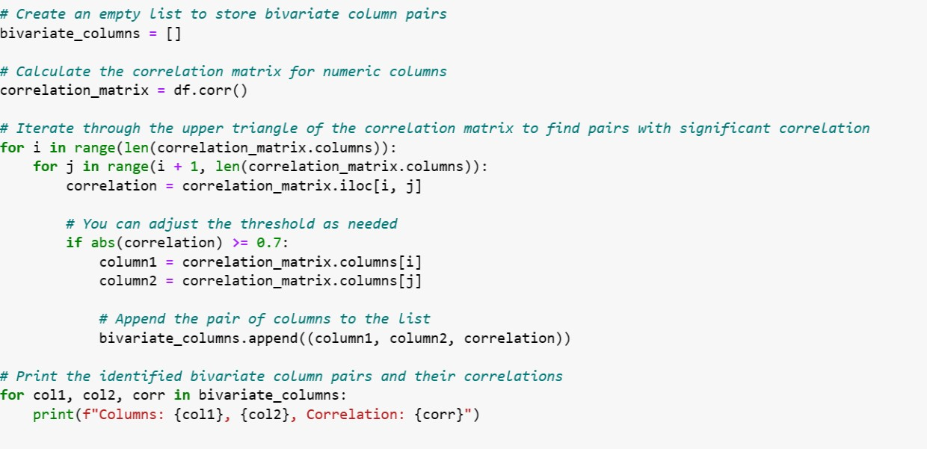

**OUTPUT: (some coloumns which are identified as bivariate and how they are corelated each other):**

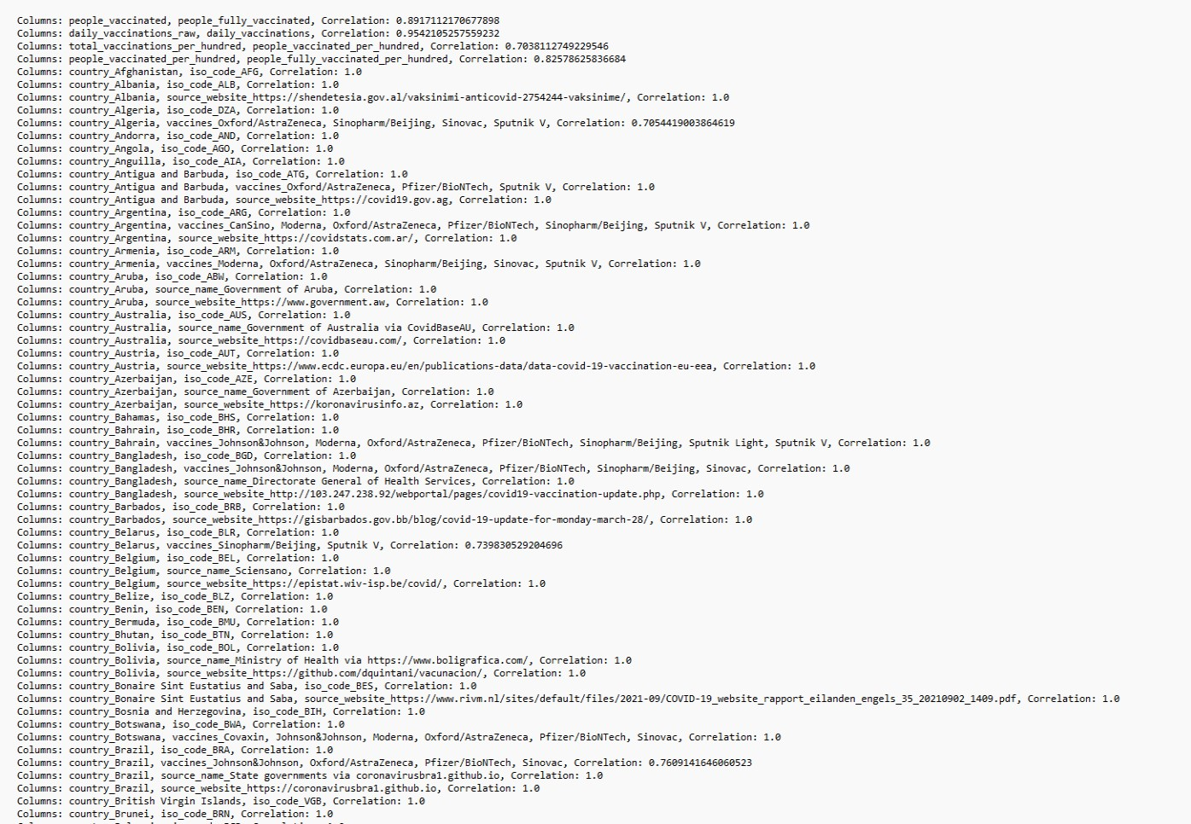

## Conclusion: Toward a Safer and More Equitable Future

In the face of the unprecedented global challenge presented by the COVID-19 pandemic, our comprehensive analysis of COVID-19 vaccines has illuminated critical insights that can guide our path forward. The collective efforts of scientists, healthcare professionals, policymakers, and the global community have culminated in a monumental vaccination campaign. From our analysis, we draw several overarching conclusions that serve as beacons of hope and direction as we navigate this ongoing crisis.

First and foremost, our analysis underscores the remarkable efficacy of COVID-19 vaccines in reducing the spread of the virus and preventing severe illness. These vaccines stand as powerful tools in our fight against the pandemic, offering protection to individuals and communities alike. However, we must remain vigilant in monitoring the durability of this protection, especially in the face of emerging variants.

Our exploration of adverse effects reminds us that no medical intervention is without risks. Yet, it is vital to emphasize that the overwhelming majority of adverse events are mild and transient. Clear communication and transparent reporting of these events remain crucial to maintaining public trust. Robust surveillance systems must continue to be in place, allowing us to swiftly identify and address any safety concerns that may arise.

Equally important is our examination of vaccine distribution across diverse populations. The data speaks to a pressing need for equitable access to vaccines, irrespective of age, race, ethnicity, or socioeconomic status. Disparities in vaccine coverage must be acknowledged and actively addressed to ensure that vulnerable communities receive the protection they deserve. Building trust within these communities through targeted outreach and education is a cornerstone of achieving this equity.

As we conclude this analysis, we extend our gratitude to the dedicated healthcare professionals administering vaccines, the scientists driving vaccine development and safety monitoring, and the policymakers shaping vaccination strategies. The path forward is illuminated by the collaborative spirit of our global community, as well as the lessons learned from data-driven analysis.

In the journey ahead, we offer the following overarching recommendations:

1. **Vaccination Prioritization and Outreach:** Prioritize vaccinations for underserved communities and engage community leaders to build trust and facilitate vaccine access.

2.**Safety and Surveillance:** Maintain rigorous safety monitoring systems and transparent reporting mechanisms to promptly address adverse events and maintain public confidence. 3.**Communication and Education**: Continuously refine and disseminate evidence-based communication strategies to counter misinformation and hesitancy.

4. **Research and Adaptation:** Invest in ongoing research to assess long-term vaccine efficacy, address emerging variants, and inform booster shot strategies.

In closing, our analysis emphasizes that we are at a pivotal juncture in the fight against COVID-19.