

**Department of Bachelor of Computer Application**

**(BCA)**

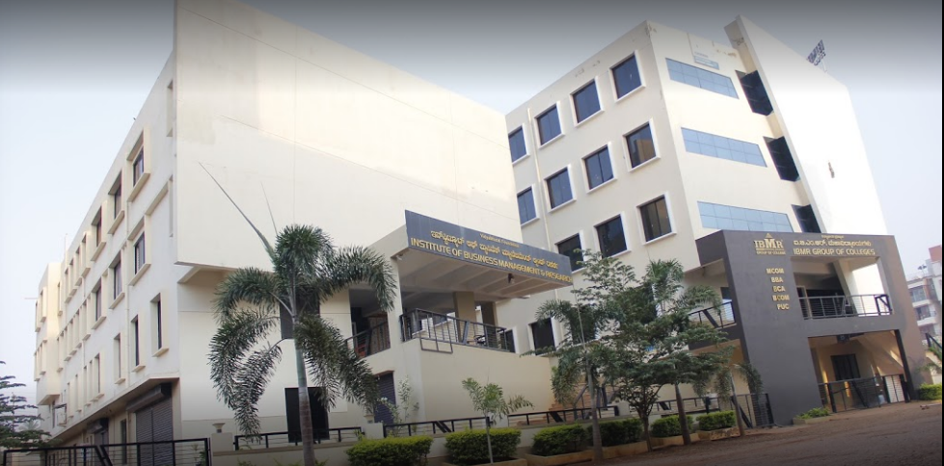

**Project Synopsis**

**Of**

[ Track my bus]

**Submitted by**

**[ Tejaswini Kumbar]**

**[ U02CH22S0140]**

**BCA VI SEMESTER-2025**

**Abstract :**

**In today’s rapidly evolving digital world, the integration of technology into daily transportation systems has become essential. However, many educational institutions, especially colleges operating their own transport services, still rely on outdated communication methods and manual scheduling, which often leads to confusion, delays, and inefficiencies. This project, titled "Track My Bus," presents a practical and low-cost solution that simulates real-time bus tracking using PHP, Bootstrap, and MySQL, designed specifically for student users and administrative management.**

**Although the system does not utilize GPS or real-time sensors, it provides a manually controlled update mechanism that mimics the appearance and functionality of live bus tracking. Bus stop data is pre-defined and updated in real time by administrators or drivers through an intuitive web interface. The system architecture includes user modules for students, admin control panels for managing buses and routes, and a display module that reflects the current status of each bus on the route. Despite its manual nature, the system offers an interactive and responsive user interface that provides users with a realistic experience of real-time updates. The platform aims to help students and staff track college buses conveniently, preventing long waits and missed rides.**

**Objectives:**

* **To develop a user-friendly interface for viewing bus tracking information.**
* **To simulate real-time bus location updates through manual inputs.**
* **To provide reliable information about bus arrival and departure times.**
* **To reduce uncertainty and wait times for college bus commuters.**
* **To build a responsive and interactive web application using Bootstrap for better UX/UI.**
* **To manage bus data efficiently using MySQL for backend operations.**

**Hardware Requirements:**

* **Personal Computer or Laptop (minimum 2 GHz processor)**
* **Minimum 2 GB RAM**
* **Minimum 200 MB of free disk space**
* **Display with 1024x768 resolution or higher**
* **Internet connectivity for web access (optional for localhost development)**

**Software Requirements:**

* **Operating System: Windows 7/10/11 or Linux**
* **Web Server: Apache (XAMPP)**
* **Backend Language: PHP 7.4 or above**
* **Database: MySQL 5.7 or above**
* **Frontend: HTML, CSS, Bootstrap 5**
* **Browser: Chrome, Firefox, Edge (latest versions)**
* **Code Editor: VS Code, Sublime Text, or any IDE**

**supporting PHP and HTML**

**Limitations:**

* **No real-time GPS integration; updates depend on manual input.**
* **Limited scalability as the system is not automated.**
* **Prone to human error due to manual data entry.**
* **Real-time accuracy is based on the timeliness of data updates.**
* **Not suitable for large transport networks without significant modifications.**

**Scope of Future Application:**

* **GPS Integration: Incorporating GPS modules for true real-time tracking.**
* **Mobile App Development: Creating Android/iOS apps for easier access.**
* **SMS/Email Notifications: Informing users of arrival times or delays.**
* **Admin Automation: Reducing or eliminating manual data input.**
* **Expanded Use: Deployment in schools, companies, and city transport systems.**
* **Analytics Dashboard: Visualizing bus performance and user behavior.**

**Overview:**

**The "Track My Bus" project is a simplified yet effective solution aimed at providing simulated real-time bus tracking functionality using manual updates. Designed for use in educational institutions, the system allows students and staff to view the current position of their assigned buses through a responsive web interface. Unlike GPS-based systems that rely on hardware and mobile data, this project offers a manually controlled mechanism that can be updated by an administrator.**

**This manual mechanism reduces cost and complexity while maintaining the core functionality users expect—bus visibility and status updates. The interface is built using Bootstrap, ensuring that it works well on both desktop and mobile devices. Users simply select their bus from a list, and the latest position is shown on the screen. This helps students reduce waiting times, plan**

**departure from hostels or homes, and increase overall satisfaction with campus transport services.**

**The system also maintains a MySQL database of buses, their routes, and tracking history. This backend functionality ensures that data is stored, managed, and retrieved efficiently. Admins can log in to update statuses, track history, or modify route assignments.**

**In essence, "Track My Bus" is an excellent demonstration of how basic web technologies can be used creatively to simulate complex systems. It’s a scalable project that lays the foundation for future enhancements, including integration with GPS, SMS alert services, and mobile apps. The project showcases how software development, even without advanced hardware integration, can improve everyday services within academic institutions.**

**The modular structure of the system ensures ease of updates and scalability, allowing institutions to adapt it to their specific needs. With a user-friendly interface, secure admin panel, and responsive design, the system strikes a balance between simplicity and utility. It stands as a strong prototype for low-cost public transport tracking systems.**