Automatic Waste Segregation Mechanism Using Arduino Uno

R. Sittalatchoumy,
Department of Electronics and Communication Engineering
College of Engineering Guindy, Anna University
Chennai , India
sittalatchoumy@gmail.com

Tejaswini V.

Department of Electronics and Communication Engineering

College of Engineering Guindy, Anna University

Chennai , India
2023105540@student.annauniv.edu

Abstract— The efficient management of waste is increasingly important due to expanding urban populations and ongoing urbanization trends. Manual methods for waste separation pose health risks and lack efficiency. This work introduces a system for automatic segregation, categorizing waste as metallic, wet, or dry through sensor integration and microcontroller-based logic. Central to the design are a metallic content sensor and a moisture sensor, managed by an Arduino Uno. Waste is guided into specified bins with the help of a servo motor. Our aim is to streamline the sorting process, foster recycling initiatives, and reduce human effort involved.
Keywords— Waste segregation, Arduino Uno, metal detection sensor, moisture sensor, servo motor, automation, intelligent waste management

- INTRODUCTION
The acceleration of waste production caused by urban and industrial growth presents numerous challenges to responsible disposal. Inadequate methods for separating waste contribute to environmental issues and can adversely affect health. Conventional management depends mostly on manual sorting, which is only inefficient and also exposes individuals to health hazards. A robust and smart system is therefore required to ensure effective waste classification at the point of generation. The designed solution uses the Arduino Uno to manage the classification process, operating a metal sensor to find metallic items and a moisture sensor to divide organic matter into wet and dry categories. After analyzing sensor input, a servo motor aligns bins as needed, automating the entire sorting mechanism and thus minimizing the need for human intervention while boosting operational efficiency

LITERATURE REVIEW
Numerous smart waste sorting systems have been desi gned with a lot of sensing techniques. Some utilize infrared or ultrasonic sensors as given in [1], while others rely on image analysis algorithms for
Kannan S.A.
Department of Electronics and Communication Engineering College of Engineering Guindy , Anna University
Chennai , India
2023105538@student.annauniv.edu

Shyamsundar S
Department of Electronic and Communication Engineering College of Engineering, Guindy , Anna University
Chennai , India
2023105554@student.annauniv.edu

classification. Methods based on image processing tend to be resource-intensive and costly. By comparison, systems using simple sensors is more accessible and economical.

Research shows that detecting moisture content and metallic properties is sufficient for separating common municipal waste. Arduino-based assemblies have become popular thanks to their flexibility, open-source software, and straightforward connection with sensors and actuators

METHODOLOGY

Overview
The implemented system comprises the following hardware: Arduino Uno, metal detection module, moisture detection module, servo motor, a 9V battery, a breadboard with jumper leads, and a laptop for software deployment and monitoring.

Working Steps
1.Place waste onto the active detection zone.
2.The metallic sensor checks if the waste contains any metal.
3.If metallic waste is identified, the servo positions the chute towards the designated metallic bin.
4.If no metal is found, the moisture sensor then evaluates the sample's water content.
5.Samples with moisture above a set threshold are set as wet waste.
6.All other samples are counted as dry.
7.The servo motor then positions the output chute for the correct bin.
8.The system prepares itself for a subsequent sorting action.

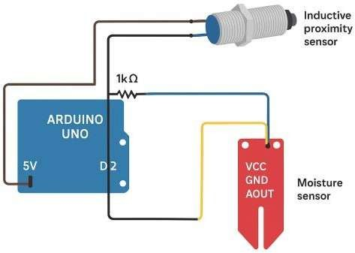
HARDWARE IMPLEMENTATION

- Arduino Uno: Functions as the primary controller, processing sensor readings and issuing commands to the motor units.
- Metal Detection Sensor: Recognizes metallic compounds by sensing variations in electromagnetic
fields.
- Moisture Sensor: Determines the level of water present in the sample.
- Servo Motor: Moves in response to control signals, aligning the sorting chute accordingly.

Power Supply: A 9V direct current battery supports the project circuit, interlinked via a breadboard

BLOCK DIAGRAM
Start

Waste == Metal?
Move the waste to the sensor region. First check with metal sensor

YES
Rotate the servo to 0°

Waste == wet/ organic? waste

NO

YES

Rotate the servo to 180°

Rotate servo to 90°

Set the servo to 90°

Figure 1 Circuit diagram
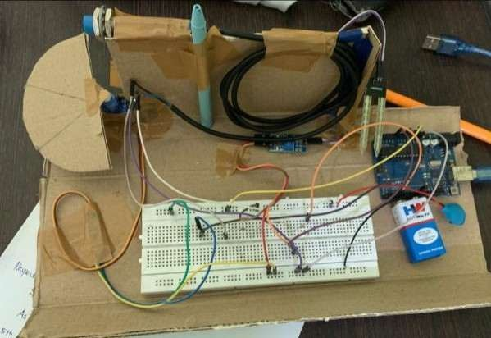
End

Figure 2 Real time Image
VI. SOFTWARE IMPLEMENTATION
NO

Programming for the system was completed using the Arduino IDE. Code reads values from all sensors, sets threshold points, and activates the servo motor when conditions are met. Real-time monitoring and troubleshooting are done through the serial interface.

CODE

#include <Servo.h> Servo servo;
int irPin = 2;//IRsensor pin
int metal_Pin = 3; // Metal sensor pin (NPN) int moisture_Pin = A0; // Moisture sensor pin int servo_Pin = 9; // Servo motor pin
int moistureThreshold = 600; // Threshold for wet/organic detection

void setup() {
servo.attach(servo_Pin);
pinMode(irPin, INPUT);
pinMode(metal_Pin, INPUT_PULLUP); // NPN metal sensor Serial.begin(9600);
servo.write(0); // Default position
}

void loop() {
int irValue = digitalRead(irPin);
int metalValue = digitalRead(metal_Pin); int moisture_Value = analogRead(moisture_Pin);

Serial.print(" Moisture Sensor: "); Serial.println(moisture_Value);
}
else if(moisture_Value < moistureThreshold){
// Wet/organic
Serial.println(">> WASTE TYPE: ORGANIC/WET"); servo.write(180); // Move servo to organic/wet bin
}
else { // Dry/non-metal
Serial.println(">> WASTE TYPE: DRY/NON- METAL");
servo.write(90); // Move servo to dry bin
}

delay(1500); // Allow servo to move servo.write(90); // Return to default delay(1500);

}

RESULTS AND DISCUSSION

During implementation, the prototype proved capable of correctly classifying various types of waste (metal, dry and wet). The metal sensor reliably detected metallic substances, while the moisture sensor differentiated the wet and dry samples. The servo motor successfully oriented itself to deposit each waste type into the proper bin according to input conditions. Even if the metal is wet, the servo rotates to metal bin because the system initially checks whether it’s metal waste.
VIII. ADVANTAGES

- The system lowers the risk of human exposure to hazardous materials.
- It Can be built and replicated with modest investment.
- The system Aligns well with environmental protection and recycling efforts.
- Convenient and compact design suitable for small-scale deployment.

LIMITATIONS

- The system is Restricted in handling only three waste types: metallic, wet, and dry waste.
- It is Unsuitable for processing larger amounts or mixed waste categories.
- Sensor calibration may require adjustment in environments with varying humidity levels

- FUTURE SCOPE

Possible upgrades include integrating computer vision with added machine learning feature, load sensors, or Internet-of-Things modules to further automate waste sorting and enable smart tracking capabilities

CONCLUSION

This report describes a simple, low-cost, and reliable automated system for sorting waste into metallic, wet, and dry bins based on sensor readings managed by Arduino Uno. The solution is intended to support better waste handling practices, encourage recycling, and streamline the management process

REFERENCE

- [1] A. Sharma, “Smart Waste Management System Using IoT,” International Journal of Engineering Research, 2021.
[2] R. Kumar & S. Gupta, “Automatic Waste Segregator Using Arduino,” IEEE International Conference, 2020.
[3] P. Singh et al., “Automation in Solid Waste Management Using Sensor-Based Segregation,” IJERT, 2022.F

