Implement A* search for 8 – puzzle
Using h(n) = number of tiles missplaced
OUTPUT:
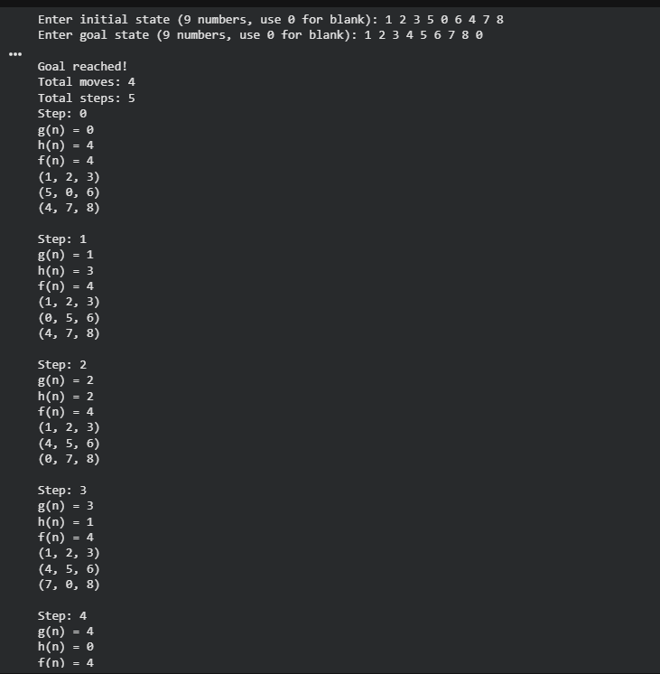
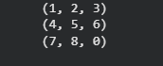

Using h(n) = Manhatten distance
