1. Round Robin CPU scheduling(Experiment with different quantum sizesfor RR algorithm)

#include <stdio.h>
struct Process
{
int pid;
int at;
int bt;
int rt;
int ct;
int tat;
int wt;
};
int main()
{
struct Process p[20];
int Q[100];
int n, TQ;
int time = 0;
int completed = 0;
int visited[20] = {0};
printf("Enter number of processes: ");
scanf("%d", &n);
for(int i = 0; i < n; i++)
{
printf("Enter AT and BT for P%d: ", i+1);
scanf("%d %d", &p[i].at, &p[i].bt);
p[i].pid = i + 1;
p[i].rt = p[i].bt;
}
printf("Enter Time Quantum: ");
scanf("%d", &TQ);
int ganttStart[200], ganttEnd[200], ganttPID[200];
int ganttIndex = 0;
while(completed < n)
{
for(int i = 0; i < n; i++)
{
if(p[i].at <= time && visited[i] == 0)
{
Q[rear++] = i;
visited[i] = 1;
}
}
if(front == rear)
{
time++;
continue;
}
int idx = Q[front++];
int startTime = time;
if(p[idx].rt > TQ)
{
time += TQ;
p[idx].rt -= TQ;
ganttStart[ganttIndex] = startTime;
ganttEnd[ganttIndex] = time;
ganttPID[ganttIndex] = p[idx].pid;
ganttIndex++;
for(int i = 0; i < n; i++)
{
if(p[i].at <= time && visited[i] == 0)
{
Q[rear++] = i;
visited[i] = 1;
}
}
Q[rear++] = idx;
}
else
{
time += p[idx].rt;
p[idx].rt = 0;
p[idx].ct = time;
completed++;
ganttStart[ganttIndex] = startTime;
ganttEnd[ganttIndex] = time;
ganttPID[ganttIndex] = p[idx].pid;
ganttIndex++;
for(int i = 0; i < n; i++)
{
if(p[i].at <= time && visited[i] == 0)
{
Q[rear++] = i;
visited[i] = 1;
}
}
}
}
float avg_tat = 0, avg_wt = 0;
for(int i = 0; i < n; i++)
{
p[i].tat = p[i].ct - p[i].at;
p[i].wt = p[i].tat - p[i].bt;
avg_tat += p[i].tat;
avg_wt += p[i].wt;
}
// Print Gantt Chart
printf("\nGantt Chart:\n");
for(int i = 0; i < ganttIndex; i++)
{
printf("| P%d ", ganttPID[i]);
}
printf("|\n");
for(int i = 0; i < ganttIndex; i++)
{
printf("%d ", ganttStart[i]);
}
printf("%d\n", ganttEnd[ganttIndex-1]);
printf("\nAverage Turnaround Time = %.2f", avg_tat/n);
printf("\nAverage Waiting Time = %.2f\n", avg_wt/n);
printf("\nPID\tAT\tBT\tCT\tTAT\tWT\n");
for(int i = 0; i < n; i++)
{
printf("P%d\t%d\t%d\t%d\t%d\t%d\n",
p[i].pid, p[i].at, p[i].bt, p[i].ct, p[i].tat, p[i].wt);
}
return 0;
}
OUTPUT:
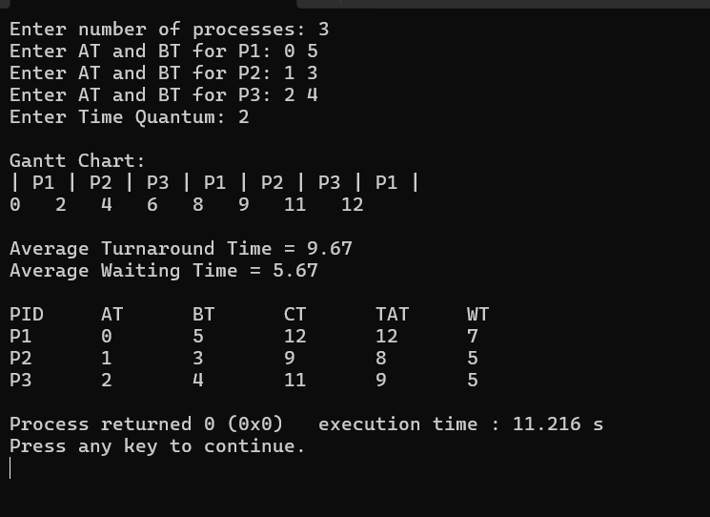

2. Write a C program to simulate multi-level queue scheduling algorithm

#include <stdio.h>
struct Process
{
int pid;
int at;
int bt;
int type;
int ct;
int tat;
int wt;
};
int main()
{
struct Process p[20], temp;
int n;
int time = 0;
int sysCount = 0, userCount = 0;
struct Process sysQ[20];
struct Process userQ[20];
printf("Enter number of processes: ");
scanf("%d", &n);
for(int i = 0; i < n; i++)
{
printf("Enter PID AT BT TYPE(0-System,1-User): ");
scanf("%d %d %d %d", &p[i].pid, &p[i].at, &p[i].bt, &p[i].type);
}
for(int i = 0; i < n; i++)
{
if(p[i].type == 0)
{
sysQ[sysCount++] = p[i];
}
else
{
userQ[userCount++] = p[i];
}
}
for(int i = 0; i < sysCount-1; i++)
{
for(int j = 0; j < sysCount-i-1; j++)
{
if(sysQ[j].at > sysQ[j+1].at)
{
temp = sysQ[j];
sysQ[j] = sysQ[j+1];
sysQ[j+1] = temp;
}
}
}
for(int i = 0; i < userCount-1; i++)
{
for(int j = 0; j < userCount-i-1; j++)
{
if(userQ[j].at > userQ[j+1].at)
{
temp = userQ[j];
userQ[j] = userQ[j+1];
userQ[j+1] = temp;
}
}
}
for(int i = 0; i < sysCount; i++)
{
if(time < sysQ[i].at)
time = sysQ[i].at;
time = time + sysQ[i].bt;
sysQ[i].ct = time;
sysQ[i].tat = sysQ[i].ct - sysQ[i].at;
sysQ[i].wt = sysQ[i].tat - sysQ[i].bt;
}
for(int i = 0; i < userCount; i++)
{
if(time < userQ[i].at)
time = userQ[i].at;
time = time + userQ[i].bt;
userQ[i].ct = time;
userQ[i].tat = userQ[i].ct - userQ[i].at;
userQ[i].wt = userQ[i].tat - userQ[i].bt;
}
printf("\nPID\tAT\tBT\tTYPE\tCT\tTAT\tWT\n");
for(int i = 0; i < sysCount; i++)
{
printf("%d\t%d\t%d\tSystem\t%d\t%d\t%d\n",
sysQ[i].pid, sysQ[i].at, sysQ[i].bt,
sysQ[i].ct, sysQ[i].tat, sysQ[i].wt);
}
for(int i = 0; i < userCount; i++)
{
printf("%d\t%d\t%d\tUser\t%d\t%d\t%d\n",
userQ[i].pid, userQ[i].at, userQ[i].bt,
userQ[i].ct, userQ[i].tat, userQ[i].wt);
}
return 0;
}

OUTPUT:
