**CS5551**

**ADVANCED SOFTWARE ENGINEERING**

**PROJECT PLAN (PG-9)**

**TITLE: VIRTUAL LEARNING**

**Submitted By**: Bala Sai Teja Gaddam (Class ID-15)

Manisha Reddy Kattukuri (class ID-27)

Teja Mosali (Class ID-34)

Tejaswini Nalamotu (class ID-35)

1. **INTRODUCTION:**

Education helps everyone to develop and progress as individuals. It has become part and parcel in everyone’s life. One way of testing our knowledge is through examinations. These help them to advance their studies, enhance their skills and let them know in which area they are lagging. Now a days most of the exams are conducted online, so our project mainly concentrates on virtual learning .Virtual learning is a place where a person gets all the information related to the examinations. It provides them with tests self-assessments reference materials, best tutors .It saves everyone’s precious time by furnishing their results immediately, assessing their results and thereby providing the reference materials tutors, through which they can emphasize on the areas that they lack in .Virtual learning provides an economic way of assessment.

1. **PROJECT GOALS AND OBJECTIVES:**

* **Overall Goals:**

The goal of the application is to provide the users a wholesome service which helps them to get all the information related to learning at a place .The users should be left with the satisfaction of learning different things in a short span of time.

* **Specific Objectives(Problem Statement):**

All the web users should be able to access the page by providing their credentials. The web page provides the different services like taking the tests, providing the resources regarding a particular area of that test and also giving information about tutors.

There are two kinds of users. They are administrator and students. The administrator had the responsibilities of managing system users, tests, subjects, questions, reference materials and results. The student can register themselves for the test, review their results and can also go through reference materials. The timer is set automatically when the test starts which enables them to cope up with time management issues. This creates various reports and graphs for evaluation purpose almost instantly.

* **Significance:**

This application helps students in enhancing their skills and makes them ready to take up exams at any time .this enables students to concentrate on weaker areas. The student get to manage the time and evaluate their results as they practice.

It inculcates self-assessment in individuals which enables the self-learning, self-analysis which help them to progress rapidly and improve their learning graph.

1. **Project Background and Related work**

* **Existing work**:

<http://www.exambuilder.com/features/at-a-glance/>

<http://www.examprofessor.com/tour>

<http://speedexam.net/exam-management-overview.html>

* **Comparison:**

Our application provides the test in such a way that the paper covers most of the questions from the area in which they lack in. This provides the students with the comprehensive materials focusing on the areas to be improved which helps them to instantly gain the necessary and required materials.

1. **Proposed System:**
2. **Requirement Specification:**

**Functional:** The application allows the student to access the page and register for the tests. The students can take up the test by describing different categories in which they are interested in. Evaluation of the results takes place providing the assessment of the tests, providing the necessary materials and also the information of the tutors in the specific area. The timer starts automatically when the test starts alerting the users. The user can understand things better with the reference material provided. The administrator can update the questions, check the results, manage and organize the questions.

**Non-functional:** The foremost criteria to judge the operation of a system is non-functional requirement instead of specific behaviors. Non-functional requirements must be distinct from the functional requirements which defines particular behavior or their functions. In system architecture non-functional requirements plan is implemented specifically. The qualities of a system can be defined in non-functional requirements. The above are the strategies of non-functional requirements.

**System requirements:**

**Software specifications:**

* Coding Language : ASP.NET with VB
* Operating System : Windows 2000/XP/Vista
* Model design : Rational Rose
* IDE : Visio Studio
* Data Base : SQL Server 2005

**Hardware specifications:**

* Memory : 256 MB
* Hard Disk : 25 GB
* Processor : Pentium 4.0(1.6 GHz)

1. **Framework Specifications:**

**Assumptions:** Everyone struggles to standout in today’s competitive world. They require someone who can evaluate their knowledge, highlight their weak point, and guide them throughout their learning process. Virtual learning guides them through the process of learning. They get to improve different skills like time management and self-assessment.

**System Architecture:**

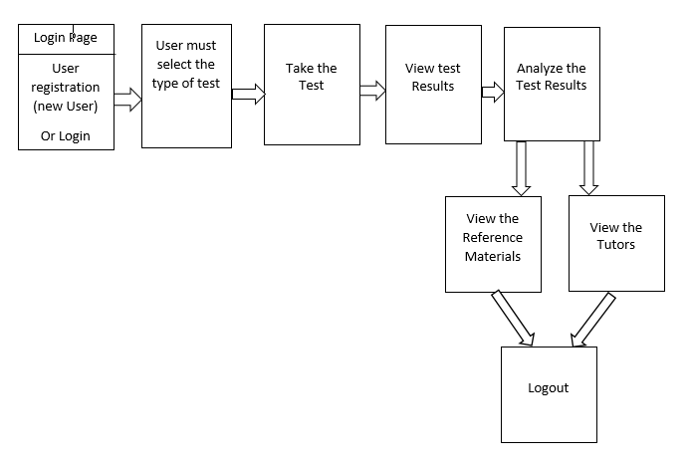

1. **System Specifications:**

**Existing services:**

1. Name: EXAMPROFESSOR

Description: Exam professor helps the students get to register into their sites for free or they can also use any major credit card. With the help of this website student can build, utilize and receive the payment with professionalism in short span of time.

URL**:** <http://www.examprofessor.com/>

1. Name: EXAM BUILDER

Description: With Exam Builder the student can do the test within minutes and generate the score board and their related certifications, spontaneously identify the practice gaps.

URL: <http://www.exambuilder.com/>

**New Services to be built:**

**Class Diagram:**

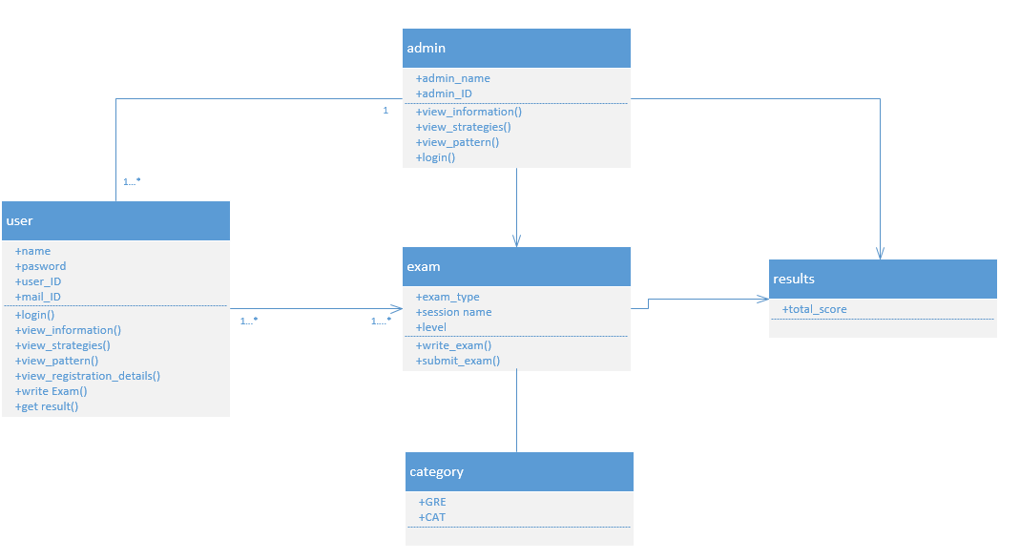

**Sequence Diagrams:**

* **Admin:**

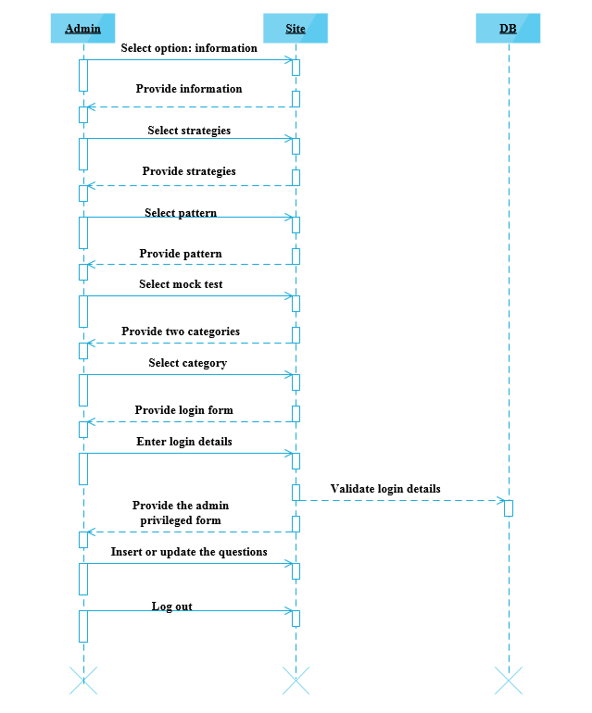

* **Student:**

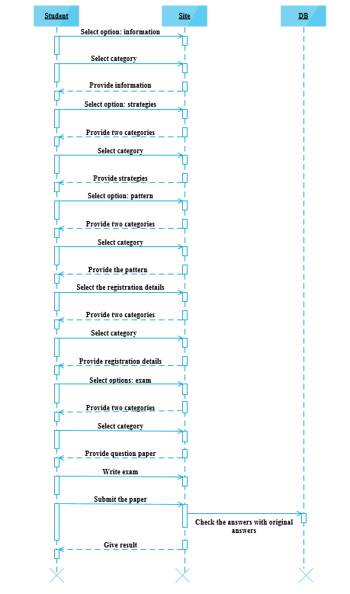

**Use case Diagram:**

* **Admin**

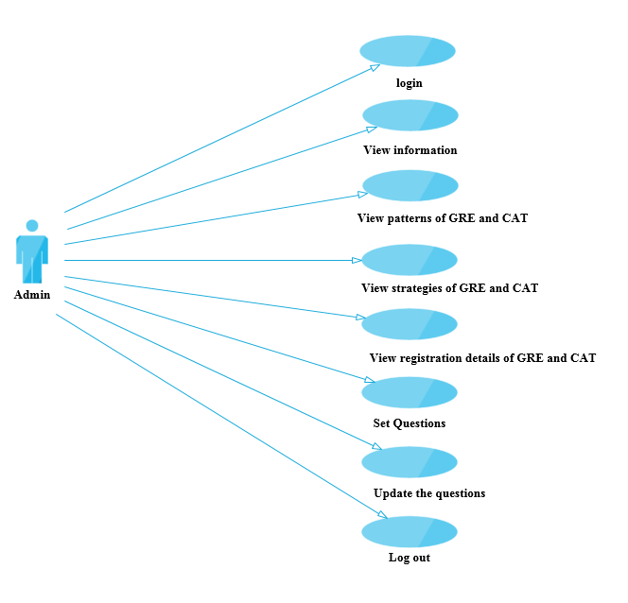

* **Student:**

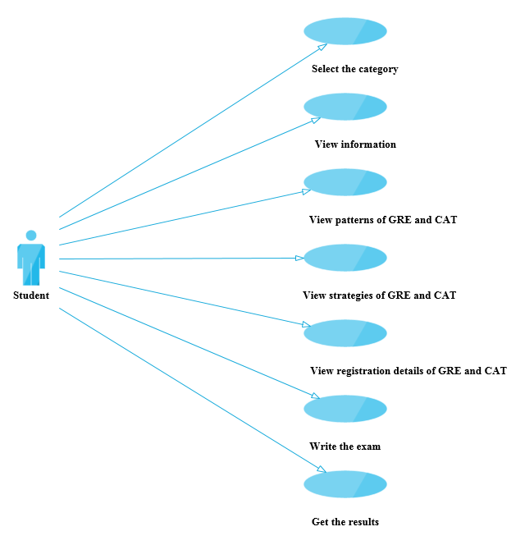

* **Service Specifications:**
* The application provides ability to the user to write the exam.
* This does not require any kind of pre-planned schedules.
* The difficulty level increases with each test depending upon the progress and performance of the user.
* The performance of each user is represented in a graphical notation which provides self-assessment for the users.
* The results of the test are generated as immediately as possible.

**Operational Description:**

* Students can register and get the credentials and can login with that credentials.
* Students can view the home page and select from different strategies and patterns of the tests.
* Each test comes up with the timer which keeps on intimating the students.
* Once exam is done the student is provided with the results, once he/she completes the test
* The admin can update the information that is viewed by the user.
* The admin can add new pattern and strategies for a test, the admin can add and delete, update the questions and pattern.

**Input/output for Services:**

**Constraints/Exceptions:**

* Genuineness of the tutors cannot be judged.

**Service or Alternate flows:**

* The system must be available 24/7 and must perform efficiently and must provide security to the user’s data.
* It must be flexible enough to undergo any kind of alterations.
* The application can be installed and can be executed on any kind of platforms.
* The application is user friendly and provides different services which makes their work easy.

1. **Plan by Services:**

<http://www.scrumdo.com/projects/project/virtual-learning1/iteration/121725>

<http://www.scrumdo.com/projects/project/virtual-learning1/iteration/121725/board>

1. **Risk Management:**

**Technological and Architectural Requirements:**

Front End: ASP.net with VB, C#, CSS3, HTML5

Back End: Sql Server 2005

1. **Bibliography:**

<http://www.slideshare.net/joyau2009/online-examination-documentation-29476109>

<http://projects.students3k.com/online-examination-report.html>

<https://www.youtube.com/watch?v=6oBmV4bG9VU>

<http://www.slideshare.net/chalexsimon/online-examination-final-project>