Link to access the notebook is:

https://databricks-prod-cloudfront.cloud.databricks.com/public/4027ec902e239c93eaaa8714f173bcfc/341354497313672/2138903707653462/1749098814917978/latest.html

CMD 2 result look like:

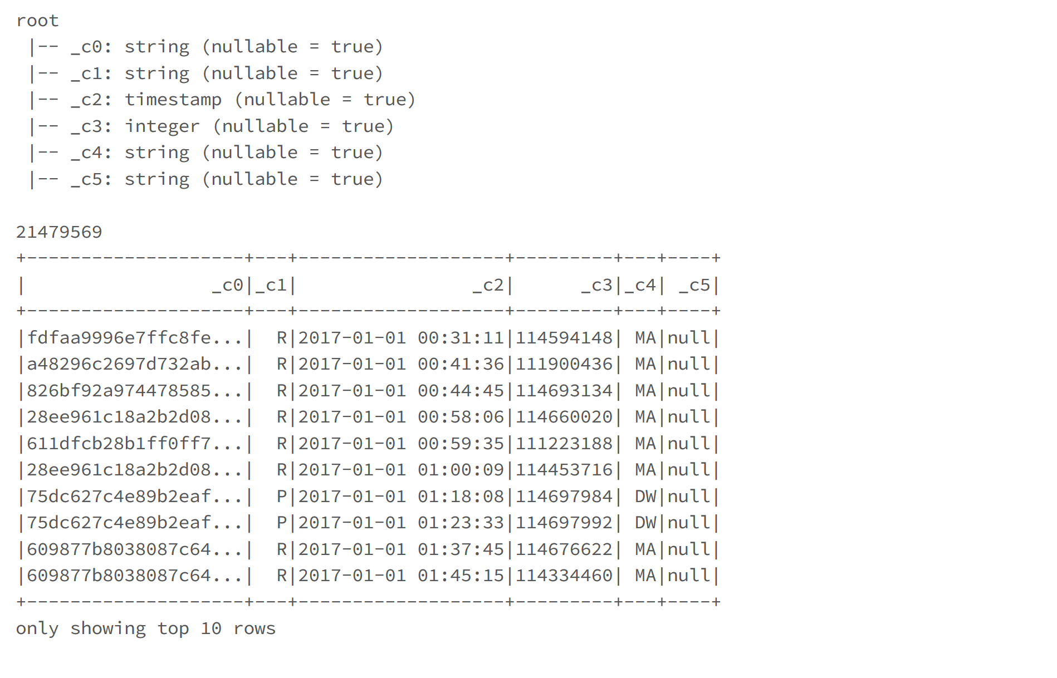

CMD 5 result look like:

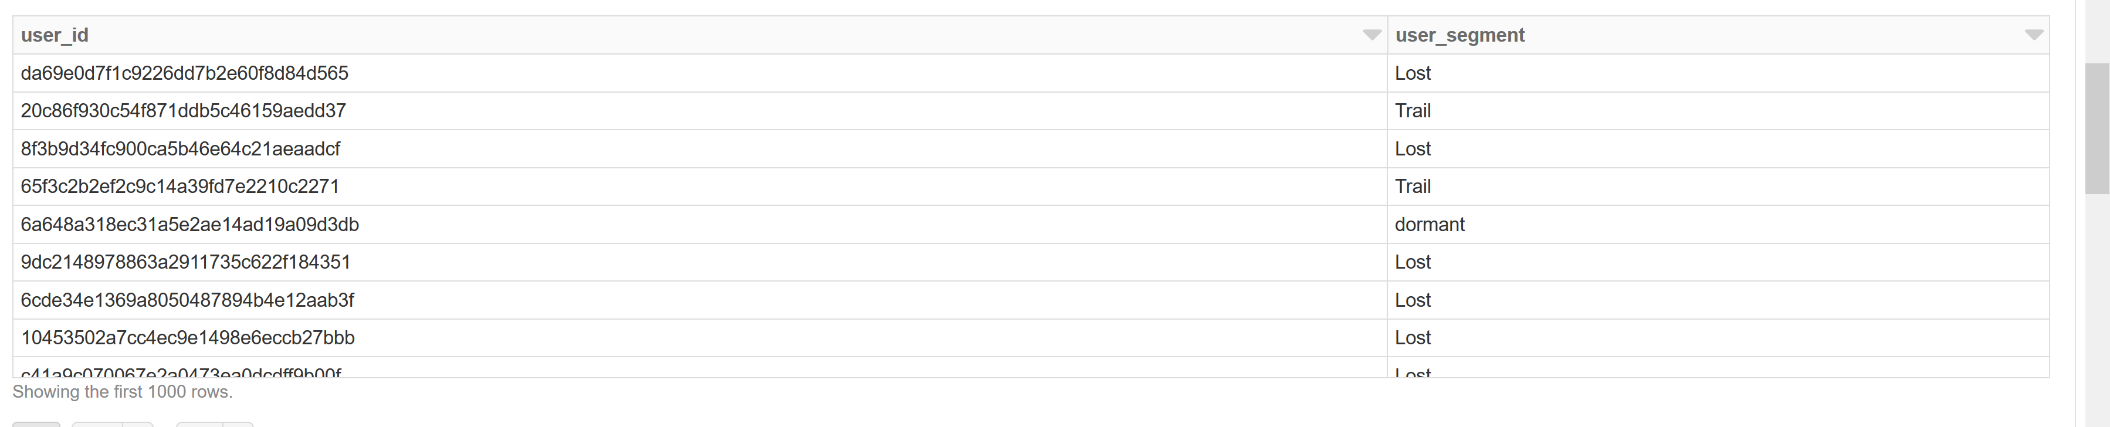

CMD 6 result look like:

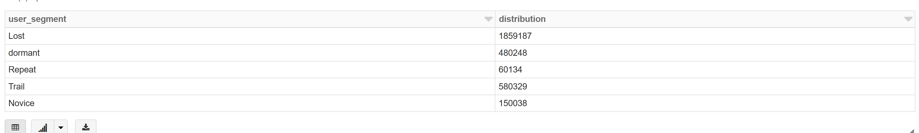

CMD 7 result look like:

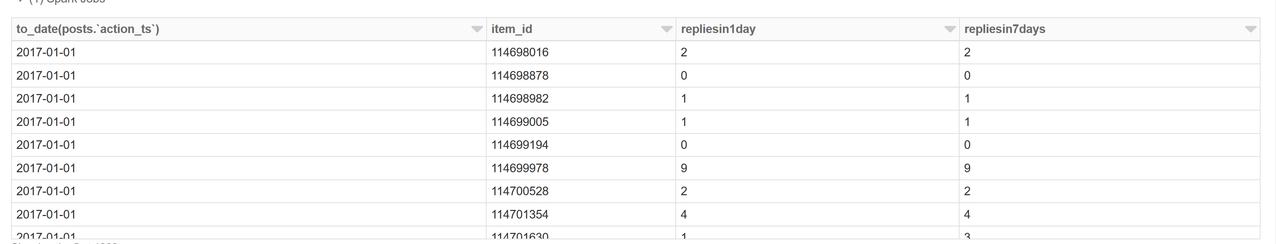

CMD 8 result look like:

